1. **Landing page Widgets headers are not converted on expanding/opening for Risk, Meetings, Change request**

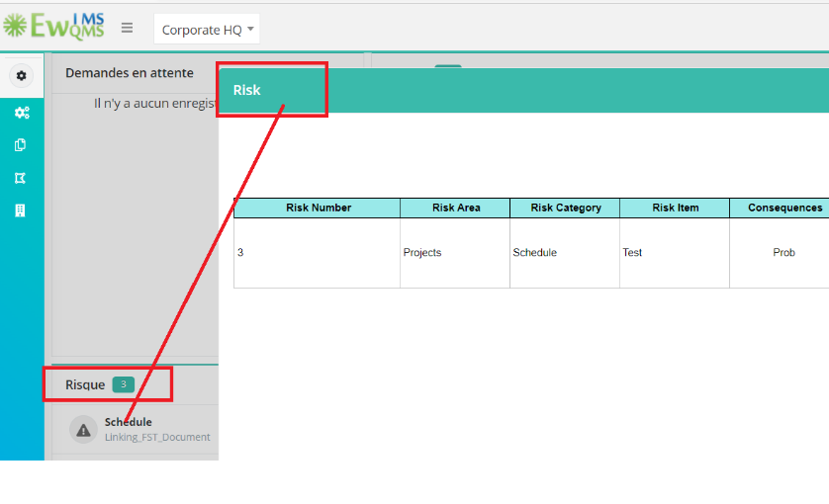

1. THL Prefix for CM widget name

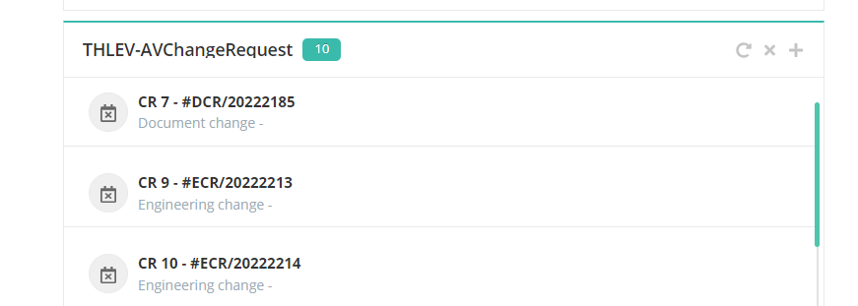

1. On clicking program the header is showing as projects
2. THL prefix for menu items. TTL Project management

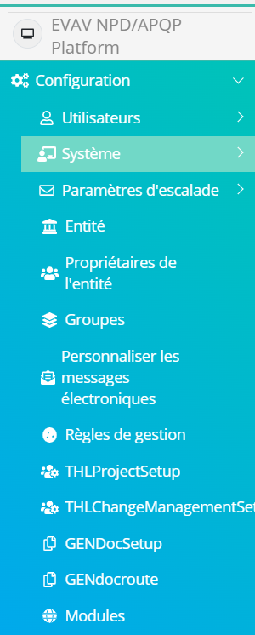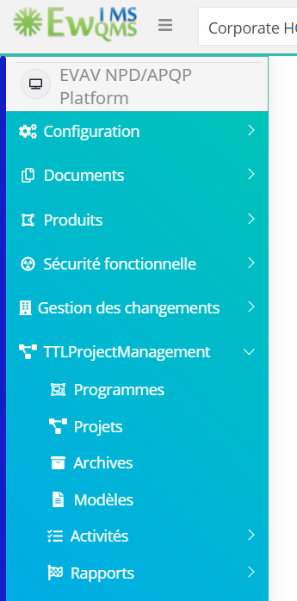

1. THL Prefix in charter template for associate pillar



1. Select Element in charter- is showing with Some spl charters for No data found



1. Forms- Publish button not changed

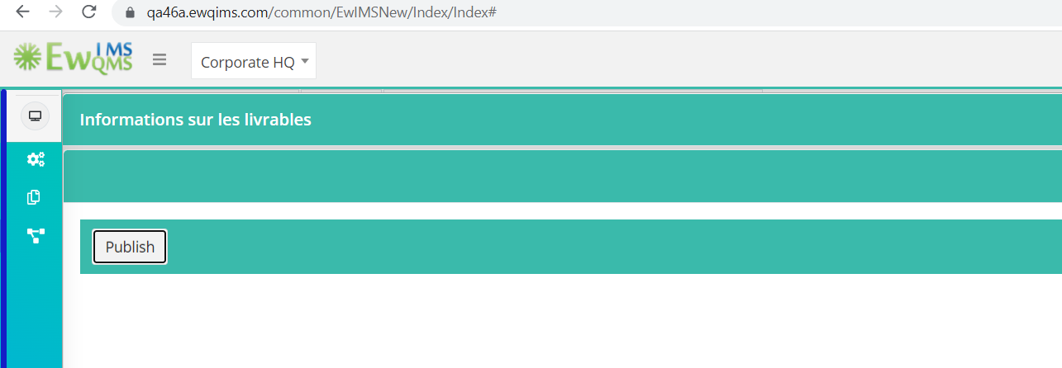

1. THL- In deliverable info page

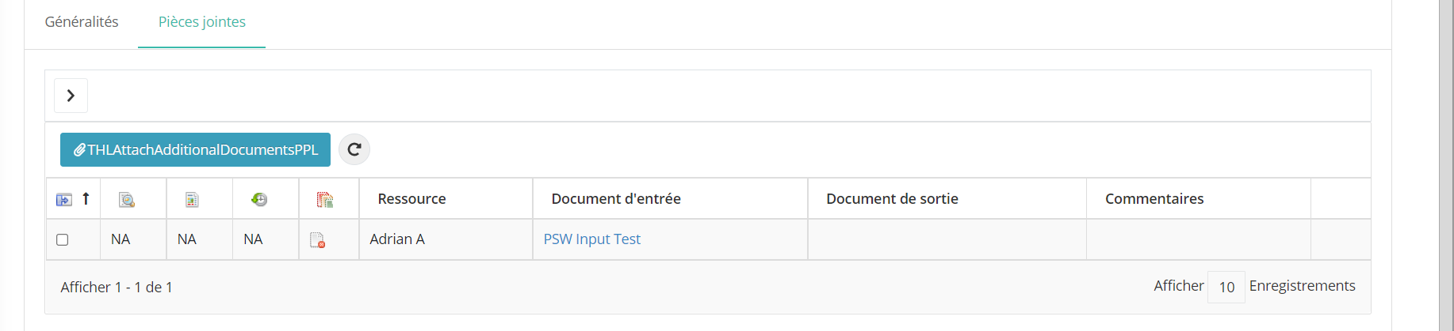

1. THL in gantt page More option

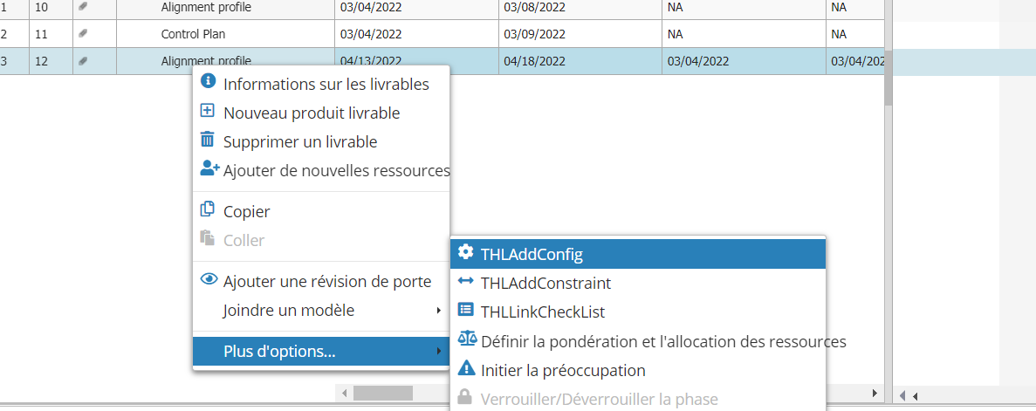

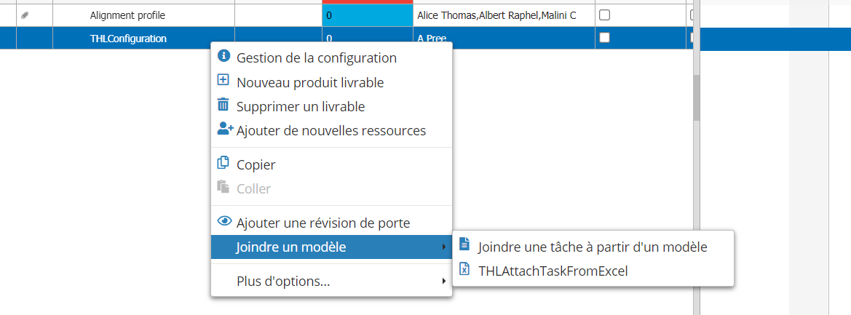

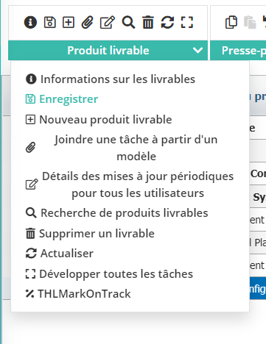 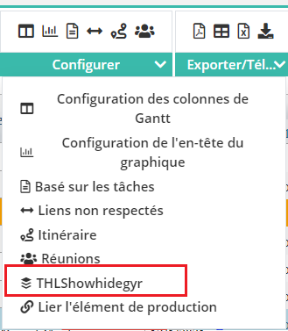 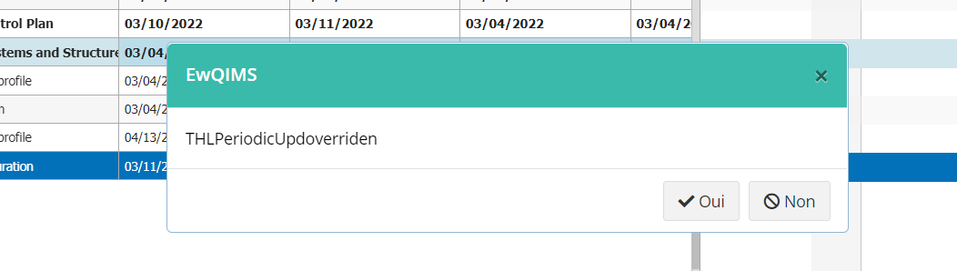

1. Over all Route in gantt page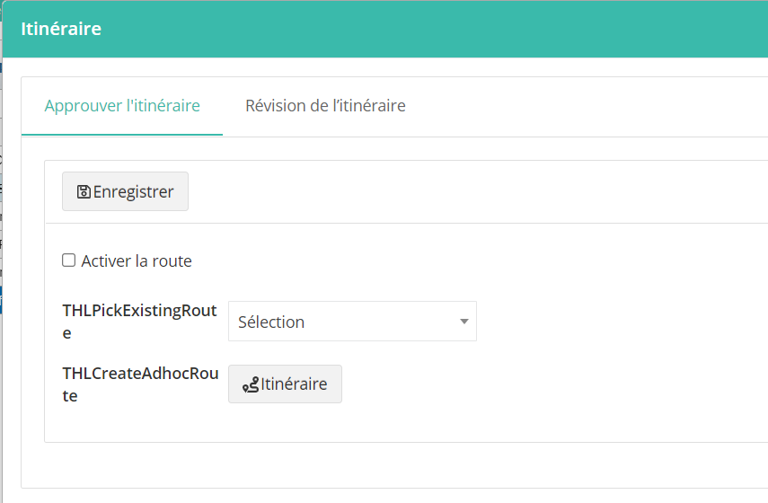
2. Attach Document- Deliverable info

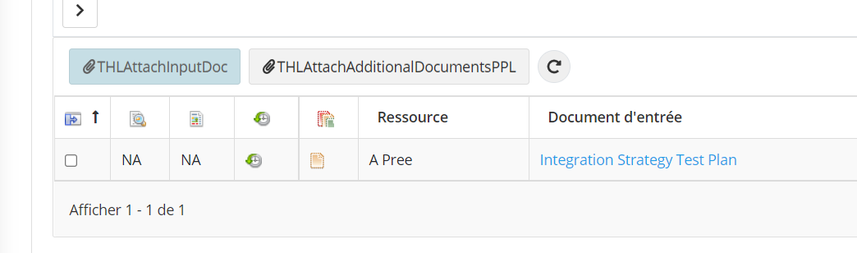

1. Landing page popup header



1. Download document popup in Gantt page

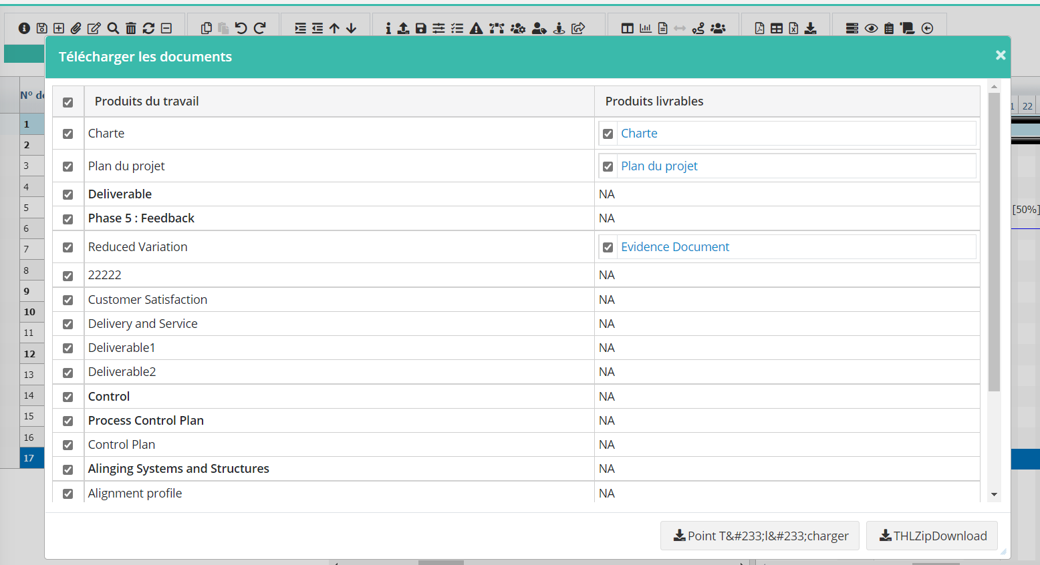

1. Landing Page-All widgets are showing THL prefix

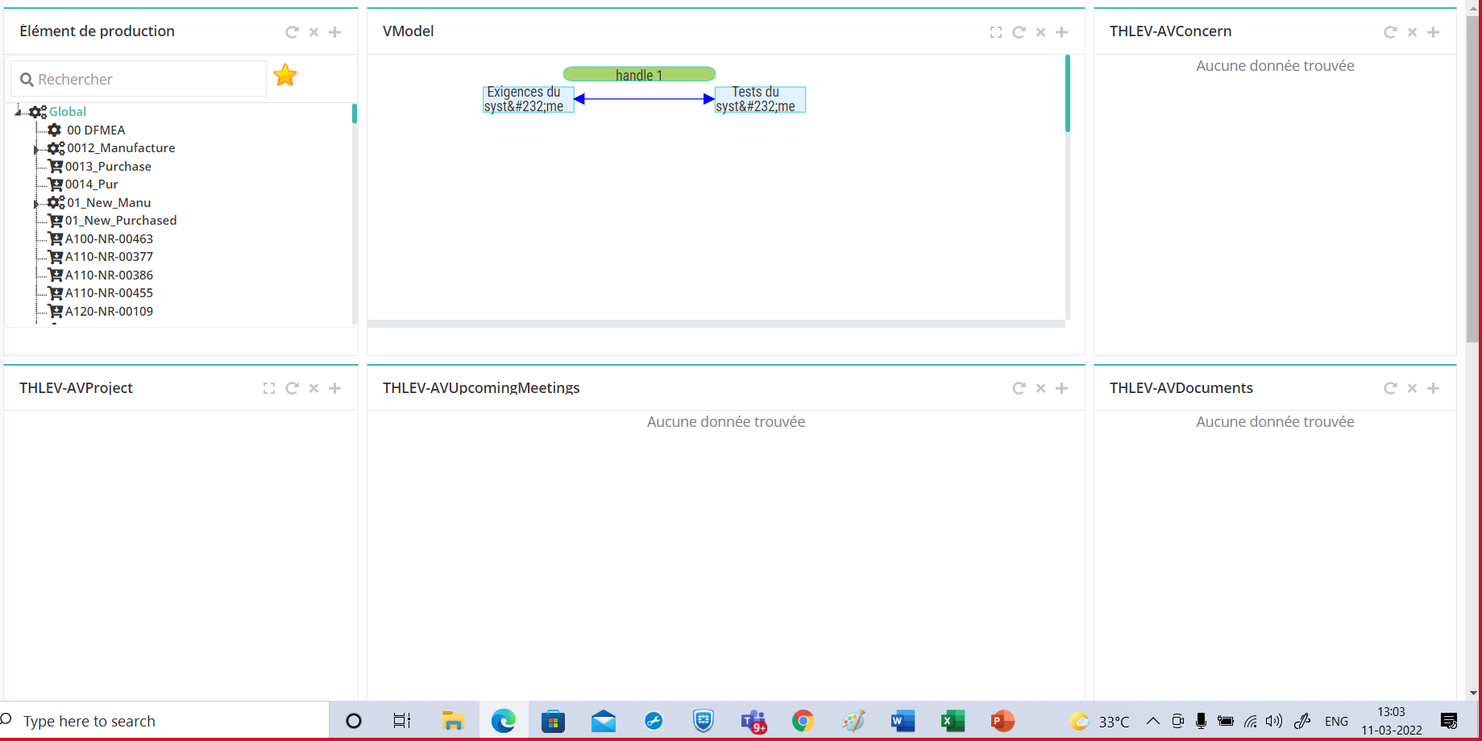

1. Project setup breadcrumb

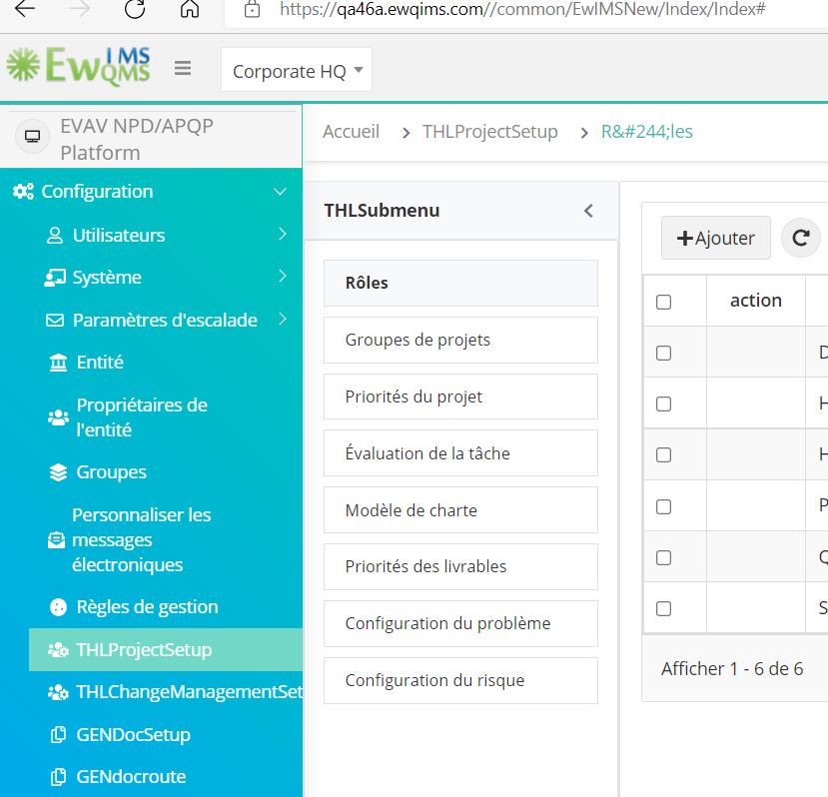

1. Customize Email Messages

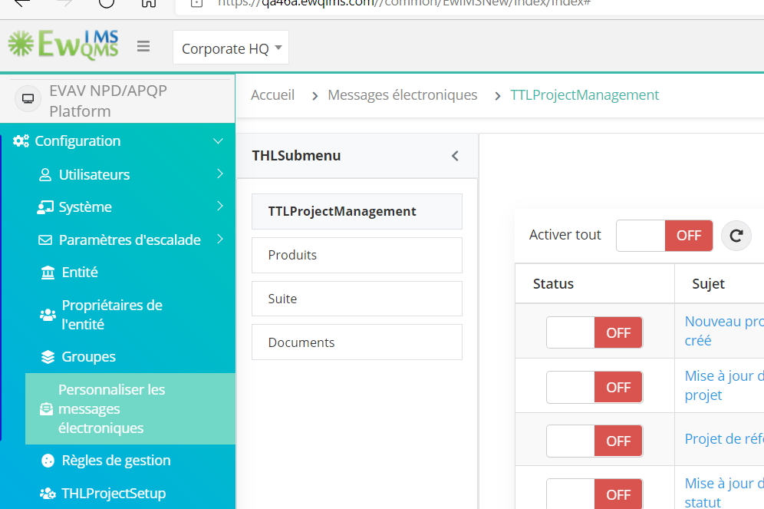

1. Programs- Showing THL prefix in tree view

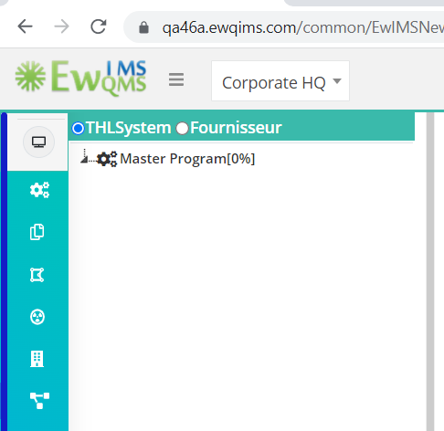

1. Change Working Time popup view

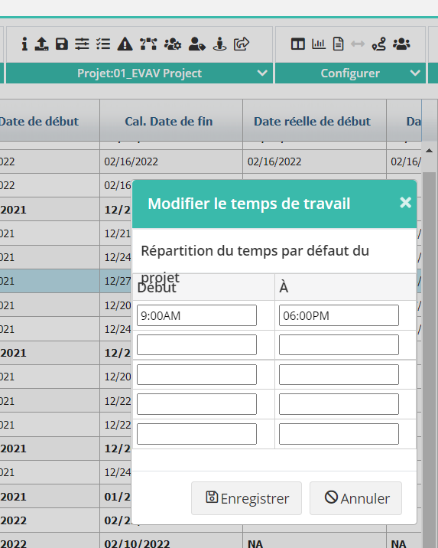

1. Score, Planned cost Actual Cost, Custom op folder in gantt is not converted

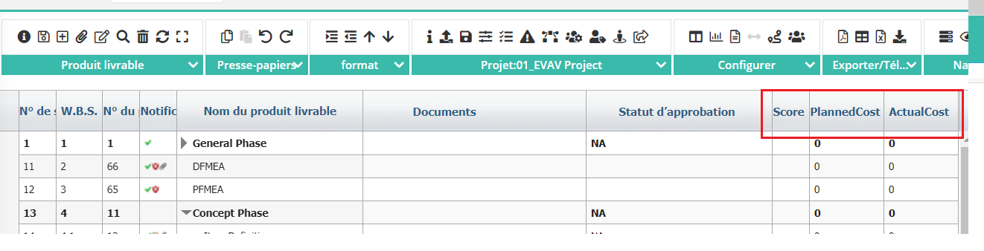

1. Planned Vs Actual popup showing thl for resource

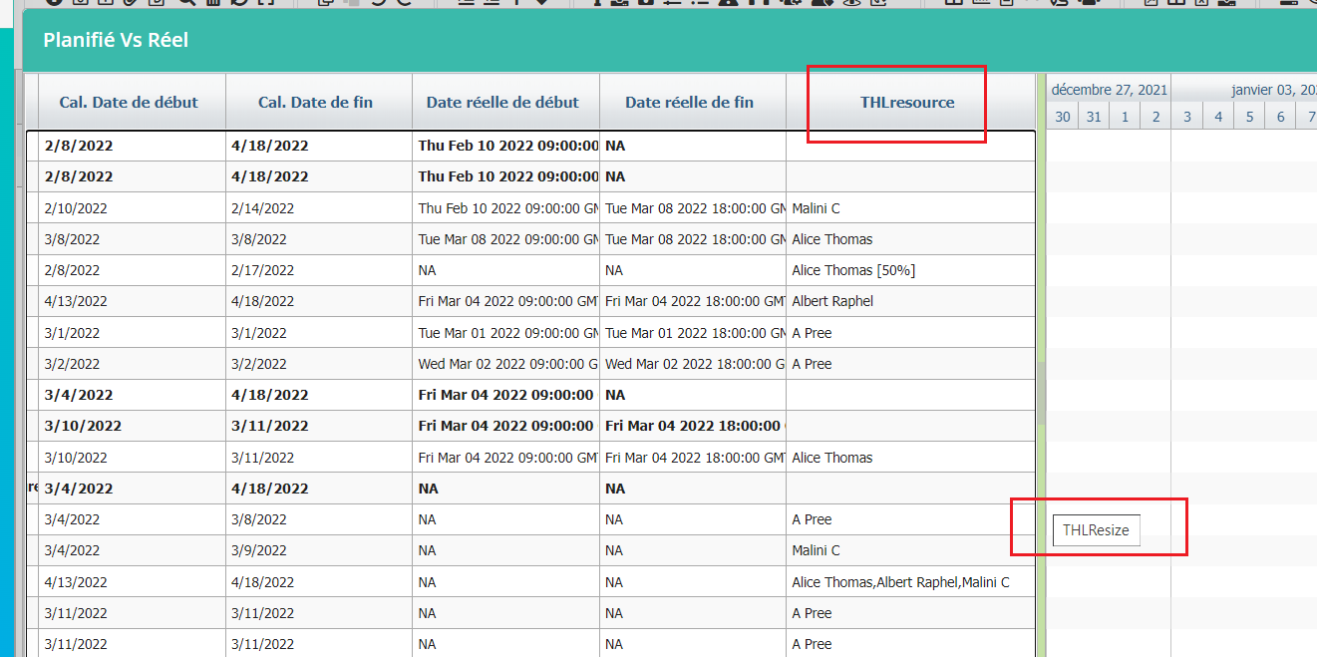

1. THL for the constraint name in the gantt page

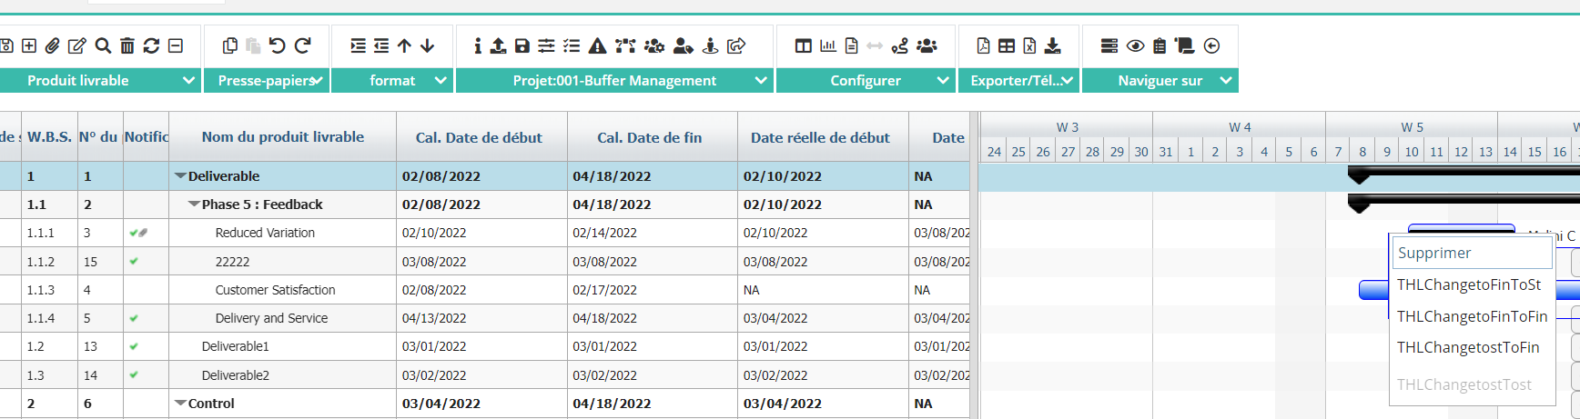

1. Issue creation popup showing THL

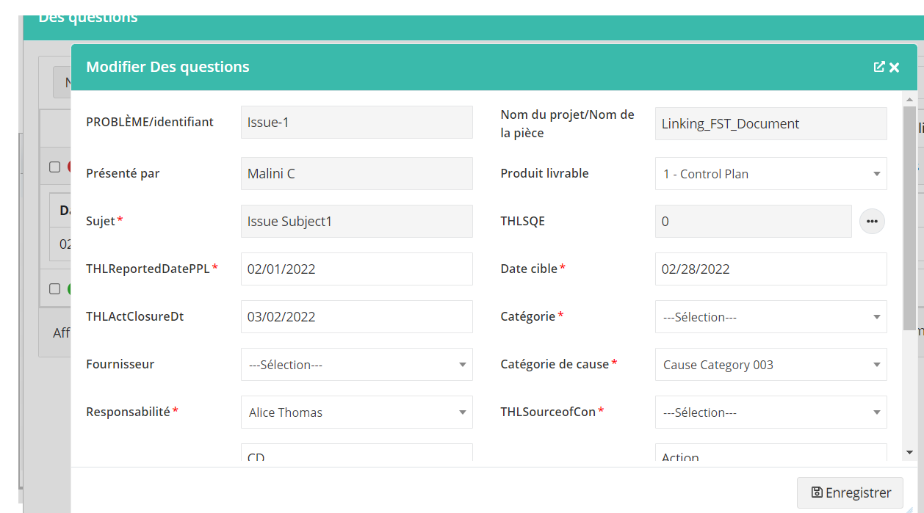

1. Actions- () is missing, search showing THL - Review Page

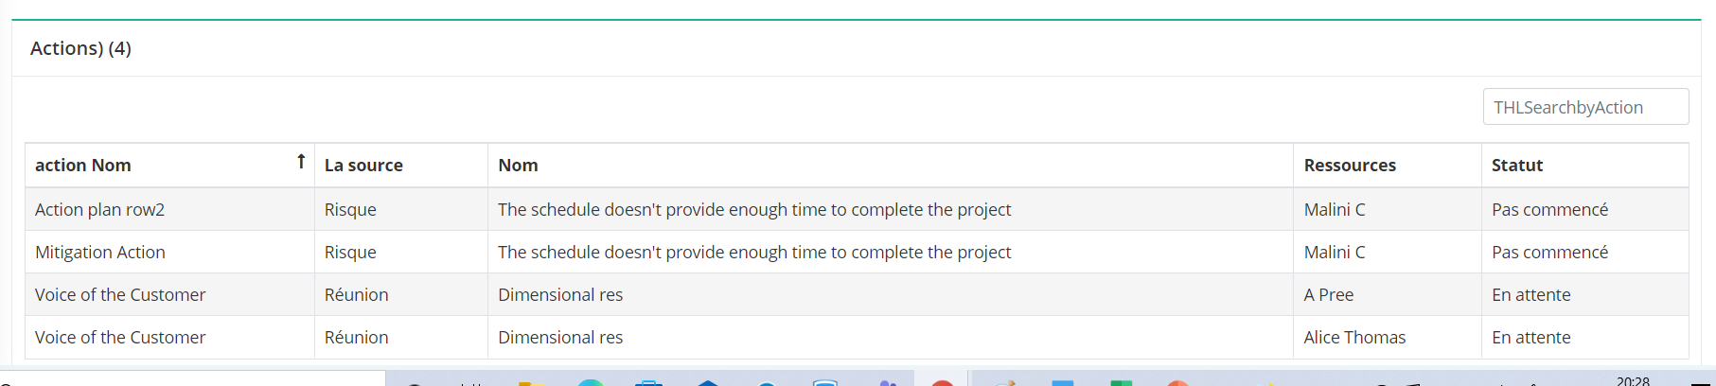

1. Mentor Comments popup- Showing THL

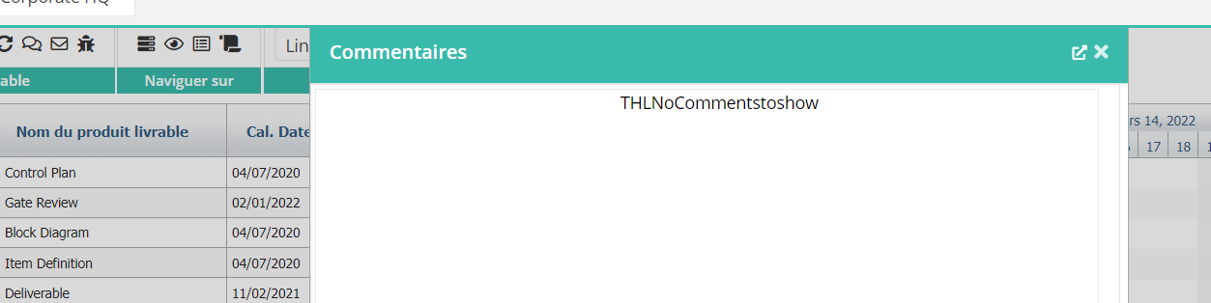

1. Resource and duration in Resource allocation across projects

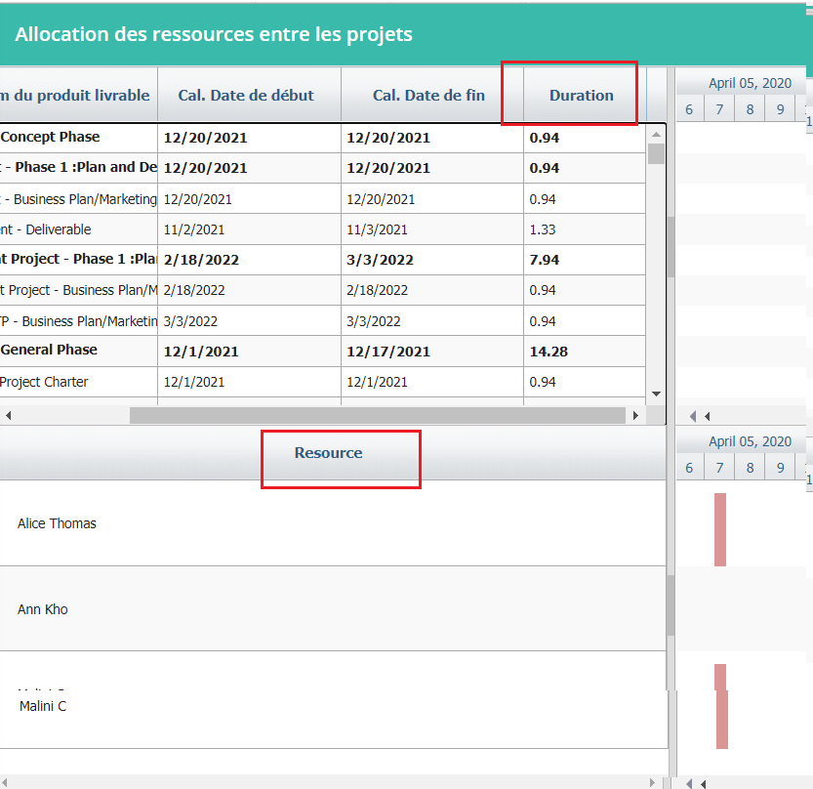

1. Periodic History Remarks field

