1. Doc pro settings🡪 For last 4 option, the label is showing along with GEN

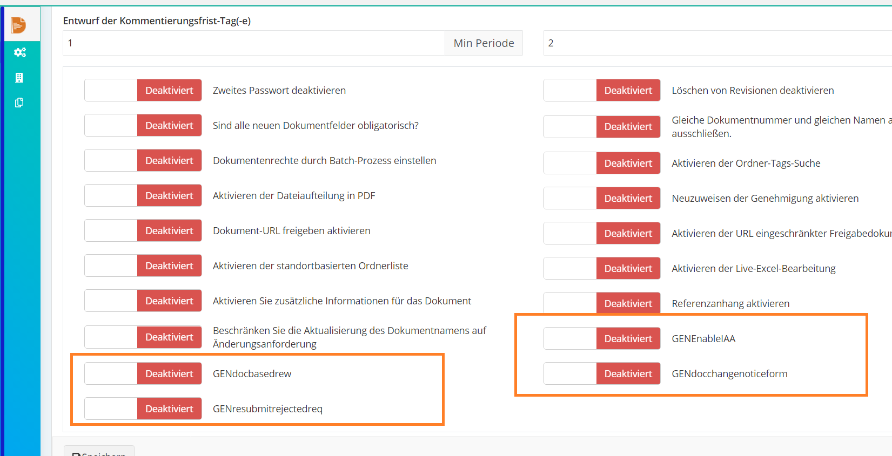

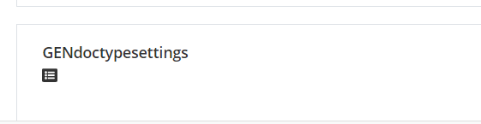

1. Doc pro settings🡪 Click on doc type settings and Enable Level for the supplier

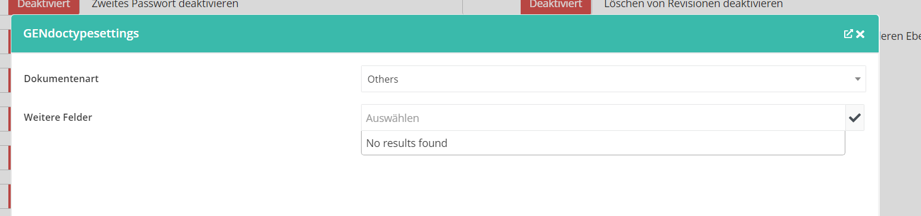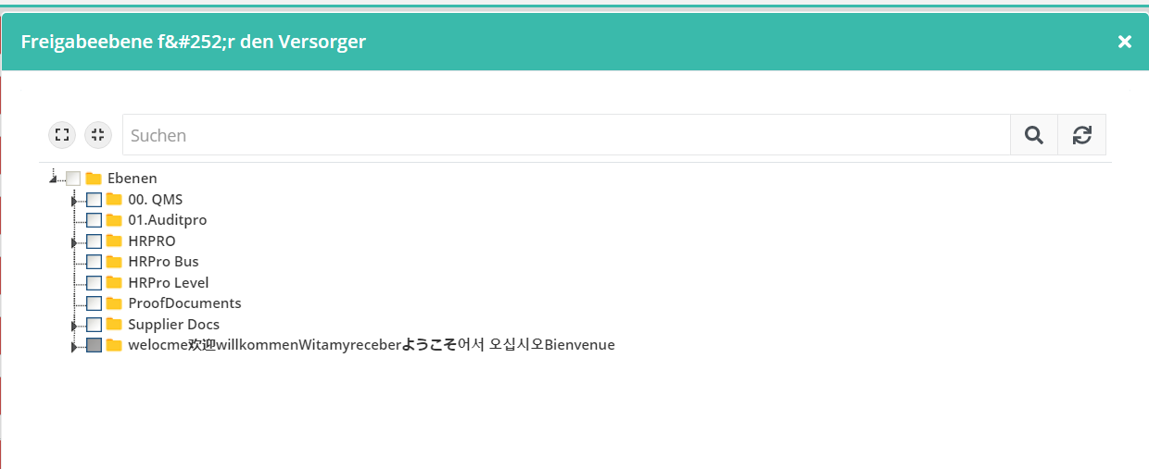

1. Landing page🡪 Document pro and our product Line up is not converted into german language

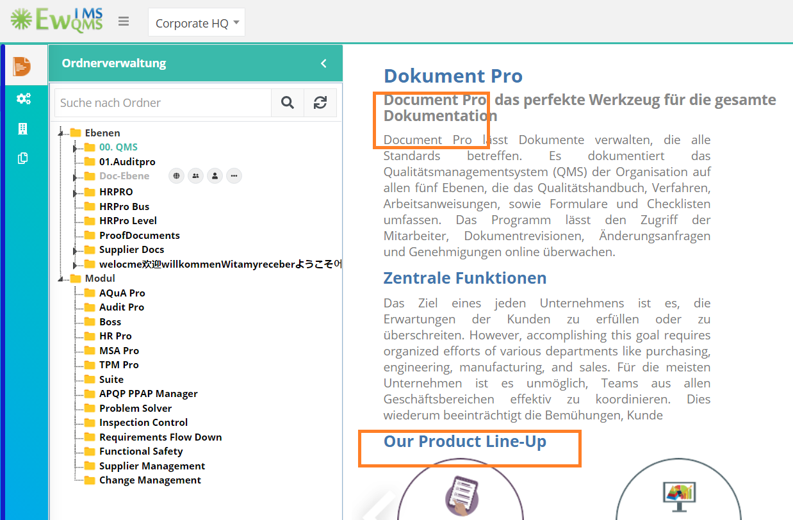

1. Folder Management 🡪 In German language, when opening the rights access, the label showing as collapsed

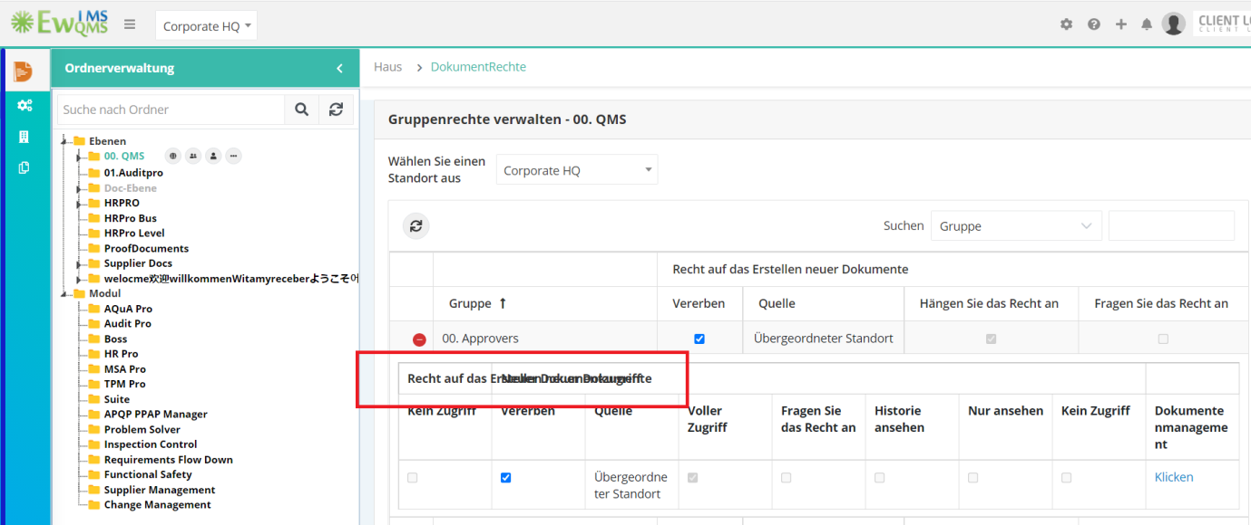

1. Folder Management🡪 Tag search option🡪 When selecting the done button, the label is showing in the tag selection field

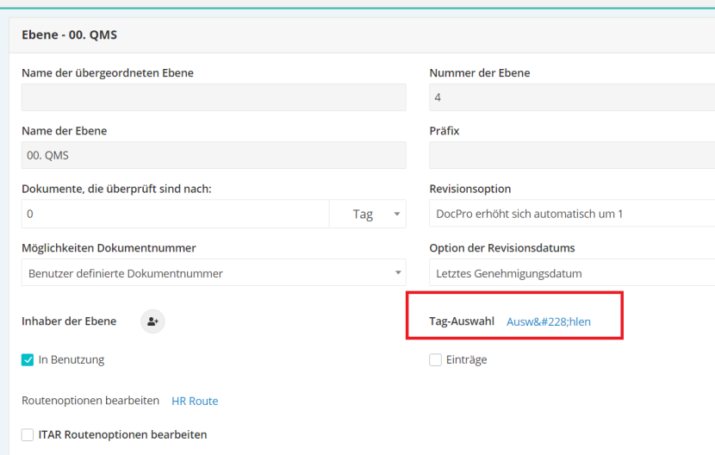

1. Folder Management🡪 when clicking on level owner icon, the label of the pop up window.

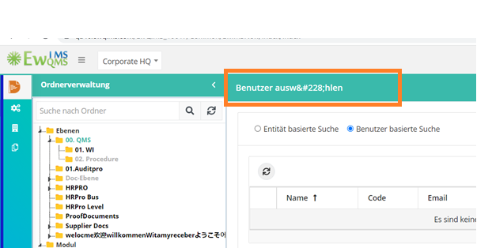

1. Route🡪 Add user -> the label of the pop up window is not showing properly

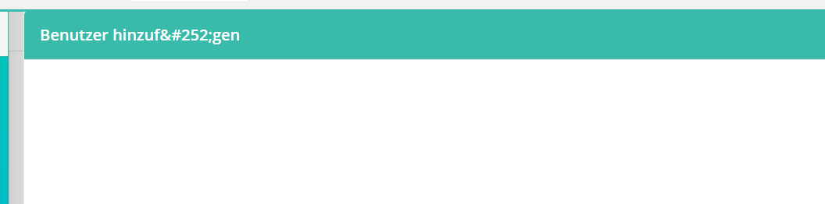8. Draft Groups🡪Group Name label, breadcrumb and pop up window label is not converted and Group name

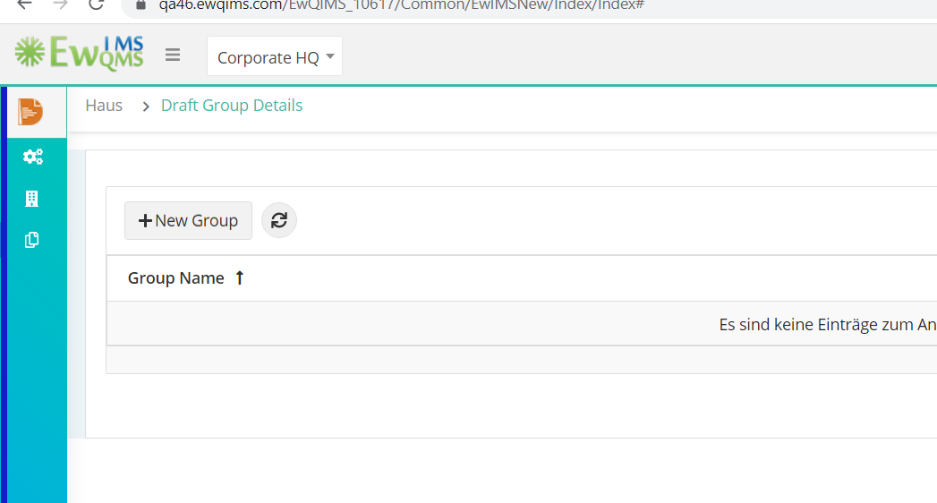



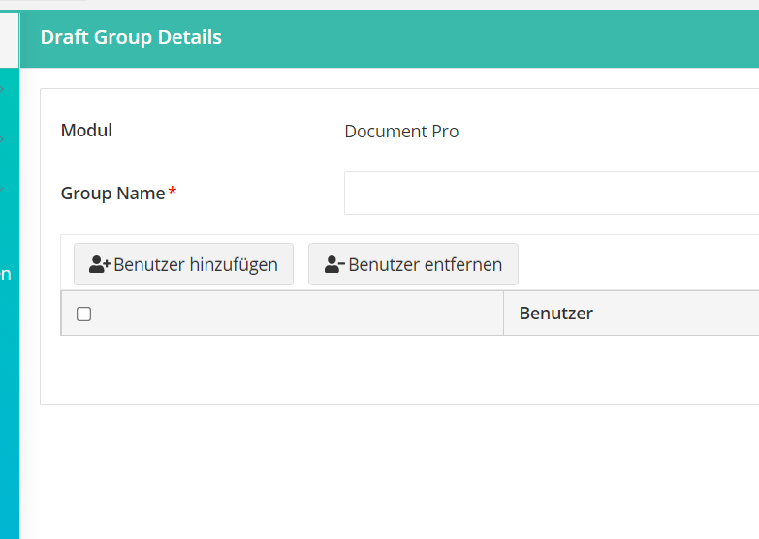

1. Draft group🡪 New🡪 Add users🡪pop up window label is not converted

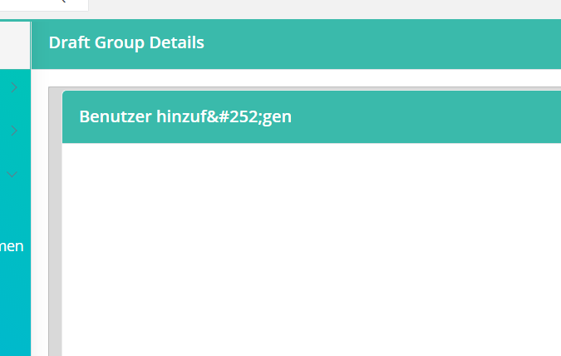

1. Pending document draft🡪 In comment section, the oldest label is not converted properly

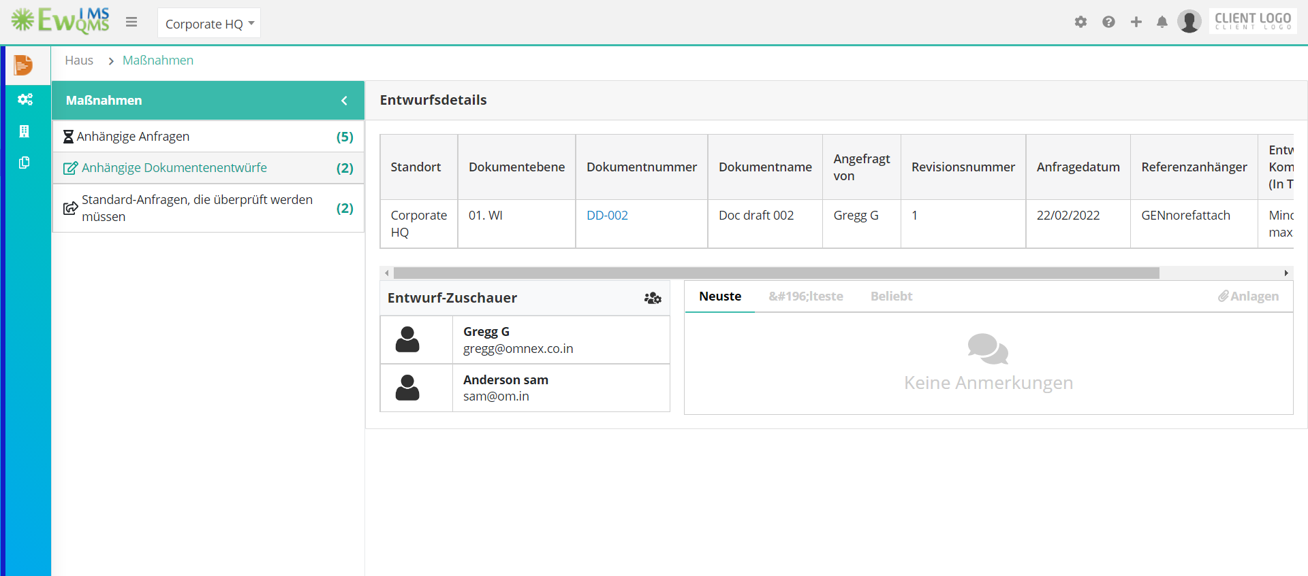

When clicking on attachment icon, it shows the same label

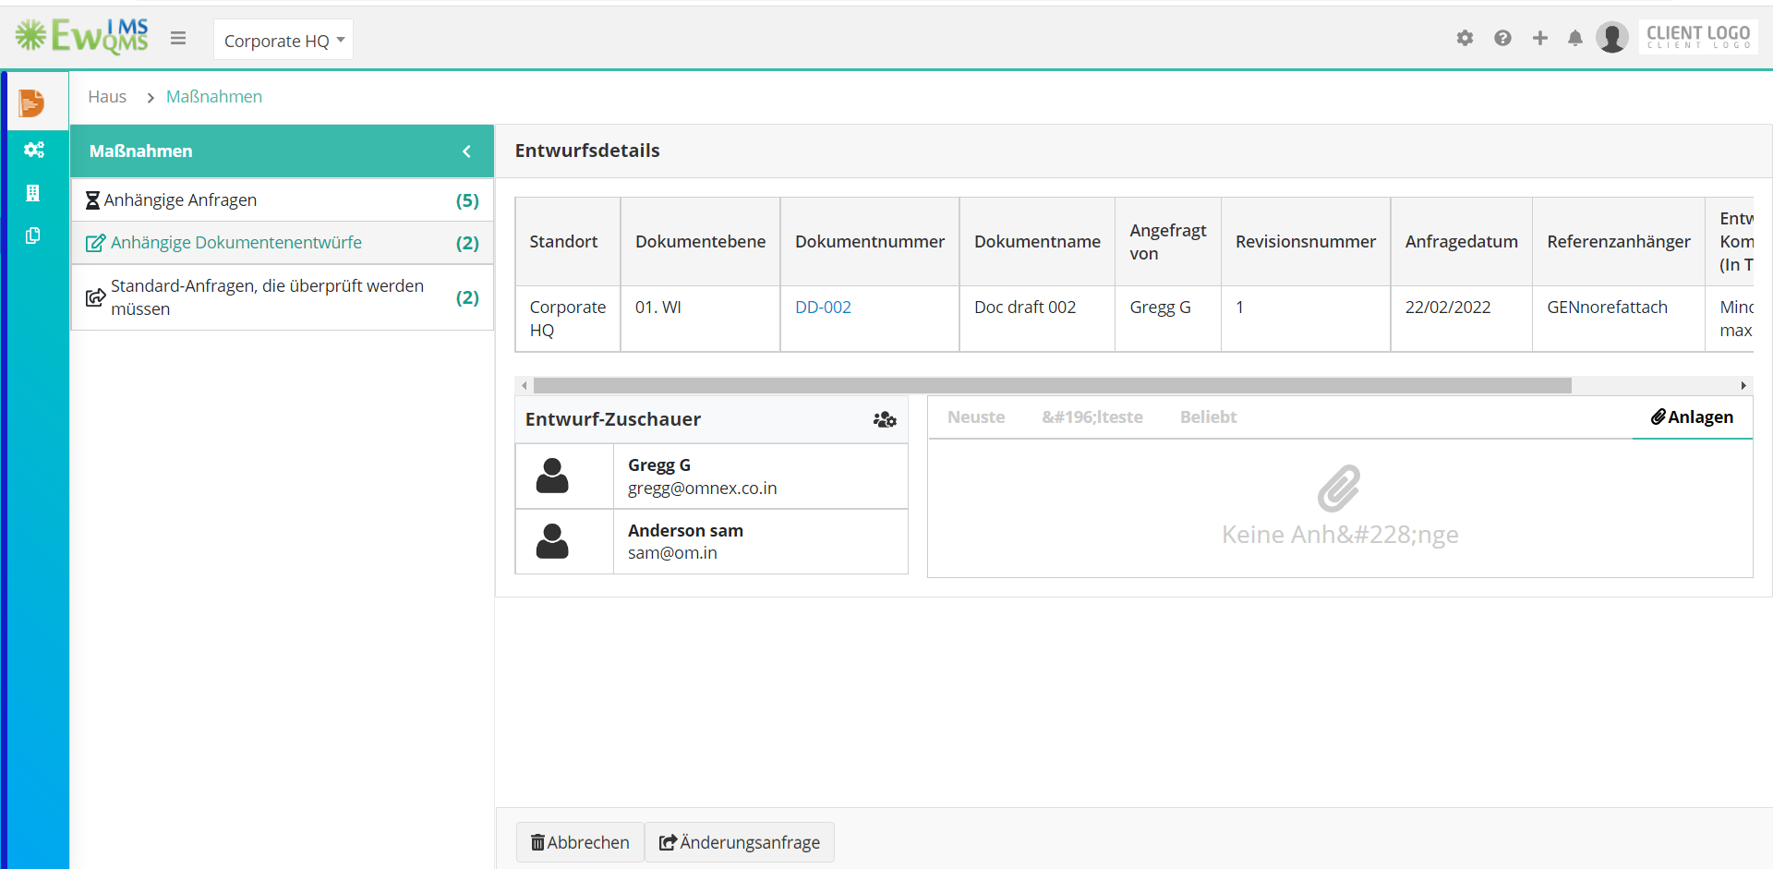

1. Tag Search 🡪 when clicking on the search tag field, it shows no result found. That label is not converted into german language

