Suite Italian language issues:

1. Entity page some of the labels are not converted

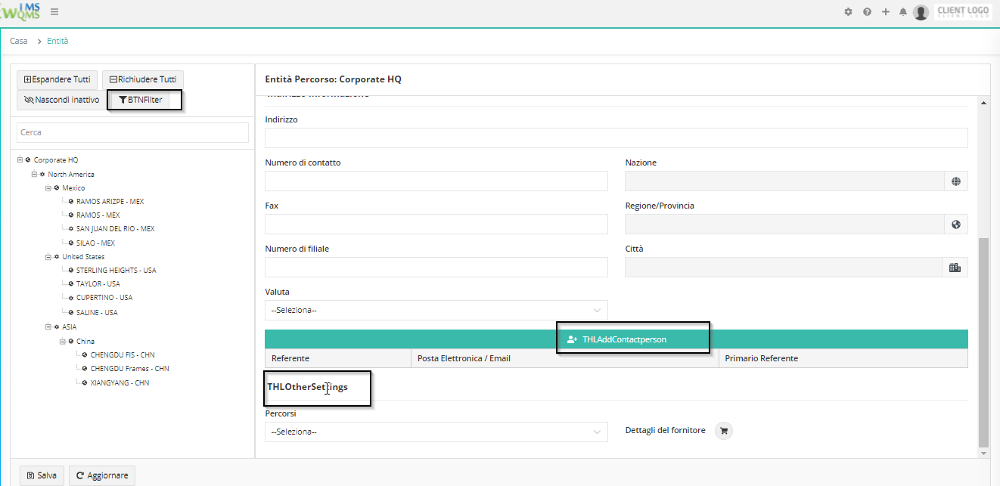

1. Entity type& Business unit and Site function label not converted

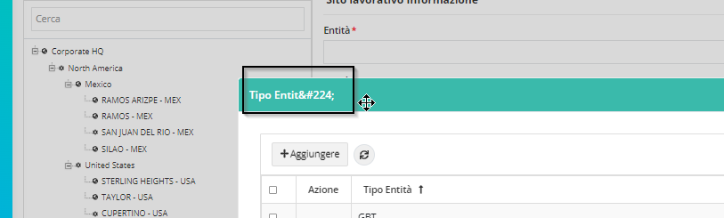

1. Entity->process entity matrix label

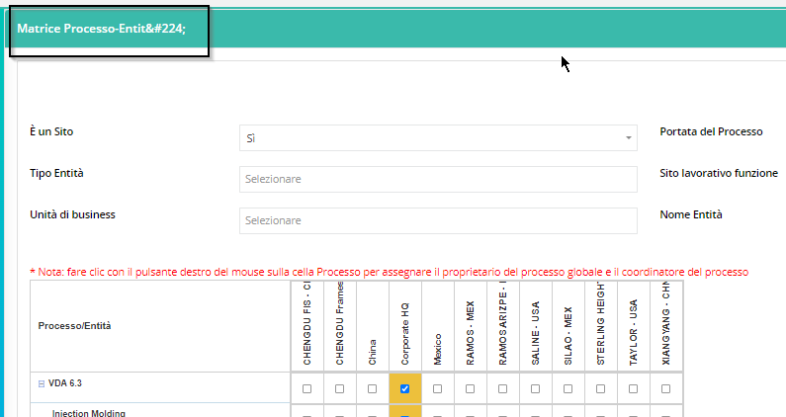

1. Administrator setting -> some of the labels are not converted

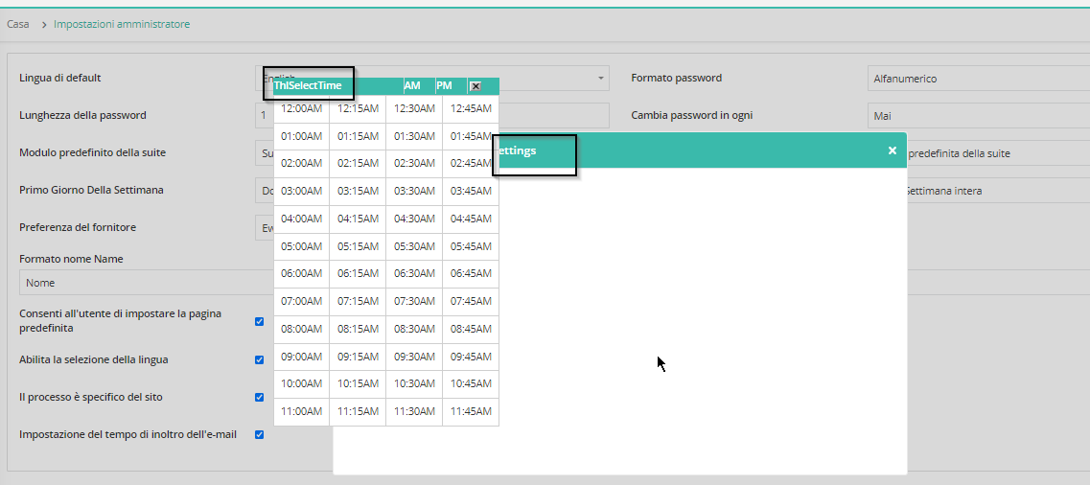

1. Configuration settings -> some of the labels are not converted

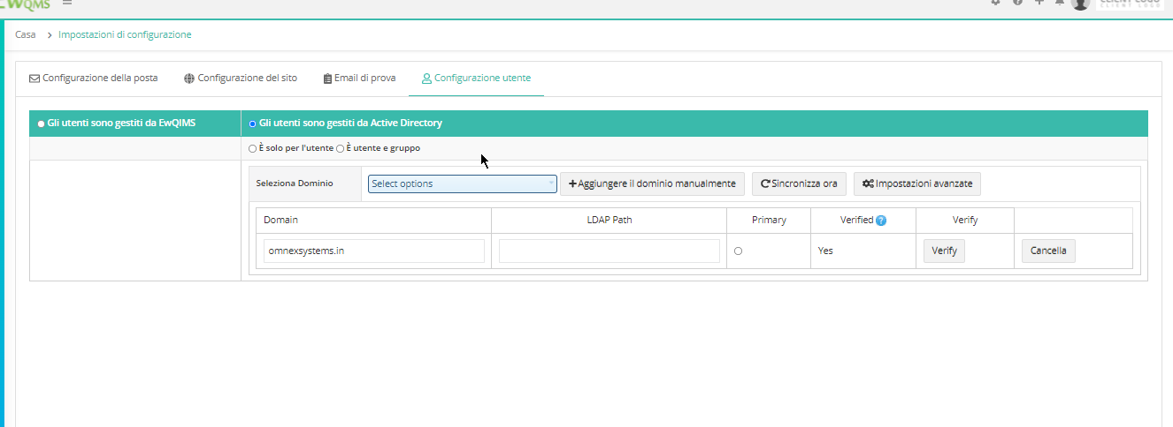

1. Customized Email messages labels -> Duplicate emails are displaying.

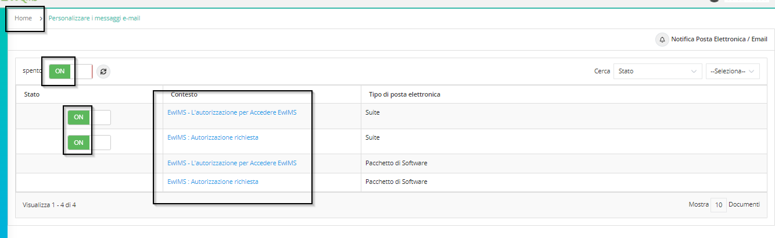

1. Process activities labels are not converted

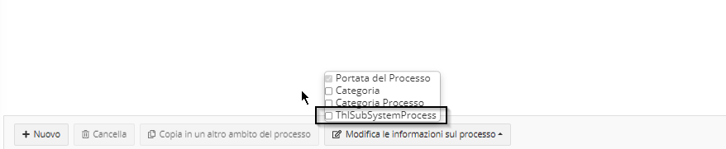

1. Users->User replacement

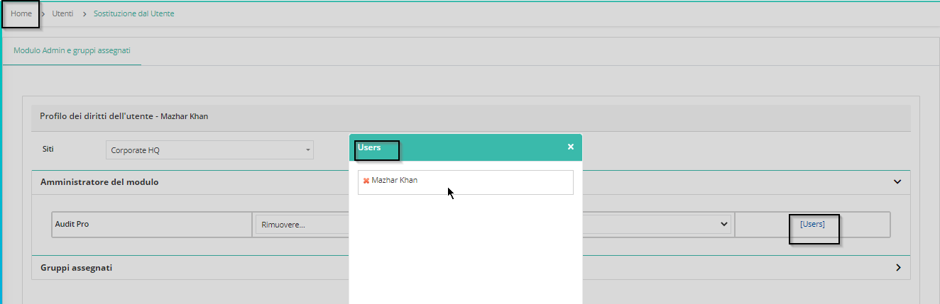

1. ITAR status close button tool tip label

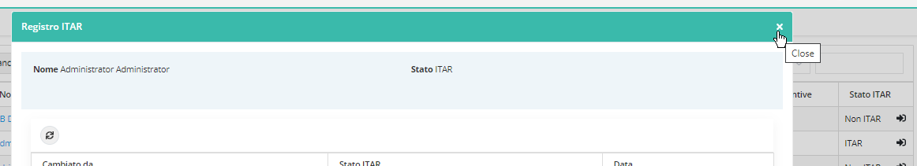

1. Session expired validation labels need to convert

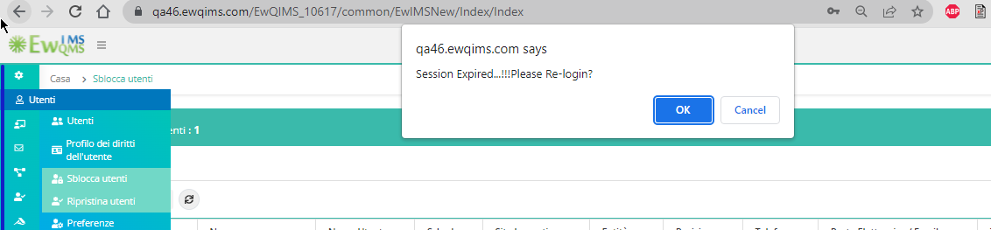

1. Restore Users labels

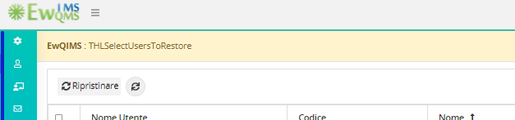

1. Organization profile -> Total users labels

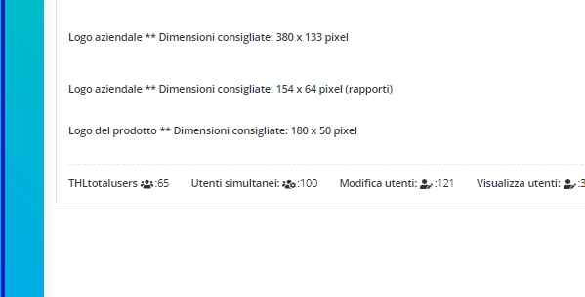

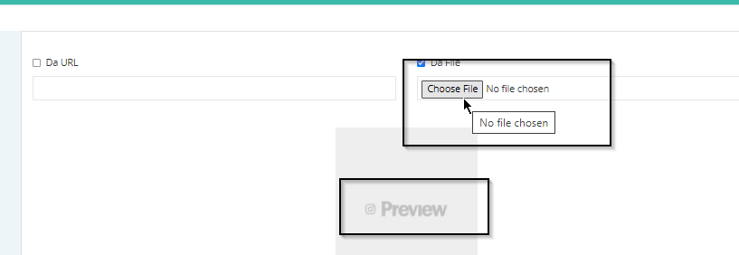

1. Teams labels are not converted

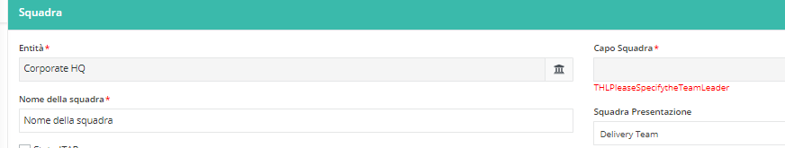

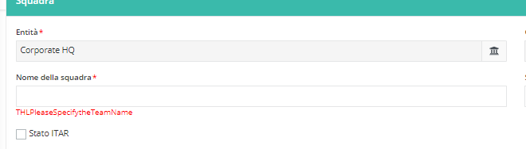  
Add team members

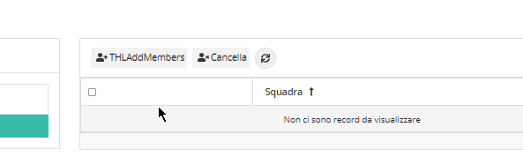

Delete external member

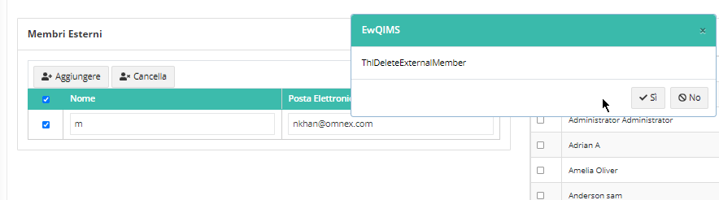

1. Supplier creation labels are not converted

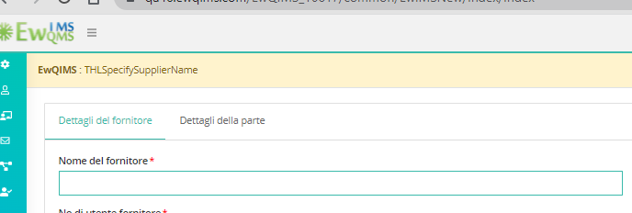

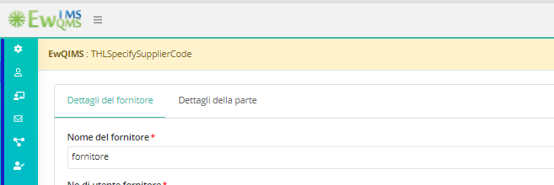

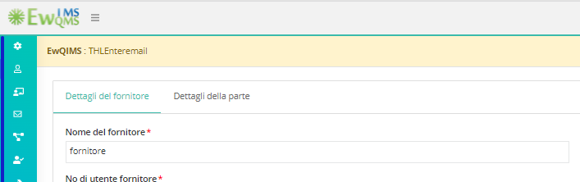

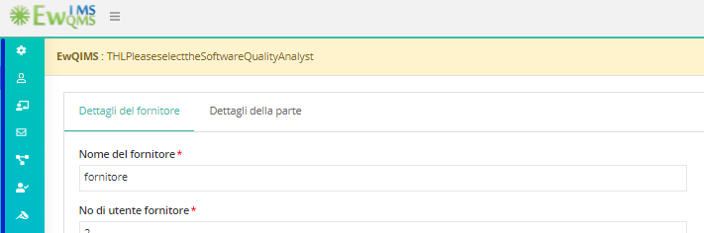  
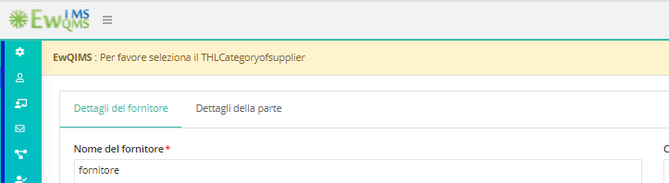

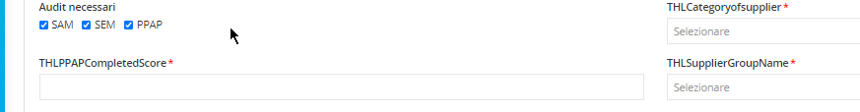  
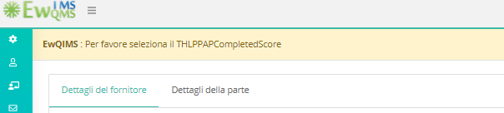

1. Meetings page labels are not converted

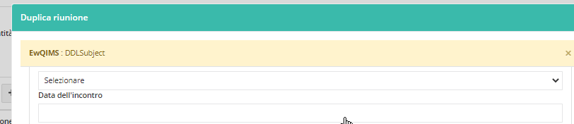

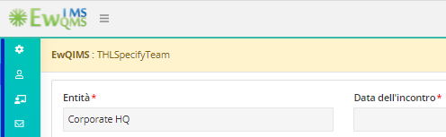

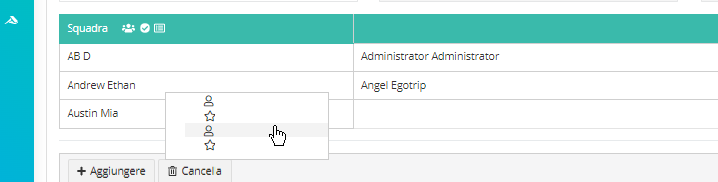

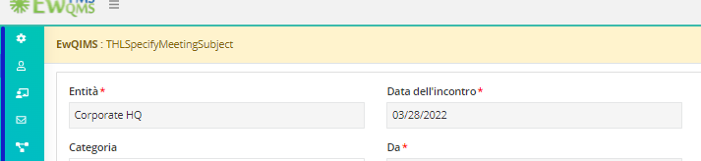

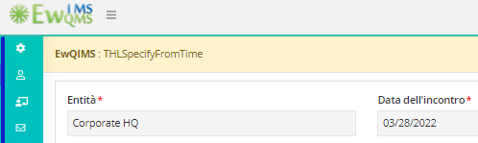

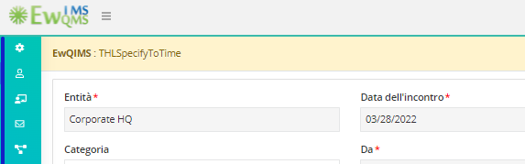

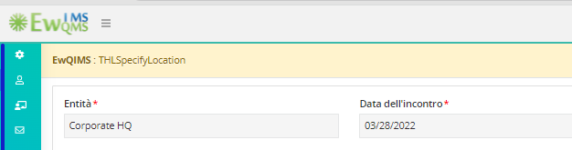

1. Meeting after save displays blank validation

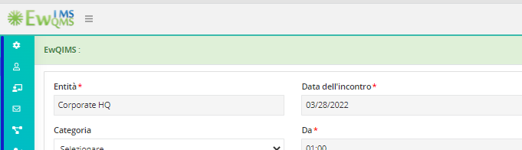

1. Some of the labels are missing in meetings page

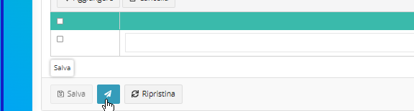

1. Delete meeting displays blank

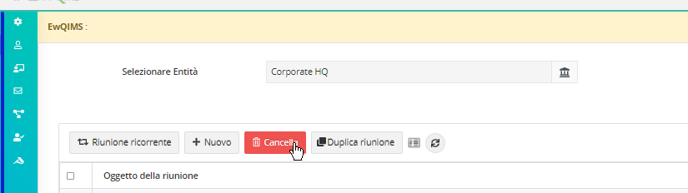

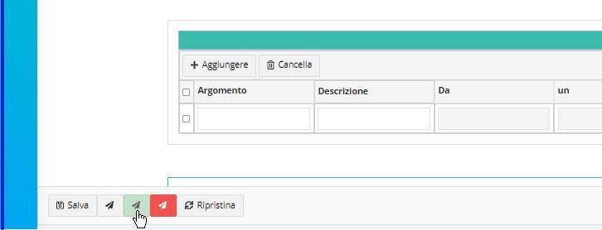

1. Shift page some of the labels are not converted

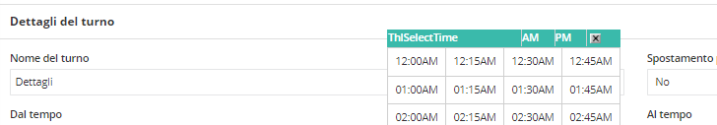

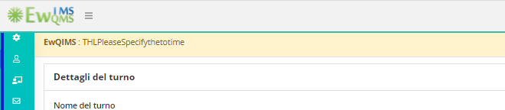

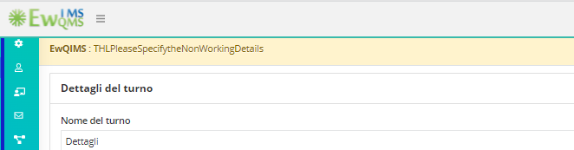

1. Delete Shift validation labels are not converted

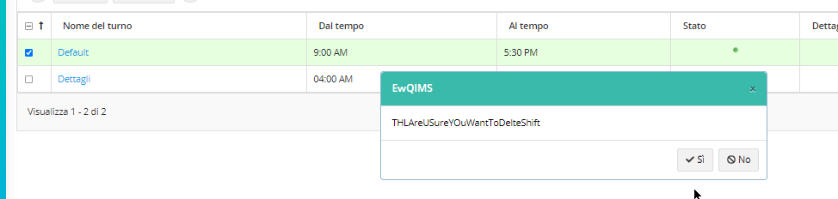

1. Country,State and city home breadcrumb labels are not converted

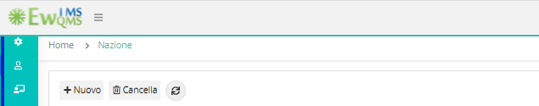

1. Labels menu is not loading

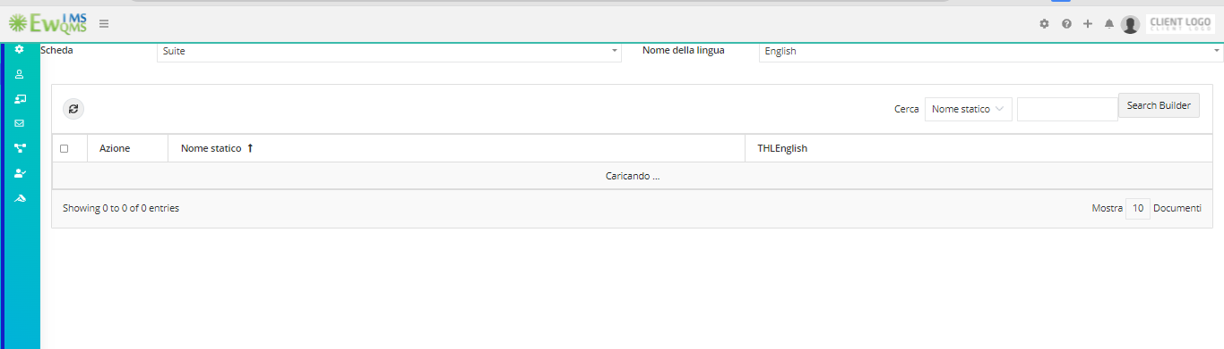

<<<<<<<End of document>>>>>>>>>