SP 11.0.0 LPA Multi Language Issues:

1. LPA Approval request displays Label issue

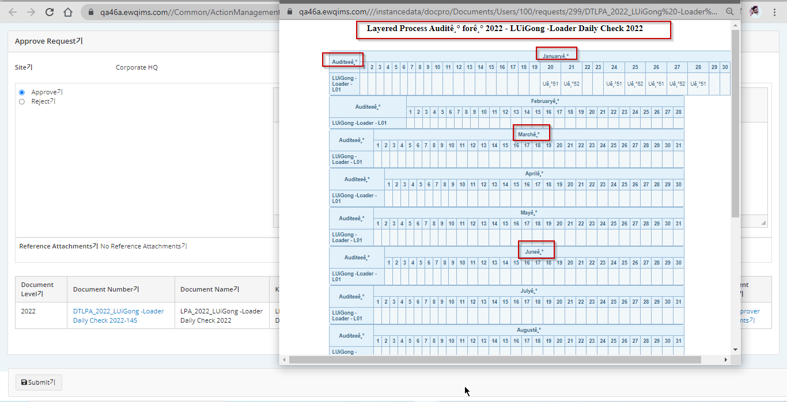

1. Audit details labels

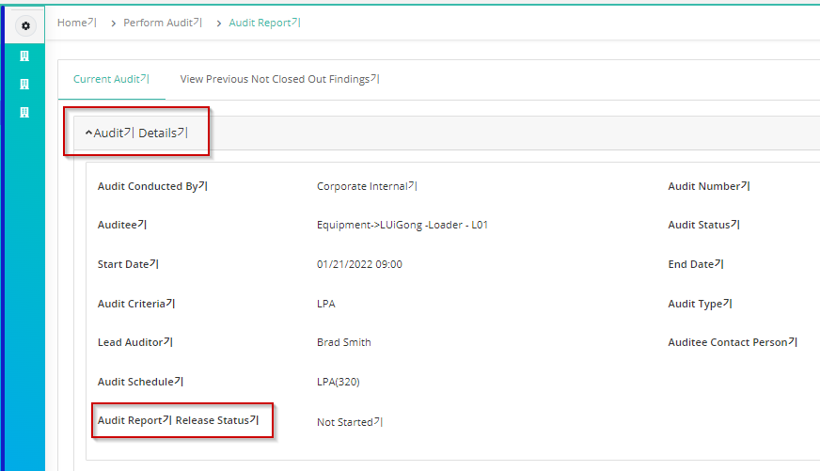

1. Perform Audit  
   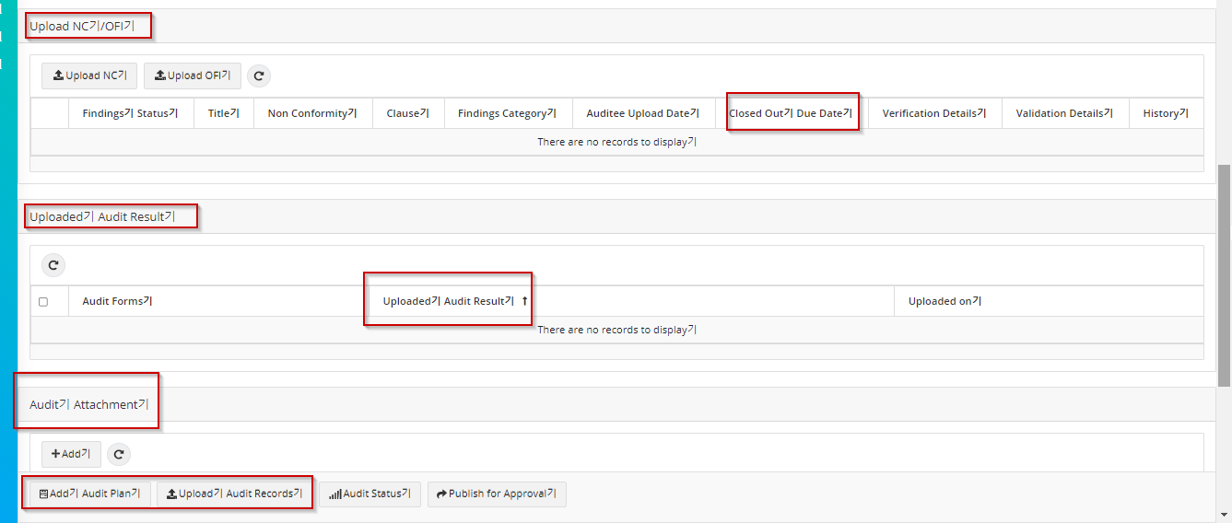
2. Perform Audit ->Fill checklist

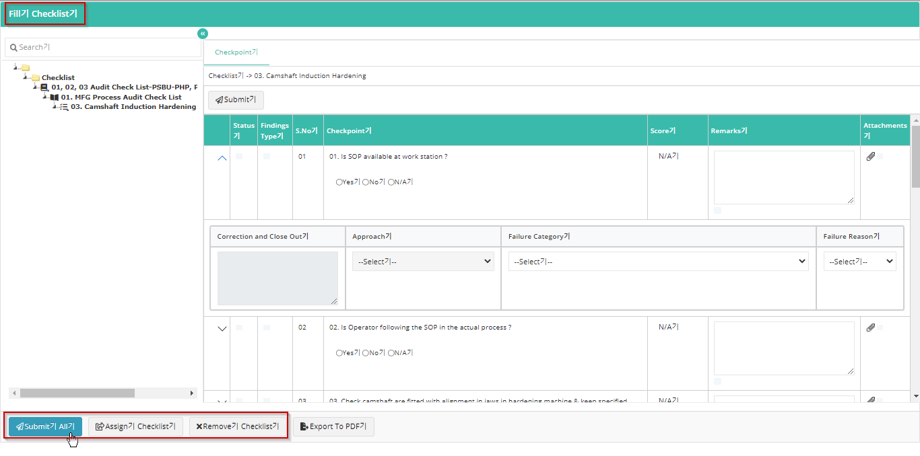

1. Fill checklist-> Checkpoint right click NC/OFI option label

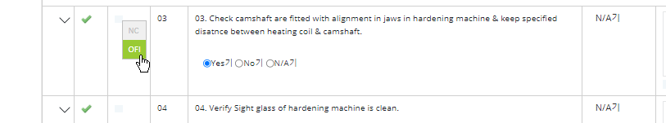

1. Audit status screen labels

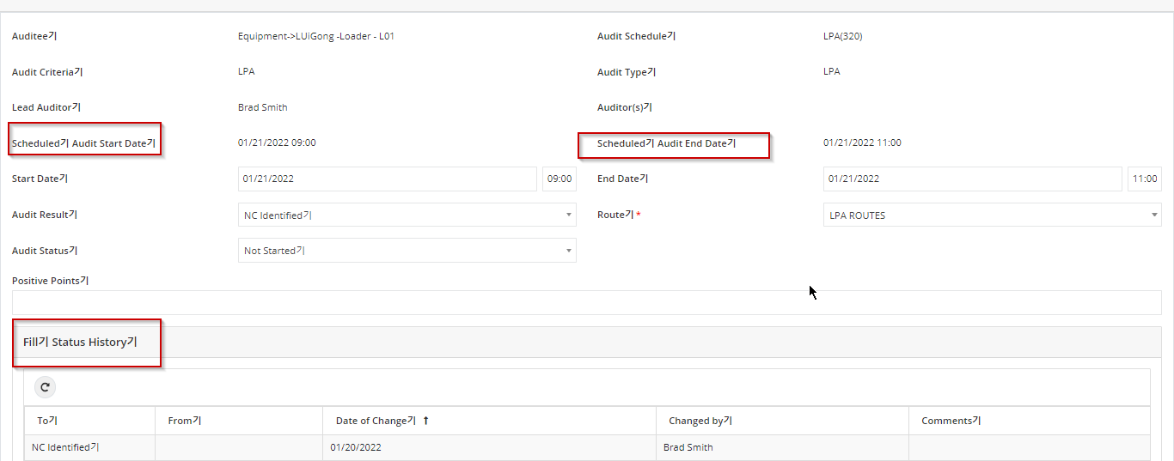

1. Add audit plan screen labels are not converted

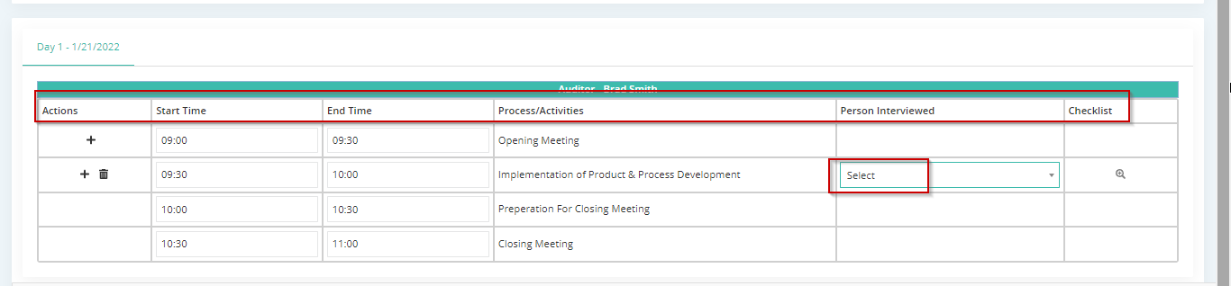

1. Audit report publish to approver -> Approver login label

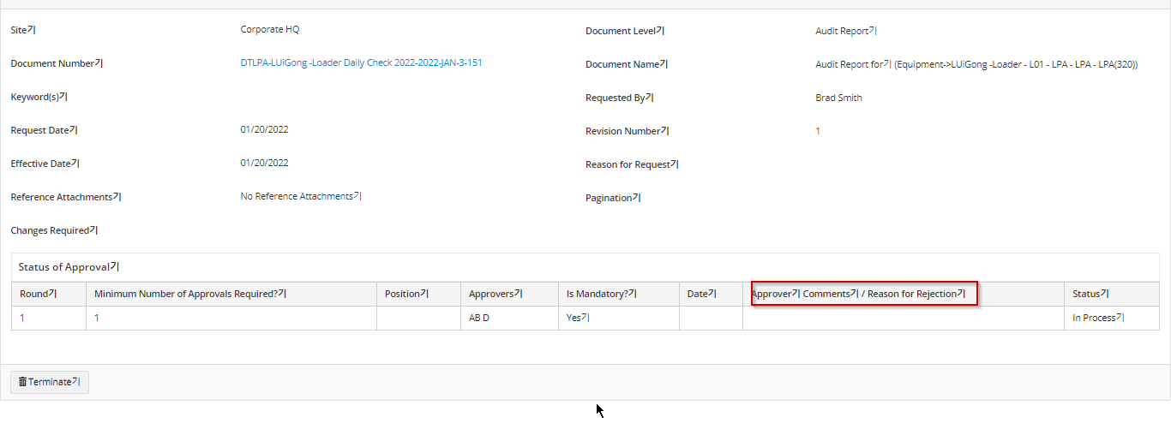

1. Audit report

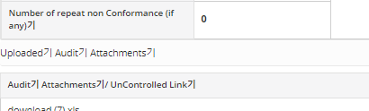

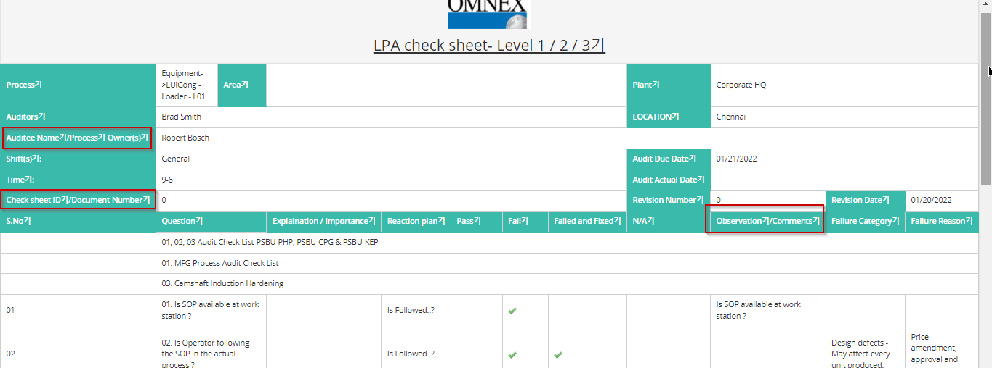

1. Publish Document labels not converted

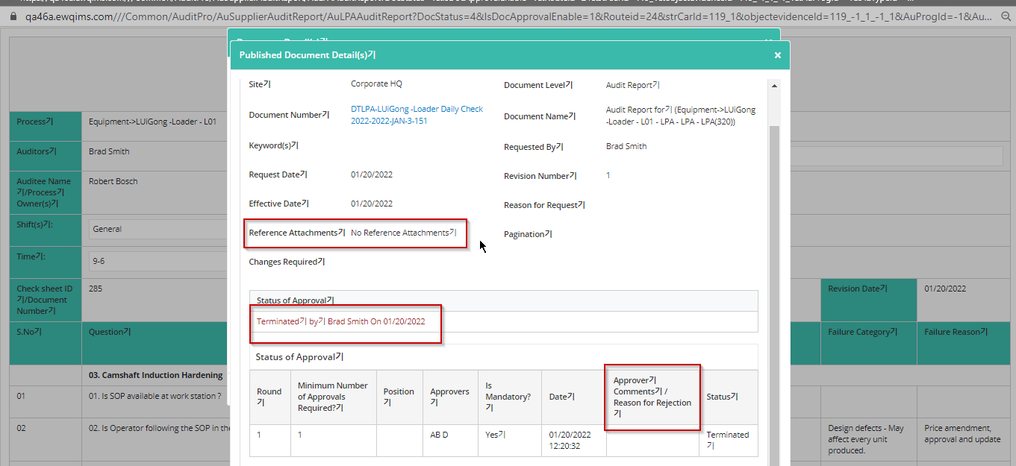

1. Business rules->Notification setup ->New reminder button label
2. Business rules -> Approval process tab-> Actual Re-audit label
3. Checklist Menu labels

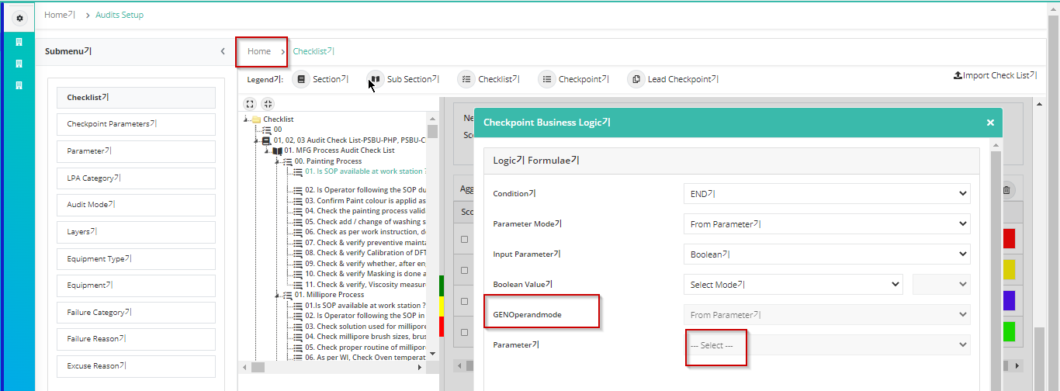

1. Checkpoint delete window labels are not converted

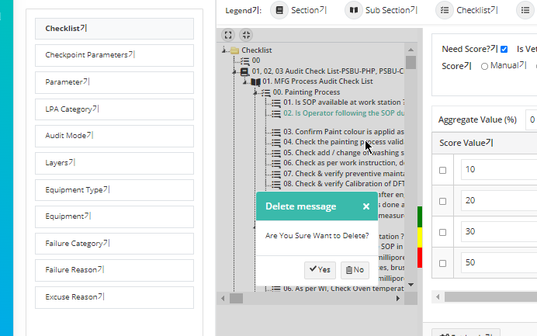

1. Checkpoint delete as well

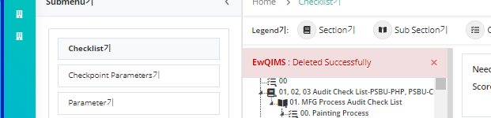

1. Checkpoint parameter -> Data type labels not converted

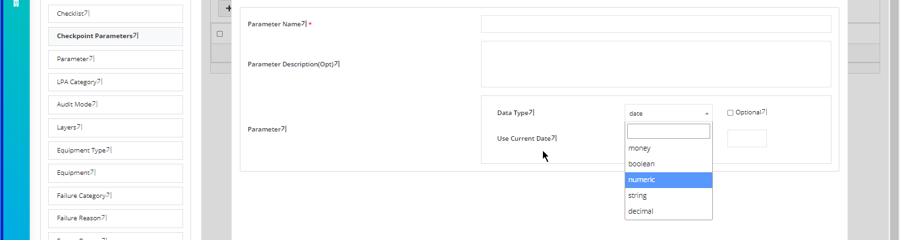

1. Parameter screen menu labels

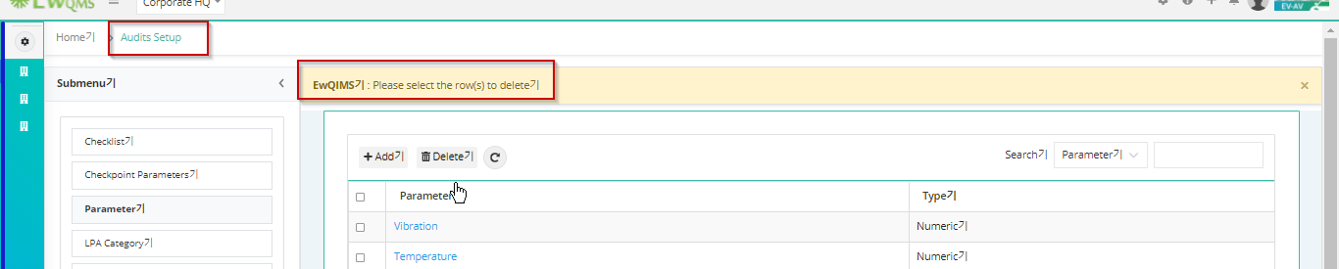

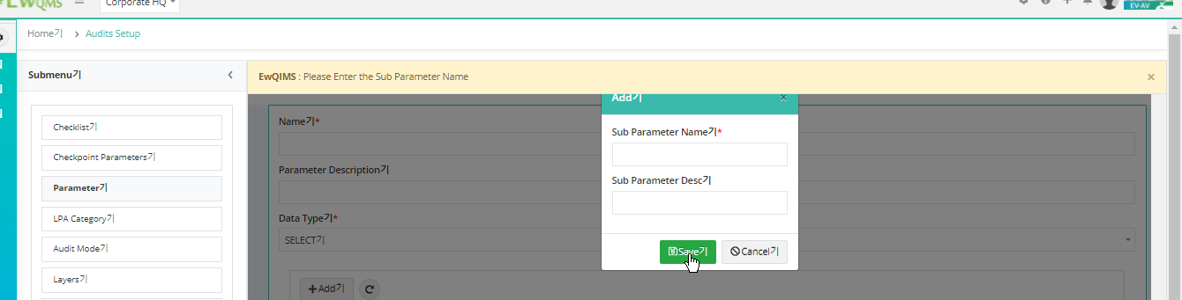

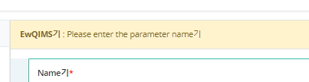

1. LPA Category Menu validation labels

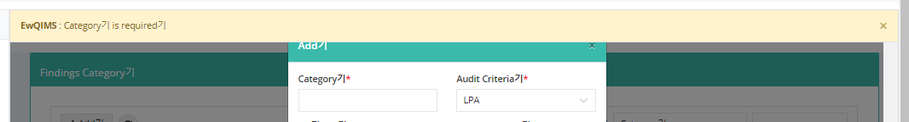

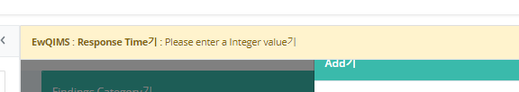

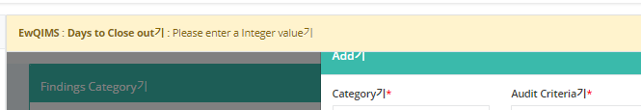

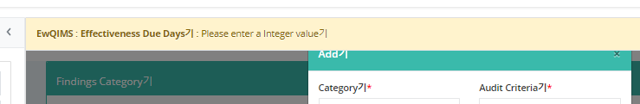

1. Audit mode Menu Labels

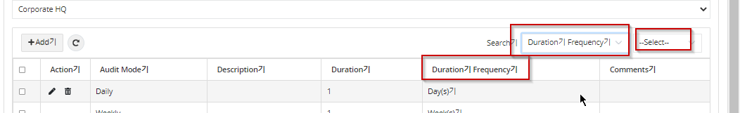

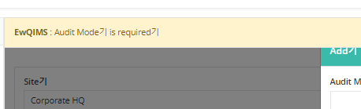

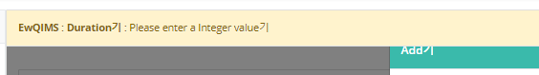

1. Layers menu Label issues

Team selection / Auditor selection windiow

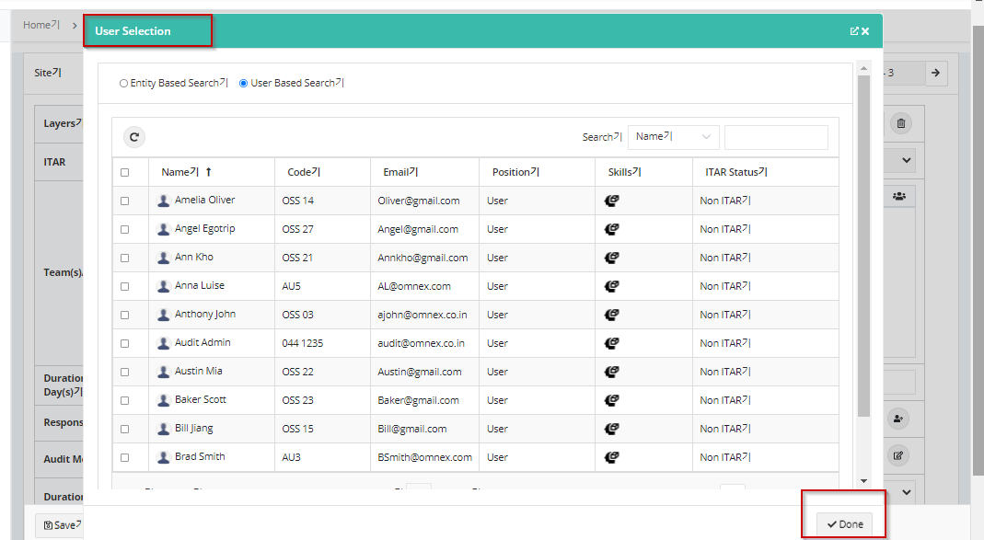

Team Creation from layers screen

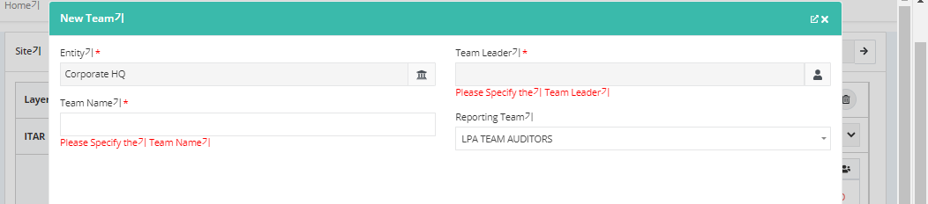

1. Equipment type menu labels

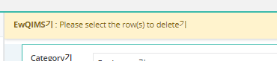

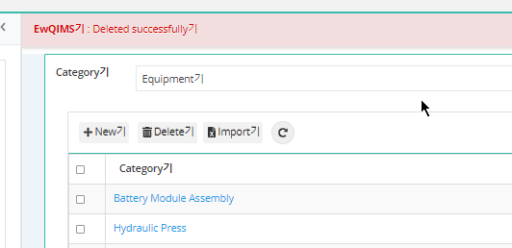

Audit setup Main Menu label

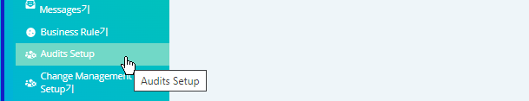

1. Excuse reason Menu label issues

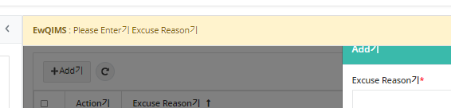

1. LPA Adhoc audit screen labels not converted

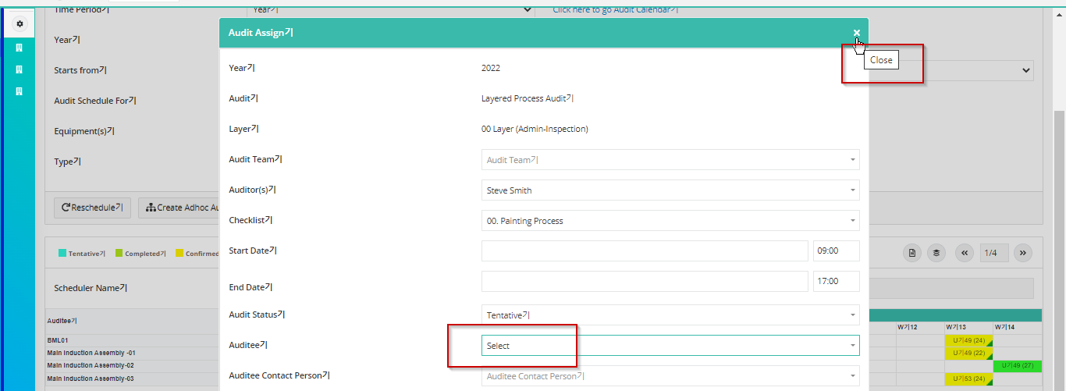

Adhoc audit -> Excuse reason labels and dropdown

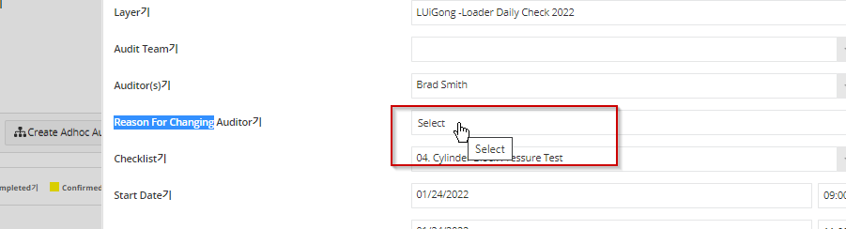

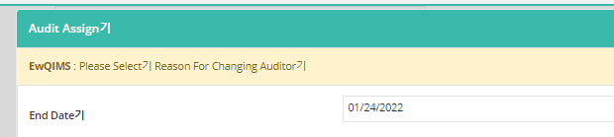

1. LPA Audit calendar labels

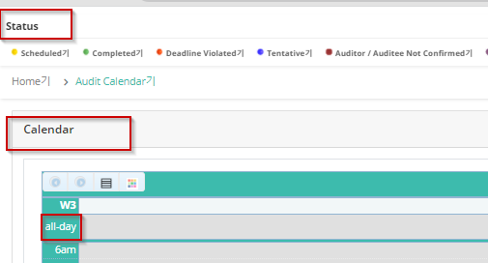

1. Audit status page -> page label

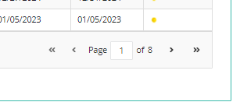

1. All reports

