### **1) Chinese**

**Landing page:**

* “Our Product Line-Up" – in English

**Setup Menu:**

* Under Setup Menu – Audit Setup displays as Audit Set up(in English)
* Under Setup Menu – CSD Details displays as THLCSD Details (in English)
* Under System sub menu – Label for Teams option appears as Teams (in English)
* Under System sub menu and Labels section, table headers appear in English (static name & English)
* Under Systems sub menu - Home Displays as Home (English) in the Breadcrumb Navigation bar.
* Systems sub menu -> Teams: Label in the Pagination(“Page”) appear in English.
* Under Users sub menu, in widget preferences – table header URL appears in English
* Groups – Delete option in Groups - confirmation pop up message box with Option NO (in English)

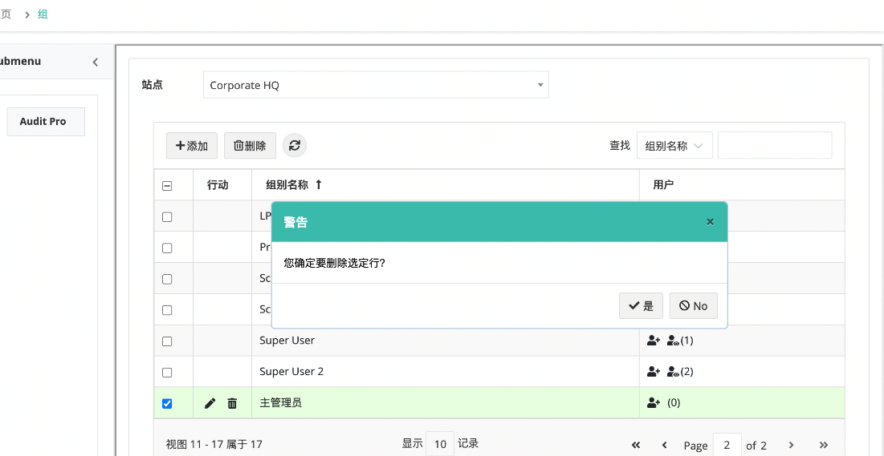

* Delete User – pop up message with Button labels in English

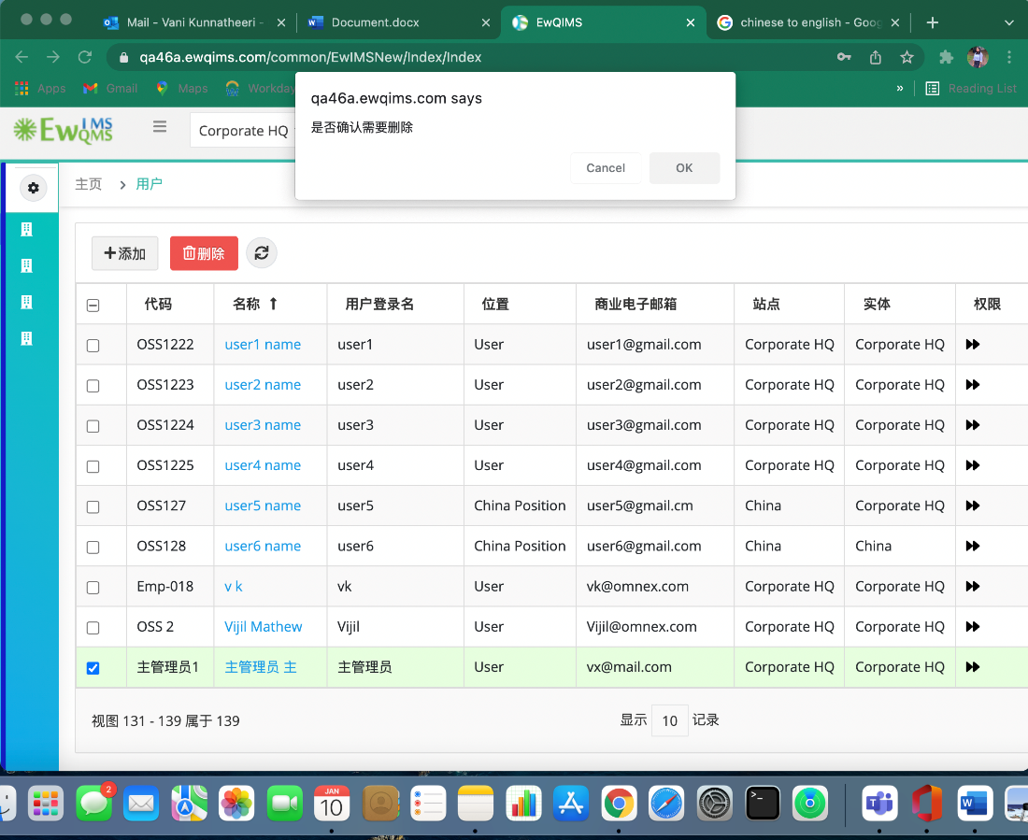

* Customize email messages – table header “Status” in English
* Audits setup – Audit Types: Audit Types in English in the breadcrumb navigation bar and the Popup message for the Audit type Delete option Displays No in English.

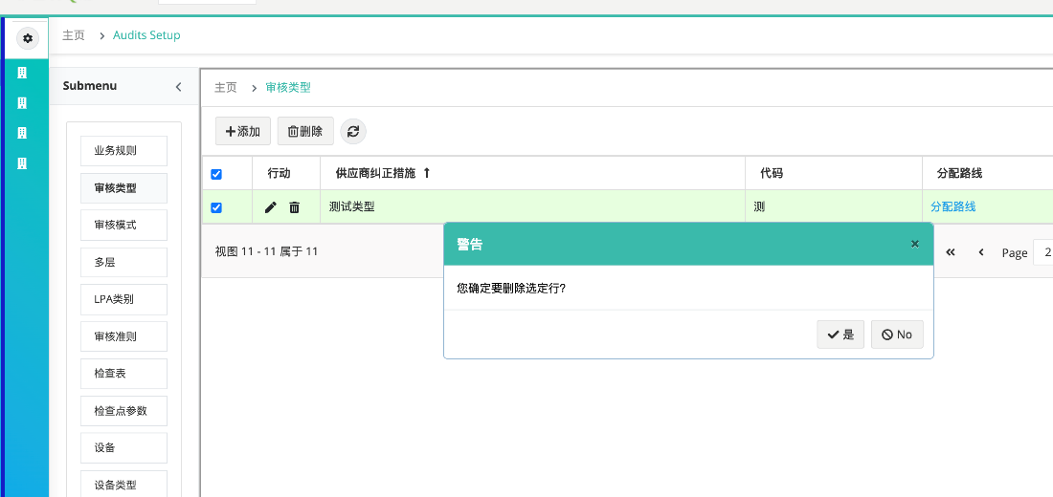

Same for the Audit mode, LPA category, Equipment Type, Failure category, Failure reason, Excuse reason

* Audits setup-> New Audit Criteria -> Map Entity -> Is a site option with “NO” in English

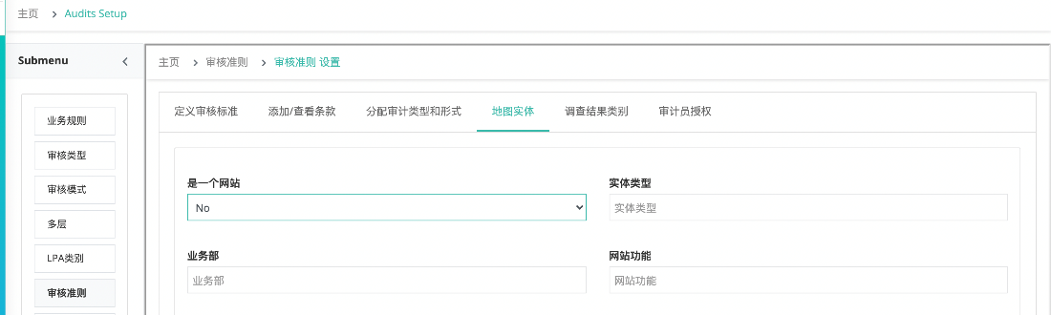

* Audit setup -> Audit criteria -> Findings Category: Table header for NC/OFI in English

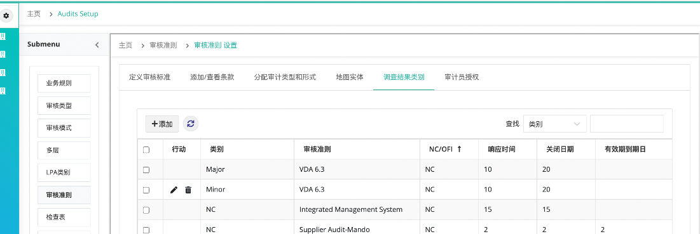

* Audit setup -> Checklist: **Home** in the Sub breadcrumb navigation is in English along with Audit Setups in main navigation.

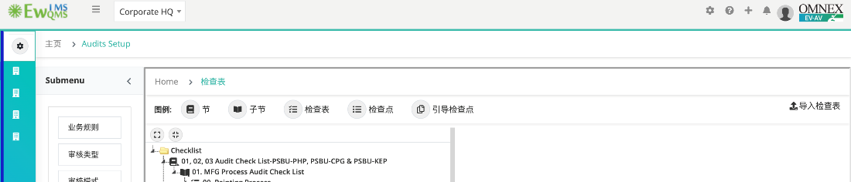

* Action Management with different English Labels (In Progress & Audit Pro)- Auditor tab also

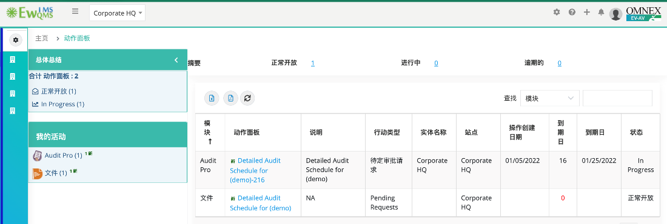

* Release Notes in English

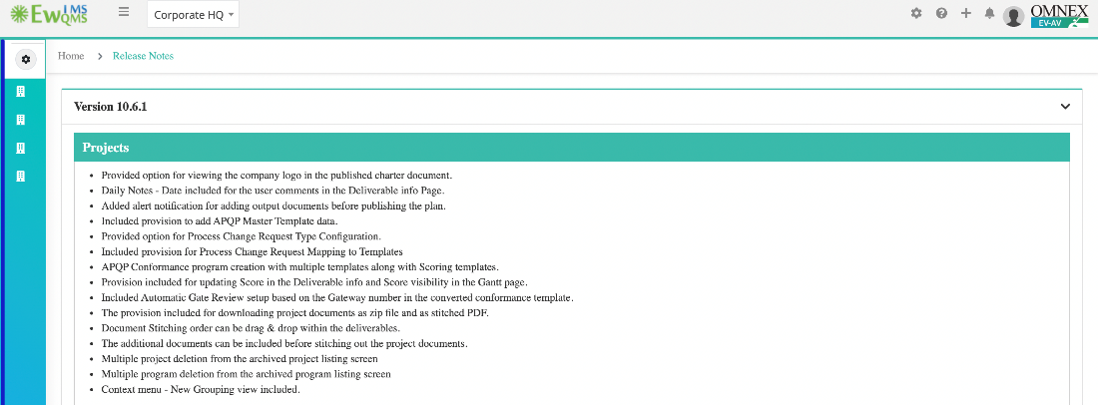

Audits:

* Audits Menu displays as Audit Pro (in English)

Documents:

* Under new document draft , getting error message in english

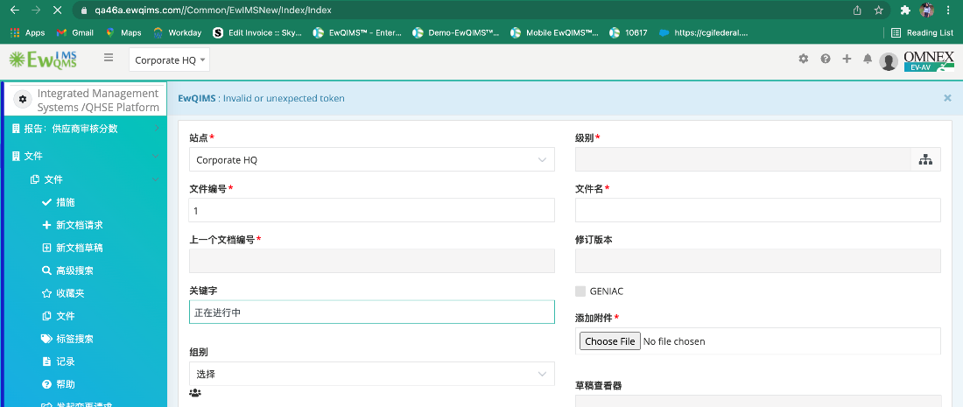

* Advanced search sub menu -> table header in English – CR Link

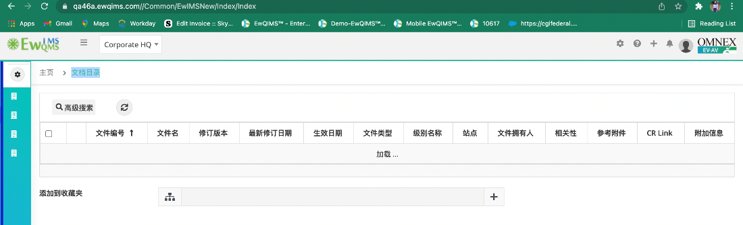

* Sub menu and breadcrumb nav in English

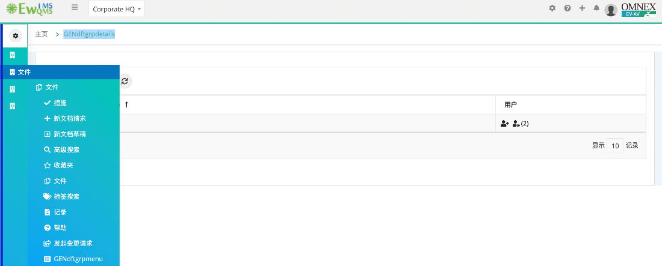

Auditor

* Audit pro and Sub menu in Audits -> Audits in English

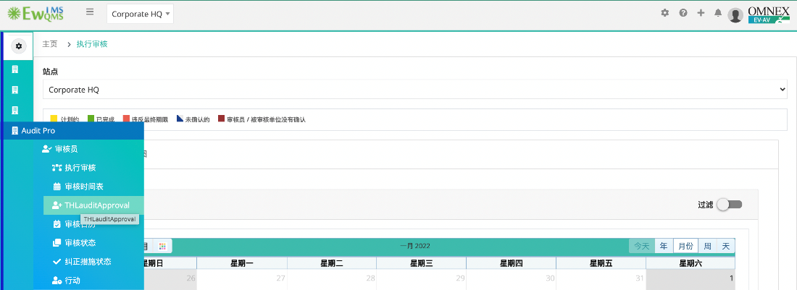

* Check box label “No” in English under CA close out

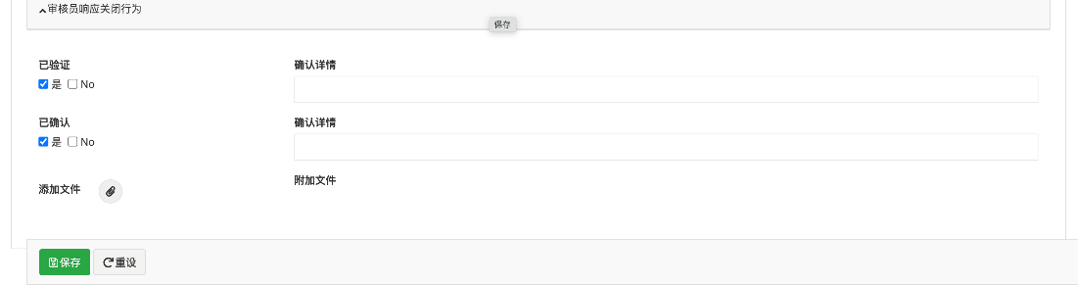

* No Chinese word associated with “5whys” in CAR approaches.