Issue # 1-> Alignment Chart->New KPI Popup from Process and Result KPI Tab->KPI-Group Selection Window -> The Pagination is not displayed. So the user unable to select the groups from page 2

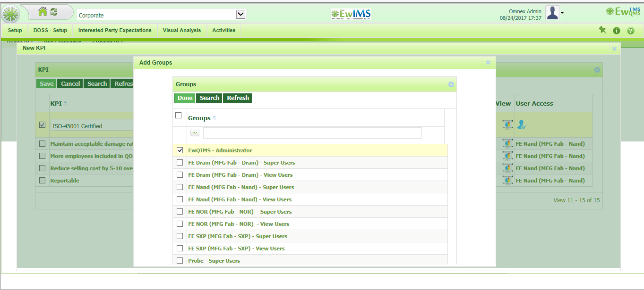

Issue # 3 -> Interested Party Expectation -> Interested Party Expectation (Customer, Supplier and other Interested party)selection popup-> The Pagination is not displayed. So the user unable to select the from page 2 (The same occurs in Benchmarking-Edit Interested Expectation page)

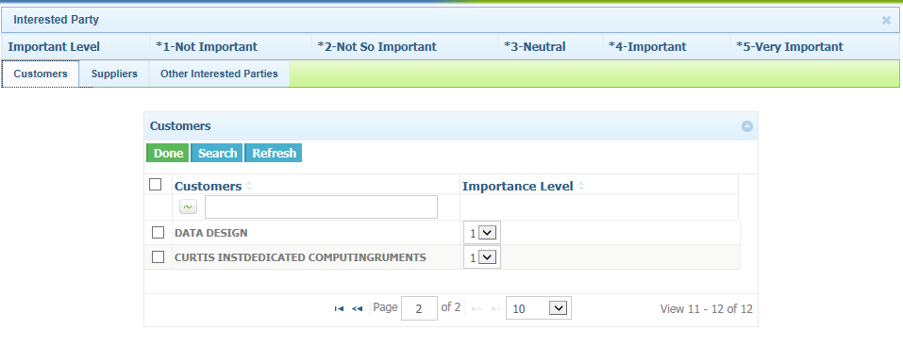

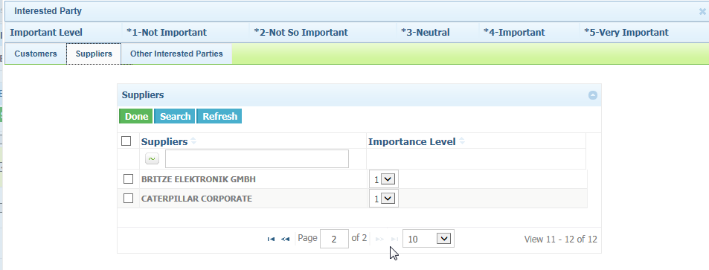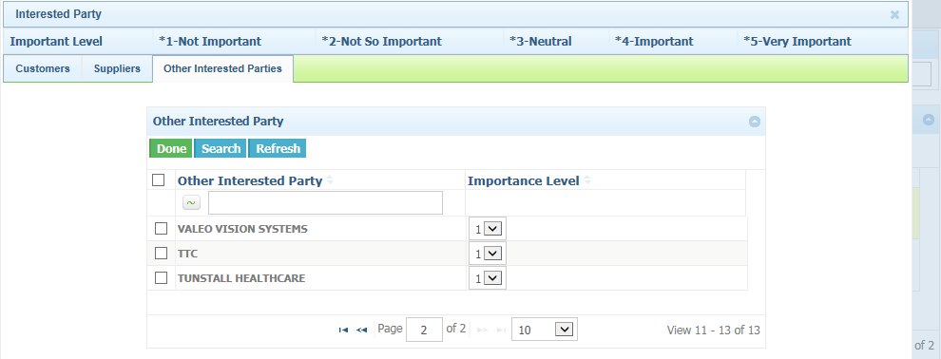

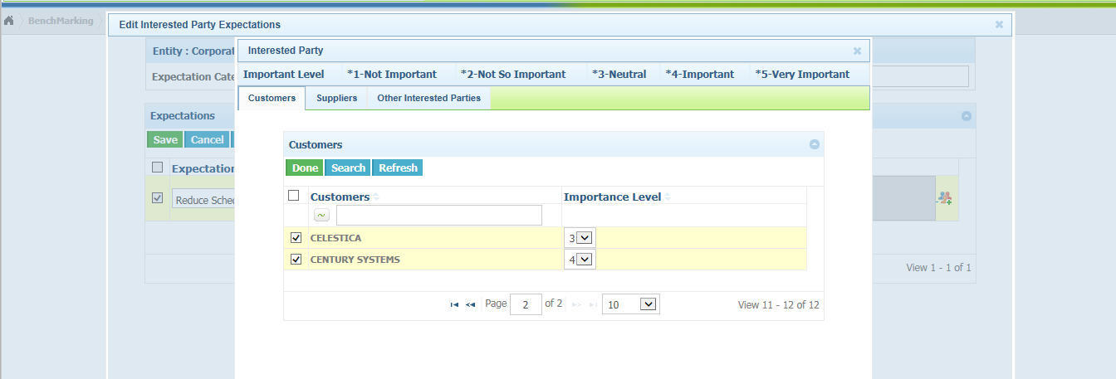

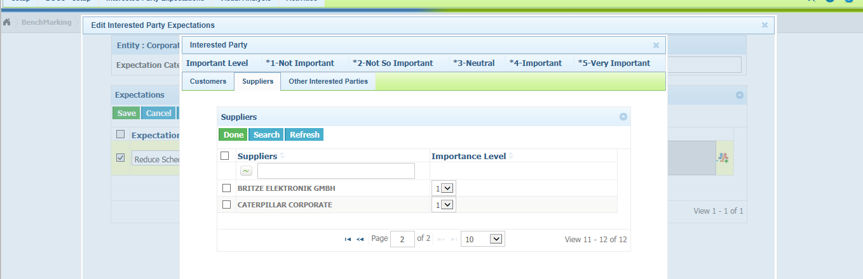

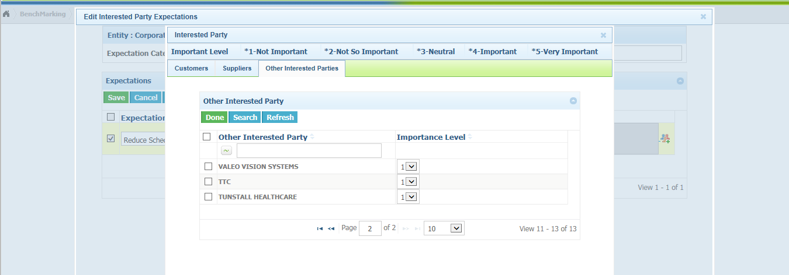

Issue # 4 -> Interested Party Expectation -> Copy Interested Party Expectation - Couple of vertical scroll bar is displayed

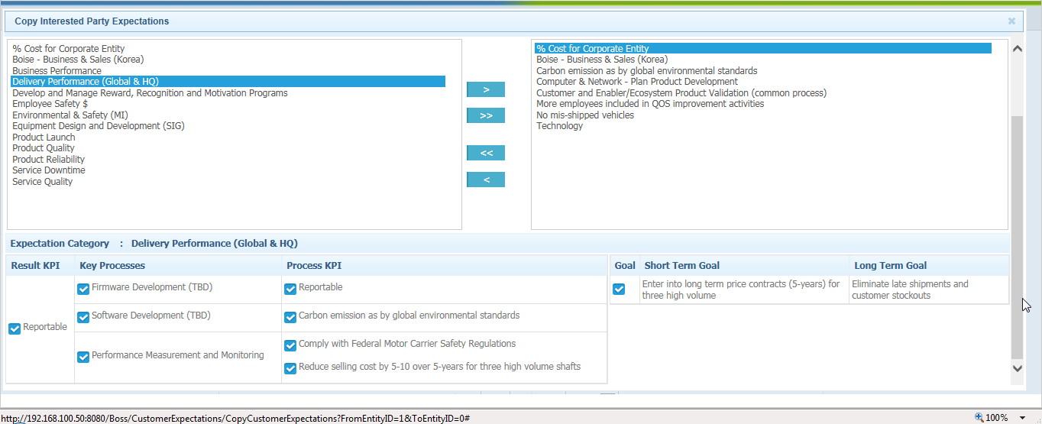

Issue # 5 -> Dashboard - Groups Selection list -> Pagination is not visible to the user

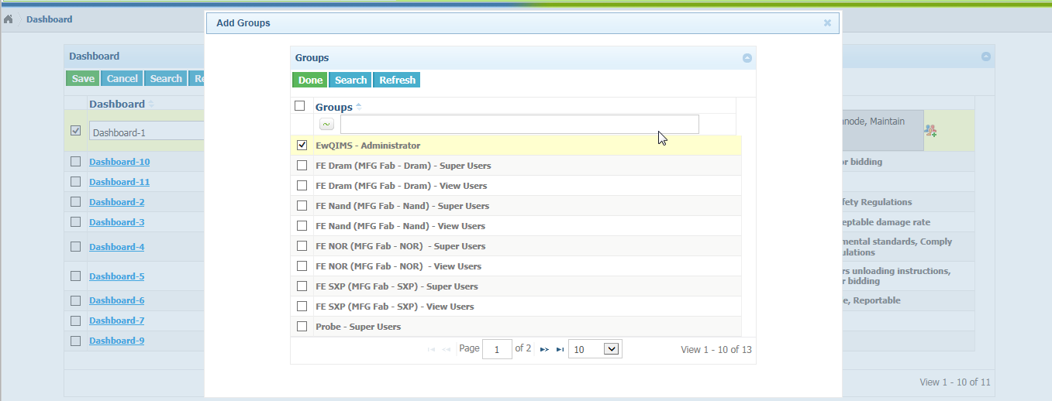

Issue # 6 -> Proposal Rating - Entity Selection Page -> The page not displayed the entity list fully. Vertical scroll bar is not displayed.

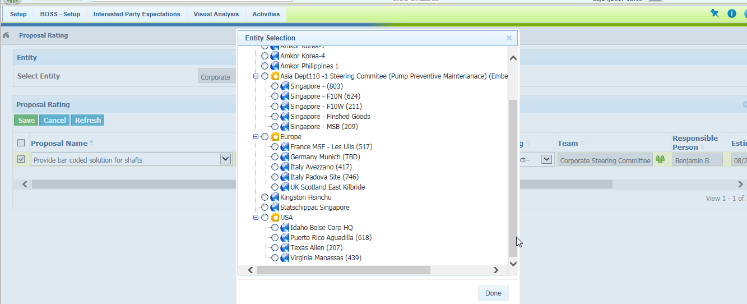Issue # 7 -> Meetings - Add KPI and Add Dashboard page -> The pagination is not displayed fully. Unable to move to next page