Dec 12:

MG Reports: Issues

1.Risk master->While updating any risk value saved success alert is not coming

2.Score settings->No mandatory alert for missing selection of supplier template

3.Checkpoint sl.no sorting portion issue (based on serial number checkpoint has not sorted)

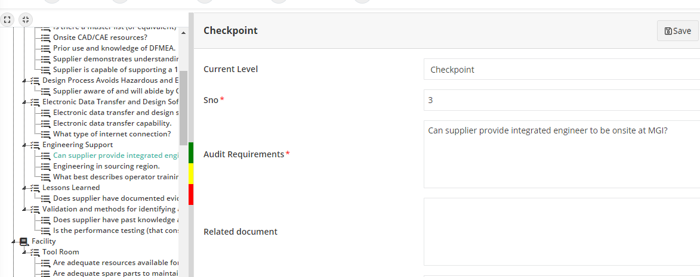

4.Unable to set risk rating guidelines in PSA checklists

5.Below option cant able to achieve in score settings in checklists master

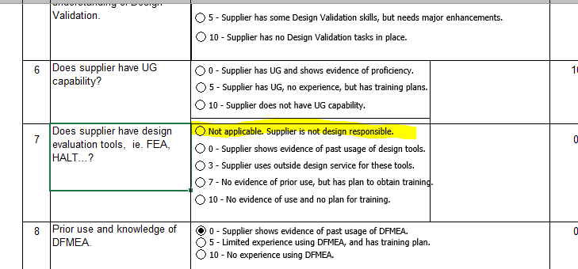

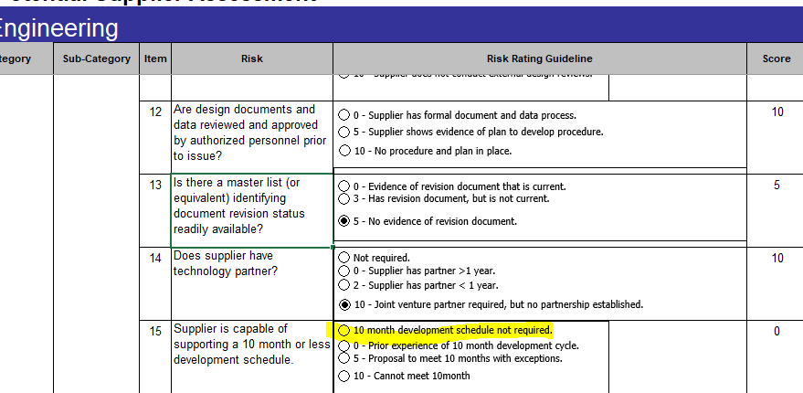

7.Inactive risks details are showing in supplier creation screen

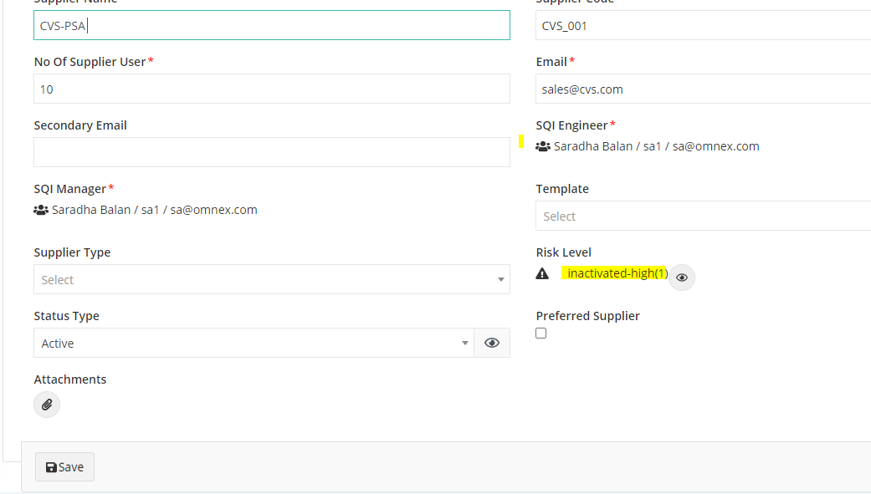

8.Audit criteria->Report template drop down->Supplier Assesment report shows twice

9. Audits->VEM audit schedule-> On clicking the supplier name VAM scheduling audit page is displaying

Also,loading label displaying

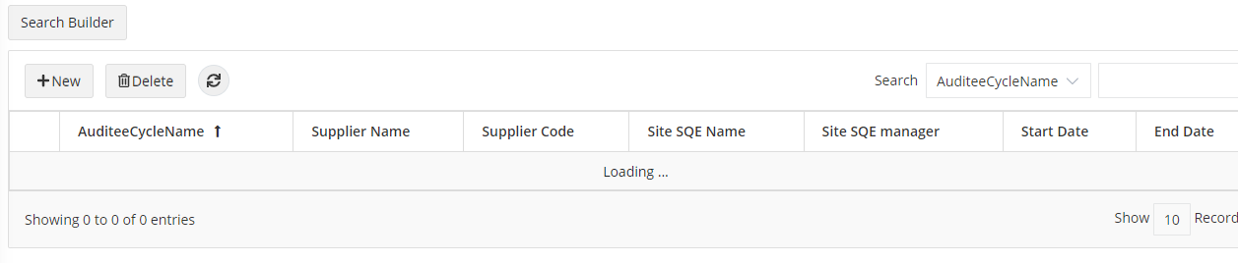

10.Perform audit->After scheduling MSIVEM audit ,the audit number has not displayed here…also no calender view and list view details

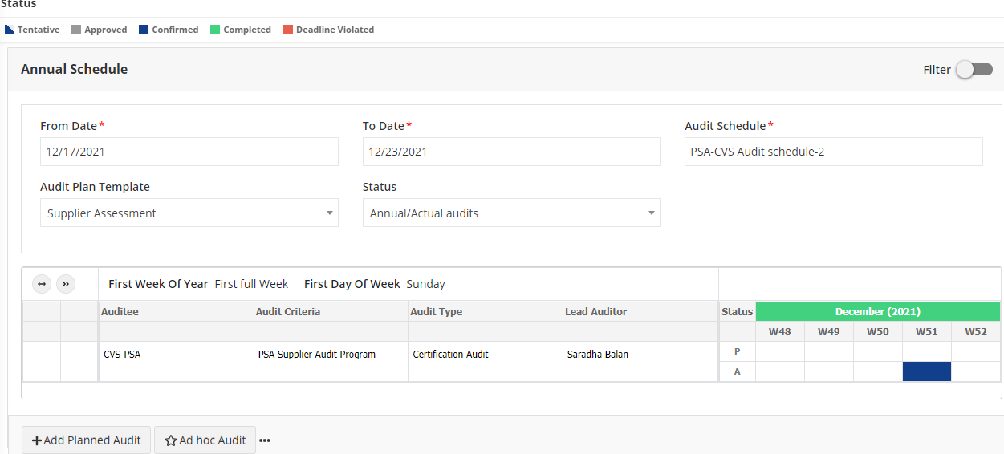

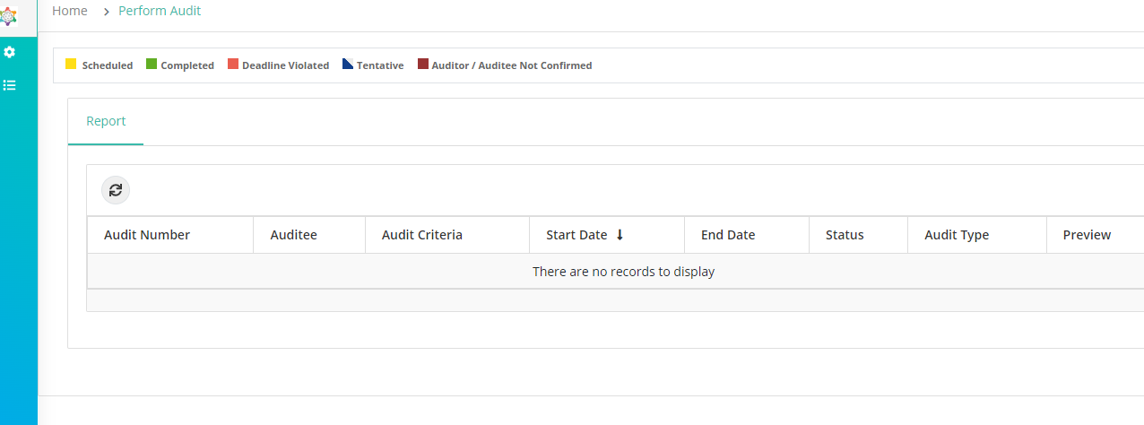

11. MSI audit schedule page->Landing screen shows no of audits pending is 1 but on clicking the supplier audit number to change tentative audit to confirmed inside no details were found

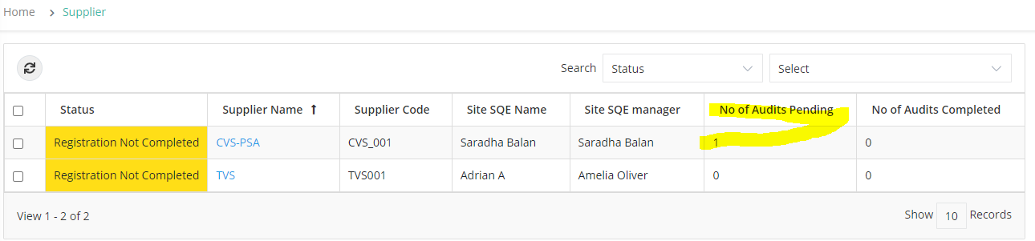

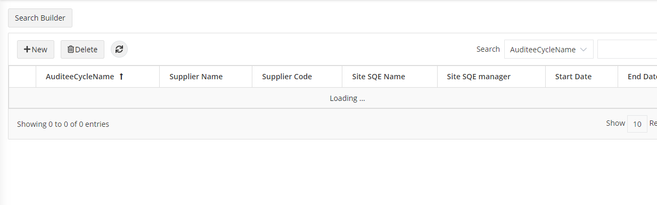

12. View checklists details: NEED TO DISCUSS

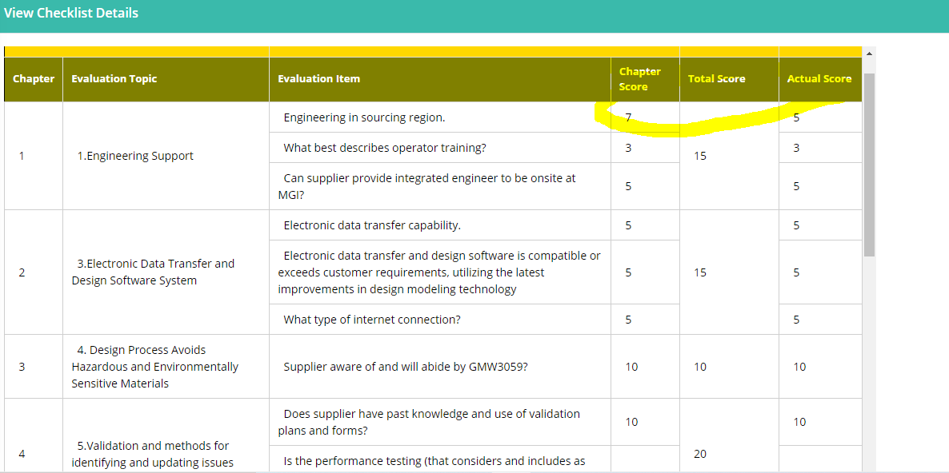

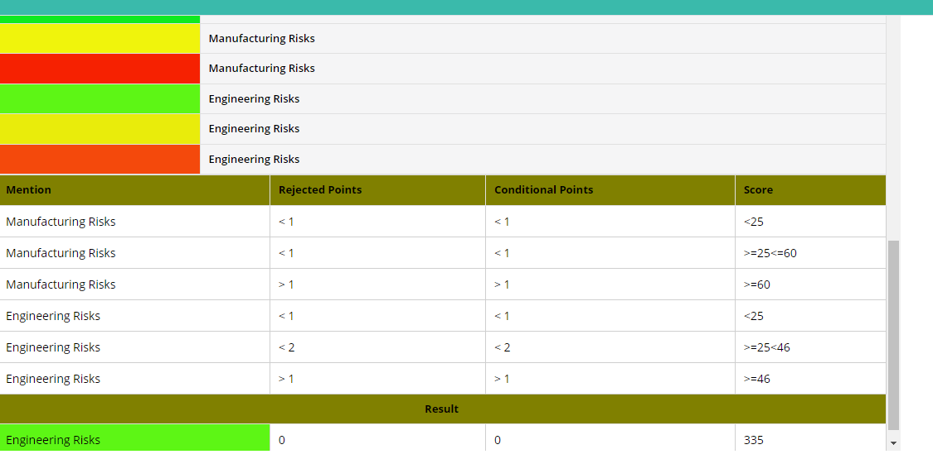

13.PSA Audit summary sheet:Auditors name should be replaced instead Auditor name

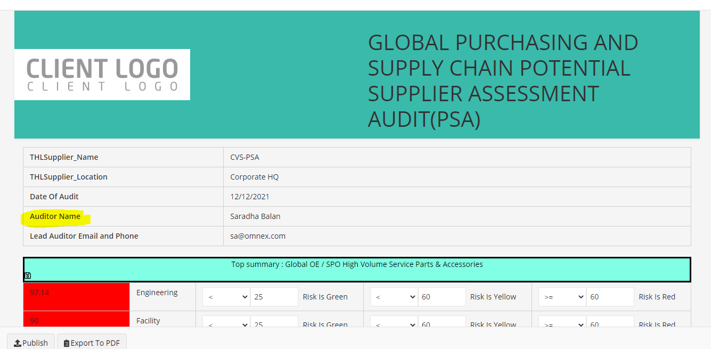

Comments->section heading not matched with customer sheet

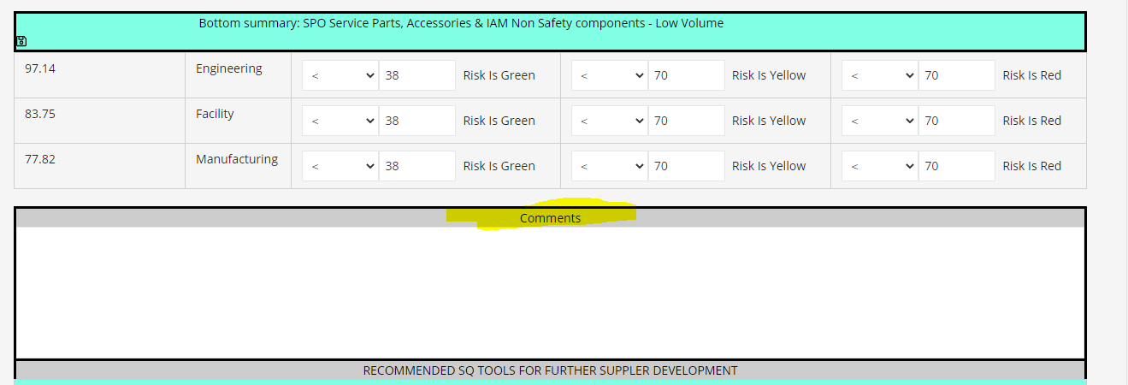

Need to discuss,

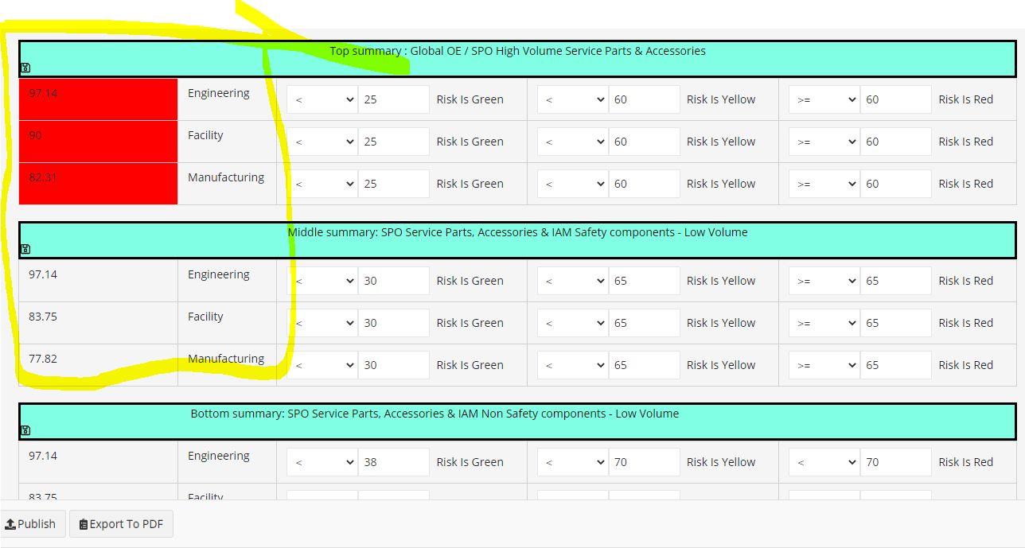

14. Unable to Publish PSA audit report..no action on clicking publish button

15.Audit VEMAudit schedule->On clicking new :Update schedule audit” page is opening

Also,Without Plant address cant able to schedule the audit

IF Supplier Plant address, Supplier template is mandatory then * should be available for plant address field

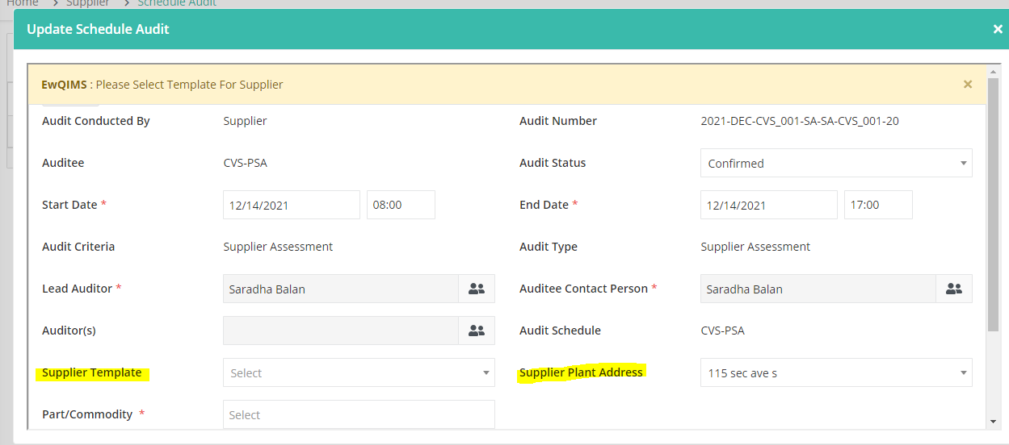

16.Add production item screen->Why it is showing VAM completed?

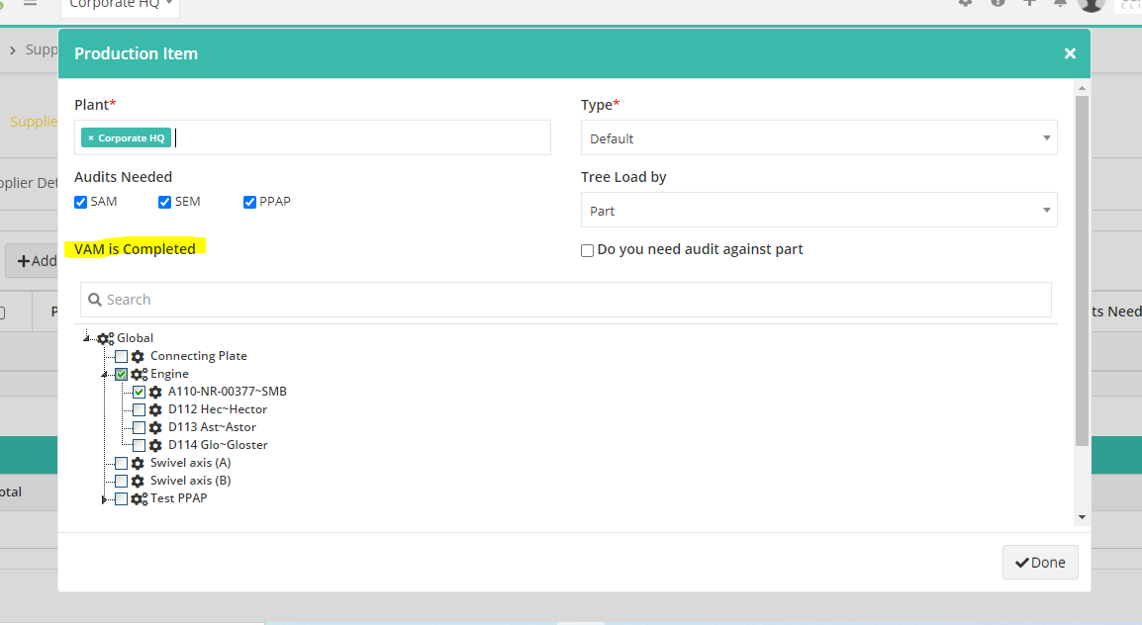

17. Unable to schedule VAM audit..No action on saving

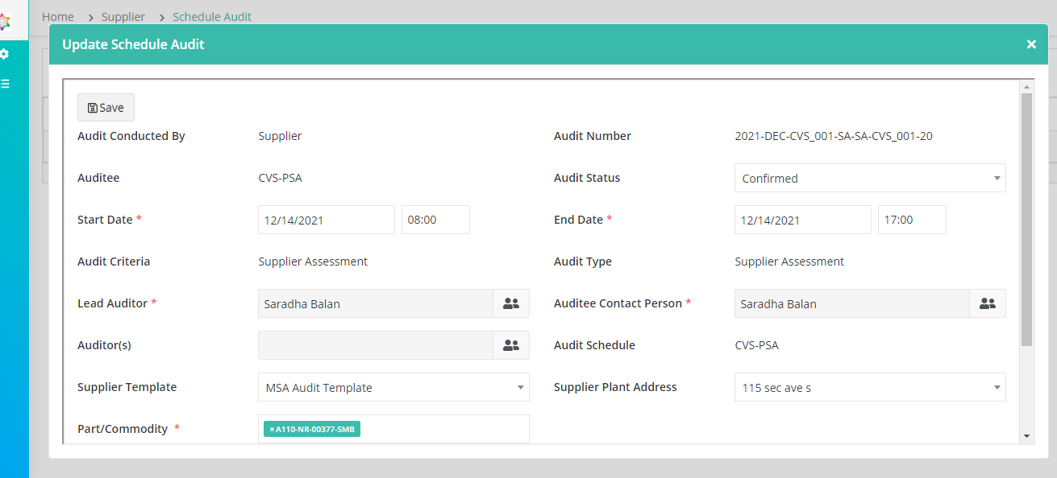

**CQI REPORT ISSUES:**

1.Audit form attachment->Attach from doc pro screen have UI alignment issues

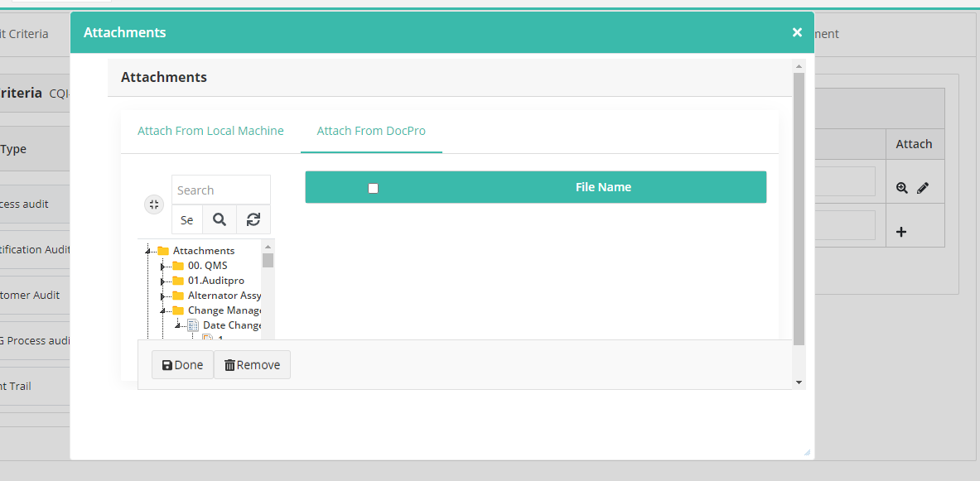

Also,after attaching from local and try to view attached file has not able to view

2.By default auditee contact person not set the primary email id User name instead it set SQI person as auditee person by default

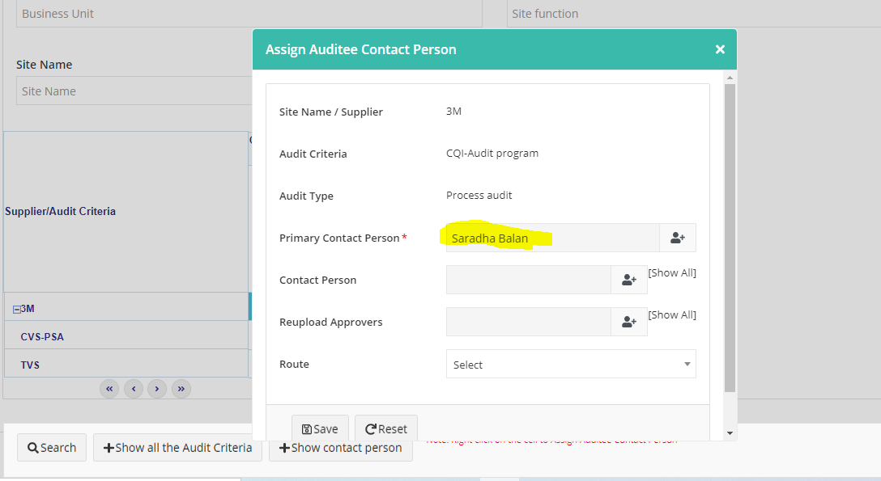

3. Supplier Risks has not displayed in add planned audit schedule page

4. **EVERY TIME AUDIT SCHEDULE FIRST TIME HAS NOT DISPLAYED IN PERFORM AUDIT PAGE, AFTER UPDATING ONLY THE SAME AUDIT HAS REFLECTED IN PERFORM AUDIT PAGE**

5. CQI Report:

Name of assessment -> Wht should display here?

Personel contact-Displays Auditor name -> NEED TO DISCUSS