1.Alignment issue in risk set up eye icon

2.If risk has set as not qualified in risk master then also able to schedule audit against the supplier

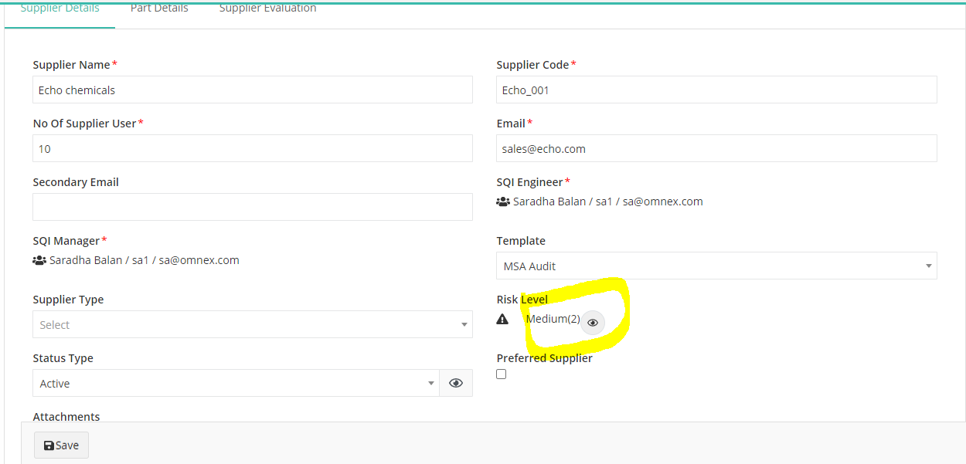

3.Alignment issue (save) button in supplier creation page

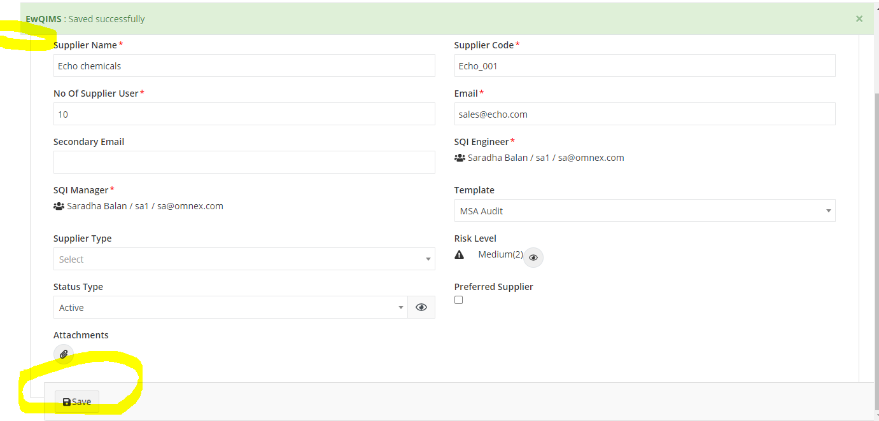

3.Supplier creation page->According to supplier template selection, checklists has not shown in audit form assign screen,instead it shows complete checklists details

4. Audit criteria->Alignment issue in map entity screen

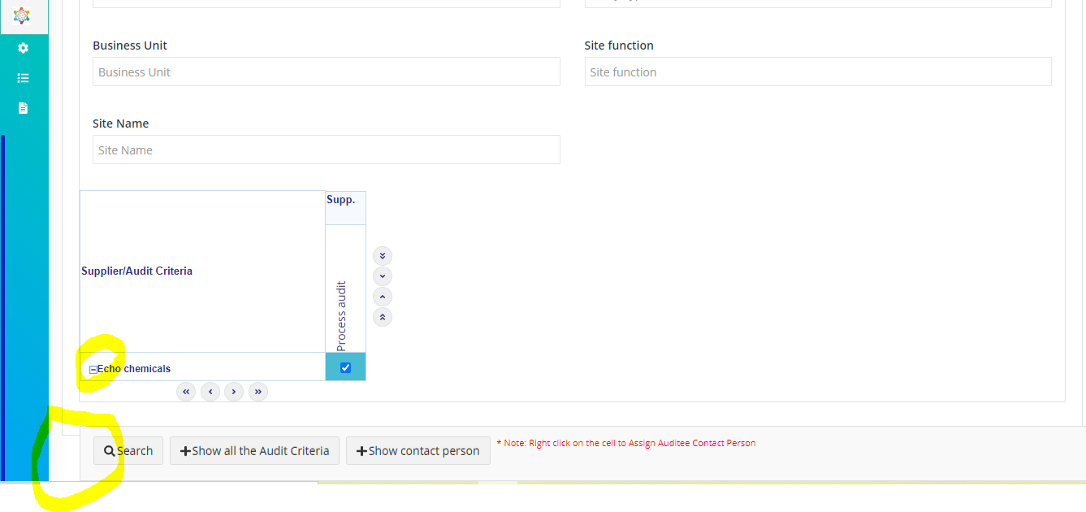

5. Able to schedule audit for Registration not completed supplier ‘s (is it correct)

6.Unable to upload NC and OFI.Data not saved message displaying

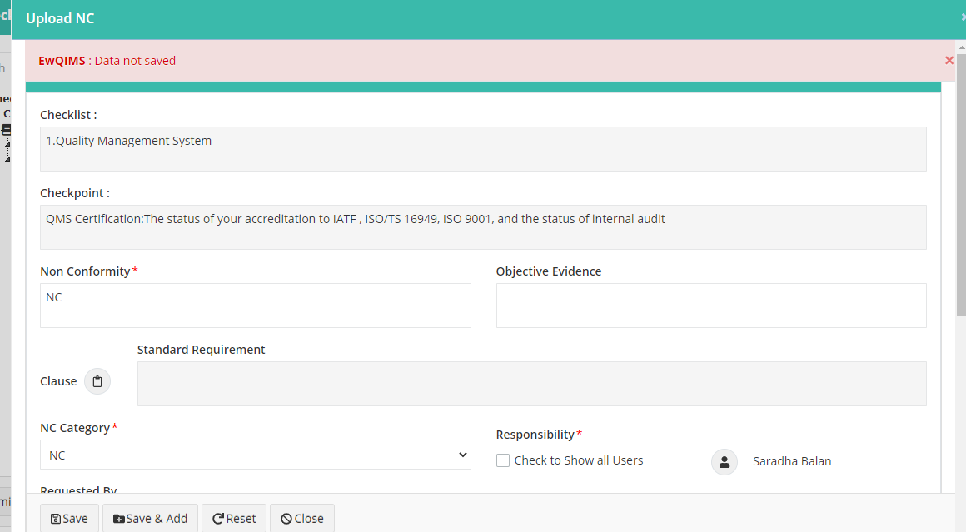

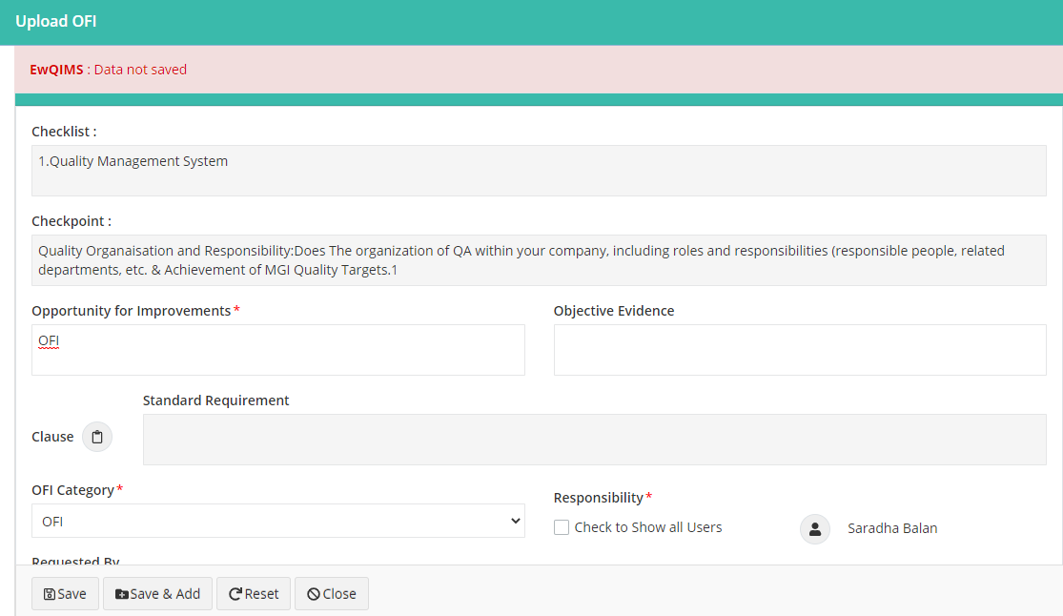

7.