1. Label Issue -> Column field & Condition field displaying is THLColumn & THLCondition

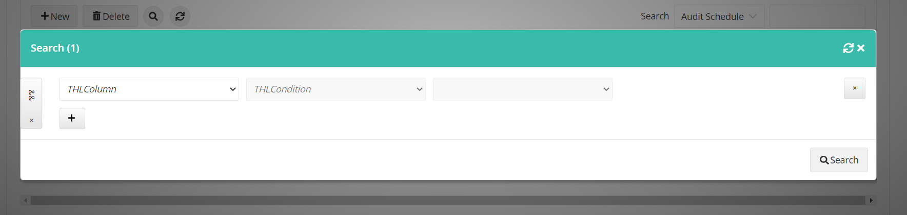

1. All Pages -> The text "Multi Search" is missing on tooltip

