**1. Multiple search is not working using with various search conditions**

Refer User: Dan / Pwd: a1.

Step: Go to any listing page of any module. Try to add multiple search input and conditions. Hit Search. The page will show all records. Else will show the result based on any one input.

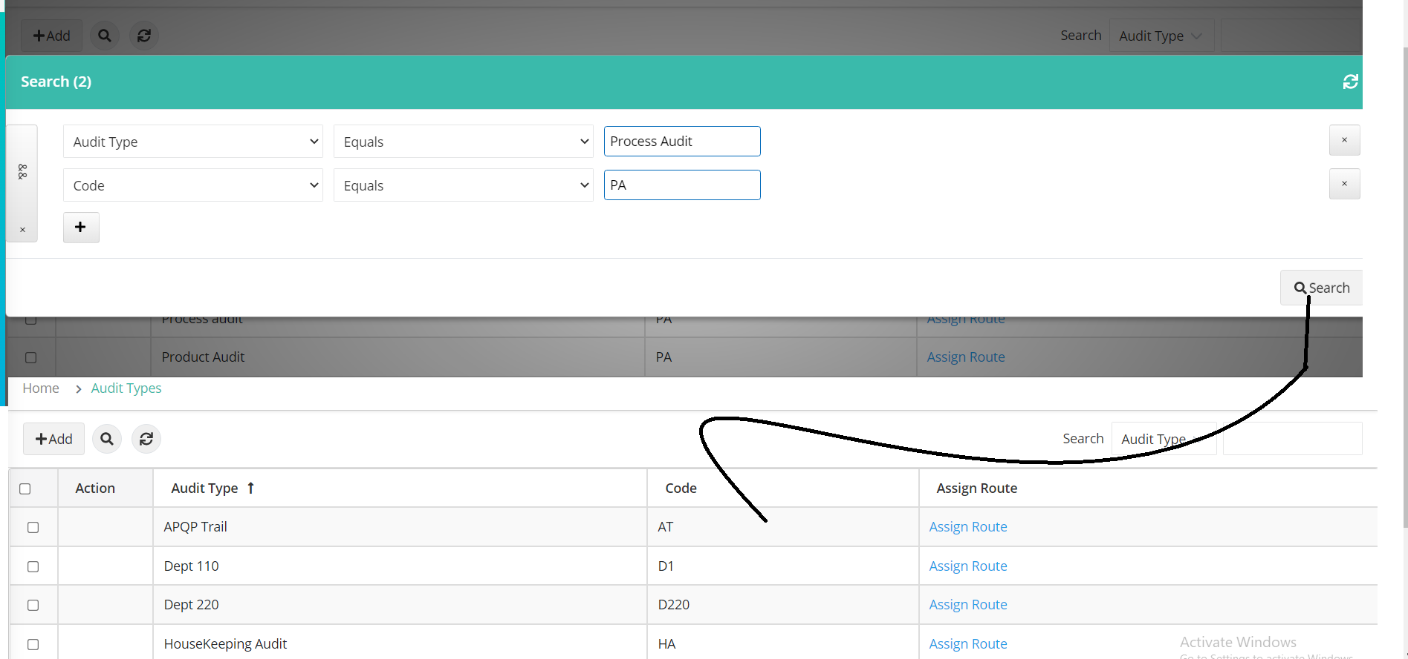

**2. Date field search -> the search result is not getting displayed if select the date from date picker and then hit the search button. When i open the search page again, the selected date is not getting displayed (If i type manually and then hit search, its showing the records)**

Refer User: Dan / Pwd: a1.

Steps:

* Login as user go to auditpro
* Expand Scheduler tab and then click on audit schedule
* Click on List View
* Click on Multi search icon
* Click on + icon and then add column
* Select Column as Start date or end date
* Select any one Condition Ex: Equals
* Click on search input field and the select date from date picker
* Click on search button
* Now the system will show all records

**3. Date field search -> Cant able to search with various dates in a row by changing dates frequently and then hit search button**

Refer User: Dan / Pwd: a1.

Steps:

* Login as user go to auditpro
* Expand Scheduler tab and then click on audit schedule
* Click on List View
* Click on Multi search icon
* Click on + icon and then add column
* Select Column as Start date or end date
* Select any one Condition Ex: Equals
* Click on search input field and the select date from date picker or enter the date manually
* Click on search button
* Again Click on Multi search icon
* The previously selected row will be displayed. In that row, just change the date and then hit search button
* Now the system will not be displayed the data based on modified input

**4. Search button is not getting displayed in specific condition. (Open search window and then click on && or close icon in LHS)**

Refer User: Dan / Pwd: a1.

Steps:

* Login as user go to auditpro
* Expand Scheduler tab and then click on audit schedule
* Click on List View
* Click on Multi search icon
* Click on X icon from LHS
* Again Click on + icon and then add column
* Now search button will not be displayed

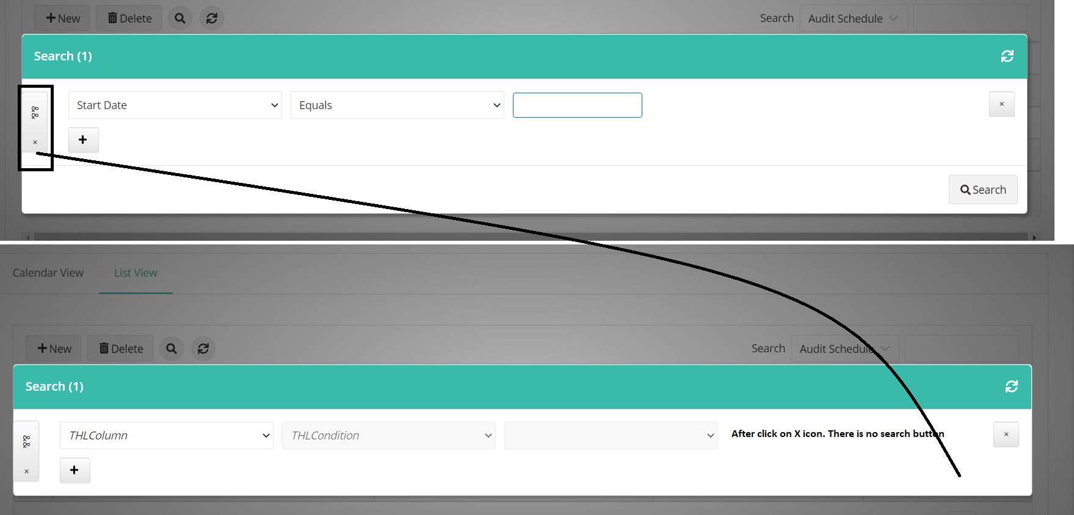

**5. Multiple Search Window - The condition && and = is not working as expected from LHS.**

Refer User: Dan / Pwd: a1.

Steps:

* Login as user go to auditpro
* Expand Scheduler tab and then click on audit schedule
* Click on List View
* Click on Multi search icon
* Click on + icon and then add column
* Select any one column
* Select any one Condition Ex: Equals
* Click on == or && icon from LHS
* Click on search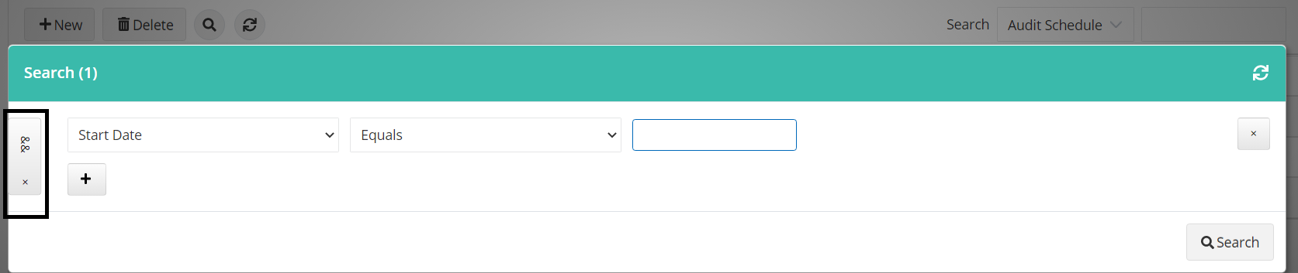

**6. Multiple Search Window - Sometime the system is displaying "No data found" sometime it’s not showing if search with invalid data with any condition**

Refer User: Dan / Pwd: a1.

Steps:

* Login as user go to auditpro
* Expand Scheduler tab and then click on audit schedule
* Click on List View
* Click on Multi search icon
* Click on + icon and then add column
* Select any one column
* Select any one Condition Ex: Equals
* Click on search input field and enter some irrelevant data
* Click on search button
* Observe the result.

**7. Multiple Search Window - Search condition is displaying only "Equals" if search input field have some static data's (Ex: Customize email messages, Audit Status, Corrective action Status)**

Refer User: Dan / Pwd: a1.

Steps:

* Login as user go to auditpro
* Expand Setup tab and then click on Customize email messages
* Click on Multi search icon
* Click on + icon and then add column
* Select column as “Status” or “Email Type” or “Context”
* Click on Condition list. It will show only “Equals”

**Expected:** The condition “Not Equals” should be displayed

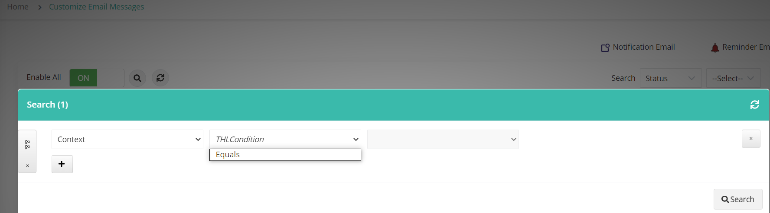

**Audit Status: Steps:**

* Login as user go to auditpro
* Expand Scheduler tab and then click on Audit Status link
* Click on Multi search icon
* Click on + icon and then add column
* Select column as “Status”
* Click on Condition list. It will show only “Equals”

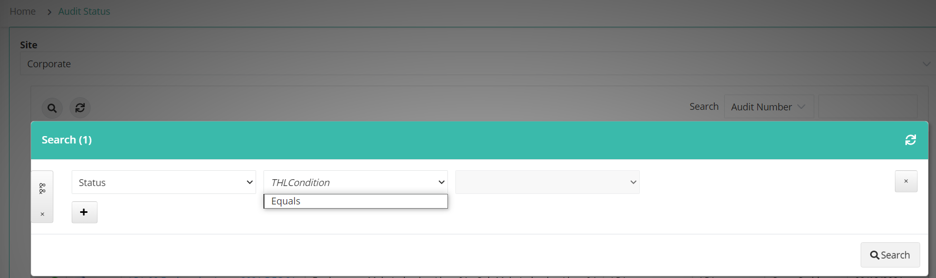

**Corrective Action Status: Steps:**

* Login as user go to auditpro
* Expand Scheduler tab and then click on Corrective action Status link
* Click on Multi search icon
* Click on + icon and then add column
* Select column as “Audit Status”
* Click on Condition list. It will show only “Equals”

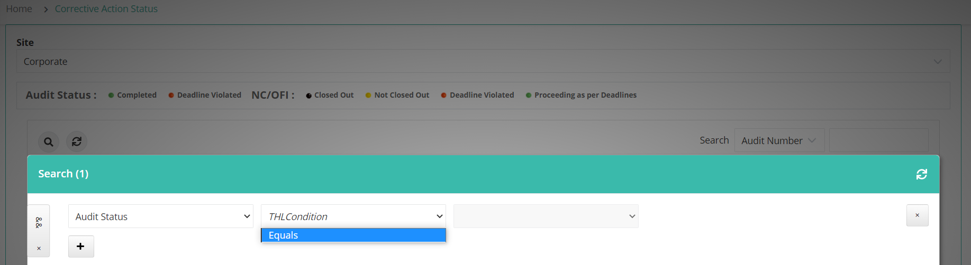

**8. Multiple search Window -> Some search condition is not working except Equal (Search input may numeric or special character or any text)**

Refer User: Dan / Pwd: a1.

Steps:

* Login as user go to auditpro
* Expand Scheduler tab and then click on audit schedule
* Click on List View
* Click on Multi search icon
* Click on + icon and then add column
* Select any one column
* Select any one Condition Ex: Equals
* Click on search input field and enter only numeric or special character
* Click on search button
* Observe the result.

