# Multiple FTA Issues

## 6/26 Incorrect Enablement for **When exactly one…** Checkbox

1. Display Add Probability dialog for a DFailU/DFail.
2. The **When exactly one…** checkbox should only be enabled when there is exactly one PCM-SM in the list.
   1. Requirement failing: *FTA0800:* The **When exactly one…** checkbox should be enabled only when there is exactly one PCM-SM in the listbox.
3. Below, you can see that the checkbox is enabled and has been checked when there are two PCM-SMs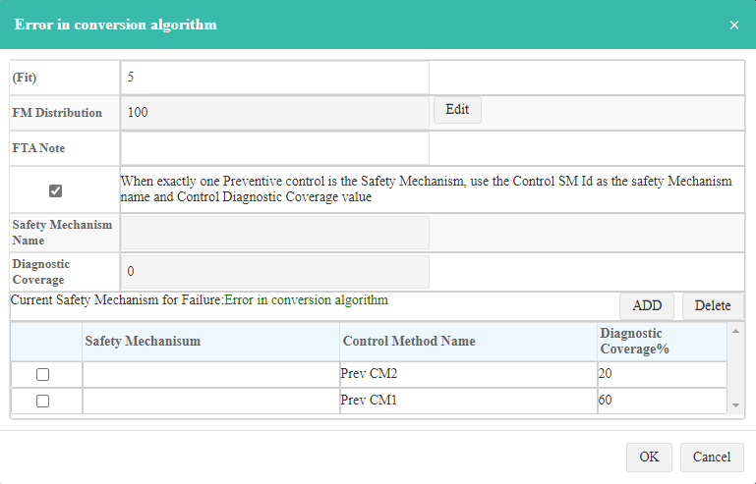

## 6/26 FTA Add Probability Dialog Showing a Non-PCM-SM

1. This shows the Design Control Methods table for Element BMS Mod2:  
   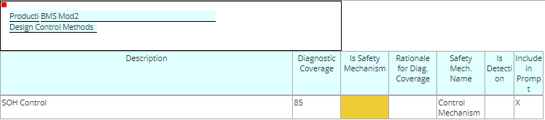
2. Notice it is not a Safety Mechanism (the Is Safety Mechanism column does not have an X in it).
3. However, the Add Probability dialog shows the PCM (which it shouldn’t):  
   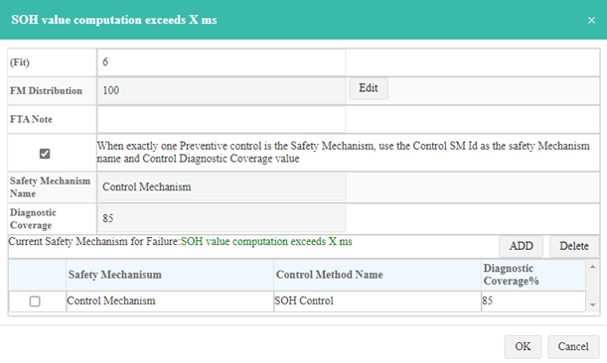

## 6/26 Can’t Edit Safety Mechanism Name or Diagnostic Coverage Fields

Can’t edit the Safety Mechanism Name or Diagnostic Coverage fields when more than one PCM-SM exists.

Requirement failing: *FTA0820:* When not checked or there are two or more PCM-SMs, the user is required to enter values in the **SM Name** and **Diag Cov** textboxes.

In the example below, there are two PCM-CMs, both fields are not editable and the cursor changes to the unavailable cursor ().  
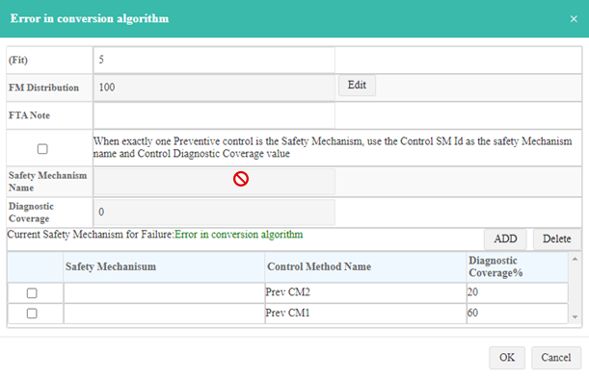

## 6/26 DFailU/DFails Not Represented as Gates

Each of the DFailU/DFails shown below should be represented as Gates.

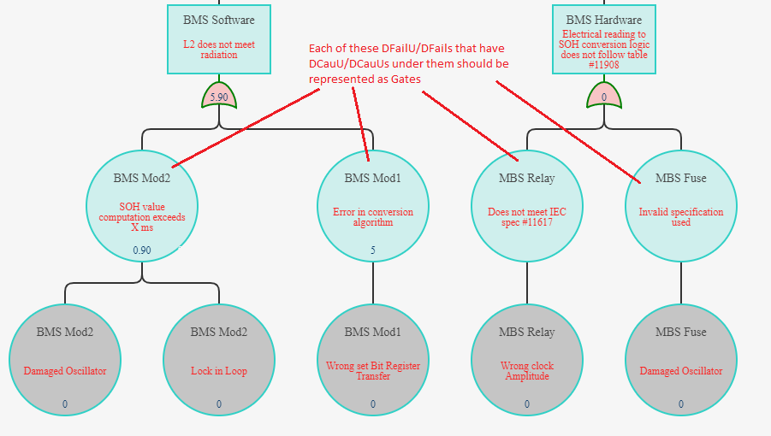

Here are examples from **FMEDA and FTA Documents\Common\Engine Example SCVDE-FTA-Final.png**:

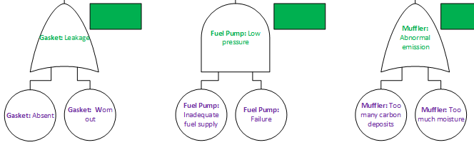

## 6/26 Incorrect LL Fails Shown

As the issue above indicates, in this example, DFailU/DFail **SOH value computation exceeds X ms** should be represented as a Gate:

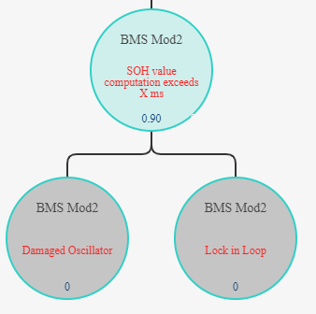

When the Add Probability dialog is displayed for it and the Edit is pressed to edit the FM Distribution value:

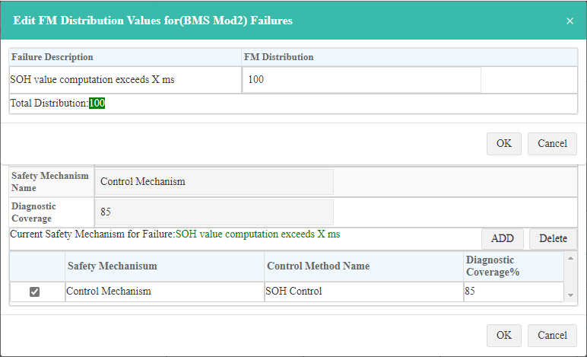

The two LLFails **Damaged Oscillator** and **Lock in Loop** (which are DCauU/DCaus) should be what appears, allowing the user to enter separate FM Distribution values for them that add up to 100.

## 6/26 Edit FM Distribution Dialog Badly Placed

As shown in the previous issue, the Edit FM Distribution Dialog is placed on top of the Add Probability Dialog, making it difficult to see that it is two separate dialogs and making it likely that the user will click on the Ok or Cancel buttons in the underlying Add Probability Dialog.

And, in fact, the user CAN click on these buttons. This shows me hovering over the Add Probability Dialog’s Cancel button:

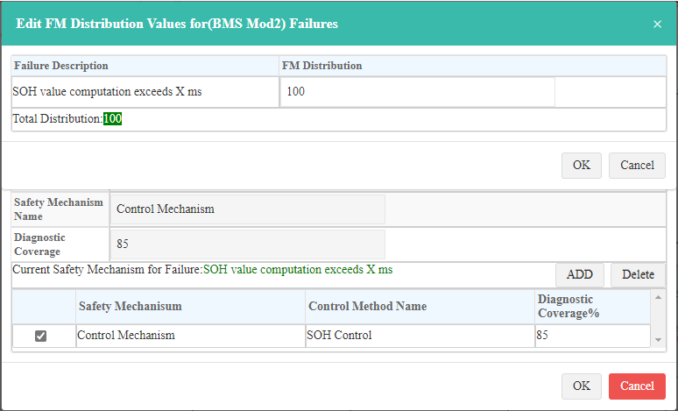

…and by pressing it, allowing me to cancel the underlying Add Probability Dialog, leaving the Edit FM Distribution Dialog displayed:

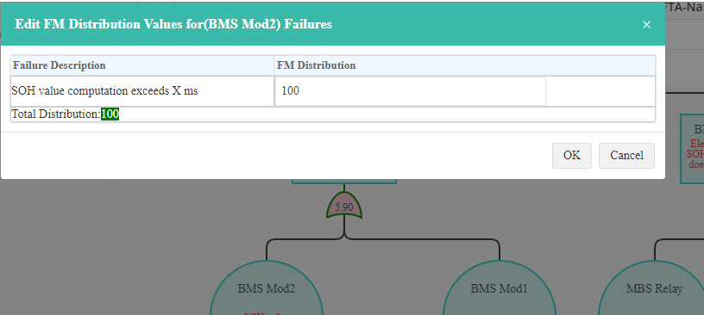

ANY underlying dialog that is supposed to be modal, should NOT be clickable, both in this situation and any other situation in all of our software, where two or more modal dialogs are supposed to be nested.

## 6/30 Don’t See Certain Flowdowns in FTA

Note DFail1 in FMEDA-FTA Engine already has several flowdowns:

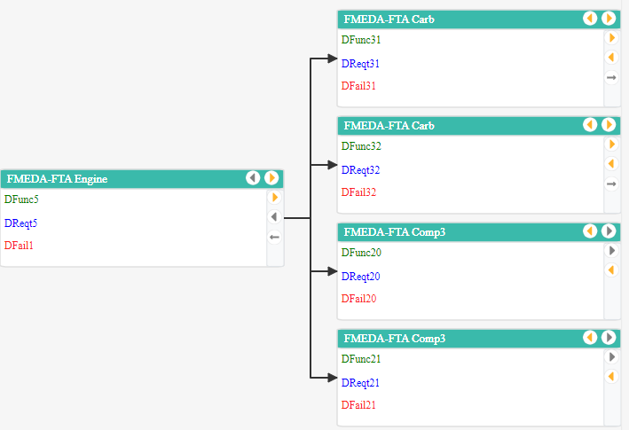

Open RTree for FMEDA-FTA Engine and expand all DReqts. This creates a bunch of **Design Requirement Usage allocated to Design Requirement Allocation** ASIs.

Open EFCTree for FMEDA-FTA Engine and see all DFails, including the one shown above. This creates a bunch of **Design Failure Usage allocated to Design Failure Allocation** ASIs.

Open FTA for FMEDA-FTA Engine for DFail1. I see the FMEDA-FTA Carb DFail flowdowns from above, but I don’t see the FMEDA-FTA Comp3 flowdowns from above:

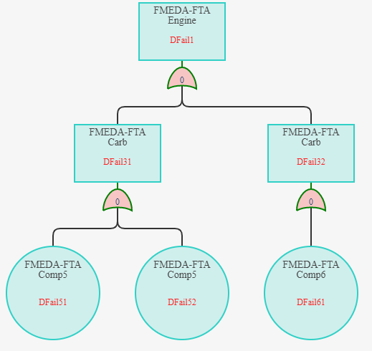

Right-click on DFail1 and selected Flow Down. Dialog shows the DFail31 and Fail32 flowdowns checked, but the FMEDA-FTA Comp3 DFail20 and DFail21 DFails are not checked and should be:

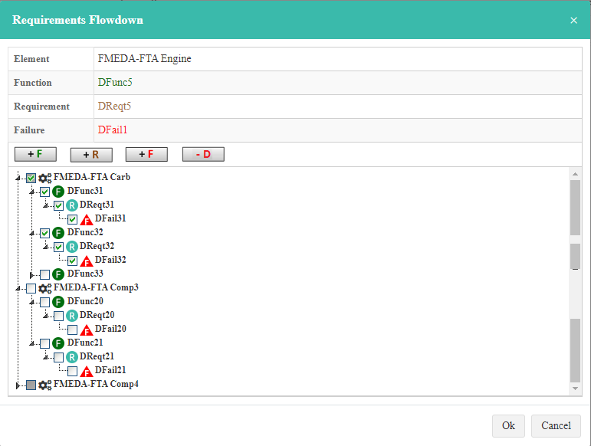

## 7/07 FTA Too Limiting

When a topic SG is selected it is used only to limit the DFails that can be selected for the topic of the FTA. After that, all DFails under the topic DFail should be shown regardless of whether they are safety related or not. This is similar to the previous issue in that it doesn’t matter how the topic DFail is found – whether an SG is used to filter the possible topic DFails or not. Once the topic DFail is determined, all DFails under it should be shown.

## 7/07 Can’t Insert a PH Gate Anywhere But Above an LL Fail

The user should be able to insert a PH Gate between any two gates anywhere in the FTA hierarchy where the parent and child Gates can be Fail Gates, PH Gates or internal Gates. Currently, the software only allows a PH Gate to be created above an LL Fail. Also, the software should give the user the choice of making the Gate connected to the parent Gate or the child Gate. That is, the Element name to show in the PH Gate can be either the parent Element name or the child Element name. The software currently does not do this.

## 7/07 Can’t Convert a Fail Gate to an Internal Gate

As indicated in the picture **FMEDA and FTA Documents\Common\MSS Engine Example\MSS Engine-30-FMEDAs-SG1, SG2, FTA-DFail1, DFail12.png** sent as part of the 10.0.0 patch containing the AQuAPro implementation of the FMEDA and FTA, **Carb**: DFail32 has been created as an internal Gate under **Carb**: DFail31. That is, the user should have the ability to move a sibling Fail Gate to be under another sibling Fail Gate, converting it to an internal Fail Gate. This currently cannot be done in the software. Note that there is also an API request in **API Documents\FMEDA and FTA API Examples-with Tokens.xml** sent as part of the 10.0.5 patch that shows how to create an internal Gate relationship. Look for this comment in the file:

<!-- Create the Engine:DFail1-Carb:DFail31 internally caused by Engine:DFail1-Carb:DFail32 -->

Starting with this example:

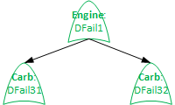

The user should be able to drag **Carb**: DFail32 and drop it on **Carb**: DFail31 to create the internal Gate relationship between **Carb**: DFail31 and **Carb**: DFail32:

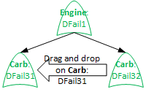

This would be the final display:



This could also be done using right-click menu items such as *Move To <Sibling name>*. Where there would be one menu item for each sibling of the Fail Gate being right-clicked.

## 7/07 Can’t Convert an LL Fail Event to a Fail Gate

I don’t see this functionality currently in the software:

*FTA1400:* An Event representing a DFailU/DFail can be converted to a Gate, provided it has BOM child Elements. Note that since the DFailU/DFail is currently represented as an Event, it can’t have any flowdowns, otherwise it would be a Gate already. The dialog for converting an Event to a Gate should prompt for *FTA1410:* the Gate Type and *FTA1420:* allow the user to select one or more BOM child component DFailUs/DFails to flow down to. *FTA1430:* The user must select at least one to do the conversion. Once the user presses the Ok button, the FTA should *FTA1440:* create the appropriate flowdowns, *FTA1450:* convert the Fail Event to a Fail Gate and create the appropriate Gates/Events under the converted Fail Gate. That is, for each DFailU/DFail that has been flowed down to, *FTA1460:* either create an OR Fail Gate for it if it has DCauUs/DCaus under it and create Events for each DCauU/DCau under the Fail Gate or *FTA1470:* create a Fail Event when the DFailU/DFail has no LocDCaus.