# 6/30 Issue 14 – Creating DFunc in TSR not Creating Flowdown

Reported 06/30/2021

Open TSR for FMEDA-FTA Car:  
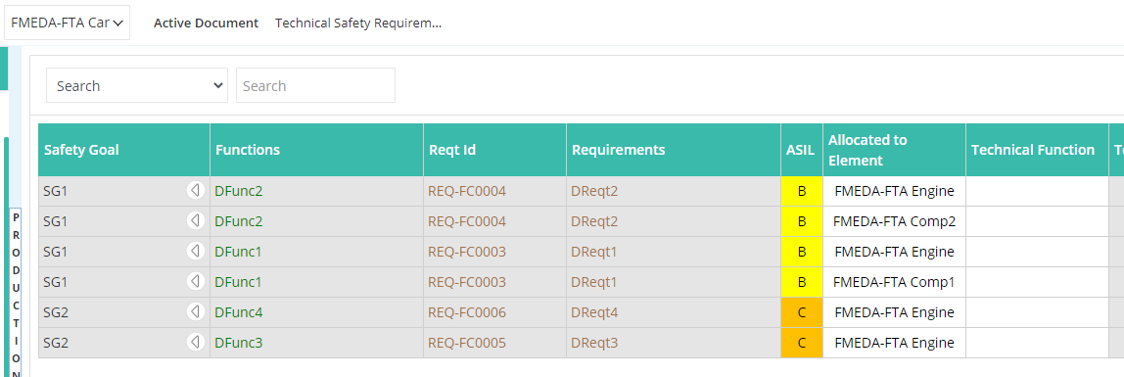

Select DFunc3 under FMEDA-FTA Comp1 in TSR:

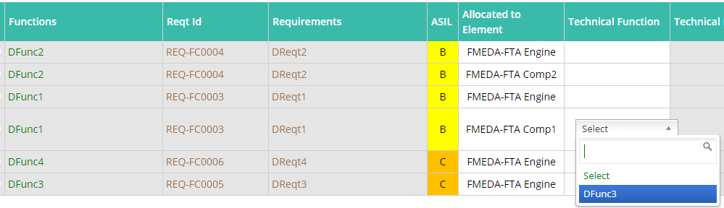

This should not only include DFunc3 in the DFMEA for FMEDA-FTA Comp1 (which is does), but should also create the flowdown from FMEDA-FTA Car’s DFunc1 (which it does not). Since it doesn’t, when I refresh the document, it doesn’t show up:

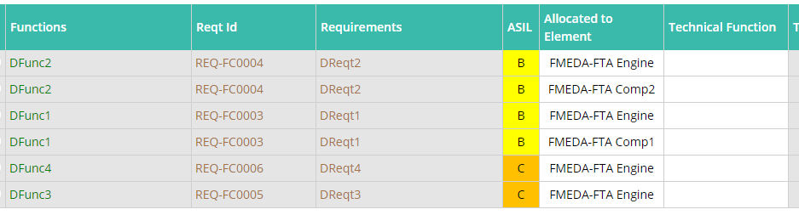

Another problem with this is that if I select a DFunc and go out of the document and come back and do it again multiple times, I get many branches of it in the DFMEA:

