# 6/25 Issue 12 – FTree Not Showing Failure Flowdowns

Reported 06/25/2021

* Create DFunc, DReqt and DFail flowdowns in AQuAPro for FMEDA-FTA Carb.
* Open FTree, don’t see flowdown arrows:

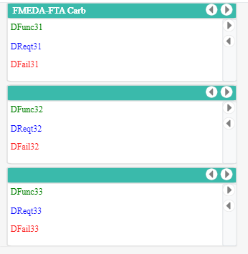

* The boxed ASIs and ATIs were created when I opened FTree:

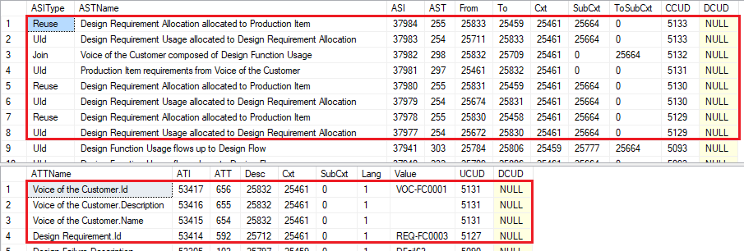

* Open EFCTree for FMEDA-FTA Carb.
* See flowdowns to FMEDA-FTA Comp5 and FMEDA-FTA Comp6.

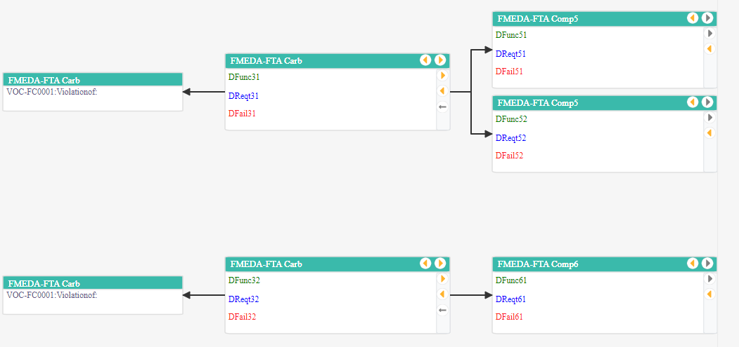

* The following ASIs were created when EFCTree was opened:

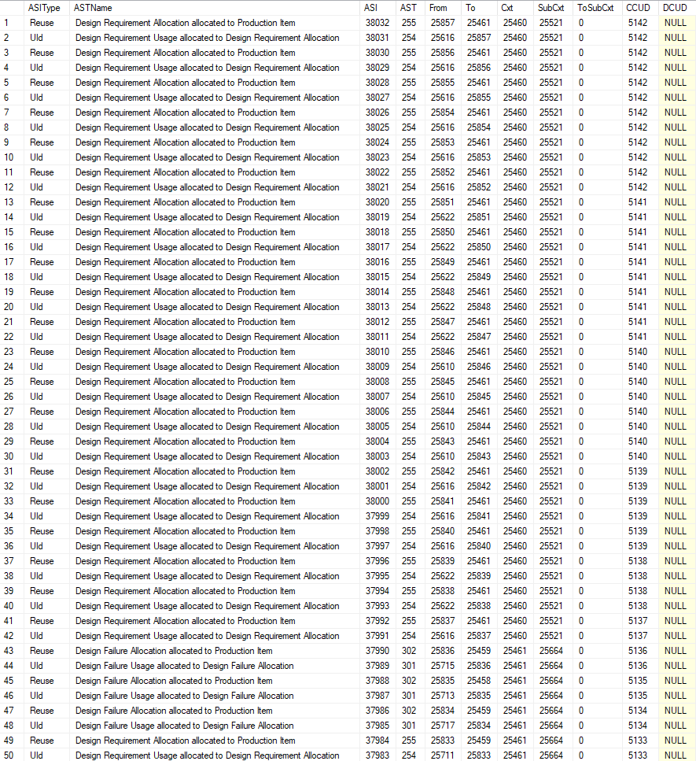

* Open FTree for FMEDA-FTA Carb.
* Now see DFail flowdowns:

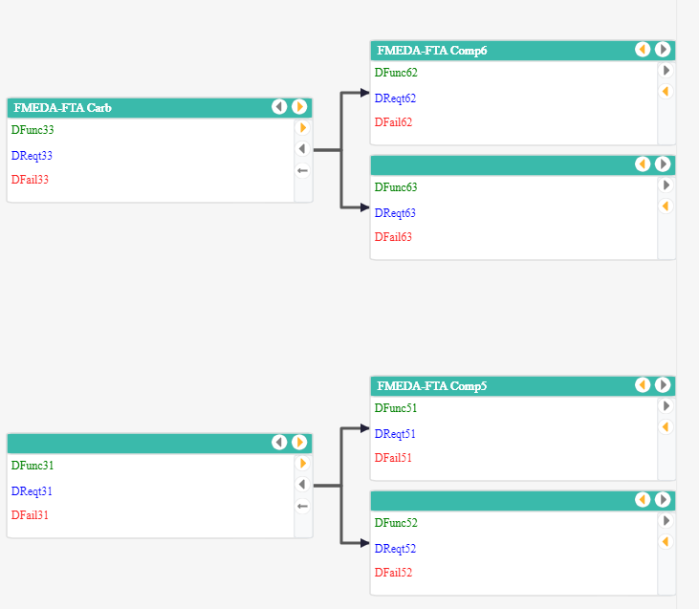

* Whatever EFCTree is doing so that FTree can be displayed should also be done by FTree or the code should be modified to work without the data created by EFCTree.