# 6/25 Issue 9 – Error Creating DFuncs or DReqts

Reported 06/25/2021

* Flowdown🡪Requirements Tree🡪Create Requirements Flowdown
* I entered name DReqt21 in the New Requirement field, pressed tab to get it shown in the list at the bottom, selected it, then clicked Ok and got the following error message.

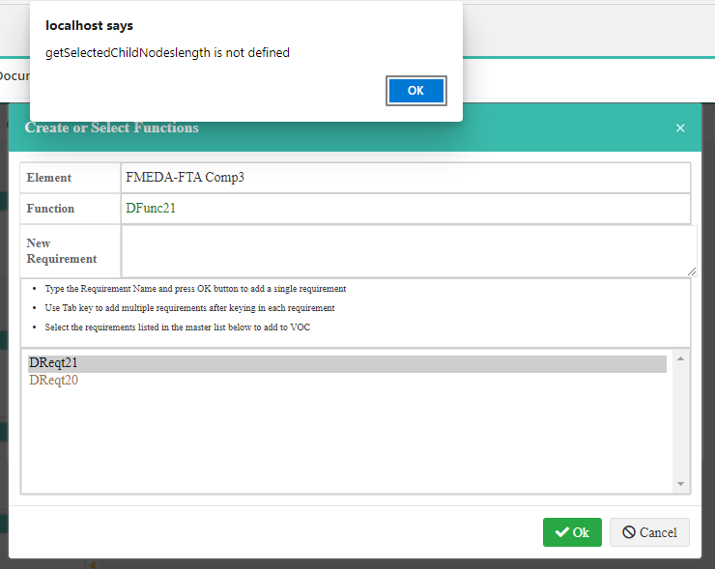

* The DReqt in fact has gotten created but does not show up in the underlying dialog:

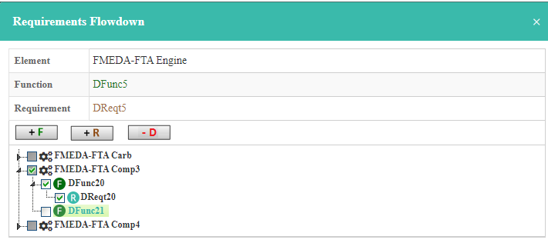

* When I re-open the dialog, it shows up:

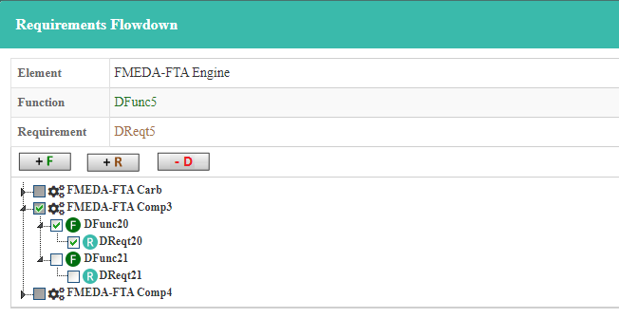

* After re-opening the dialog as shown above, I checked DReqt21 to get it included in the RTree. It does get included, but the entire diagram reloads with none of my previous requirements expanded. Even if refreshed, the tree should redisplay the requirements already expanded and scrolled to where I was working.