# 6/24 Issue 7 – Global DSeg and Map Entry Incorrectly Created

Reported 06/24/2021

* Open FSR
* DSeg created at Global level (Cxt=1079) that should NOT be created. This at least accounts for one of probably many places where this is occurring. Current DB I got from Biju had 48 of these Global DSegs, all included in Global’s Design Segment Map.

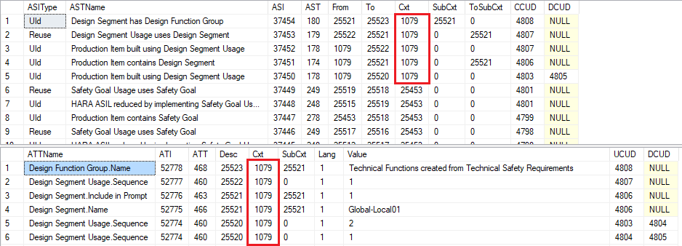

* Opening a VOC for another Element sometimes creates a Global DSeg.

# Redundant Creates, Deletes and Updates

Creates, deletes and updates that are done and then deleted and then sometimes re-done are happening often enough, that I’m going to use a shorthand for indicating when they happen. Using **C** for create, **D** for delete and **U** for update, running a sequence together will indicate what is being done. For example:

Design Requirement Usage.HARA ASIL, **CDC**, final value=C

means in one operation a create of a blank value, then delete, then another create were done, where the final value in the create was “C”. If the sequence ends with a delete, then there will be no final value.