# 6/24 Issue 6 – Column Widths not Being Saved for HARA

Reported 06/24/2021

* Open HARA
* Adjust Exposure column width to be wider:

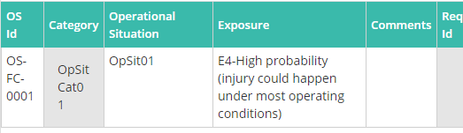

* Re-open HARA and see Exposure column width back to default. Didn’t check, but I’m assuming this is happening in other documents as well.

