# 6/24 Issue 5 – Malfunction Associated Then Deleted Then Re-Associated

Reported 06/24/2021

* Show FA
* Select a MF.

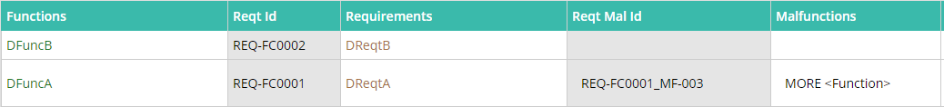

* Look in DB and see MF gets associated (ASI=37417) in CUG=4774, then association deleted in 4775 and created again (ASI=37418). This is causing extra time that is not needed.

