# 6/23 Issue 3 – Creating an Op Sit Branch in Table

Reported 06/23/2021

* When an Op Sit branch is created in the Op Sit table, the correct PI contains Op Sit ASI is created (See first red box below), but why are five ATI records with blank values created for the Id, Comment, Speed, Location and Road Conditions properties (See second red box below)? This is causing extra time that is not needed.

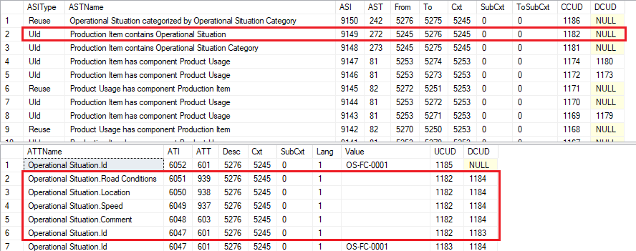

* After setting the following values in the columns shown below:



* Extra DB operations are occurring that don’t need to be while filling in the line. This is causing extra time that is not needed. Here they are, grouped by the CUDGroups that contain creates, updates and deletes that are run to satisfy one user action:
  + Fill in the Operational Situation column with *OpSit01*. CUDs:
    - 1182 – create ATIs for OpSit.Name=*OpSit01*, OpSit.Id=*””* and other 5 properties to blank (not needed) and create ASI PI contains OpSit.
    - 1183 – delete ATI with OpSit.Id=*””* and create OpSit.Id=*OS-FC-0001*.

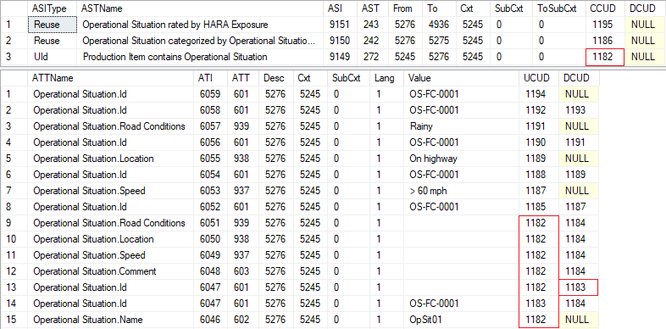

* + Select Category=*OpSiteCat01*. CUDs:
    - 1184 – delete OpSit.Id=*OS-FC-0001* (not needed)and delete 5 other blank properties (not needed if they weren’t created in the first place).
    - 1185 – create OpSit.Id=*OS-FC-0001* (not needed if it wasn’t deleted).
    - 1186 – create ASI OpSit categorized by OpSitCat.

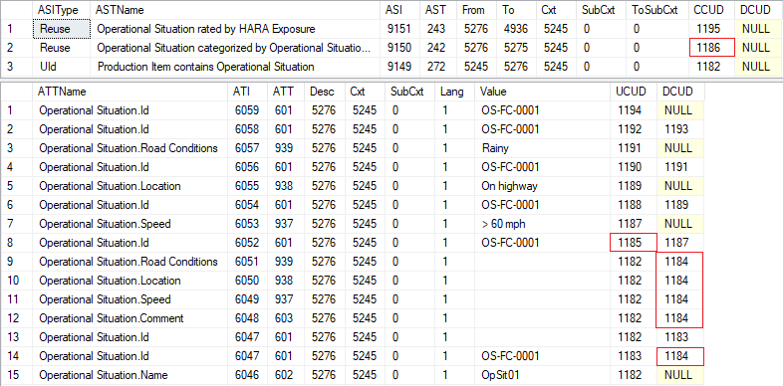

* + Fill in the Speed column with *> 60 mph*. CUDs:
    - 1187 – delete OpSit.Id=*OS-FC-0001* (not needed) and create opSit.Speed=*> 60 mph*.
    - 1188 – create OpSit.Id=*OS-FC-0001* (not needed if it wasn’t deleted).

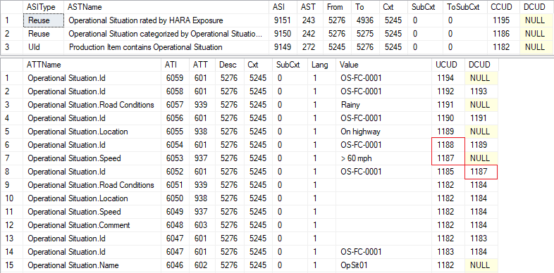

* + The other three columns (Location, Road Conditions and E) basically follow this same pattern of deleting and creating OpSIt.Id, while updating the three columns.