Mail issue :

1. Content is missing for Audit assign notice -not fixed

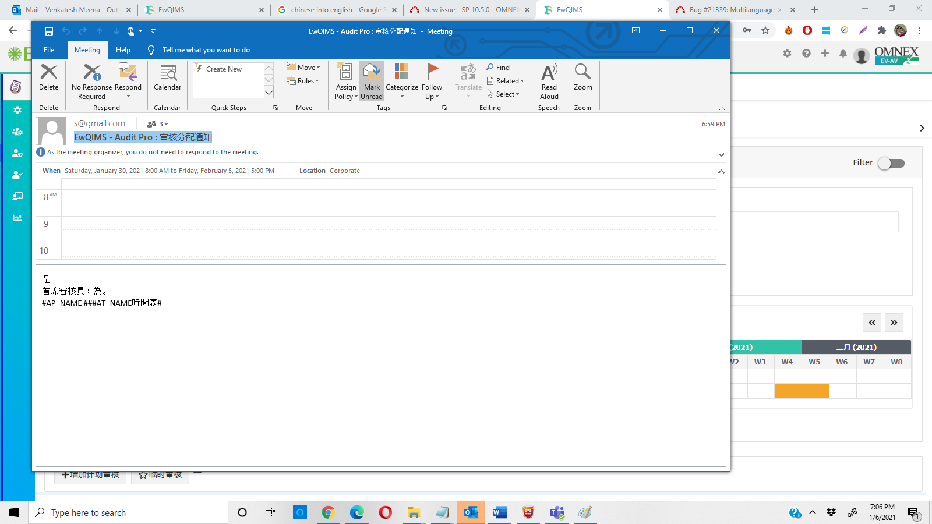

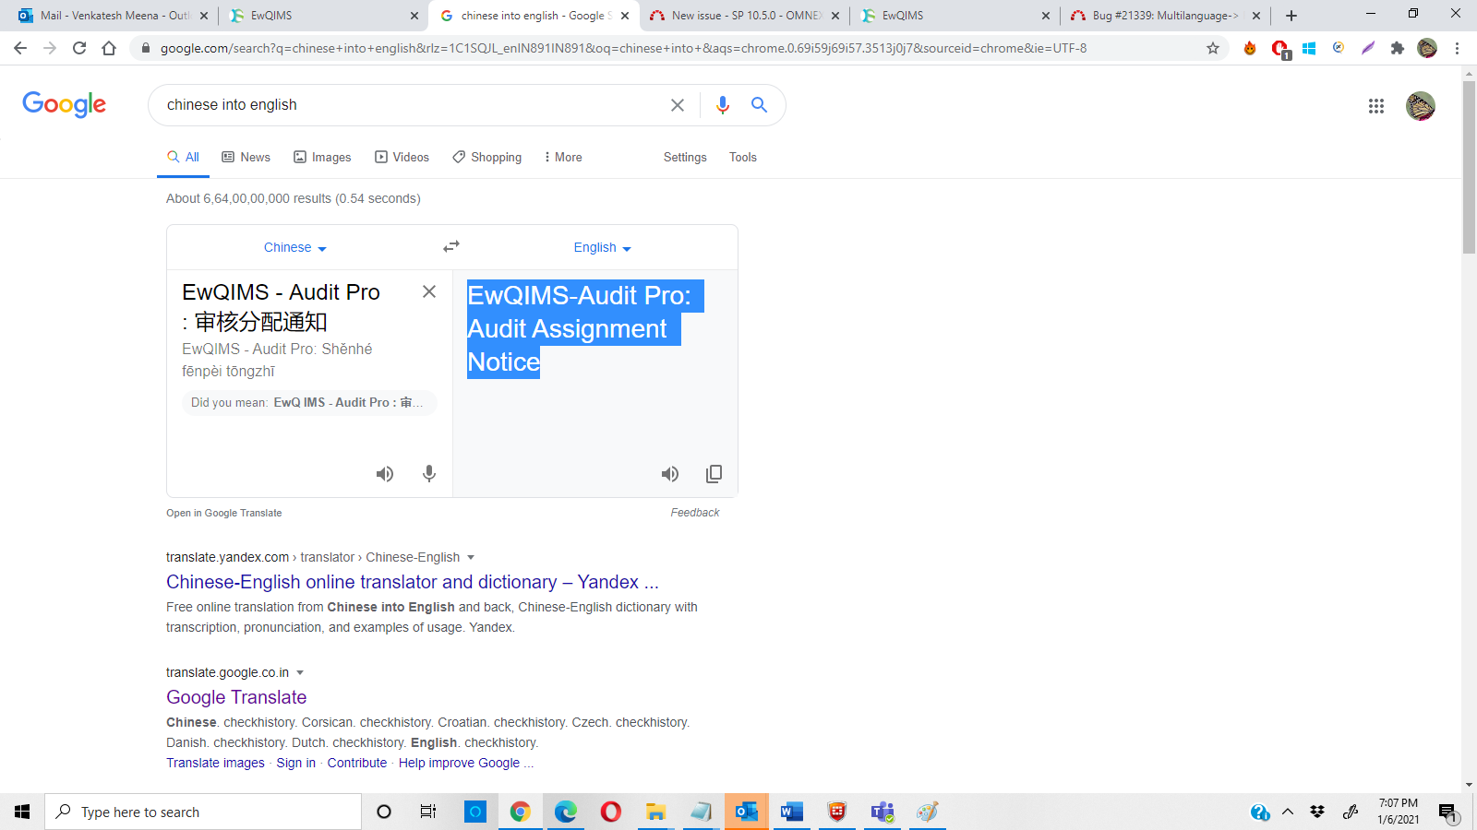  
  
2) Auditor assign notice to lead auditor ,auditee, auditor and not redirect correct location  
mail are corrupt -Fixed

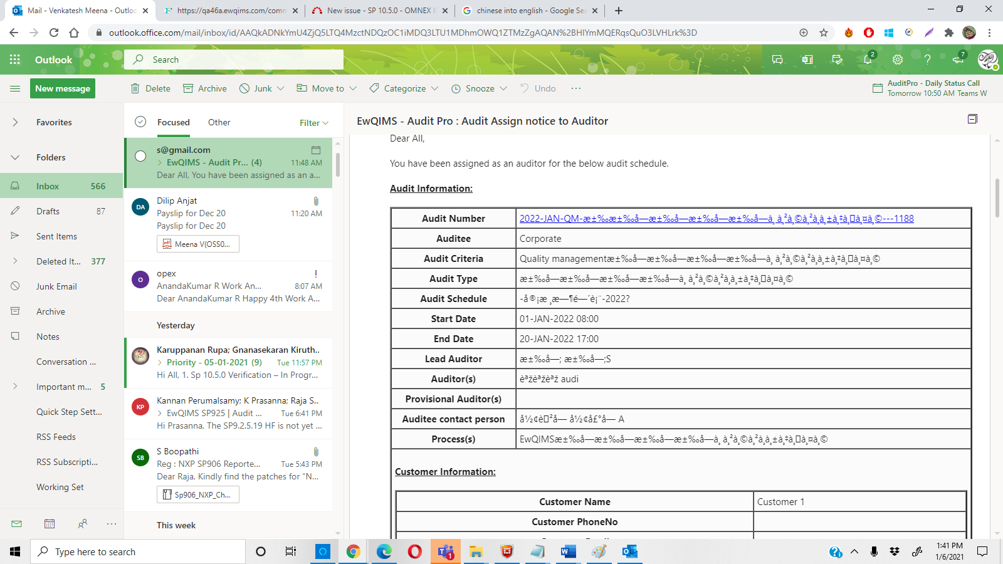

3)Auditee response is missing – not fixed  
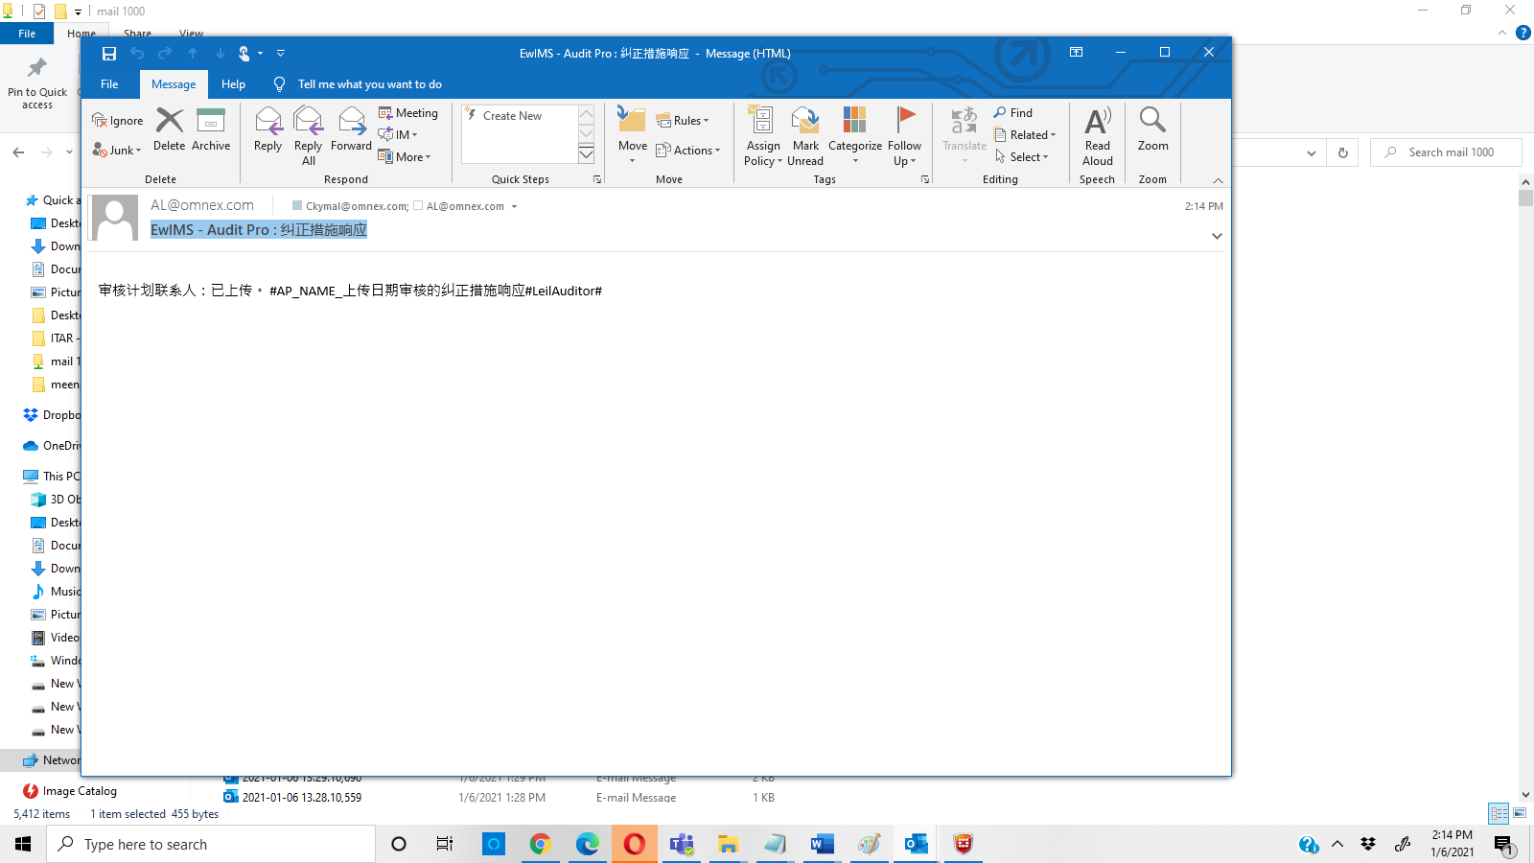

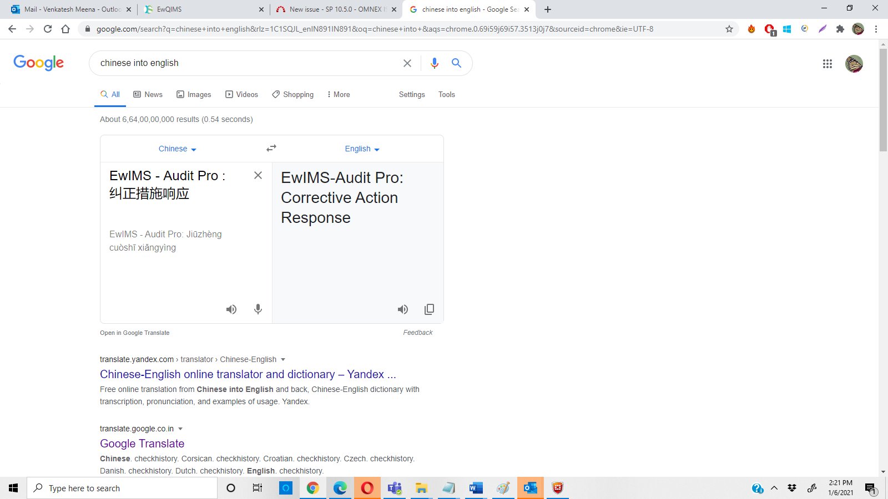

4) Text need to convert include regards - </br> tag is displayed – not fixed

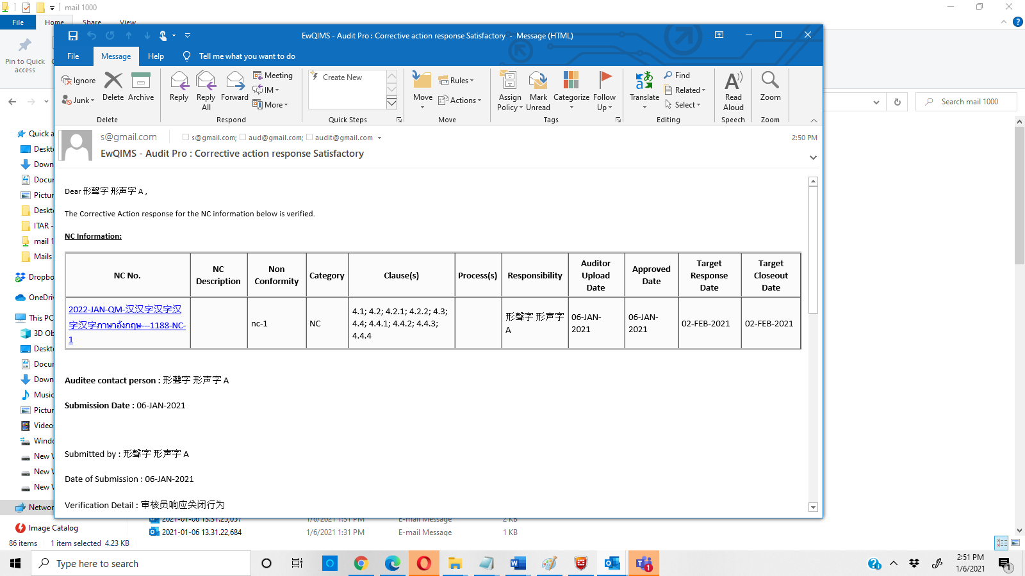

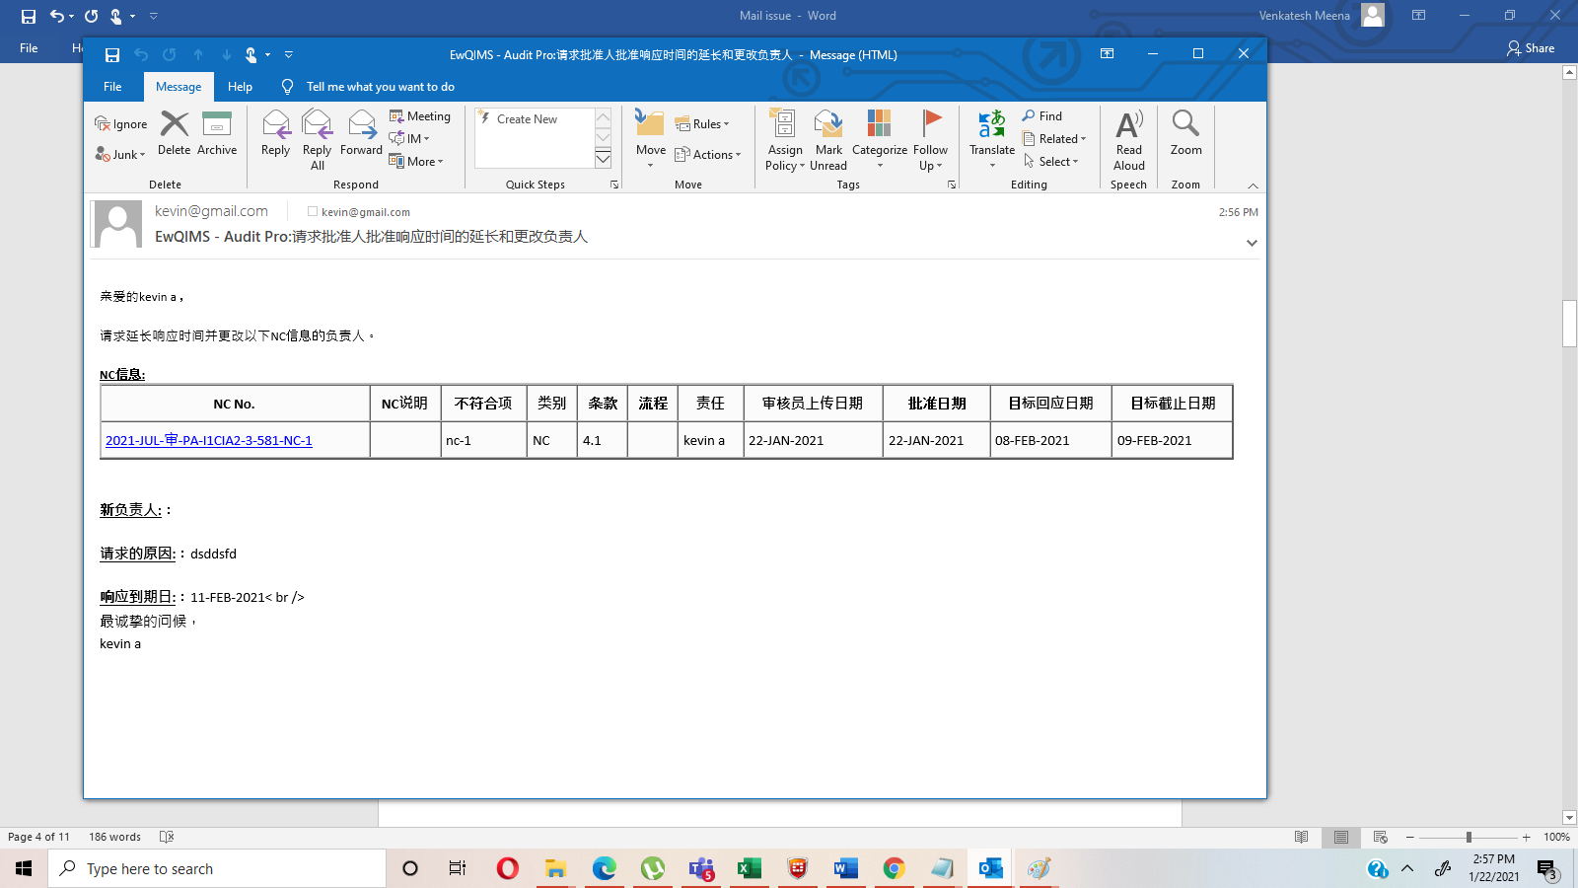

5) Auditee assign notice – not fixed

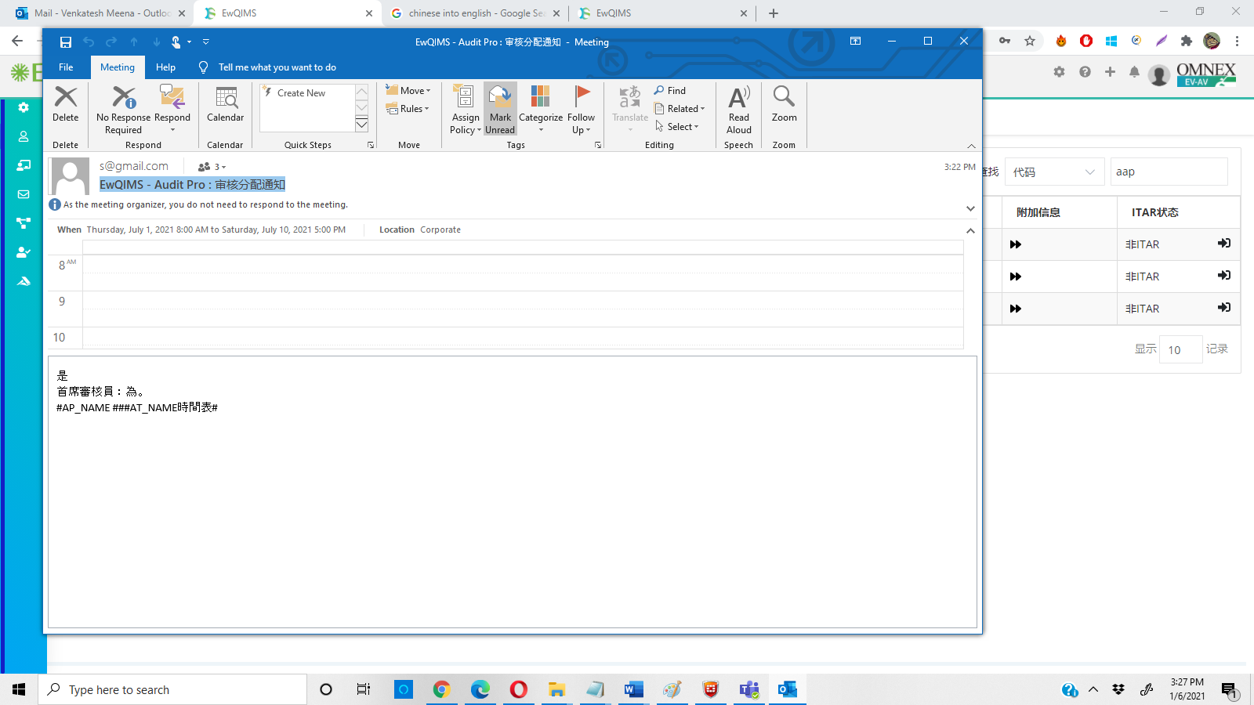

6) Before approver approve the audit, Audit completed message is generated -not fixed

7) Message need to convert and remove colon-> Action owner mail is not generated -not fixed

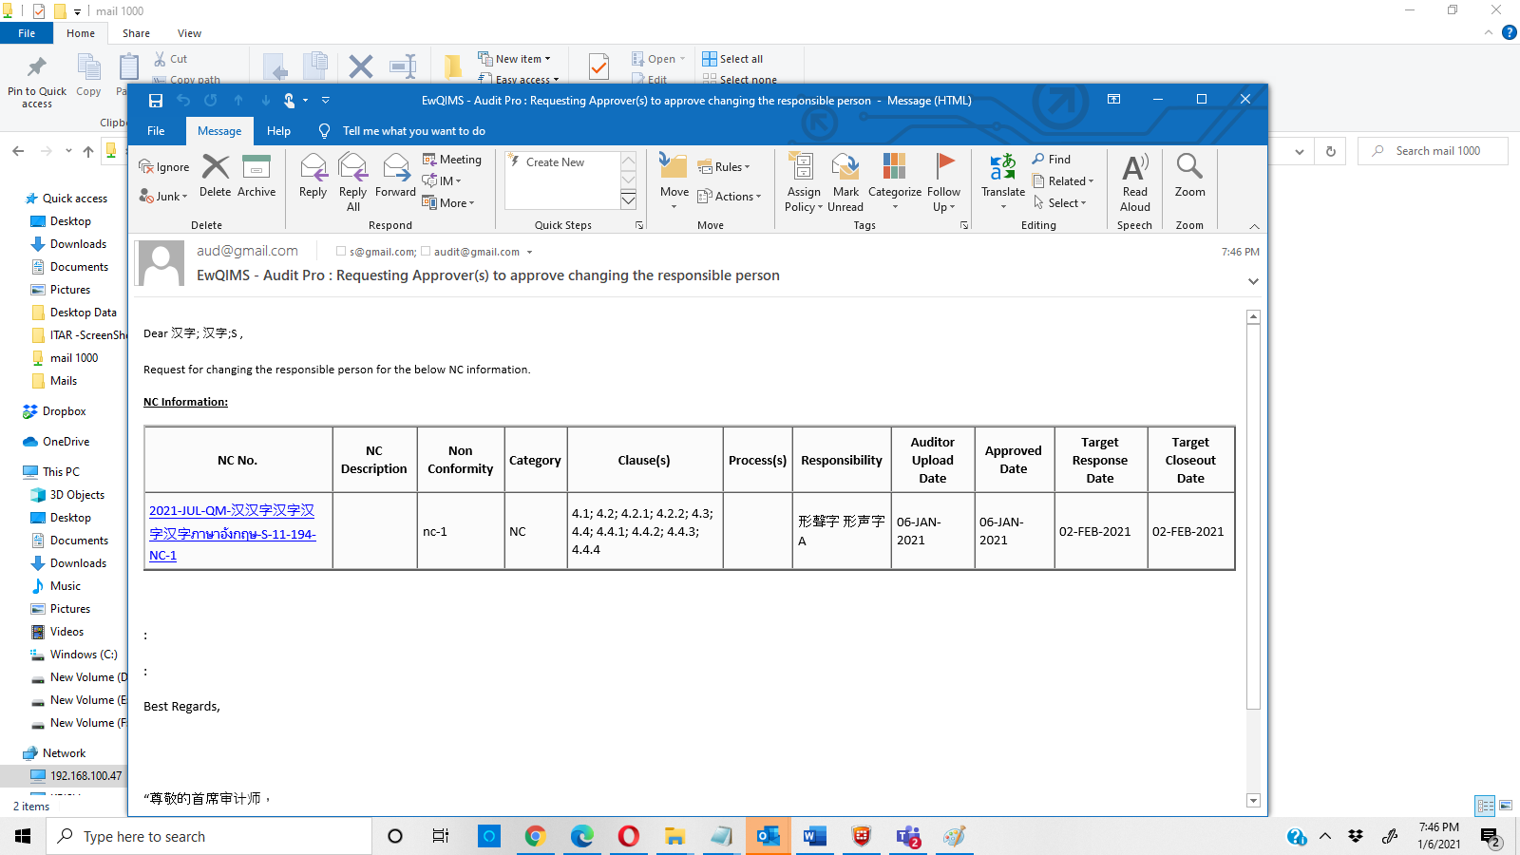

8) Response date extension ->Duplicate records is displayed-not fixed 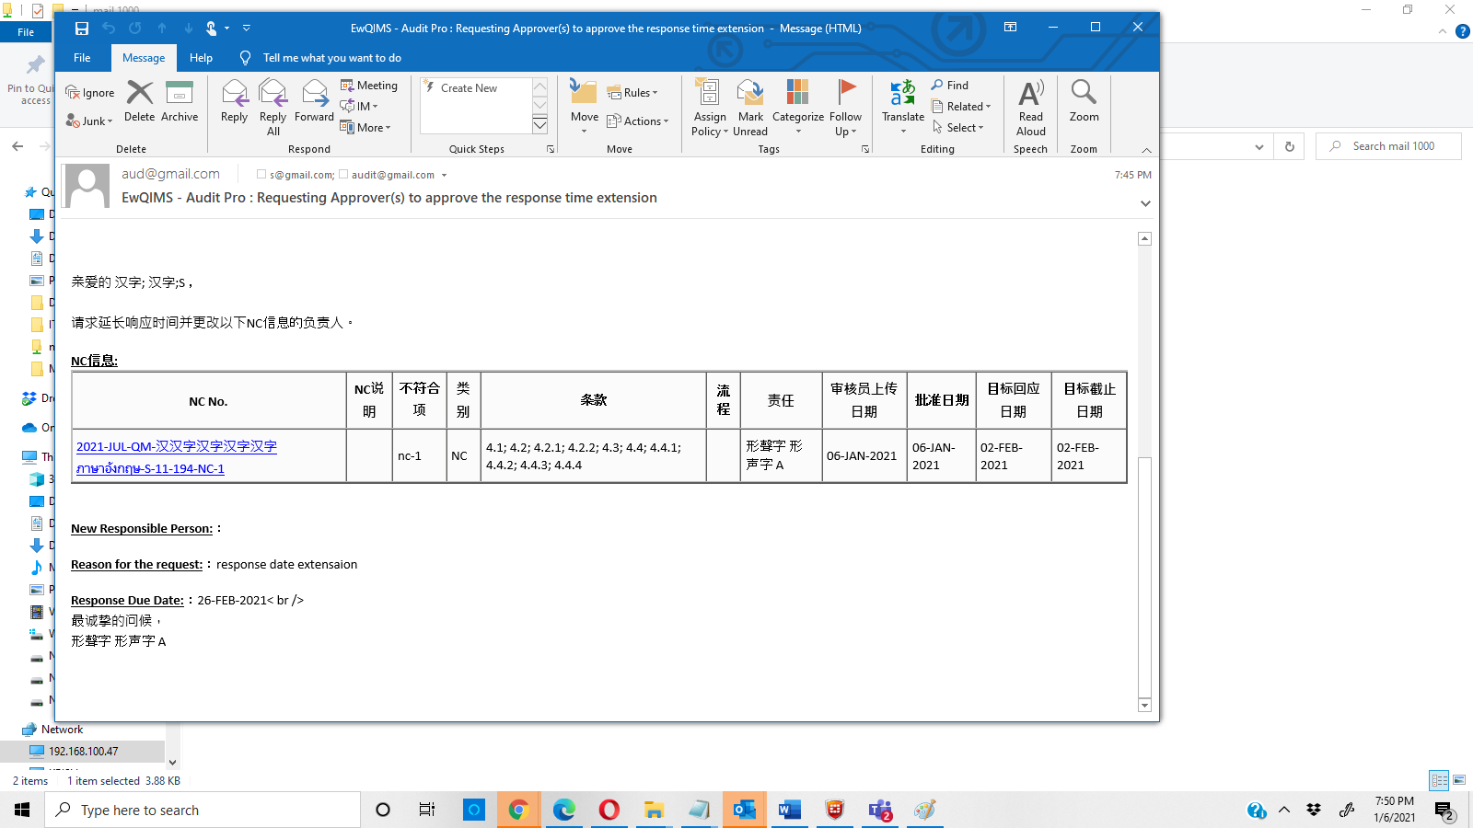

9) Corrective action response Not Satisfactory-> Duplicate records is displayed in single mail +label conversion is not proper-Not fixed

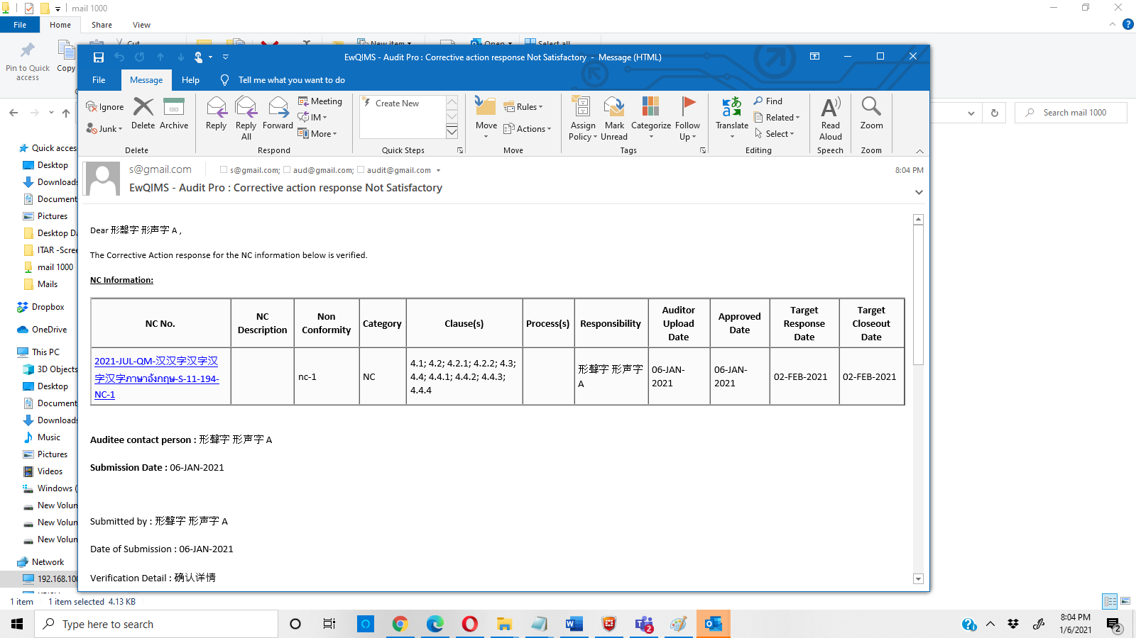 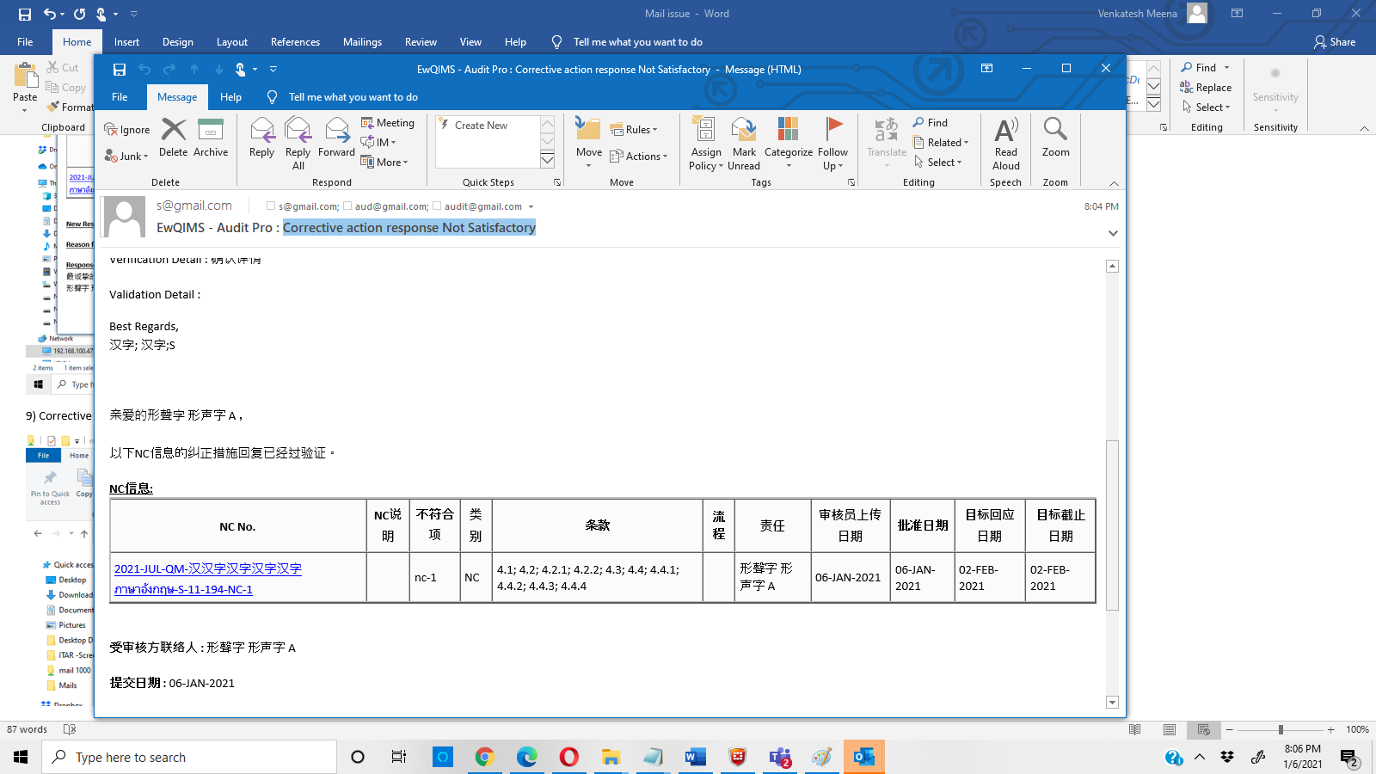

10)EwQIMS - Audit Pro : Corrective action response validation failed- Corrective action response Not Satisfactory-> Duplicate records is displayed in single mail +label conversion is not proper -not fixed

EwQIMS - Audit Pro : Corrective action response Satisfactory-> same issue

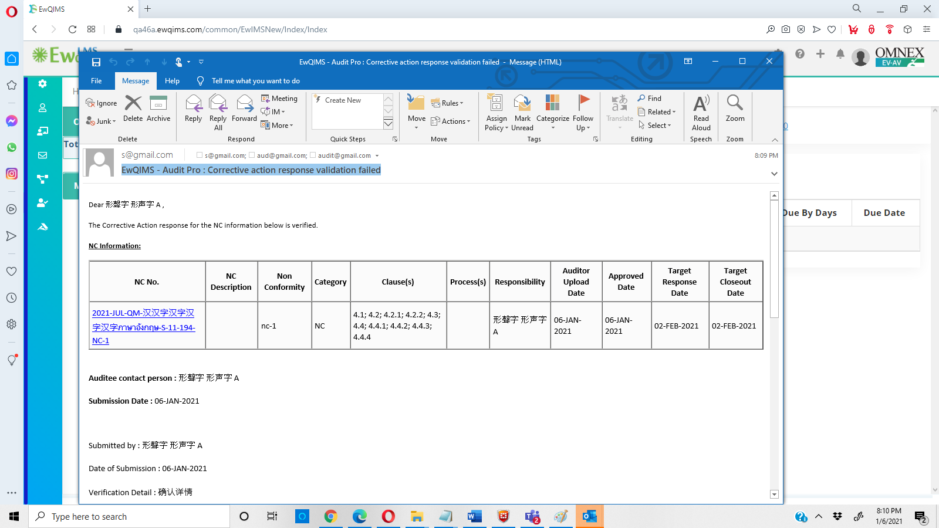

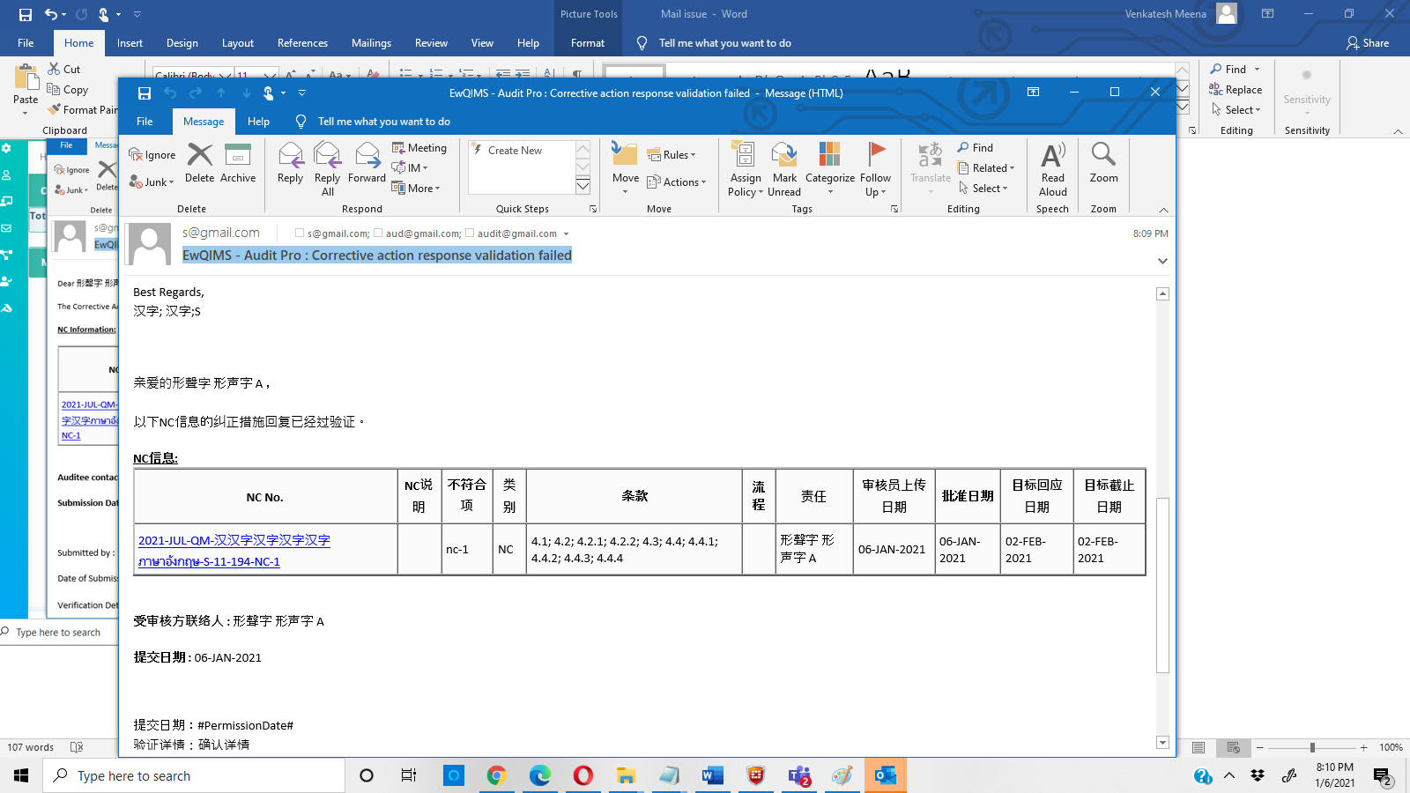

11) EwQIMS - Audit Pro : Corrective action response Satisfactory-> Duplicate mail is displayed

Duplicate records is displayed in single mail +label conversion is not proper

12) Effectiveness mail is not generated both yes/No -not fixed