1. New Groups creation clicks on Add directly.

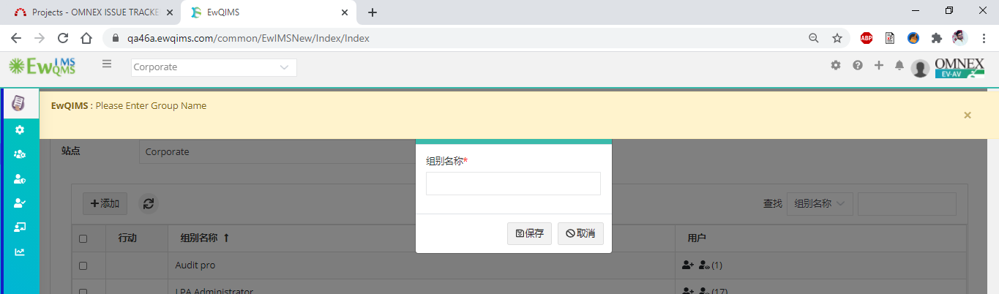

1. Customer creation New button

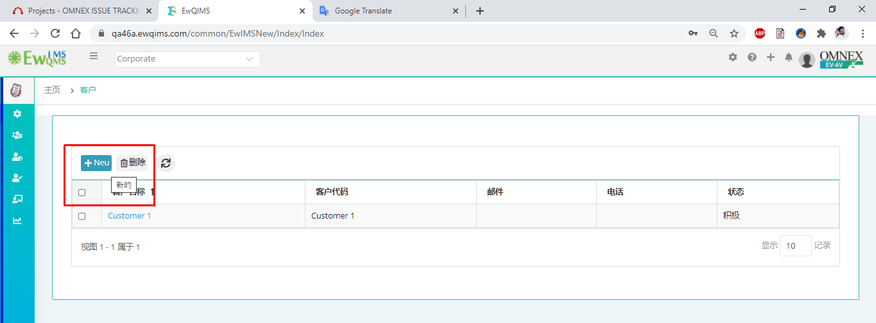

1. Customer part Details Screen & also Save validation displays Blank

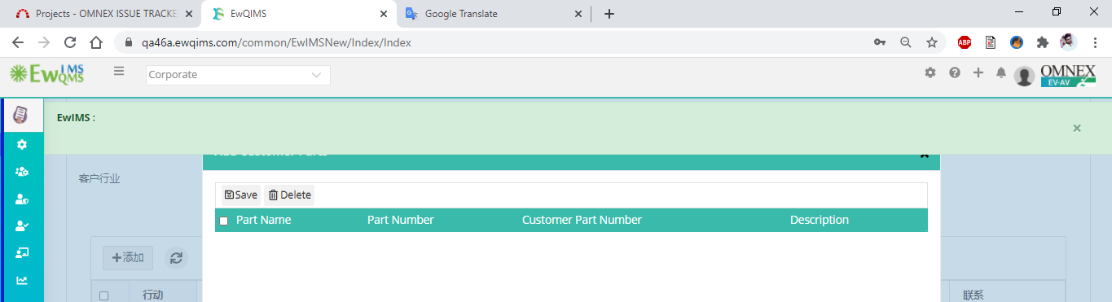

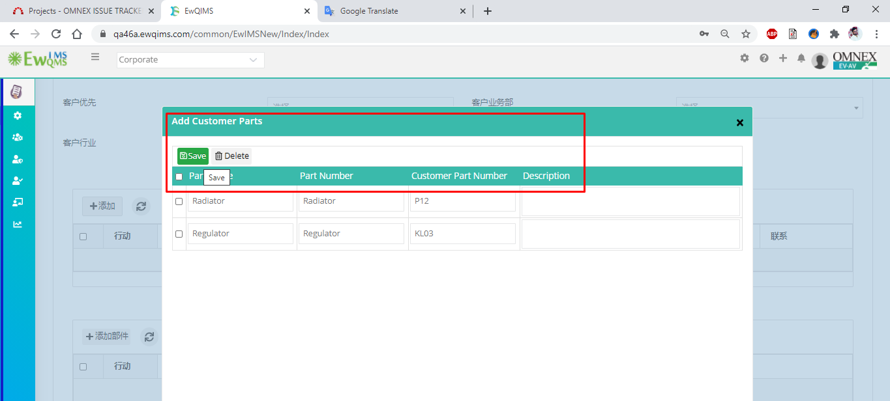

1. New vendor creation button

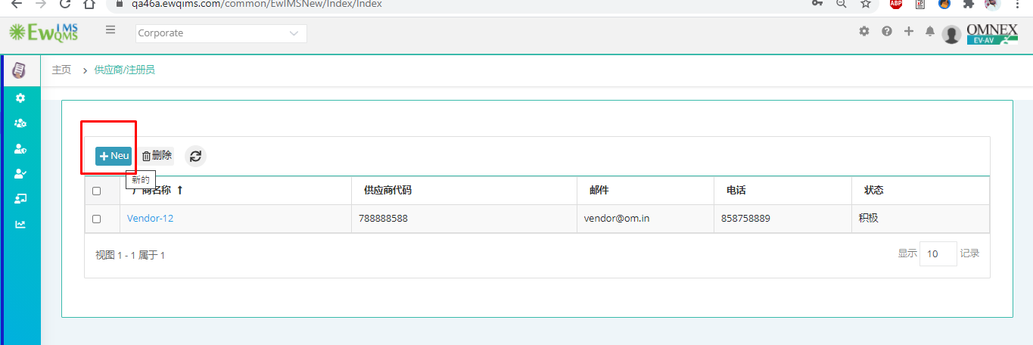

1. Customized Email messages labels

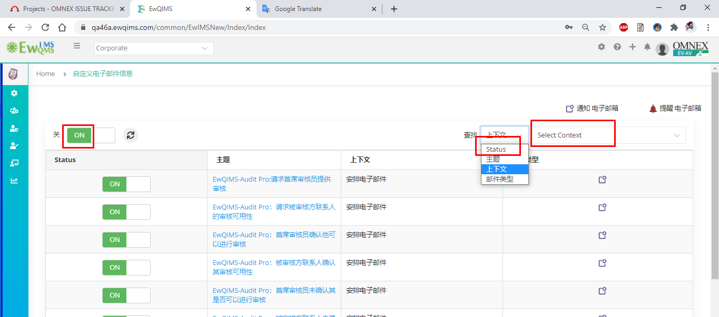

1. Define Folder structure

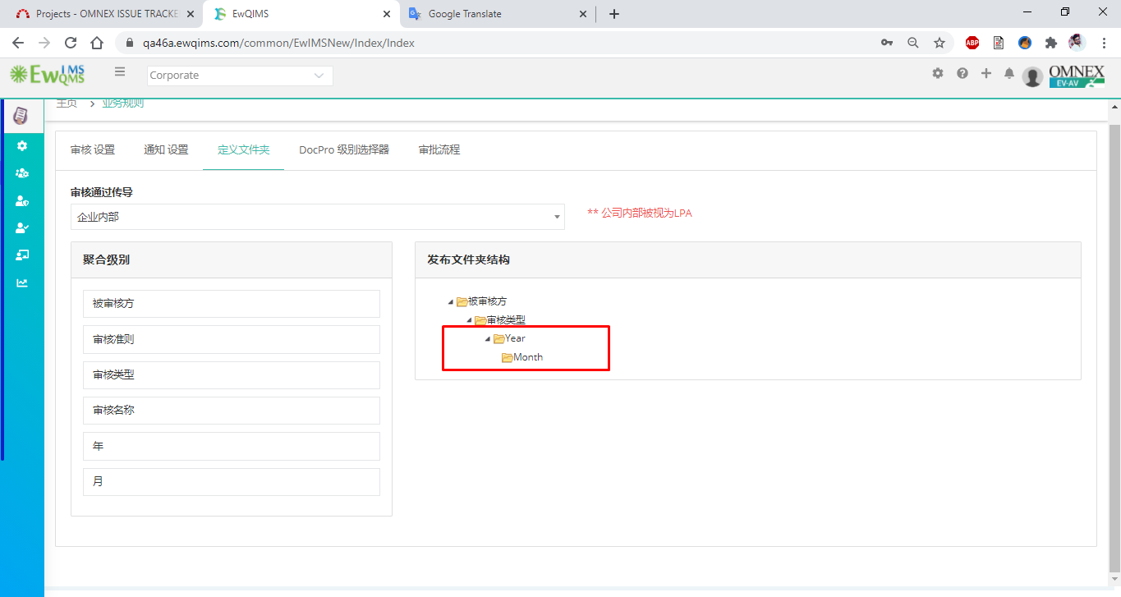

1. Team Page -> New tem creation button and Below issue

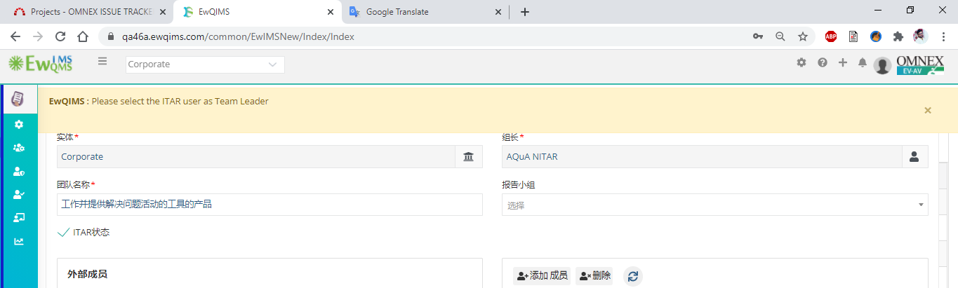

1. User selection window done and header label buttons in Layers Auditor selection

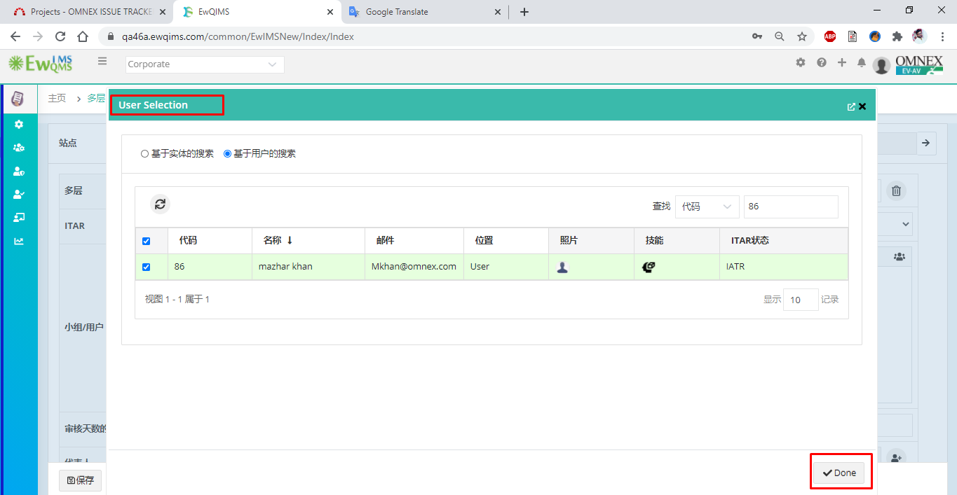

1. Layers Save successfully displays Blank validation

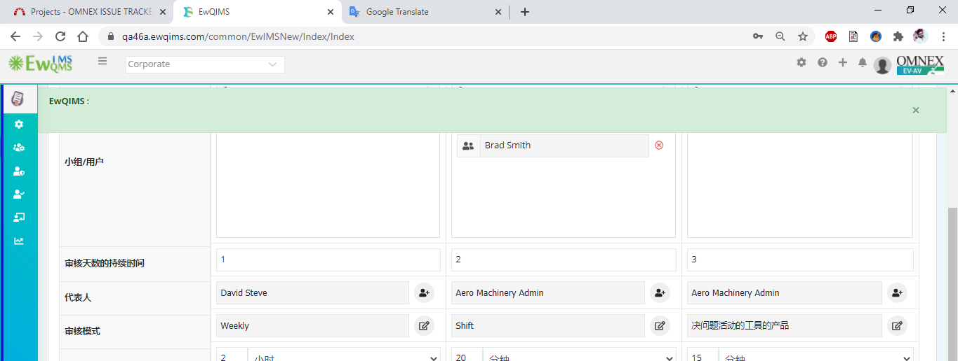

1. Checklist page Parameterized score label

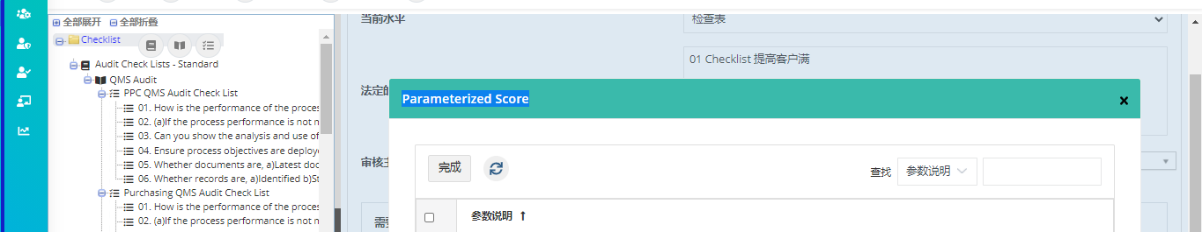

1. Checkpoint label

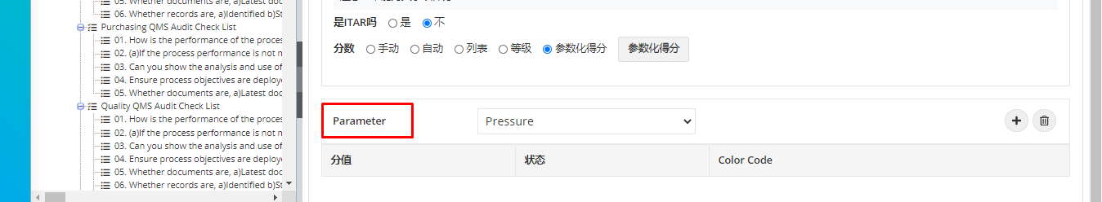

1. Audit topic as Chinese accepts field but when choose for checkpoint and save displays validation
2. Checkpoint -> Set logic

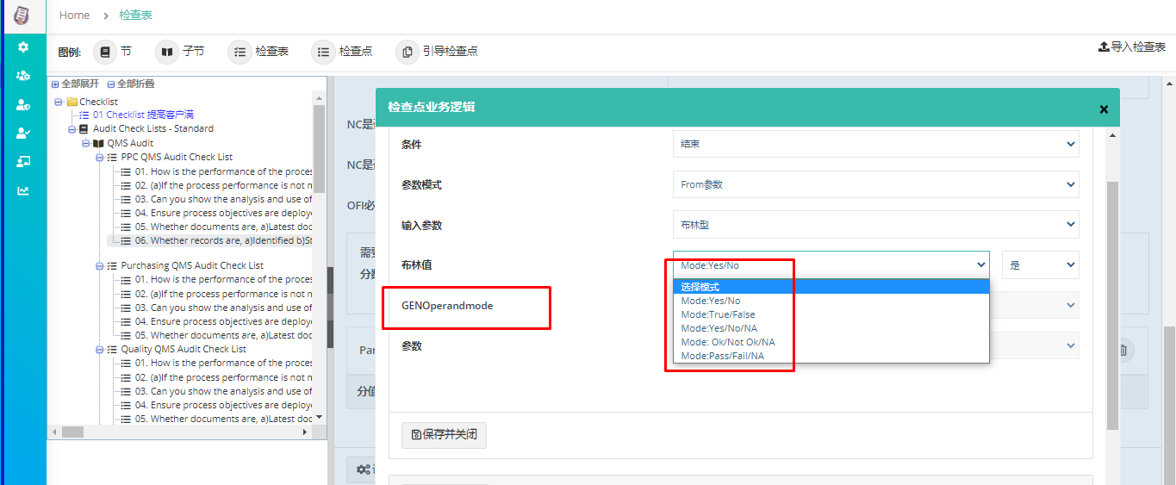

1. Parameterized score validation

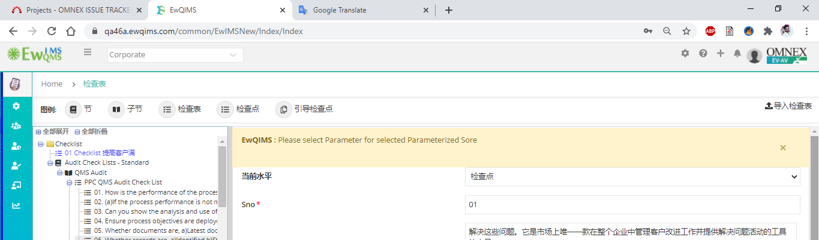

1. Import Excel

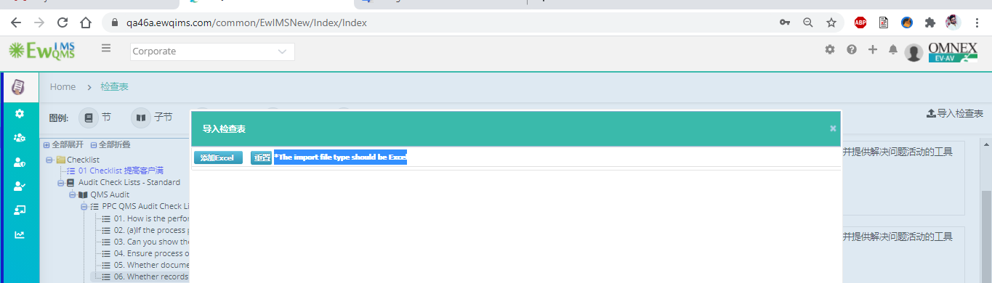

1. Parameters screen

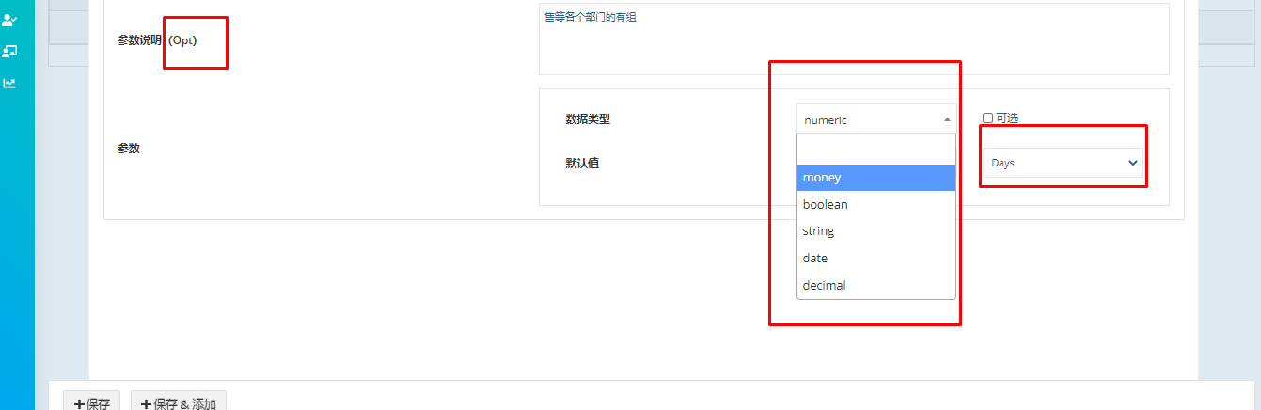

1. Failure category ???

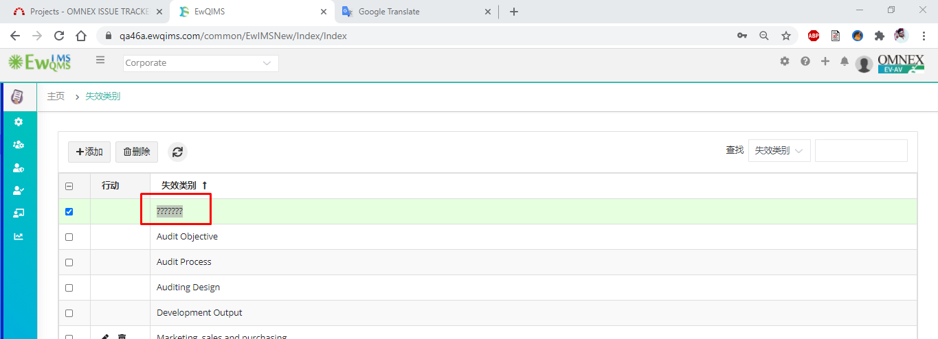

1. Excuse reason directly click on save does not display any validation

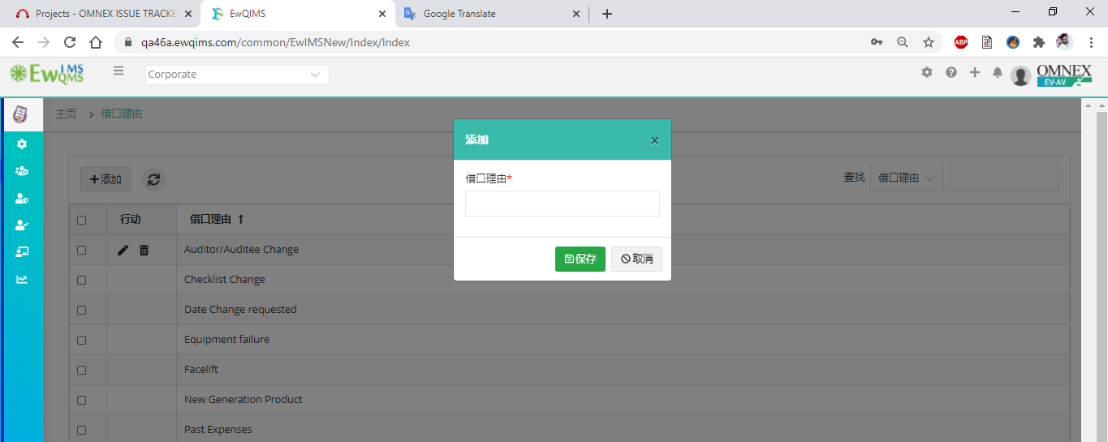

1. Approval route window labels

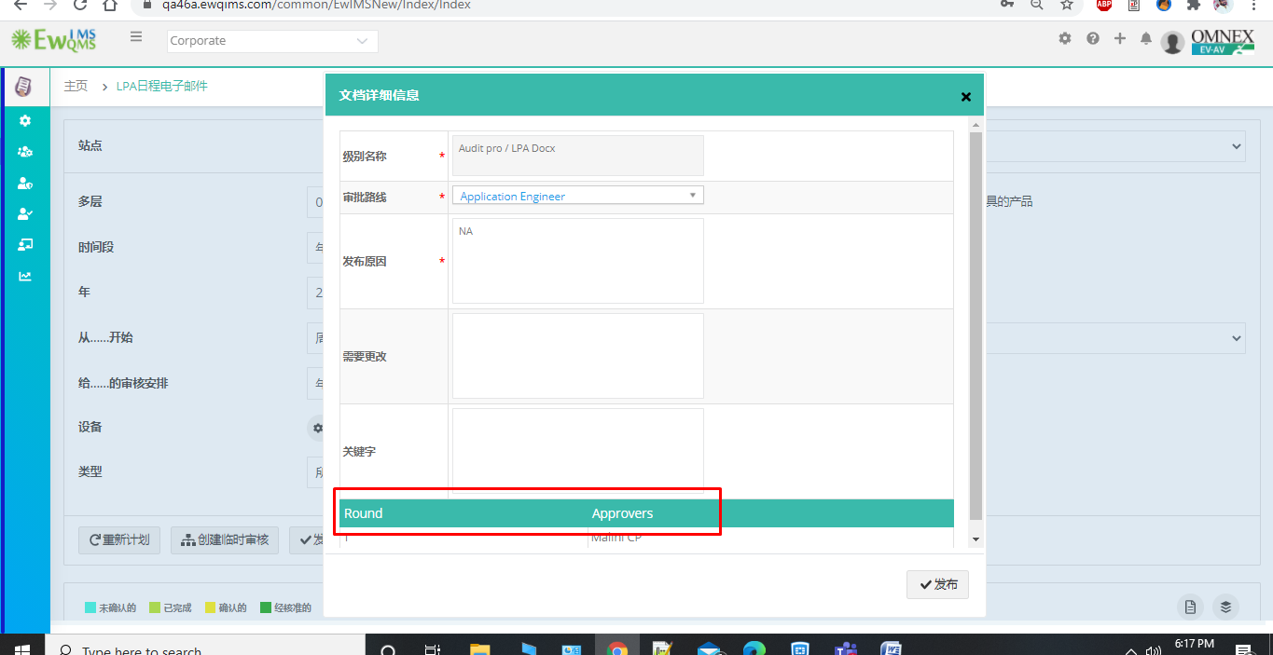

1. Audit result Bench mark label need to convert
2. Calendar label

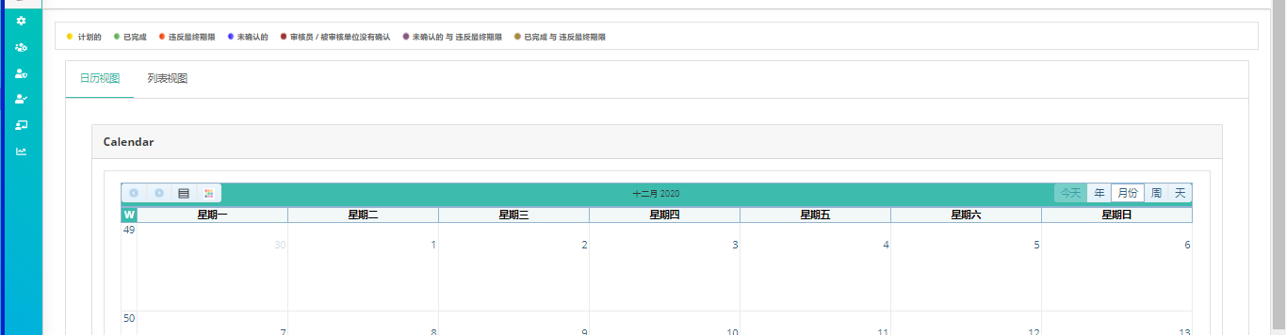

1. CA Closeout

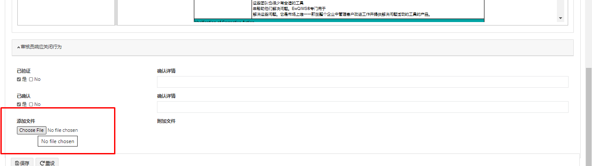

1. Audit plan validation

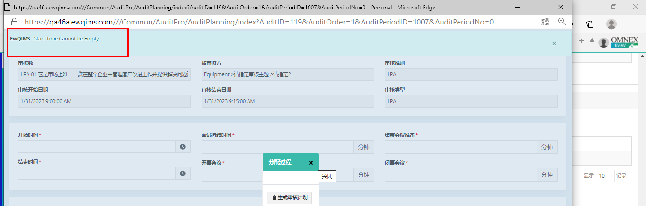

1. Layers page paginatation in Spanish language

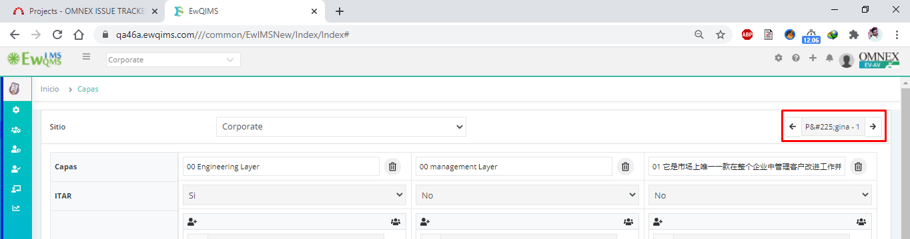

1. ITAR option difference in screens

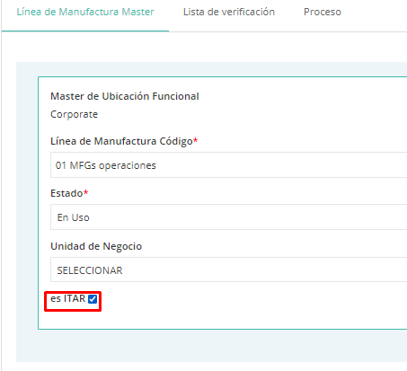

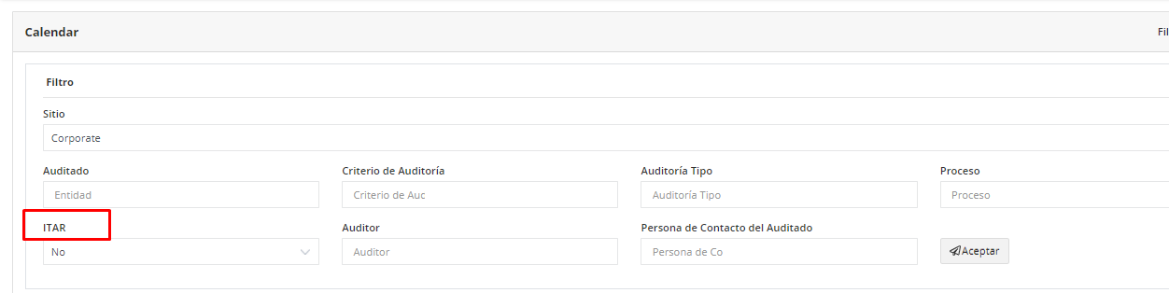

1. Validation Auditor and Auditee availability confirmation email displays in English

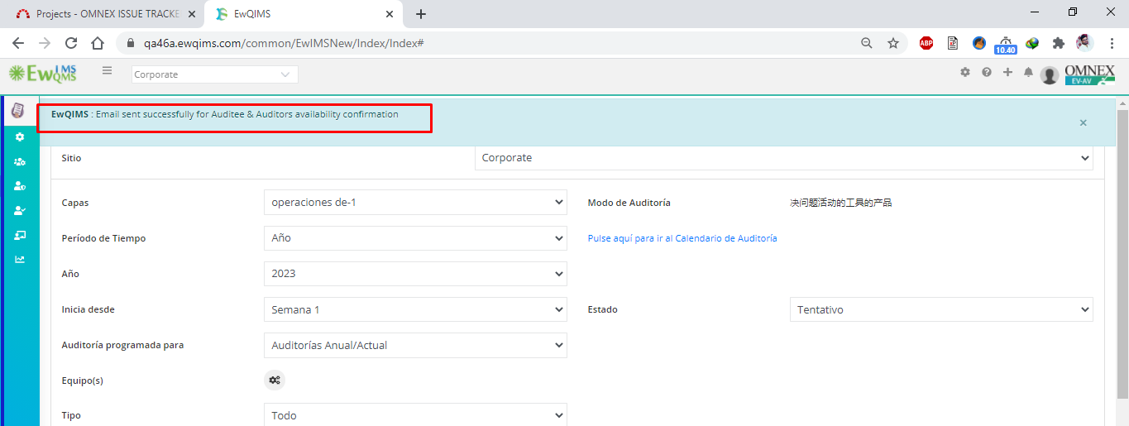

1. Audit assign notice to LA and Auditee contact person red color

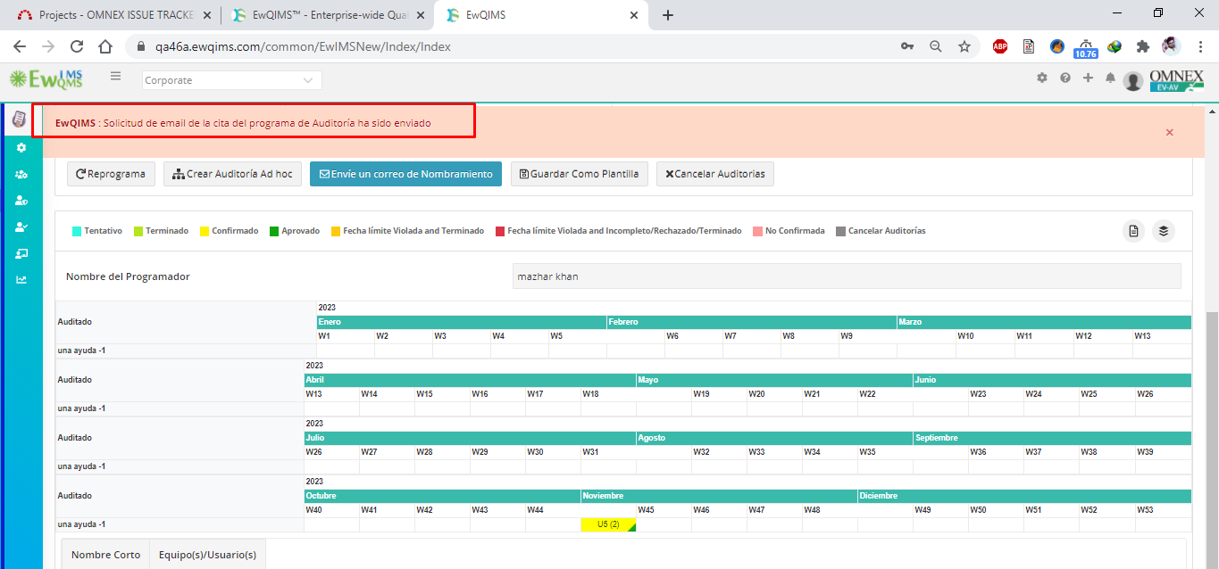

1. Validation when Correction and closeout is not specified validation label issue

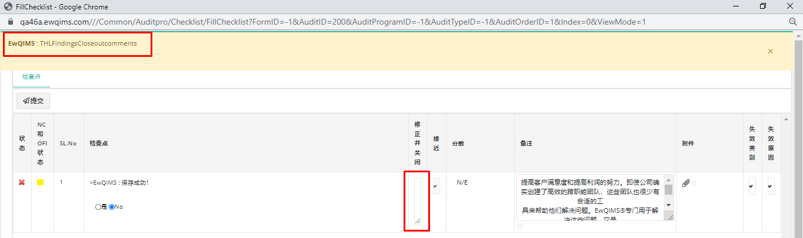

-----------------------------------------------------------End of Document--------------------------------------------------------