VDA Issues

1. Percentage Allocation - Size for Step numbers are too small

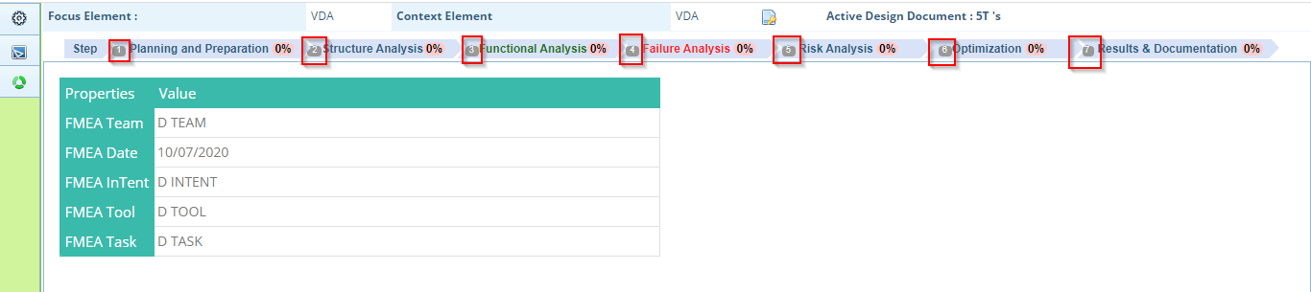

1. Percentage number is not aligned properly

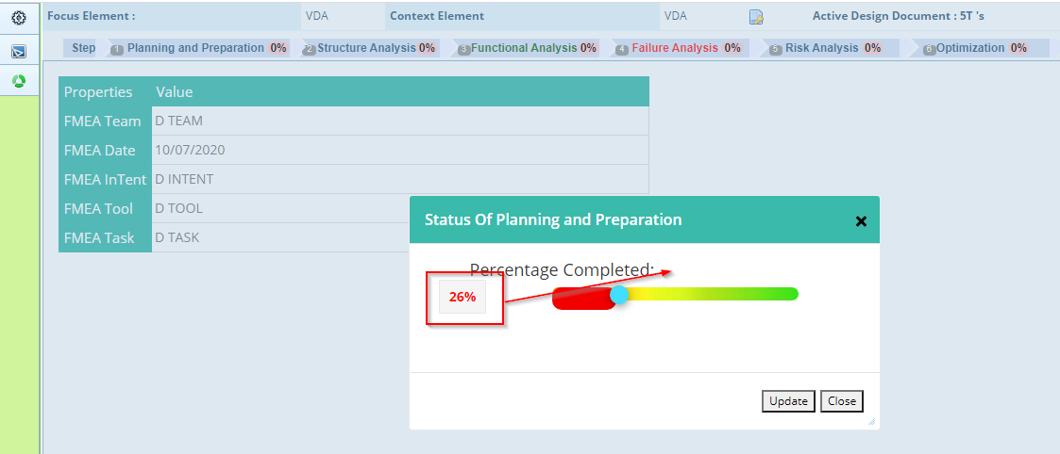

1. Alignment for header section is not good. Focus element and Context element are way part from the headers

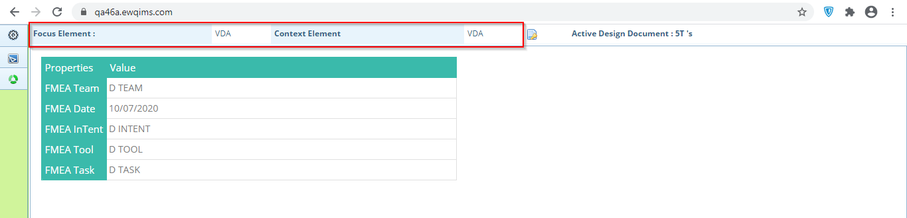

1. Close icon is not displayed in Copy/Move popup. It is shown only on Mouse hover

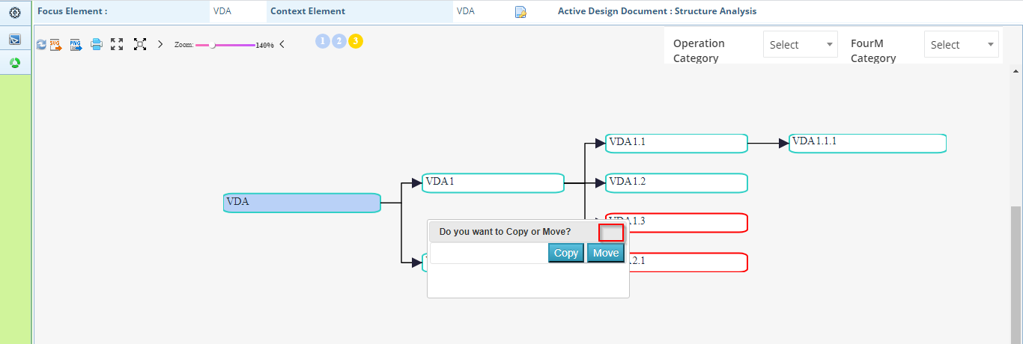

1. Design Structure Analysis – Show characteristics is not displayed properly.

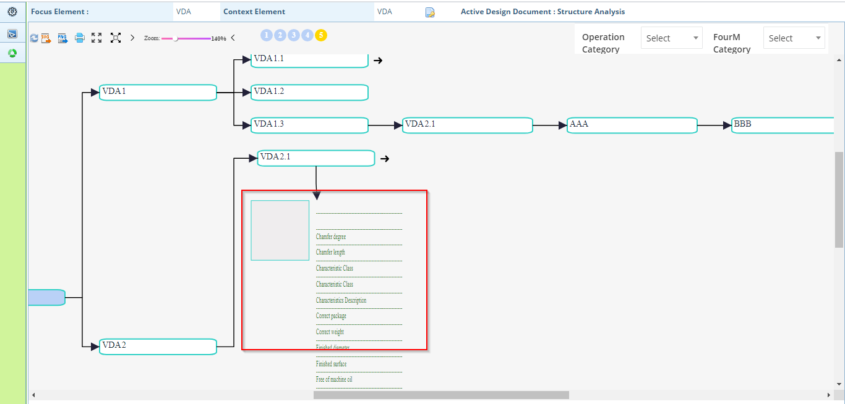

1. Delete confirmation for Exclude Element

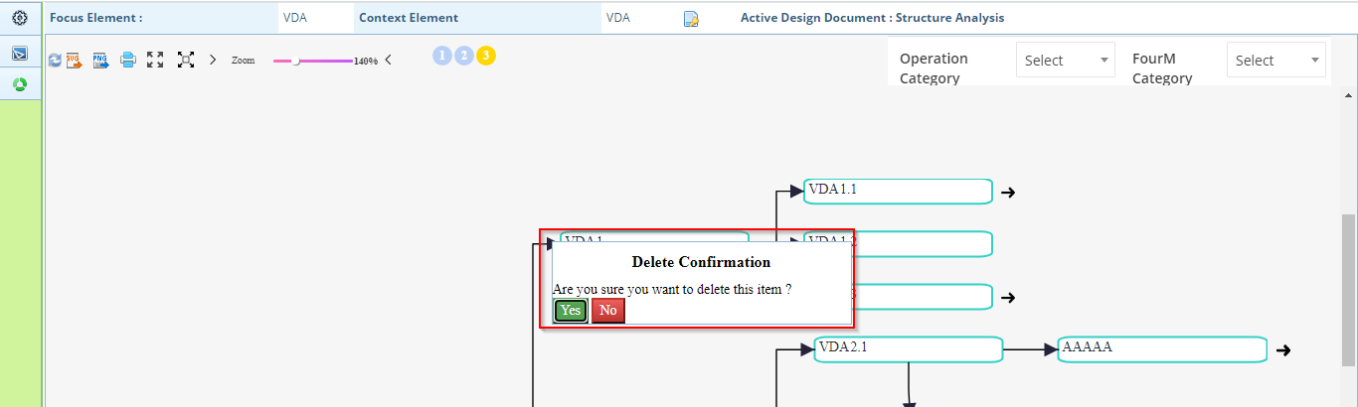

1. Edited PI name is reflected only after refresh
2. Open as SVG and PNG is not shown properly. It is hidden partially

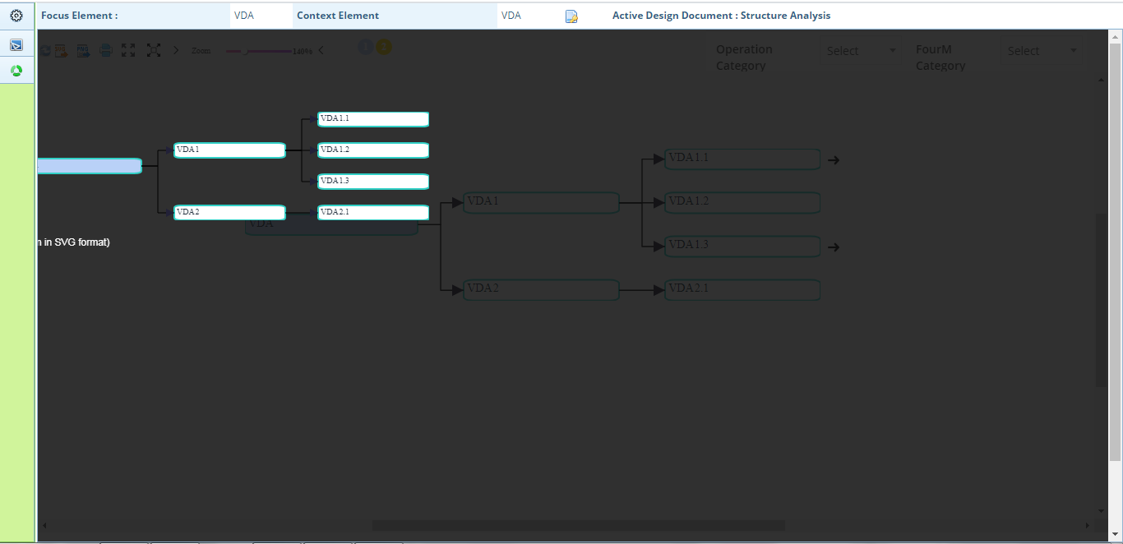

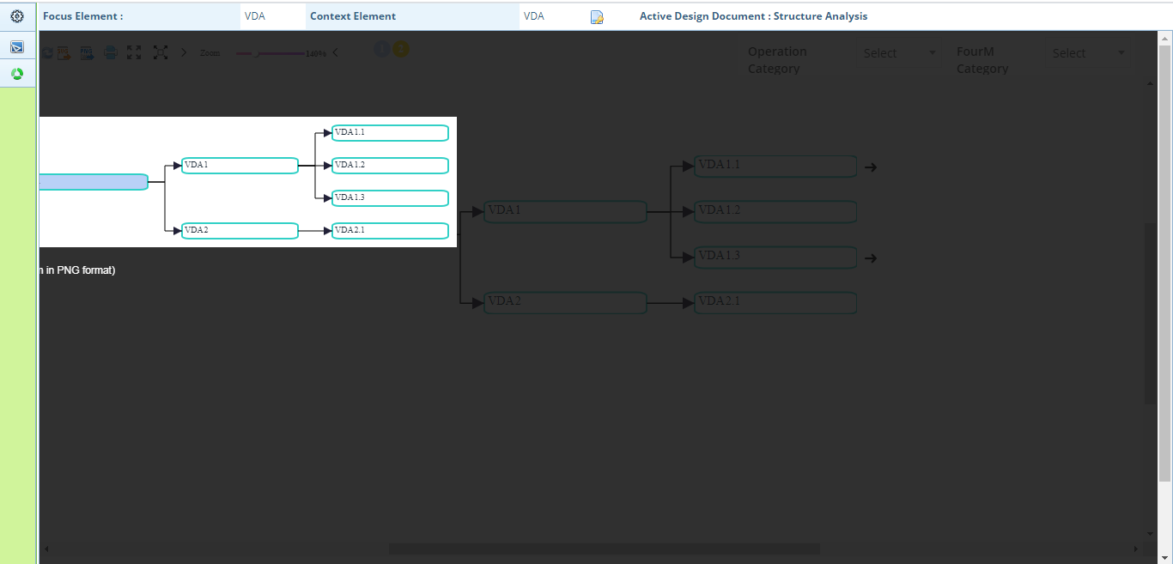

1. Unnecessary icon is shown in Add/Remove Elements popup which shows ? and ! symbols

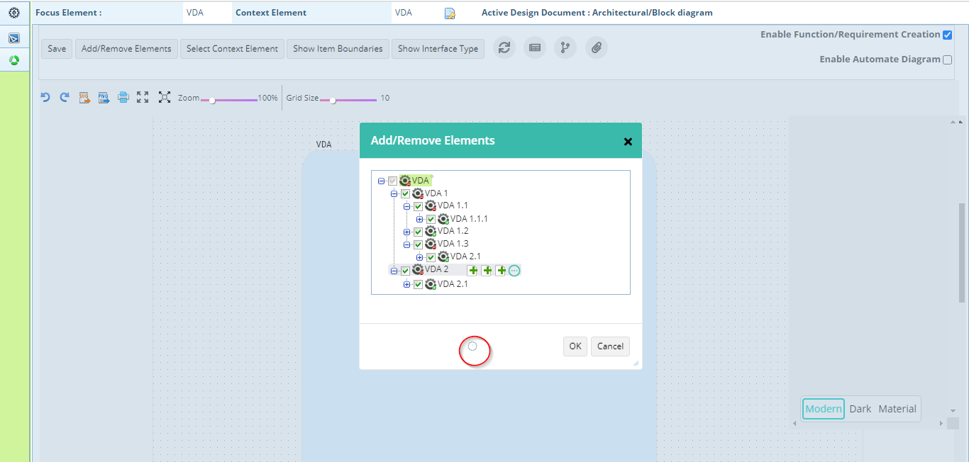

1. UI changes are not done in Comments popup. Also system does not respond on clicking OK button.

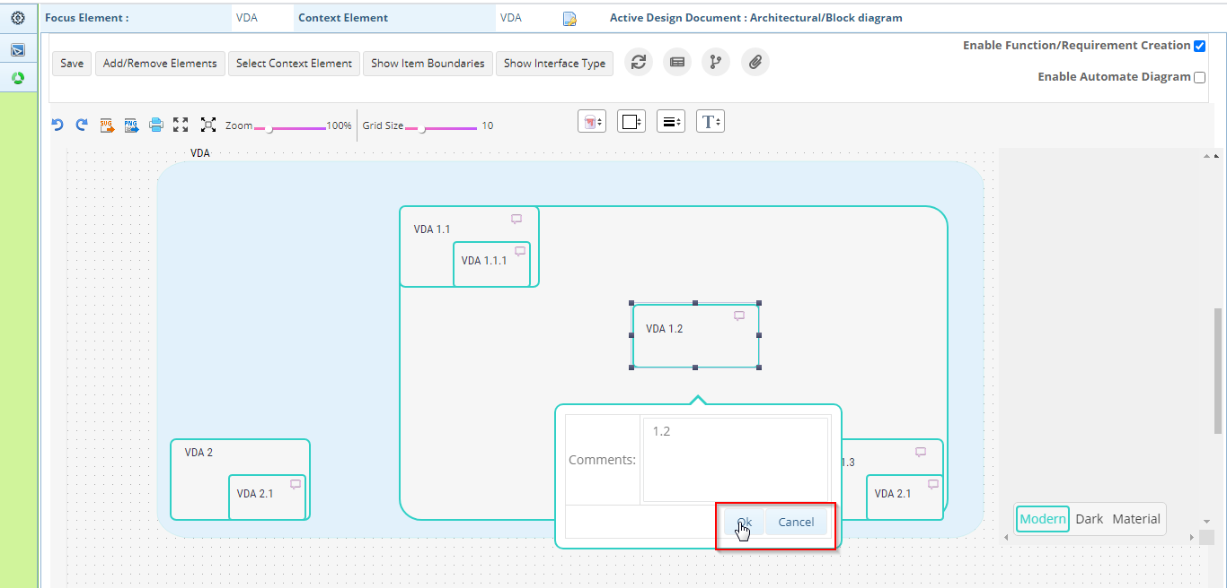

1. While clicking on these options (except more options), no response is made. This occurs in RHS also

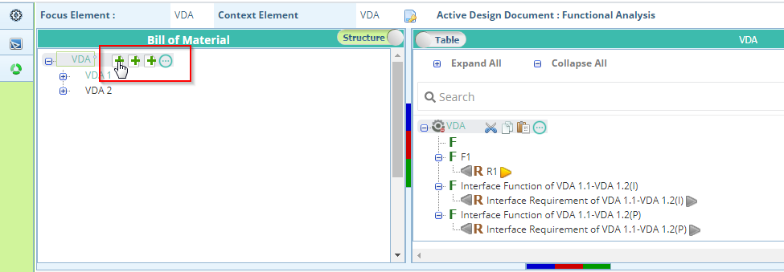

1. While opening Functional/failure analysis pages, these options are displayed by default and after clicking somewhere, it is going off.

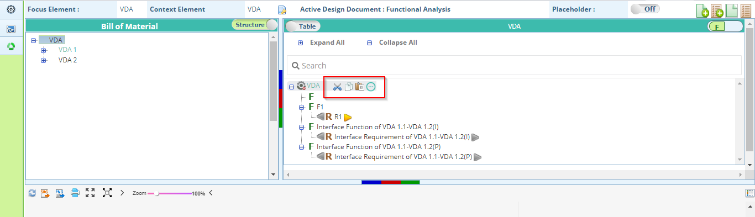

1. Saved Successfully for result & Documentation is not good.

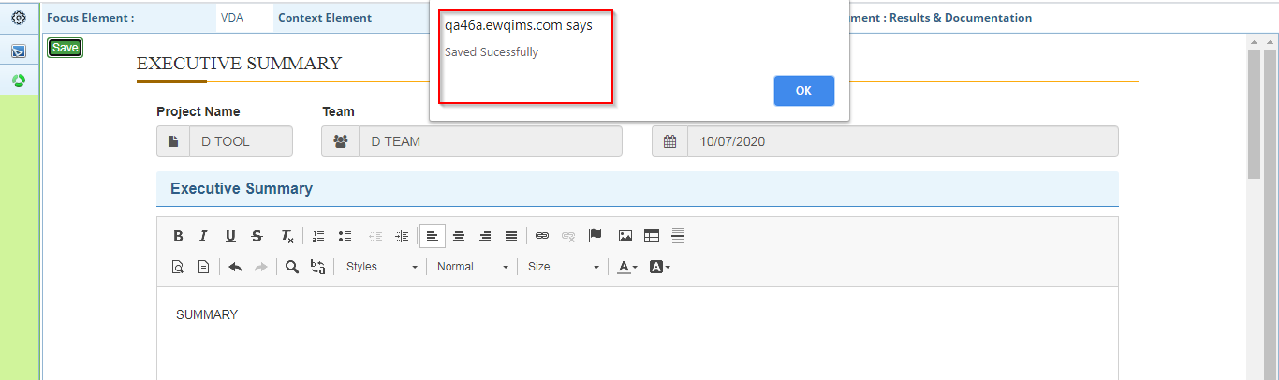

Process VDA:

1. Segment popup window displays Cut, Copy and paste options

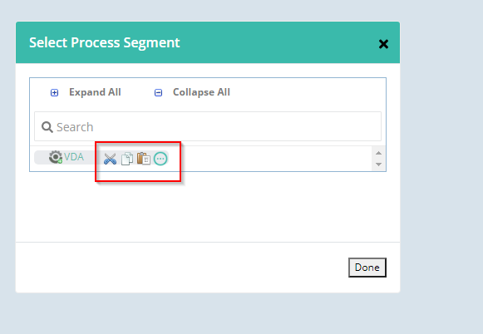

1. Process Structure Analysis – FourM can be added only after refresh
2. After Right Click on Operation, Icons are displayed at the bottom

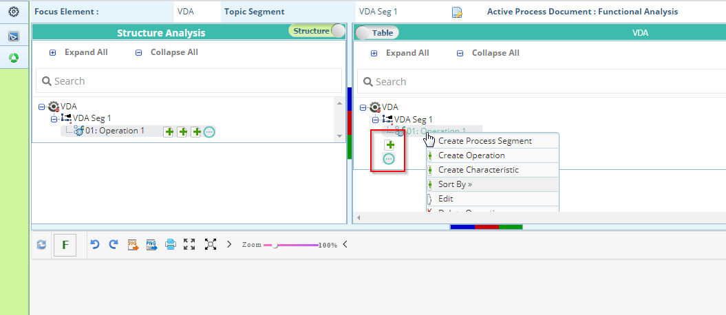

1. Delete Confirmation for all items are not good.

