**BOSS – CHINESE**

Common in all the pages

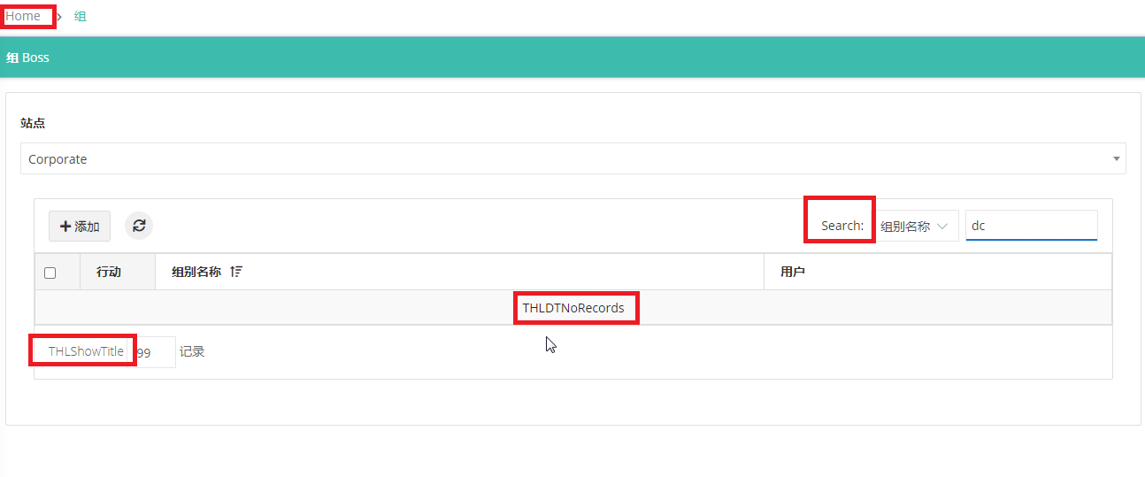

1. Boss menu in both Spanish and chinese

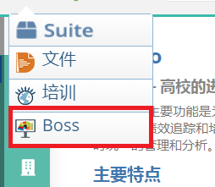

2.Boss setup menu in both Spanish and chinese

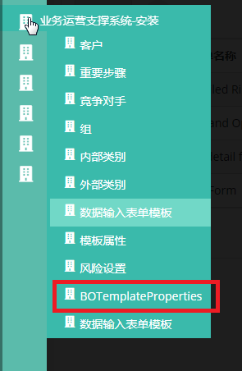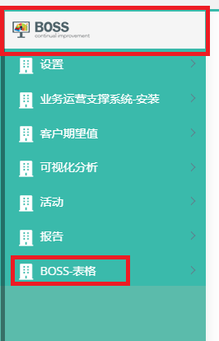

3.Groups page

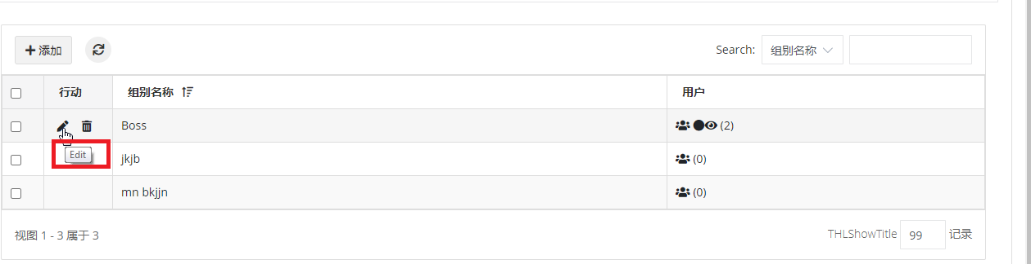

Alert sa

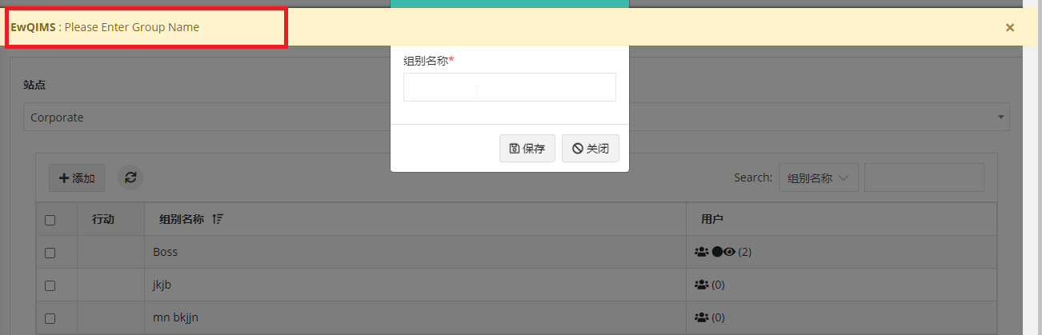

4.Business rule page – when click add and save, without enter data

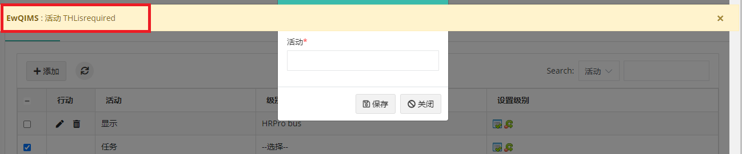

The added value in the business rule are not shown in the multilanguage. But in English language it is shown

Checkboxes are available for default data; it should not display it. But in English language it is not shown

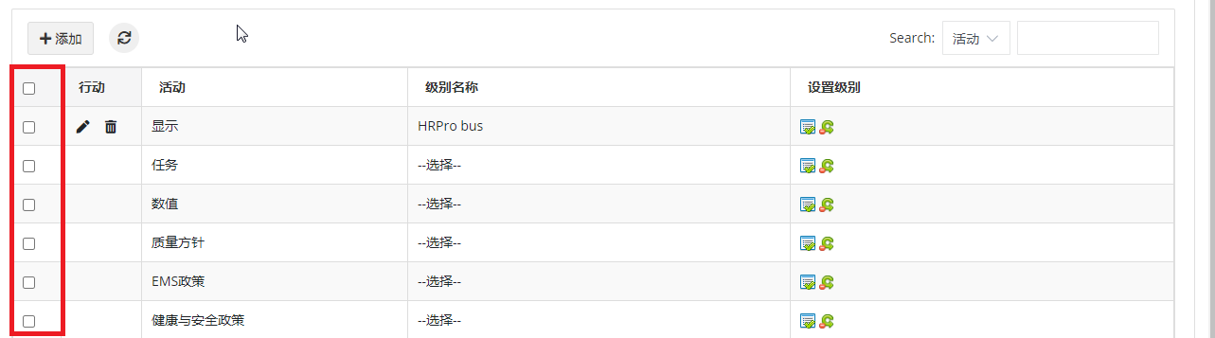

5. Other interested party – new button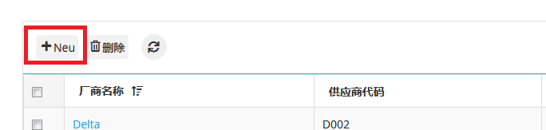

6.Other interested party - creation page

Other interested party/customer Email validation Alert

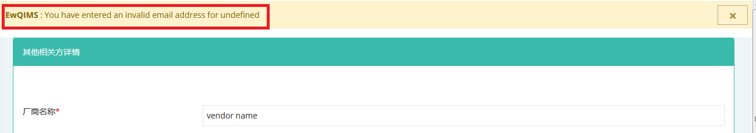

7.Other interested party/customer contact – add popup – email id alert

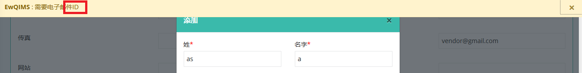

8. Other interested party contact – add popup – dropdown

Drop down is same in the customer page

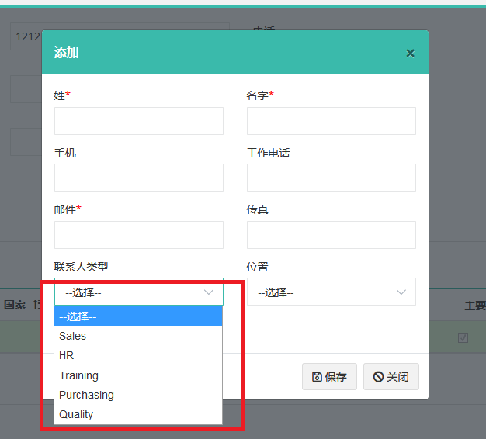

9.Customize email messages

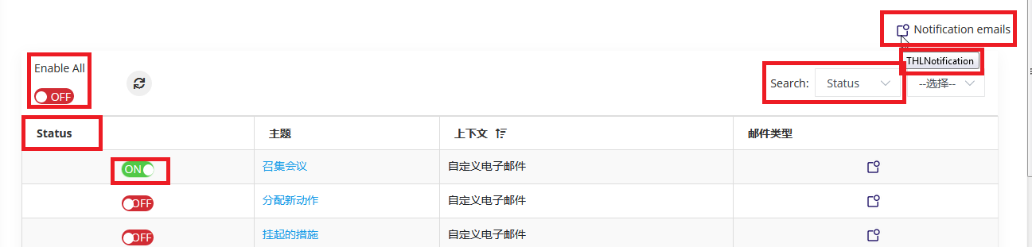

10.Supplier page

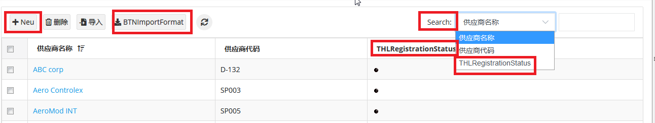

11. Supplier creation page

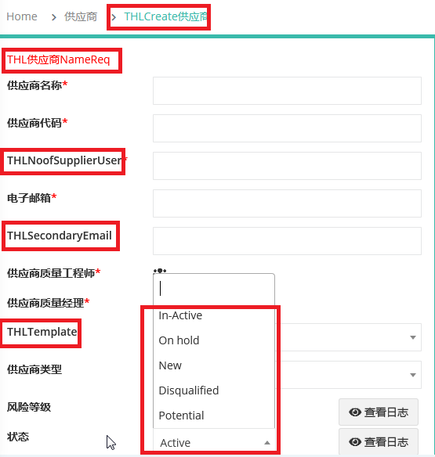

12.Supplier code alert

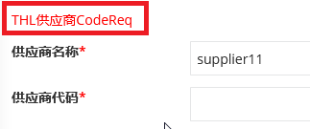

13.Supplier page - No of supplier alert, email alert, secondary email alert, sqi engineer alert,

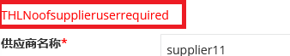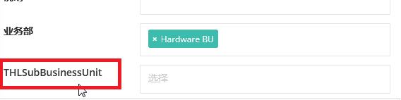

14.Customer page

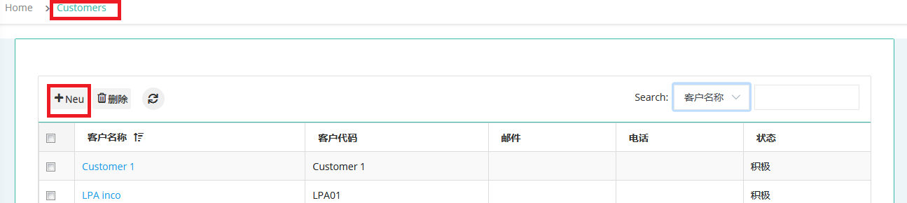

15.Customer add parts label, add contact page and popup

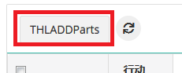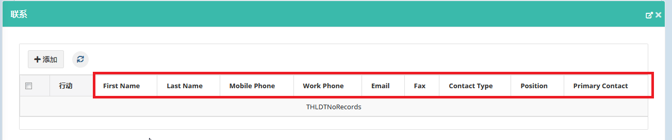

16.Save, delete alert in add contact

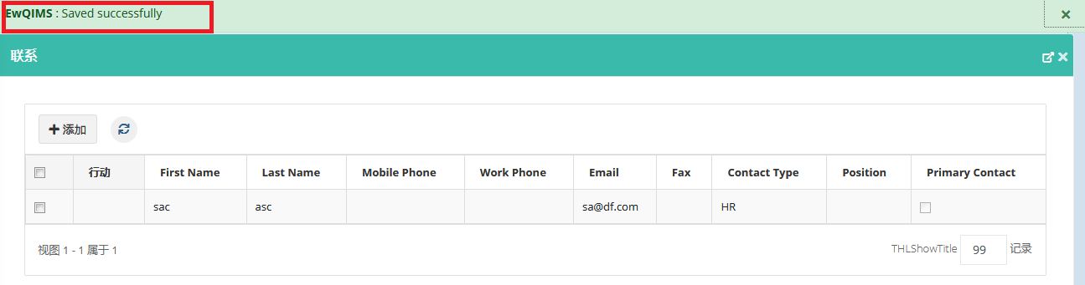

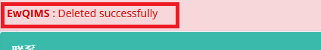

17.Key process – when click copy to other process scope, please select rows alert



Copy to other process scope page

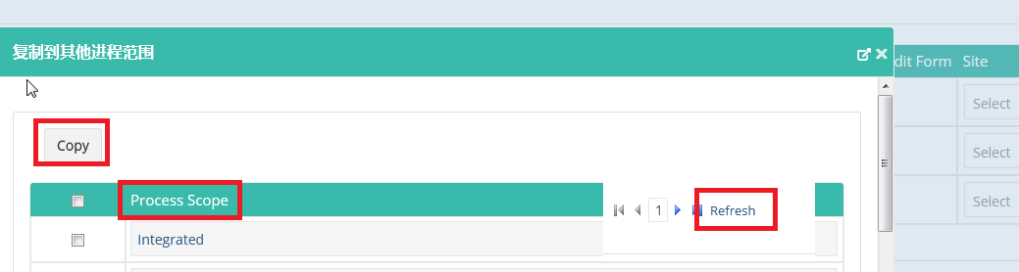

18.Competitor - competitor is req alert

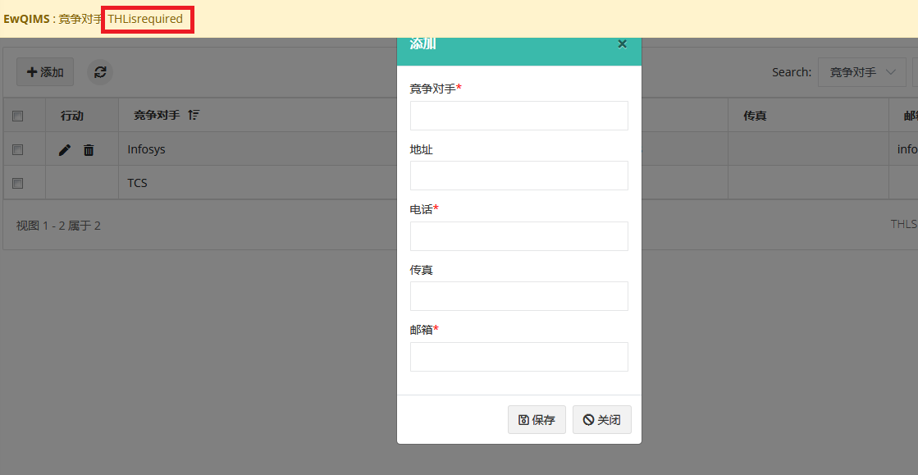

19.Teams page,

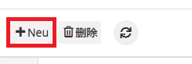

20. Teams page – external member delete.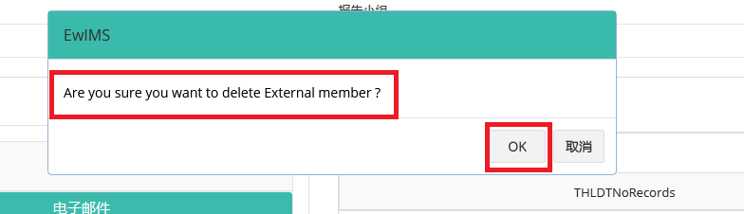

21.Teams page – valid email alert



22. Template

When click label not found, it takes to next page, when comeback to this main page, label not found is changed to view

Not converted to Chinese

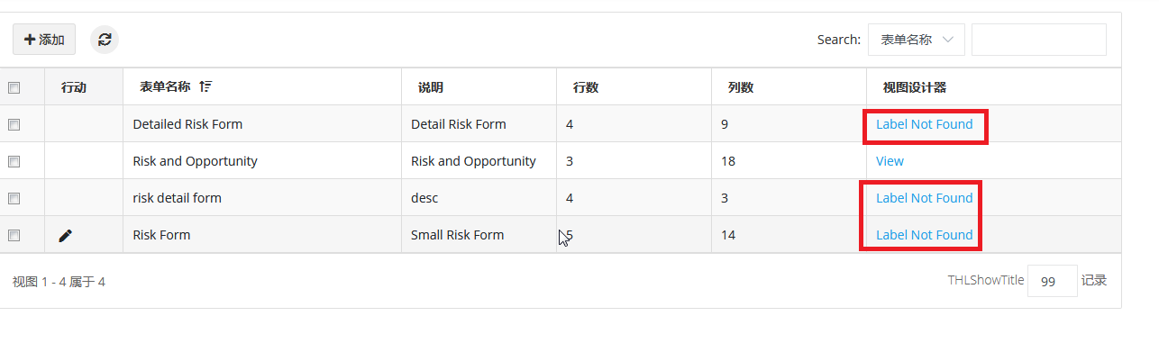

Form name req, description req, no of rows, no of column req, you can enter only number for No of Row also same for column alert

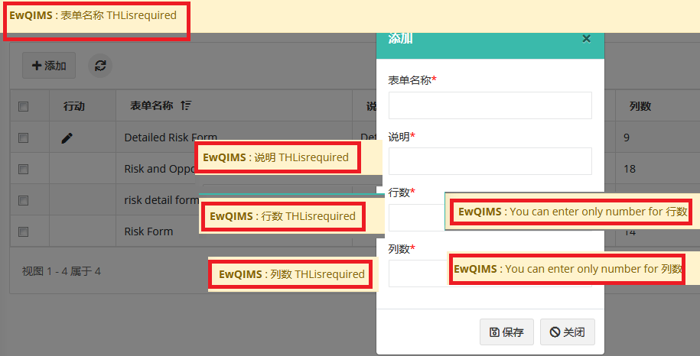

23.Template - save alert – empty



24.Template properties

Class name req, spec char alert

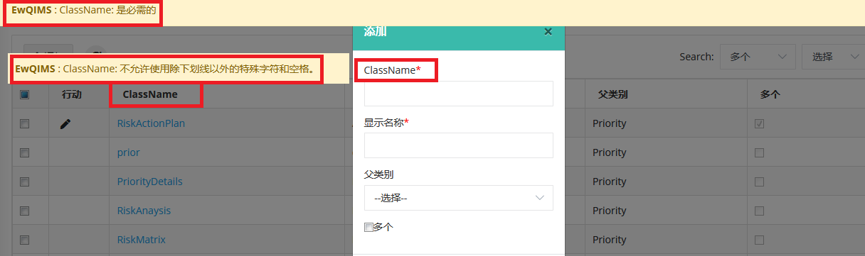

Click on class name and add it

Alerts not converted, save alert is empty

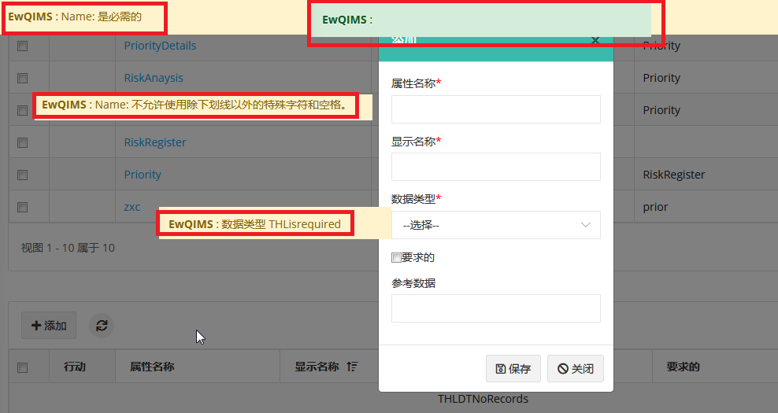

25.Risk setup

In all the menus, the validation alert includes “THLisrequired”

Risk category, risk failure mode – select category text in english

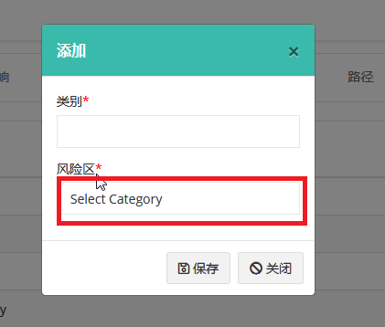

Priority score page – you can enter only number for is not converted – start, end range\

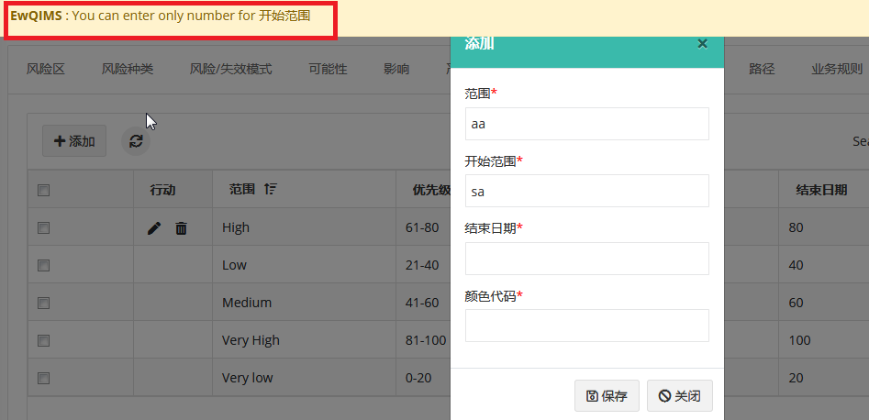

Priority score calculation – alert not converted

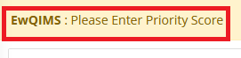

26.Data entry form template

Click on form name

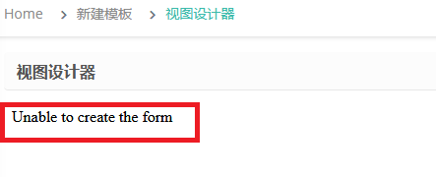

Add popup – alerts not handled

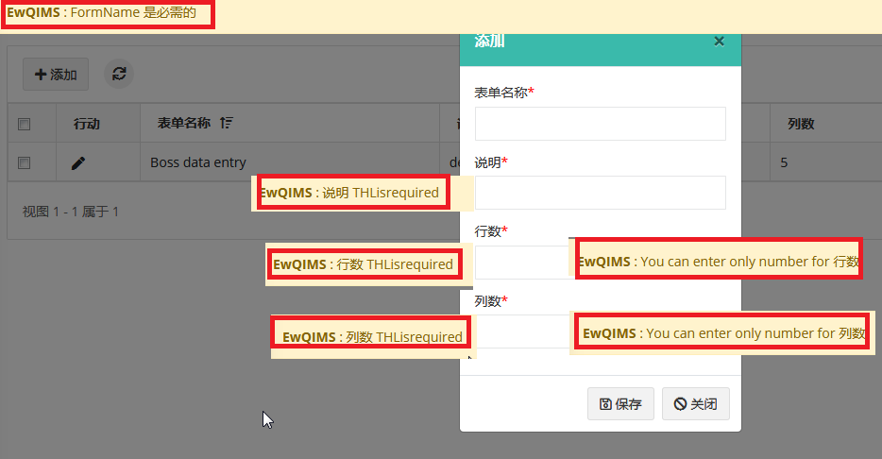

27. Interested party expectations – when delete it shows undefined. But deleted



28.Context page

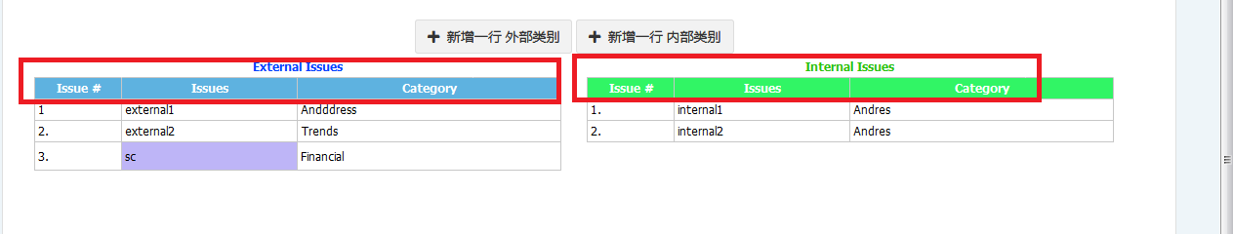

29. Visual analysis – KPI page

Alert not converted

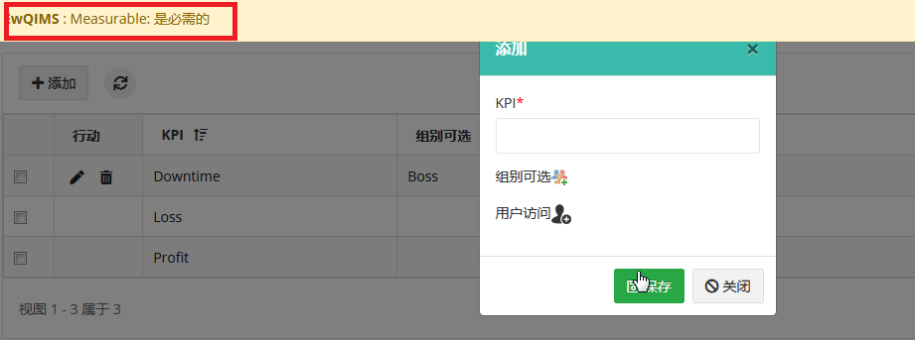

30.Improvement proposal page

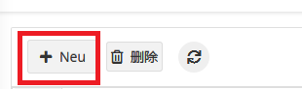

Proposal type dropdown in creation page

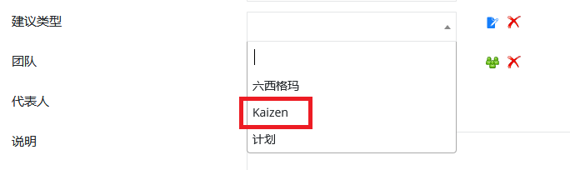

31.Proposal rating page

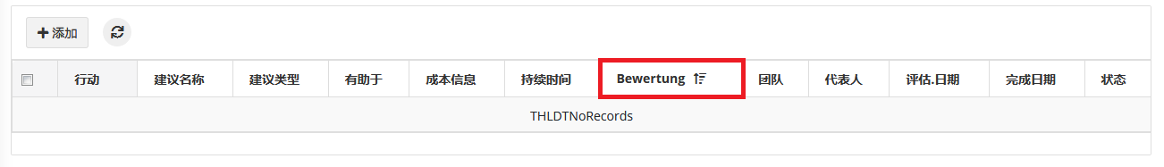

**SPANISH**

3.Groups page

Edit – tooltip not converted

Please enter group name alert – in English

Refer screenshot in the Chinese language

4.Business rule page – When click add and save, alert not converted”THLis required". Refer screenshot in chinese language as per the number

The added value in the business rule are not shown in the multilanguage. But in English language it is shown

Checkboxes are available for default data; it should not display it. But in English language it is not shown

5. Other interested party – vendor code required alert

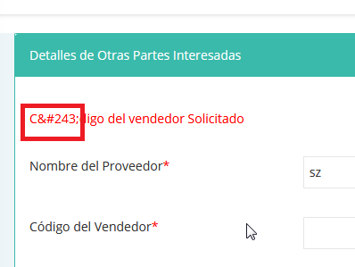

6.Other interested party creation page – email alert - “You have entered an invalid email address for undefined” show in English

Refer image in Chinese language 6

8. Other interested party/customer contact – add popup – dropdown

Refer screenshot in Chinese 8

9.Customize email messages - refer screenshot in Chinese 10

Same issue in common

10.Supplier page – except new button all the issue in common. Refer screenshot in Chinese 10

11. Supplier creation page – same THL issue is there. Refer screenshot in Chinese 11

12.Supplier code alert. Refer screen shot in Chinese 11. Same issue in common.

13.Supplier page - No of supplier alert, email alert, secondary email alert, sqi engineer alert, - Refer screen shot in Chinese 11. Same issue in common.

14.Customer add parts label

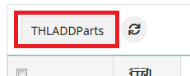

18.Competitor - competitor is req alert

Refer screenshot of Chinese in 18

22. Template

When click label not found, it takes to next page, when comeback to this main page, label not found is changed to view

Not converted to Spanish. Refer screenshot in Chinese 22