1. Entity Save validation Blue ribbon

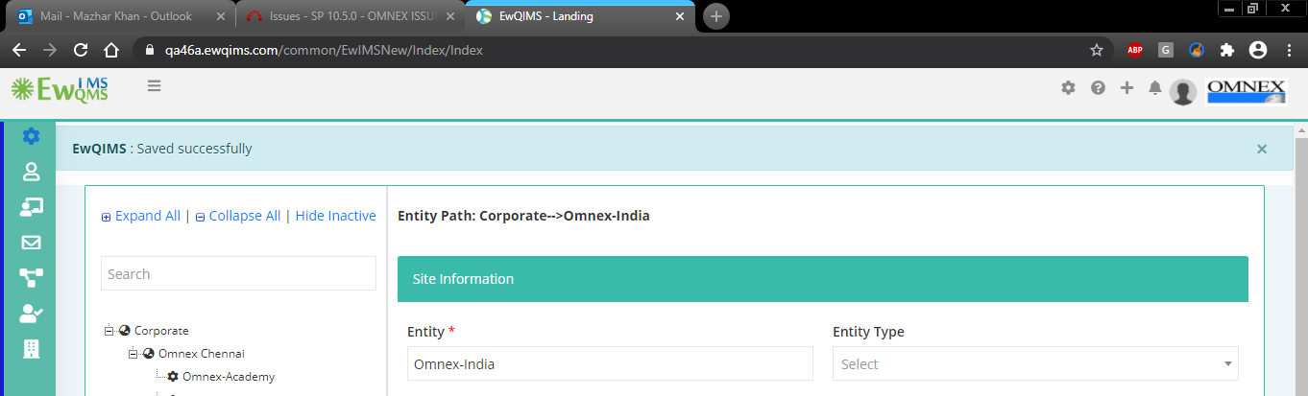

1. Entity Type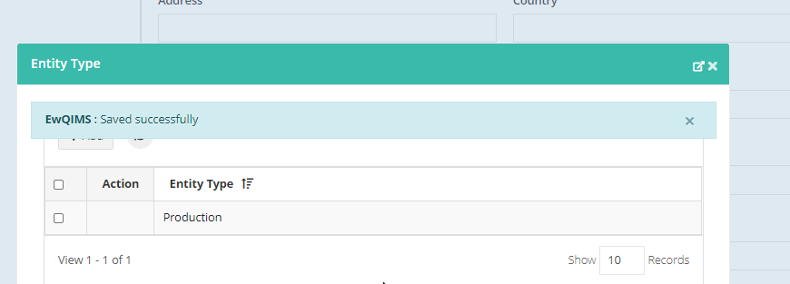
2. Entity type Delete

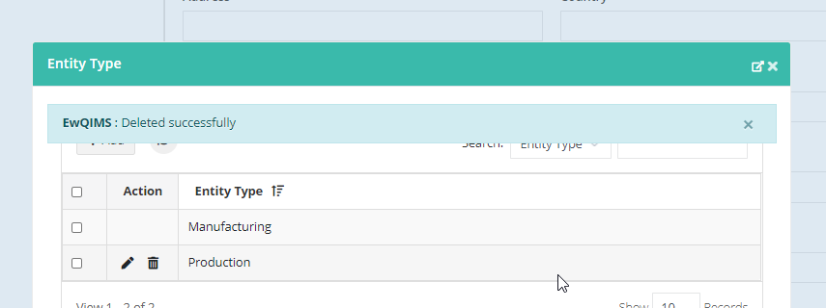

1. Business Unit and Site Function area also displays same validation color
2. Entity Owner save

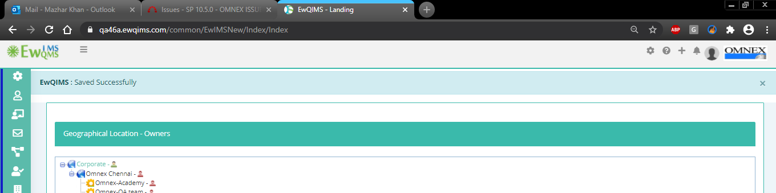

1. Administrator settings

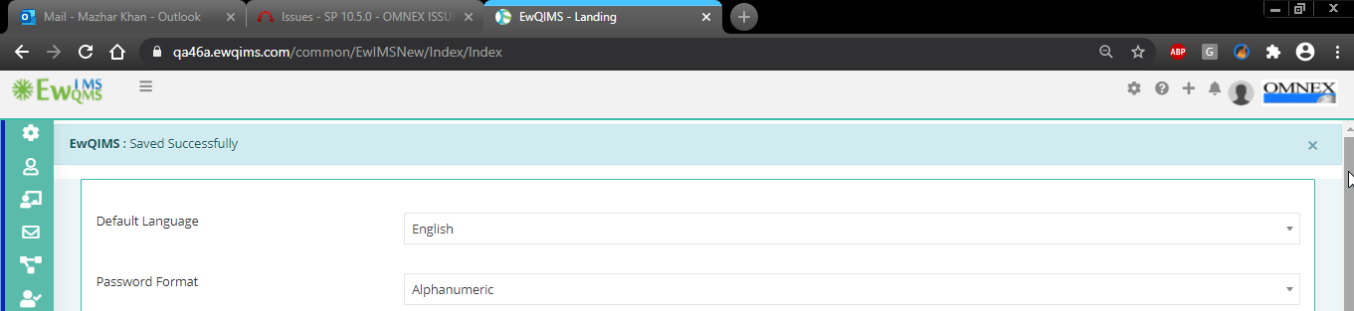

1. Create Department

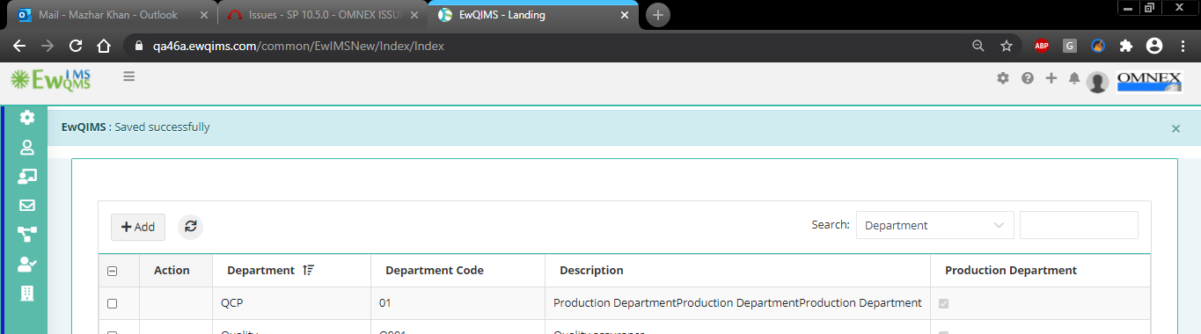

1. Department Delete

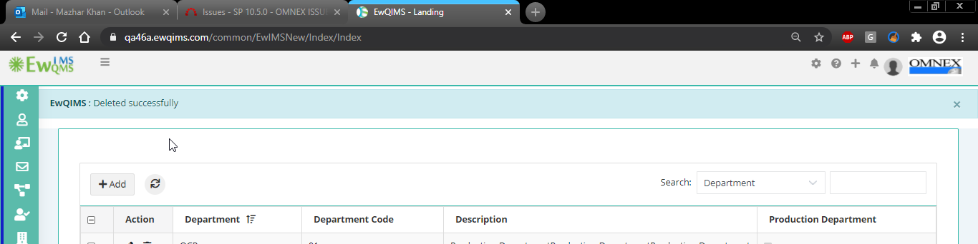

1. Updated Successfully

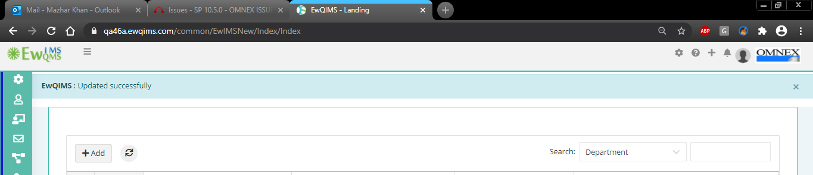

1. Assign dept contact person remove validation

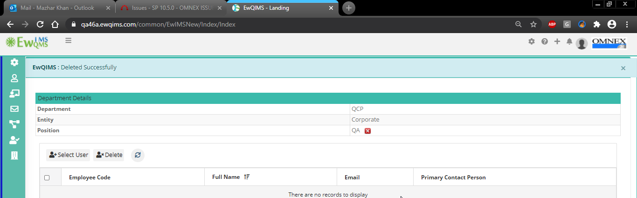

1. Document management

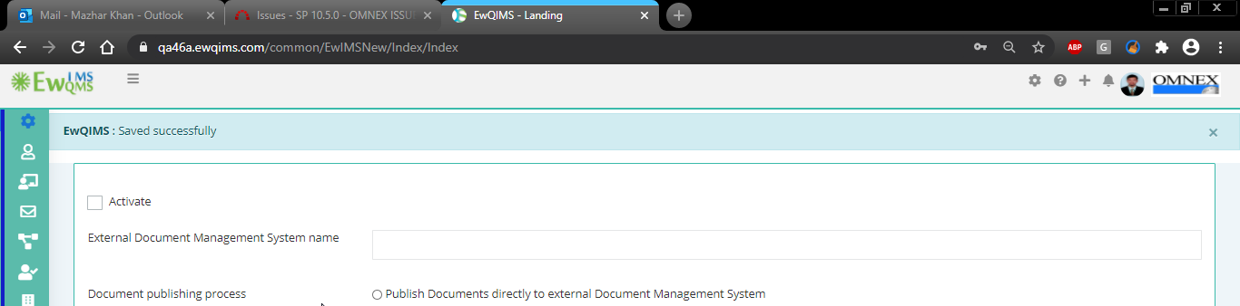

1. Widget setting

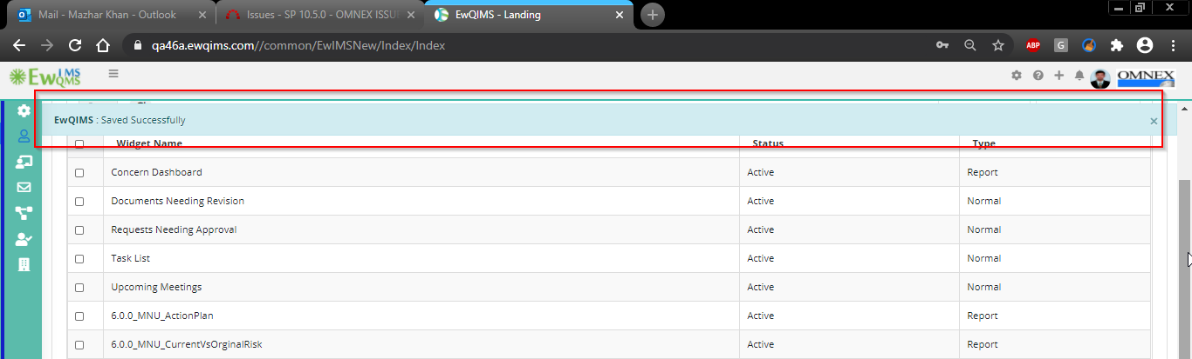

1. Widget settings

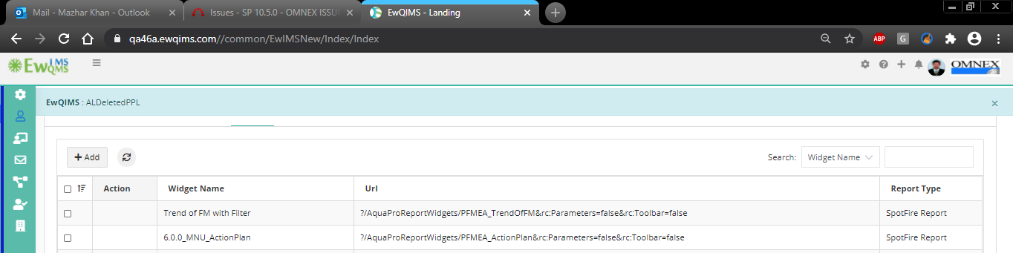

1. Organization profile

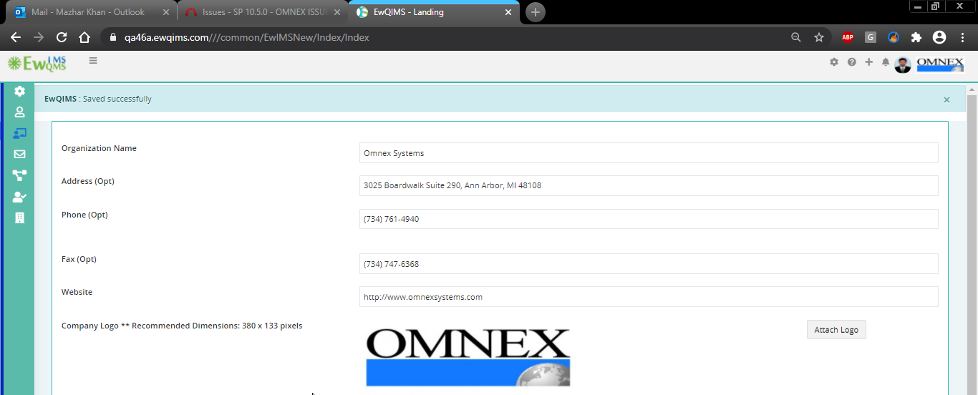

1. Holidays list Delete validation

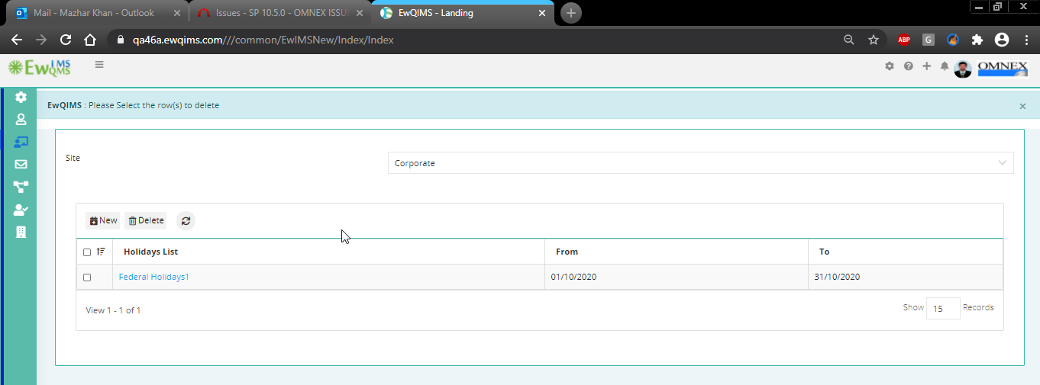

1. Deleting Shift validation

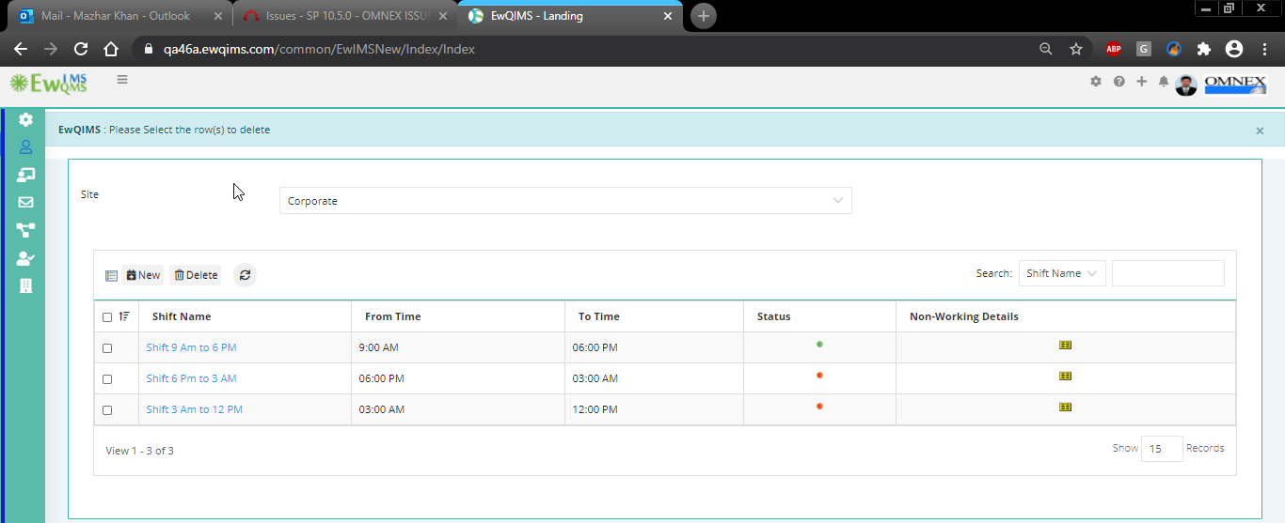

1. Shift Deleted successfully validation

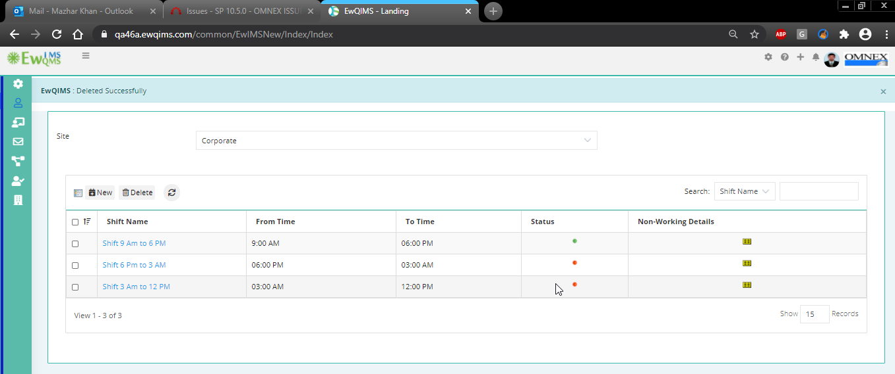

1. Select position to delete displays red ribbon

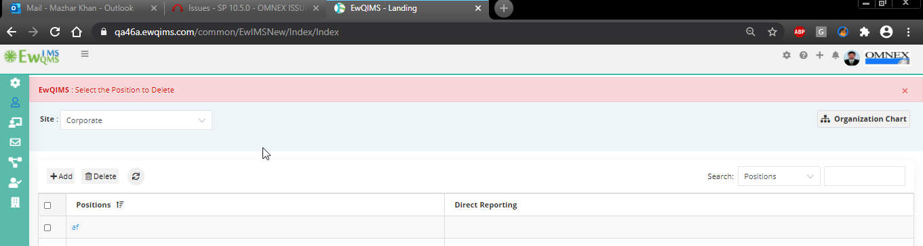

1. Without entering position/Description validation ribbon

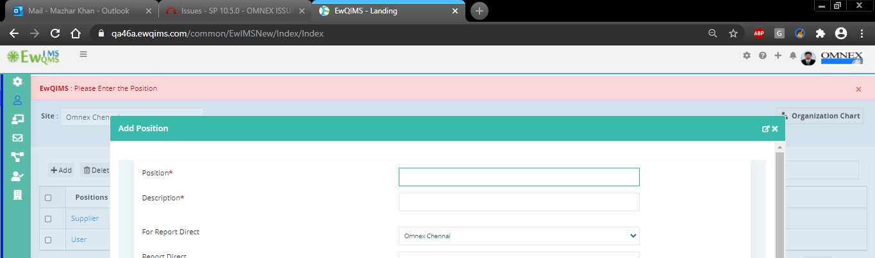

1. Assign route on delete displays warning this is information and later on select warning to be displayed

