**HRPRO – Chinese**

**Common issue – All search text, THL show title, THL no records found, Edit title in popup, Home in breadcrumb**

1.Groups page

Delete confirm alert

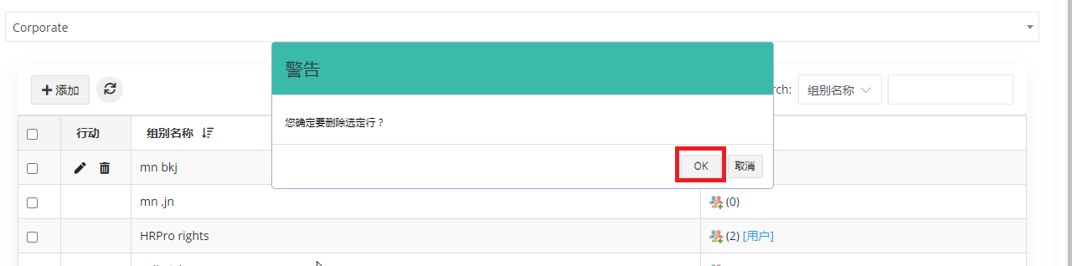

Groups select user’s page and save alert not showing any message

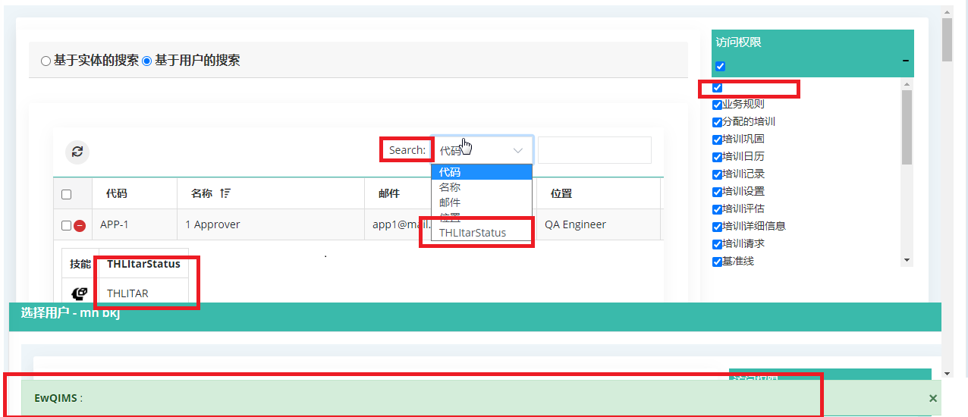

Edit group

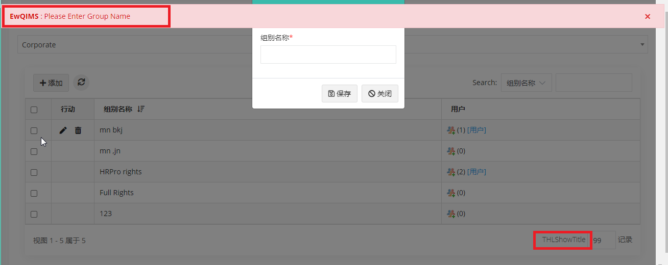

2.Users page

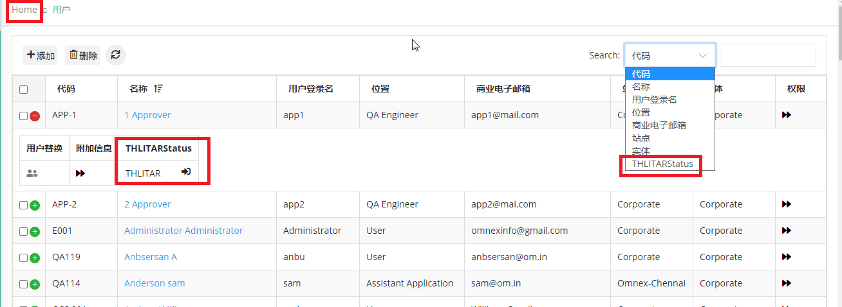

New user creation page – having opt field

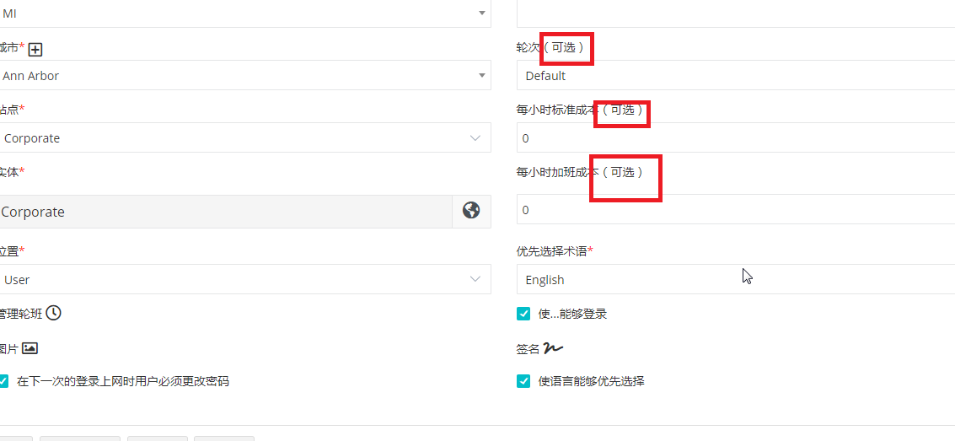

3.Positions page

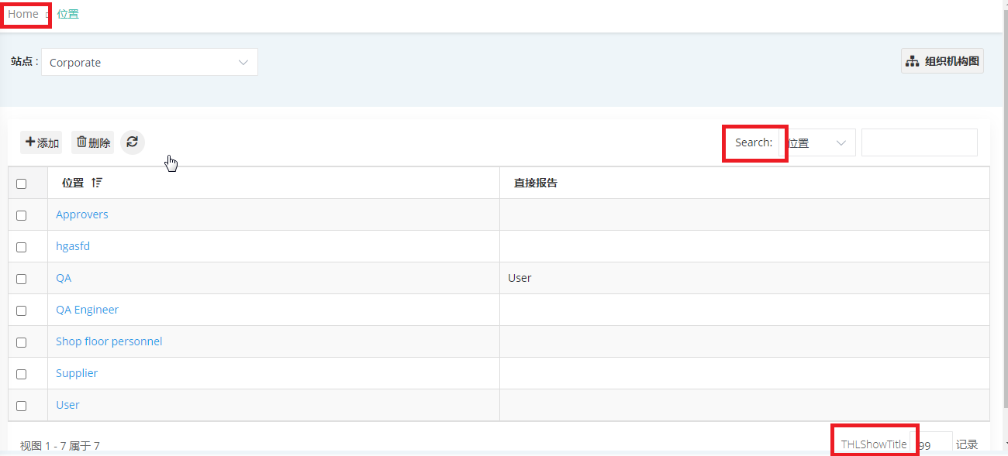

4.Customize email messages – not showing any mails and the show record in left side instead of right side

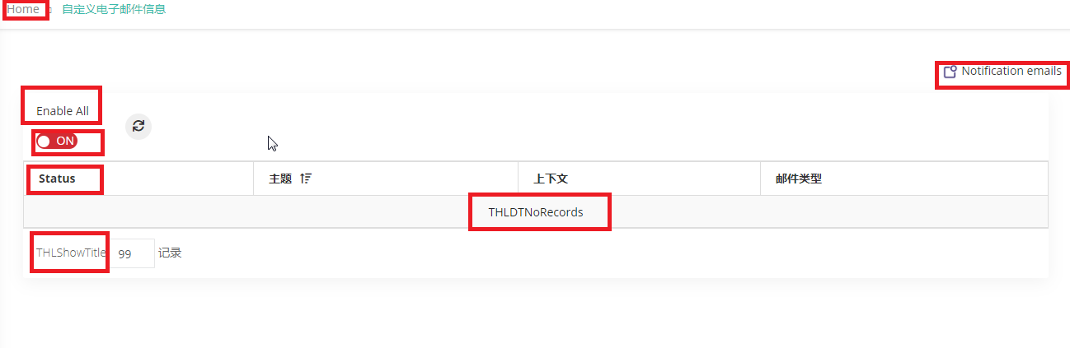

5.Route - add page

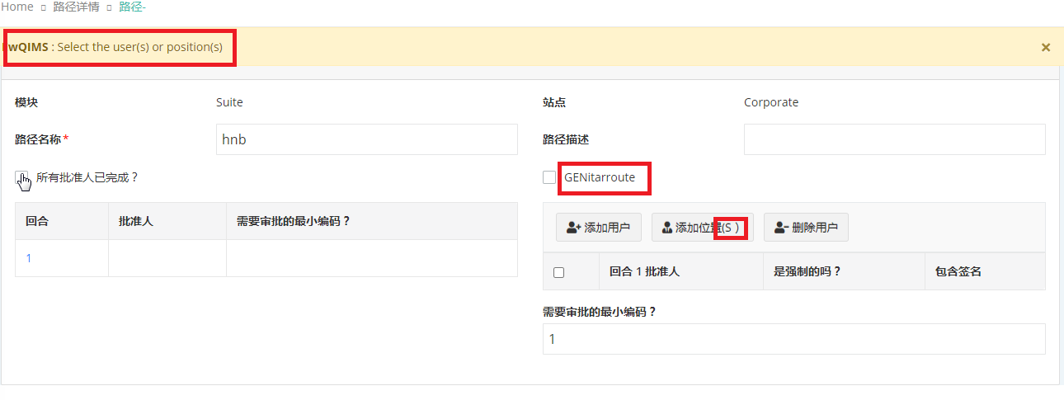

6.Shop floor personnel page

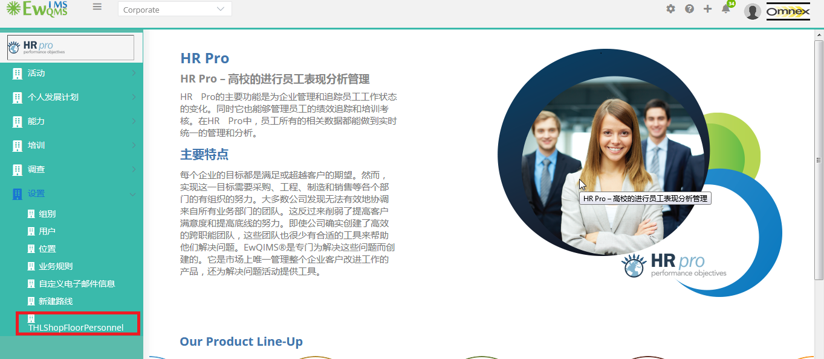

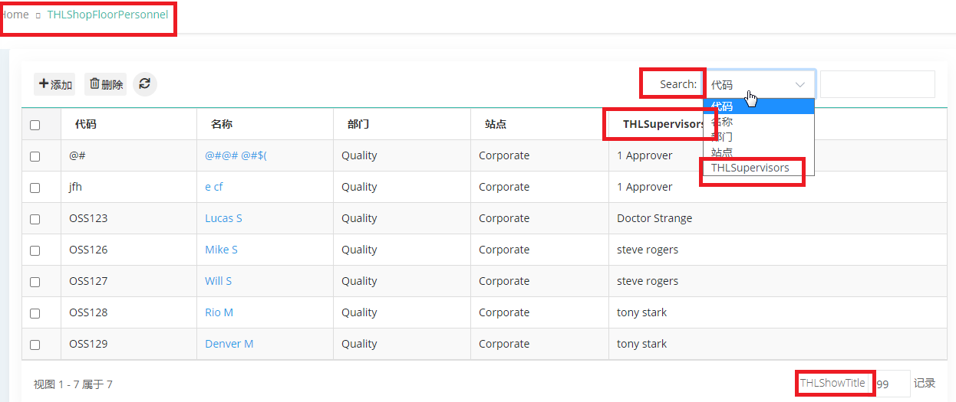

While click delete – alert not converted



Creation page

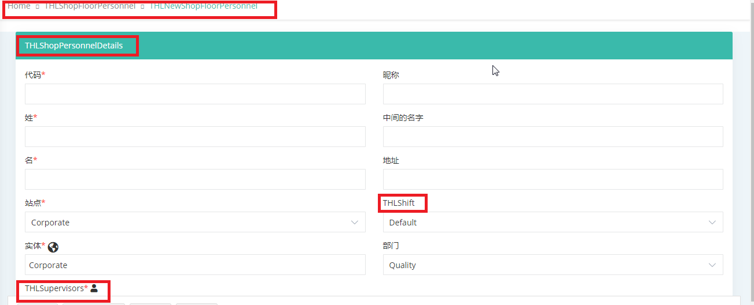

Alert



Add supervisor page

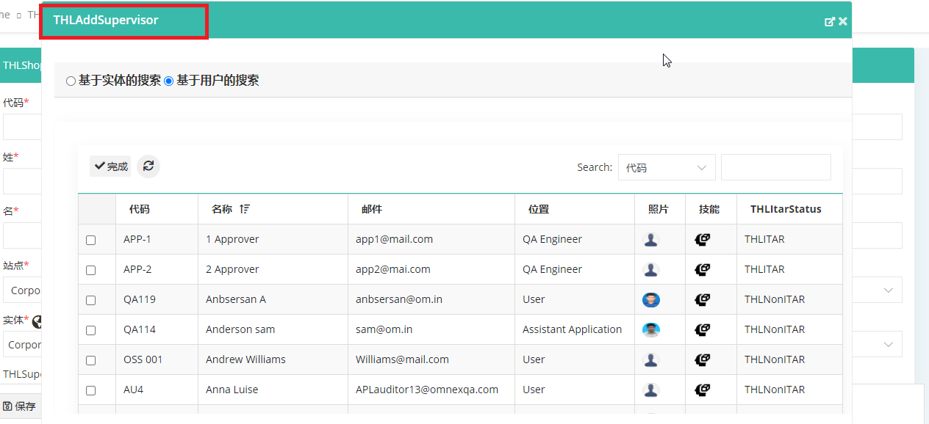

7.Survey page

Rating –without enter any data, enter only rating desc and save,

Delete confirm alert – OK button not changed

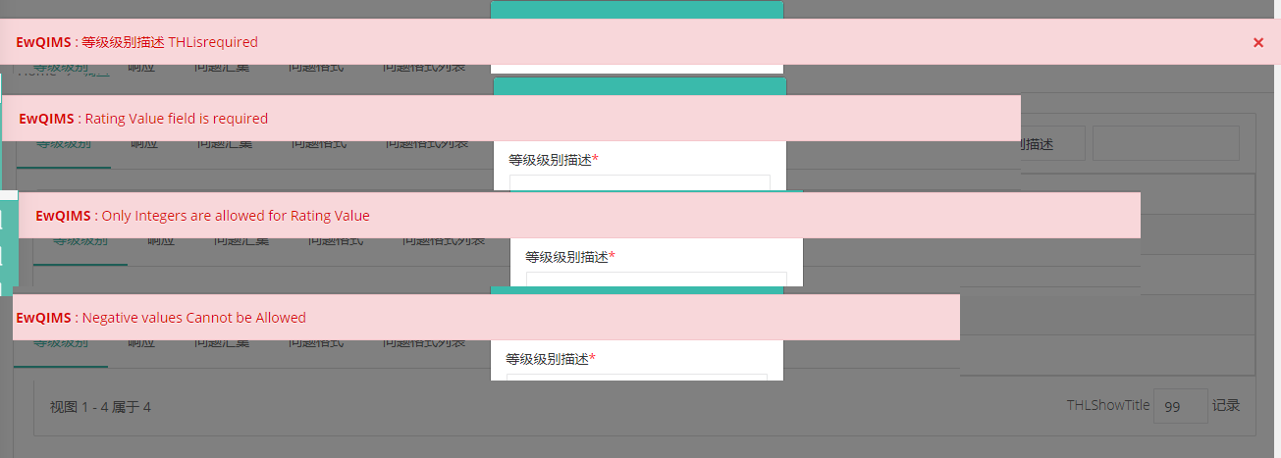

Response page

Question pool – Without enter any data, select category alert

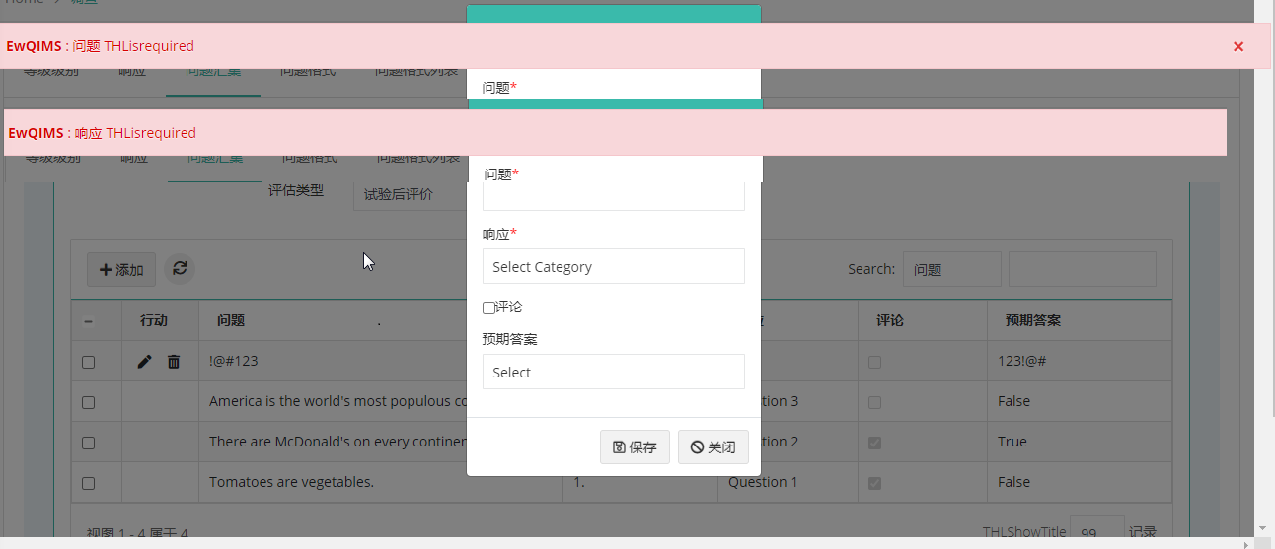

Question format – questionnaire page

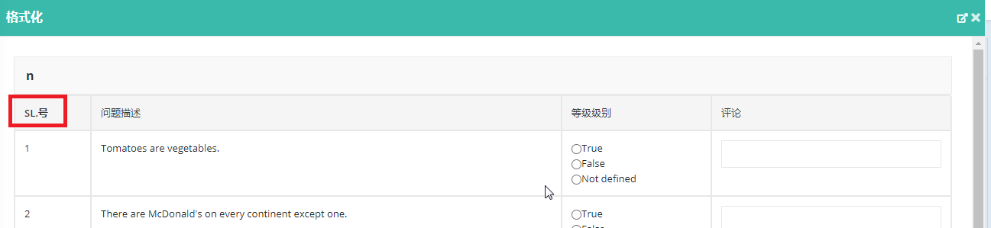

8.Training

Training setup – training series page – add popup – without any data click save, status required alert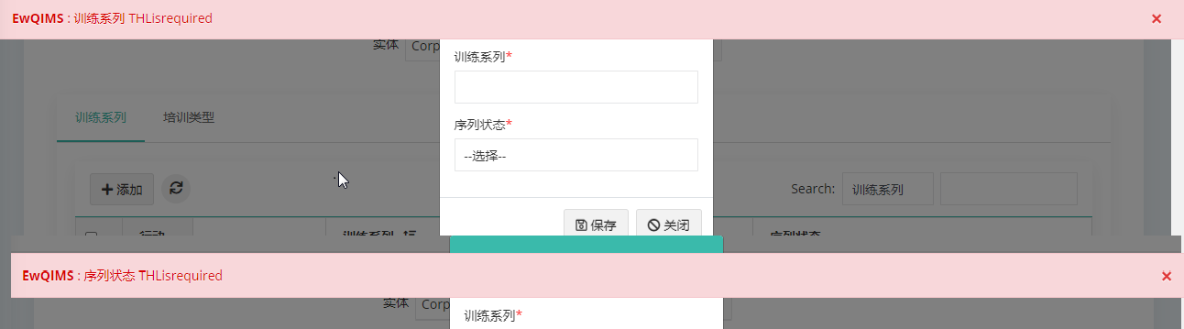

Training course page – course name enter alert, start date alert, course status alert

Confirm delete alert – OK button not changed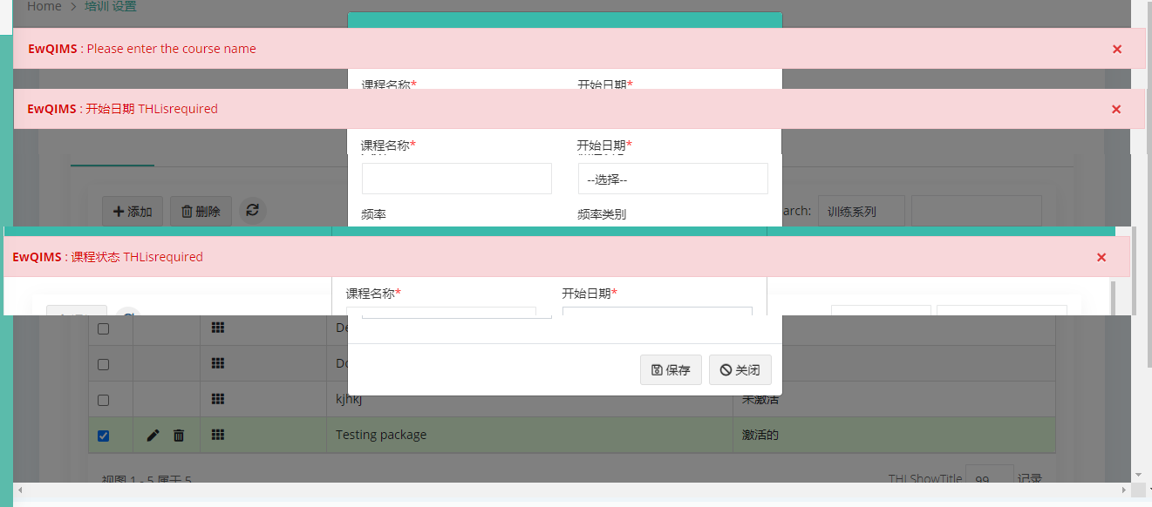

Training type page

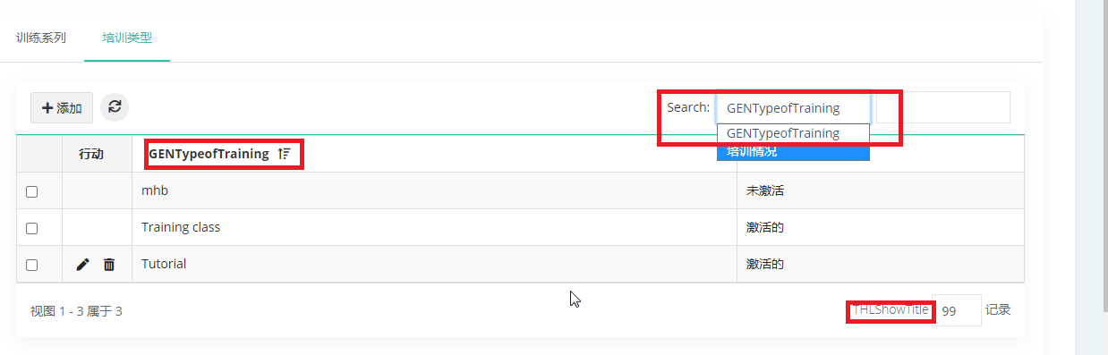

Training type – type of training req alert, course status alert

Delete confirm alert – OK button

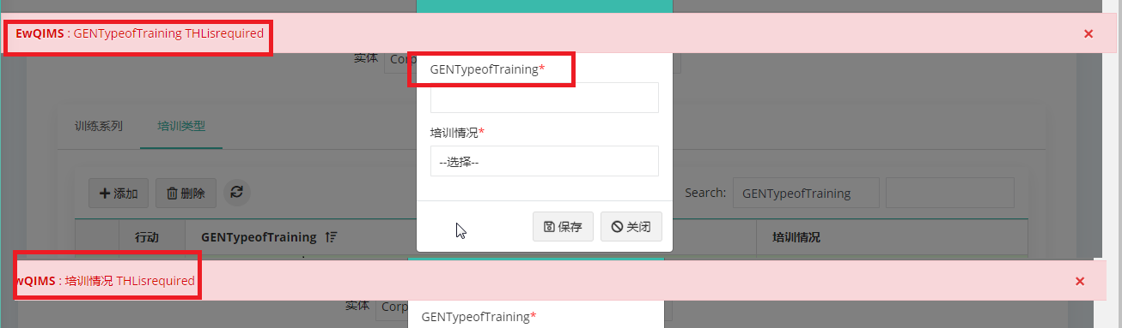

Training request page

New button not changed



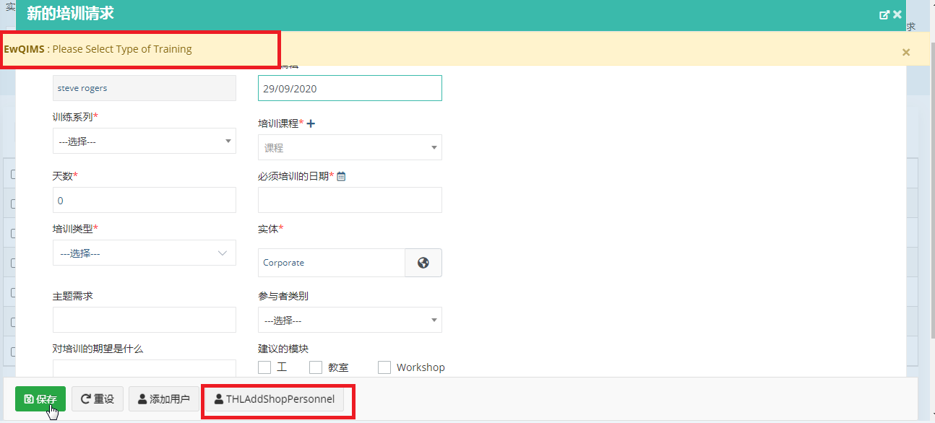

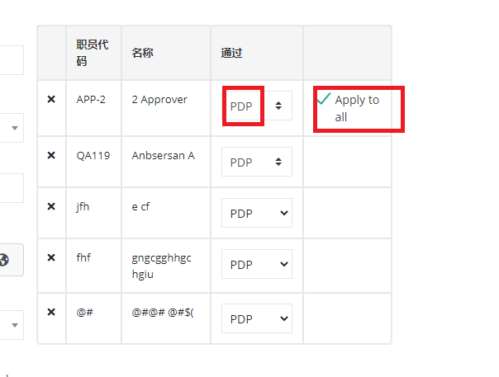

Consolidate page – not converted







While consolidate, it throws this alert, so not able to consolidate it



**IN ALL PAGES WHEN THERE IS NO RECORD IT shows “THLDTNoRecords”**

9. Training – consolidation

Training consolidation – checklist page - yes, no not converted

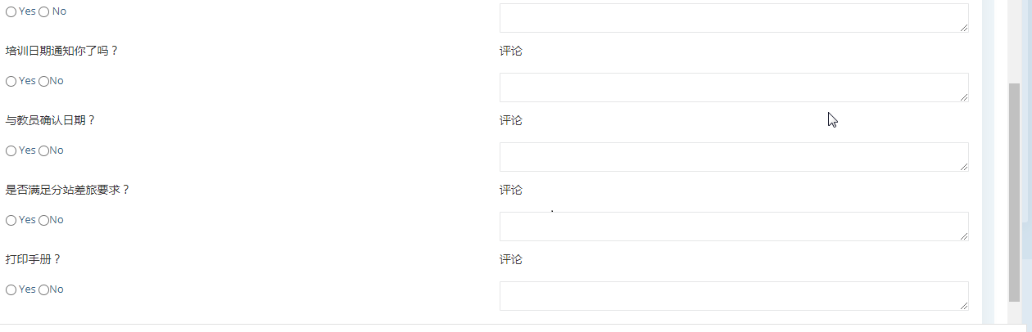

10. Records page

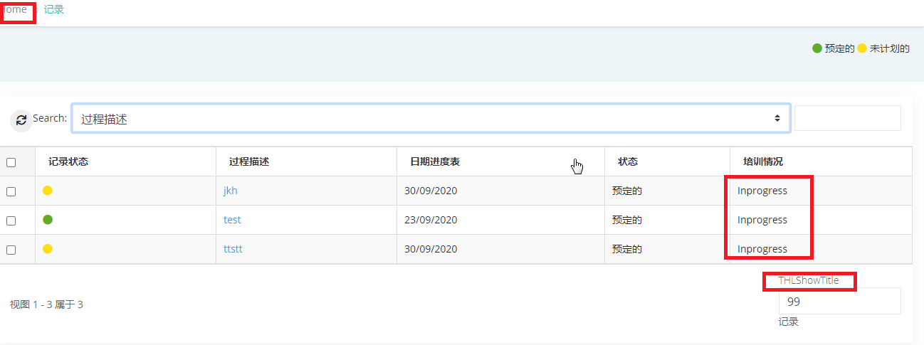

Records – training records page

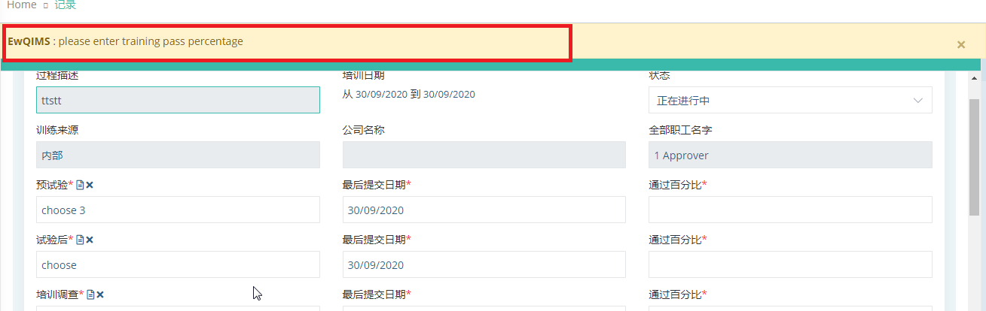

11. Evaluation page – evaluation log details page

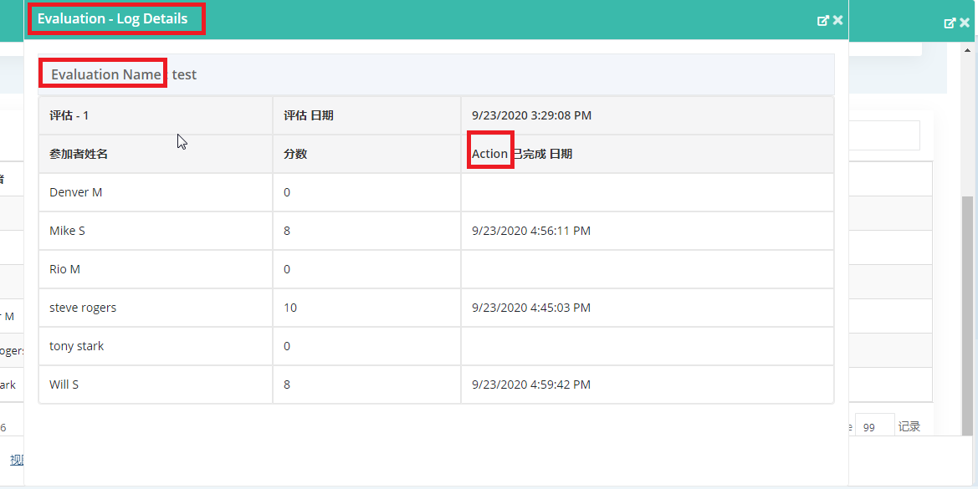

By questions page

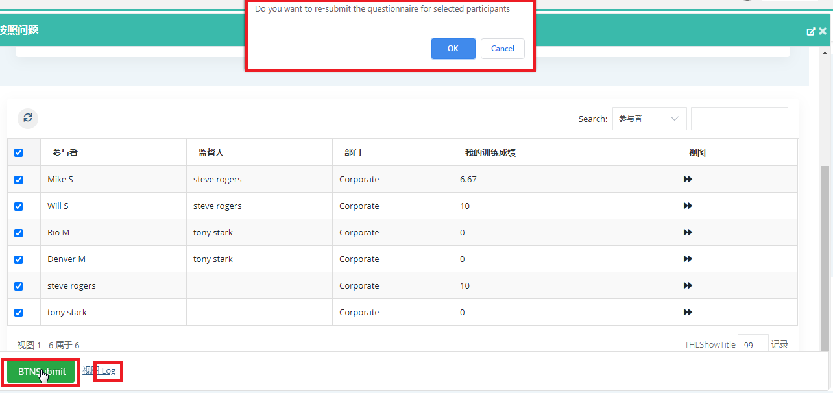

**Evaluation page – Tooltip of by questions and by comments icon – not changed shows in English**

12. Calendar page

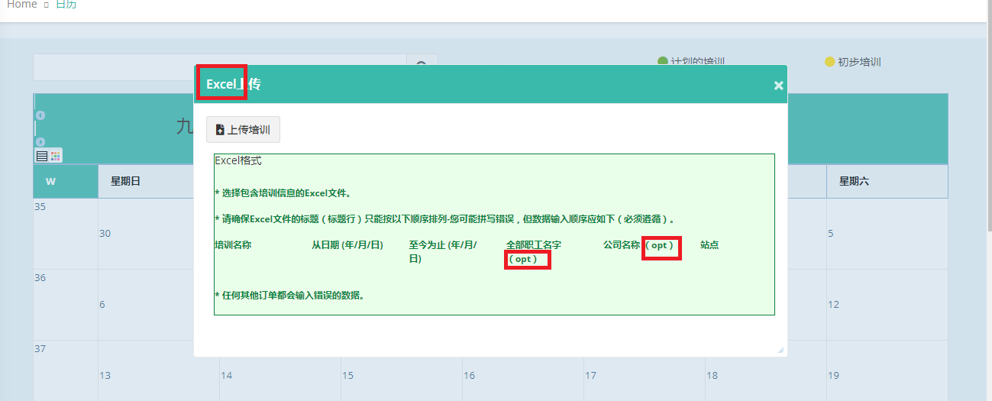

13. Training assigned page

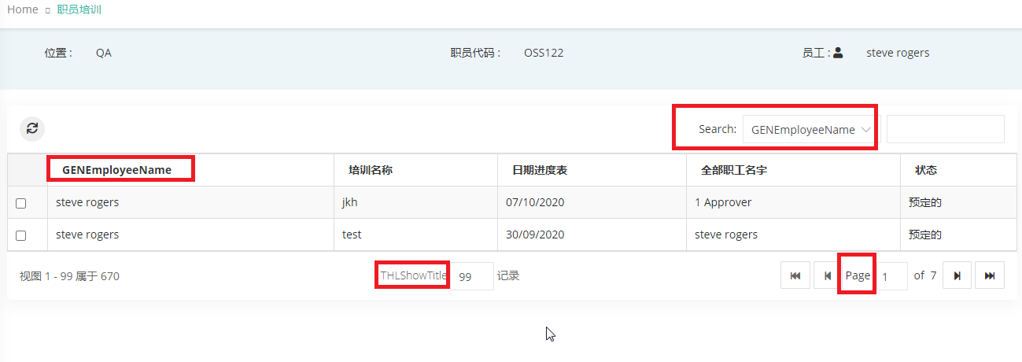14.Job requirement page

While add/edit requirement – when click save, without select mandatory or nice to have, Alert throw as opt

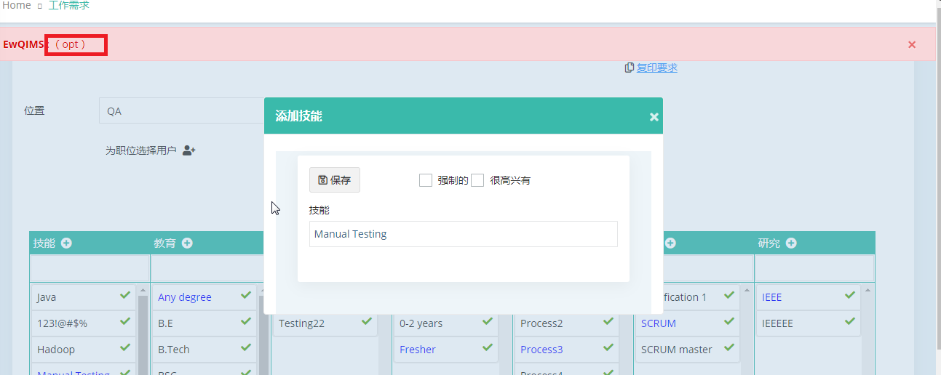

15.Competency evaluation

User category selection popup

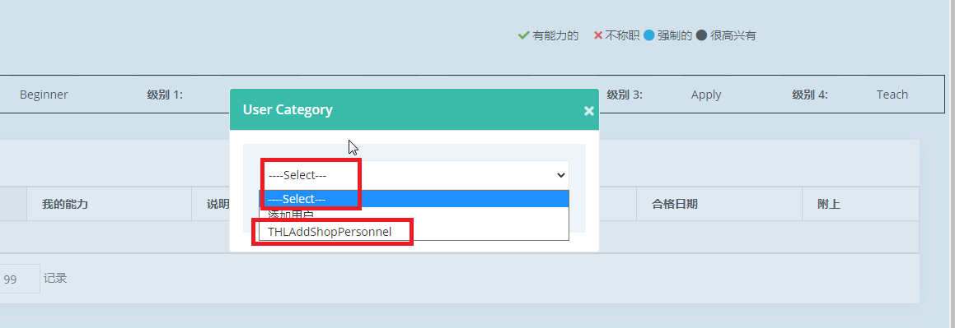

Legend for levels page – while edit- without enter data and click save

Edit title not converted

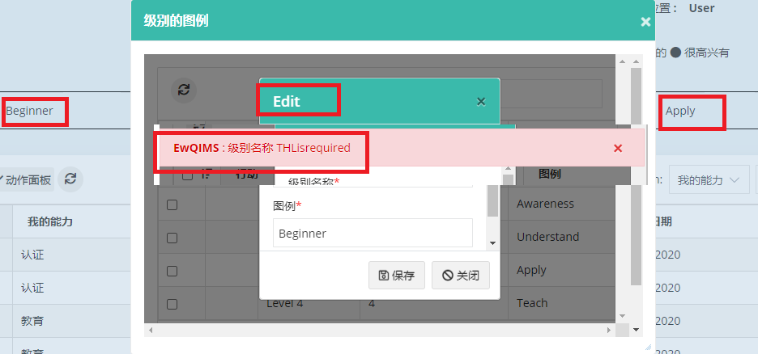

Legend for levels page

This beginner, awareness, understand, apply, teach not converted in main page of competency evaluation. Refer above image marked as red in background

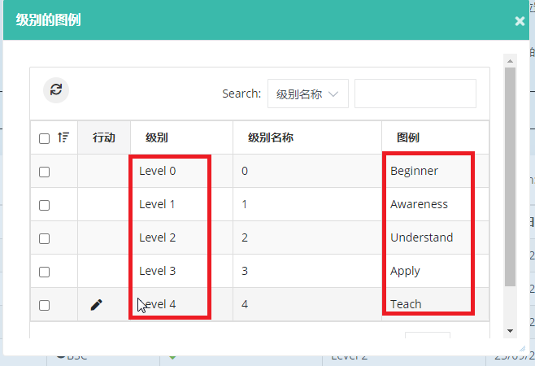

16. Update competency – Proof attach page

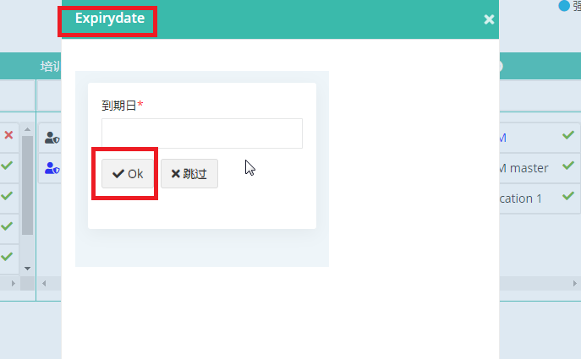

17. Certification details

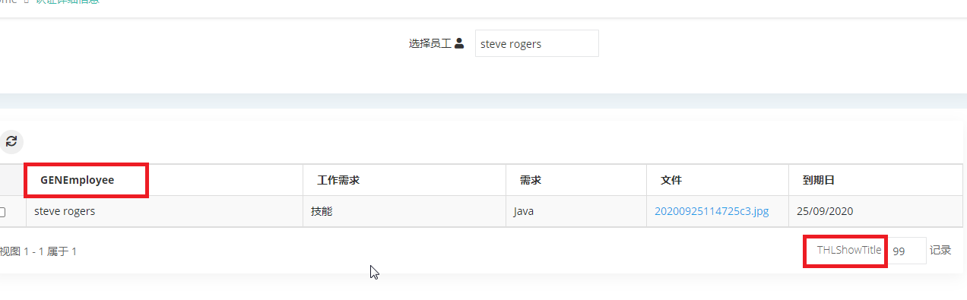

18. Expectation category page

New button, search not converted

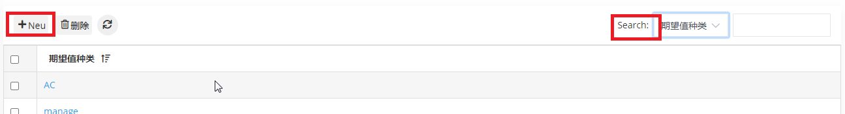

Alert message not converted – target value, target date, frequency

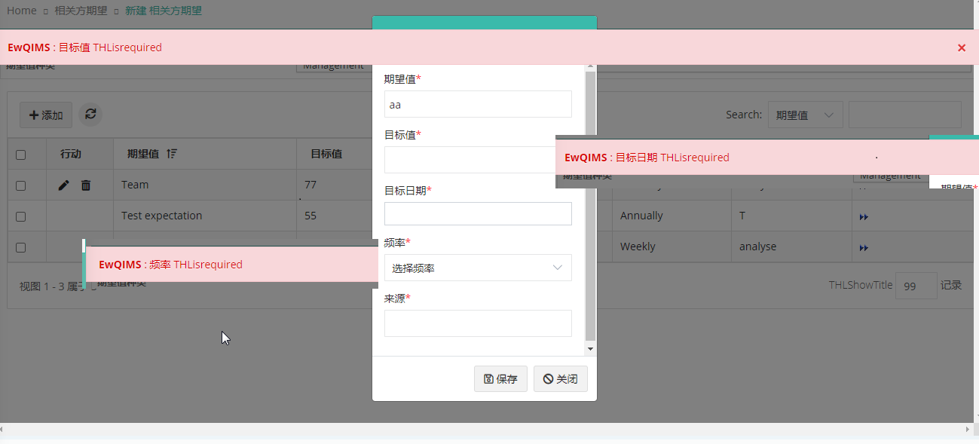

Frequency drop down in english

Edit popup title not changed

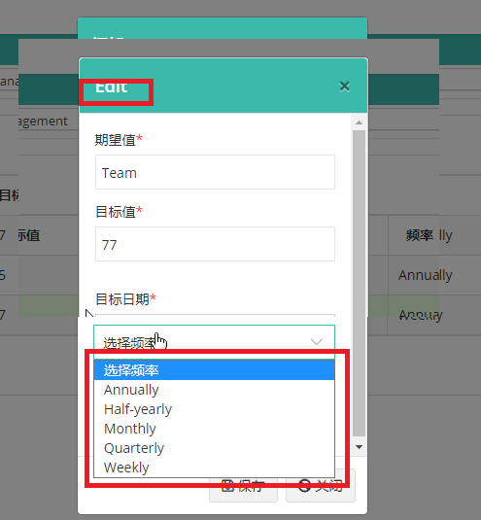

19. Goals and objectives page

Alert not proper - Expectation alert, short term, long term goal alert

Edit popup title not changed

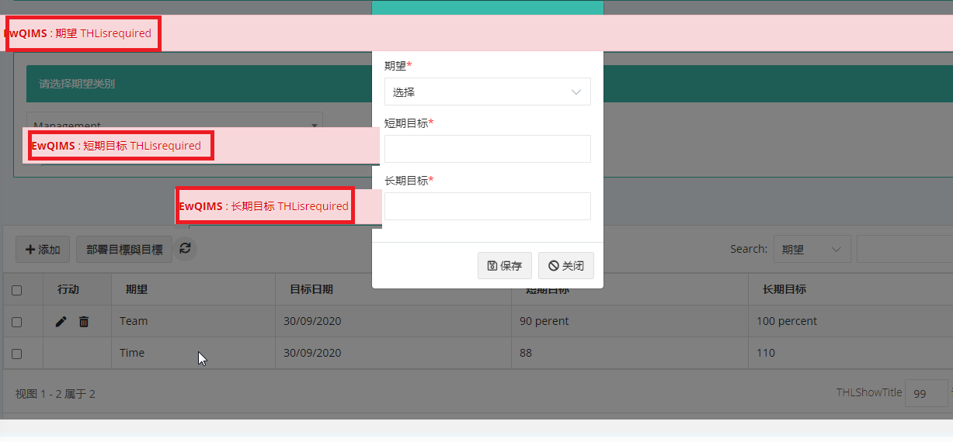

20. Benchmark page

New button converted



21.Performance review report

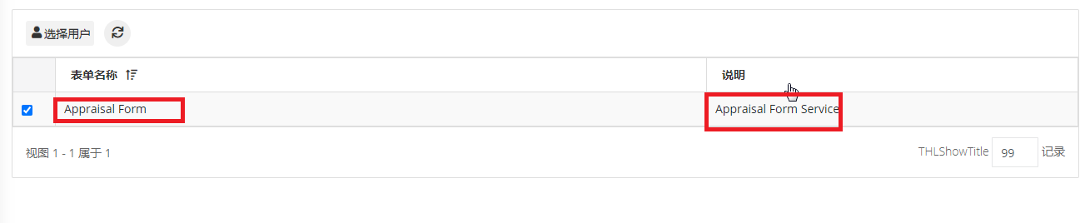Select user page

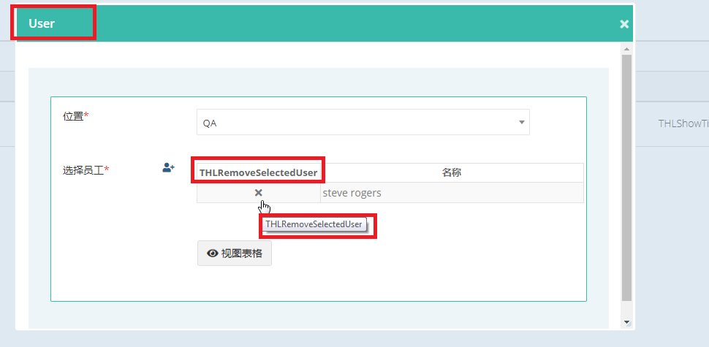

22. Actions page

Search field and export, excel button place is changed

In normal site also having same issue – Mozilla browser

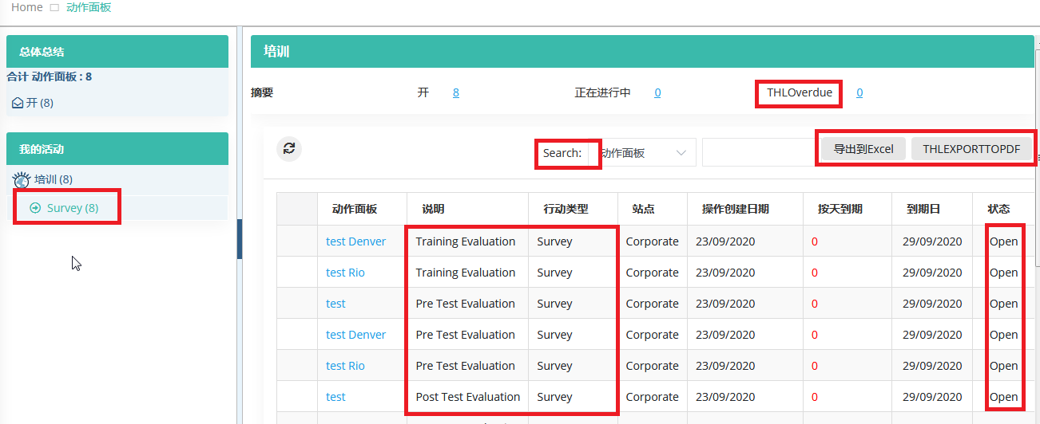

**SPANISH**

1.Groups page

Delete confirm alert – ok button

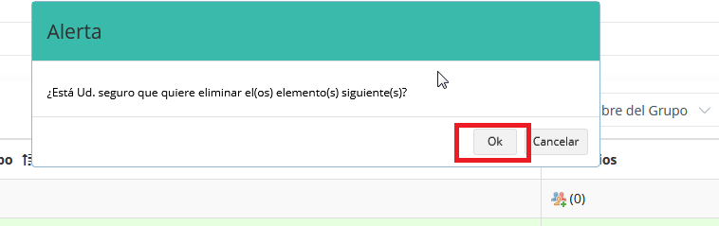

Select user’s page

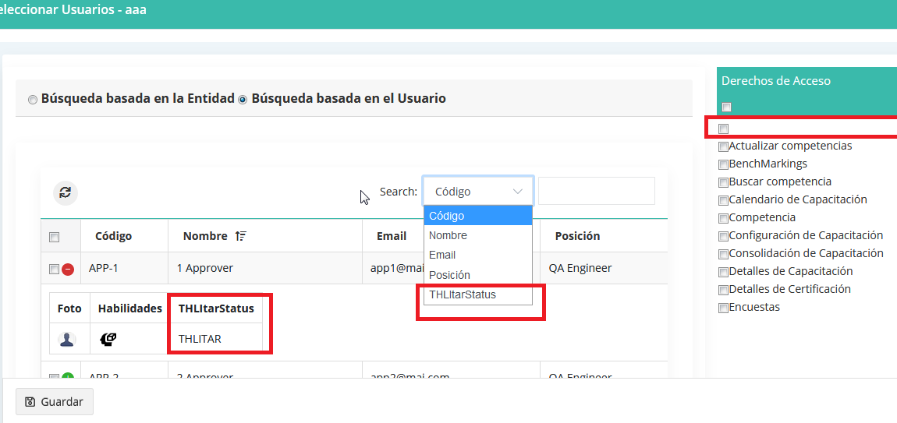

Alert not converted – while click save without enter data

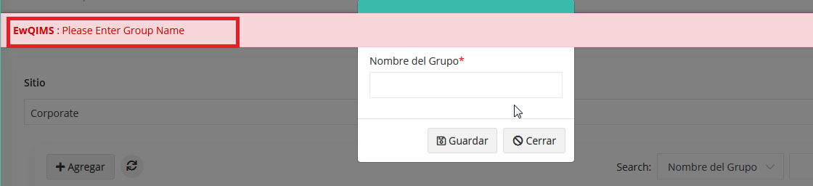

2.Users page

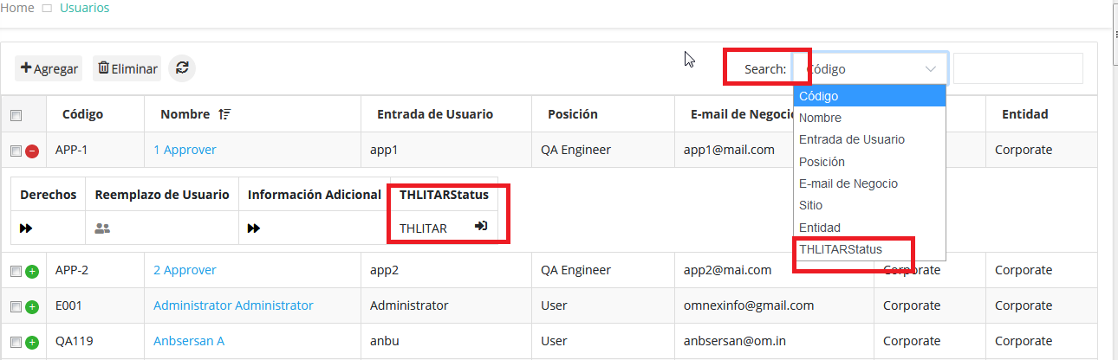

User creation – having unnecessary term

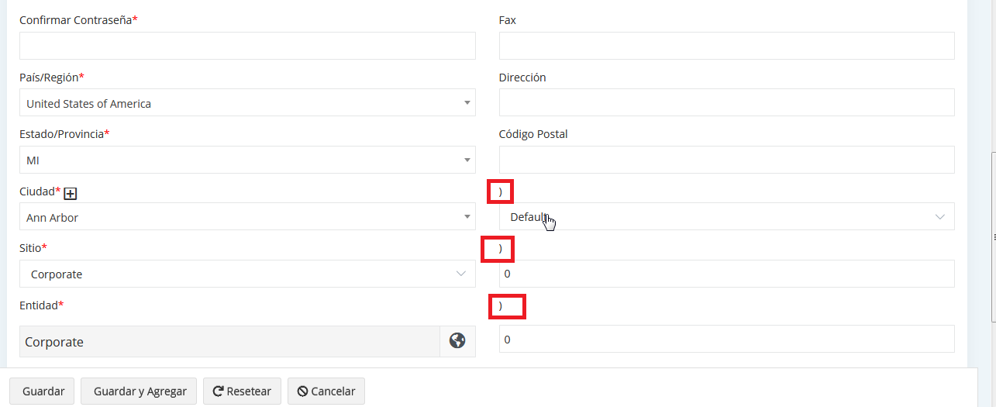

3.Customize email messages – emails are not shown

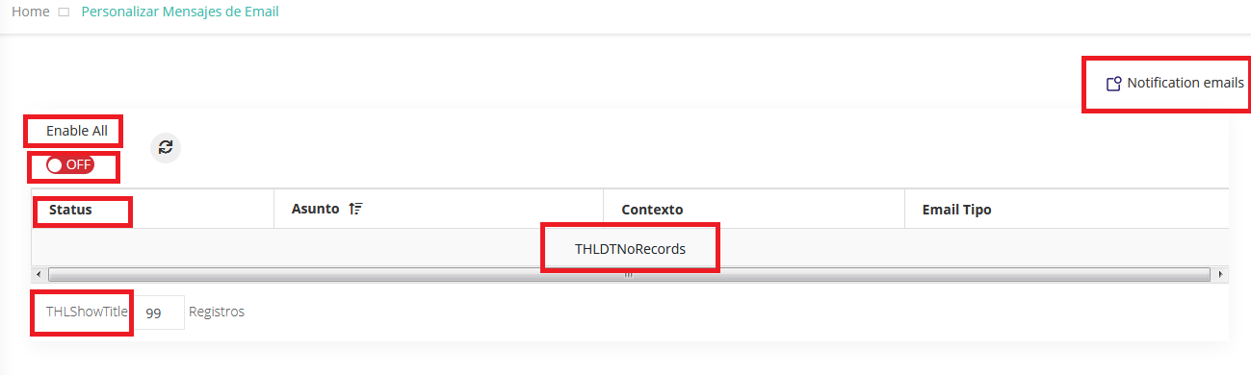

4. Route

Add positions page – unwanted term

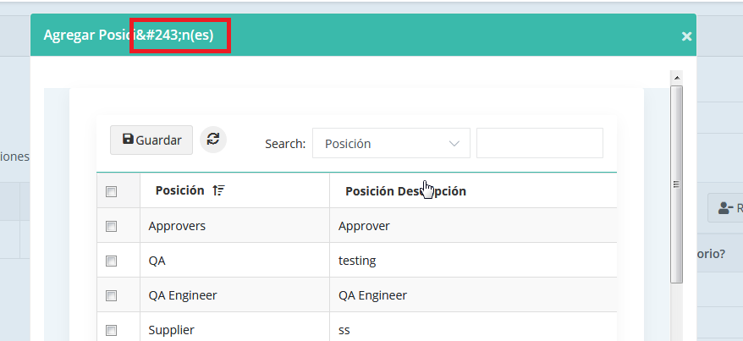

Route creation page – alert not converted

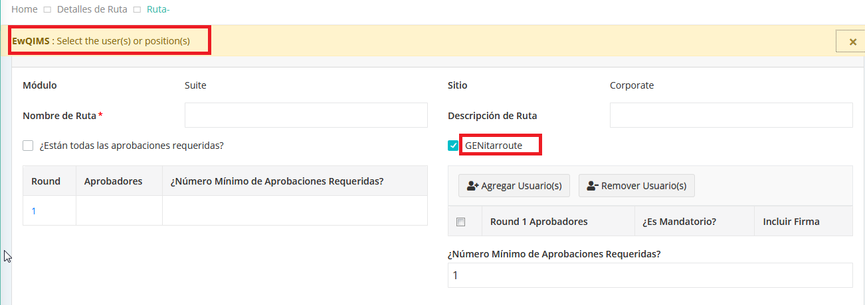

5. Shop floor personnel page

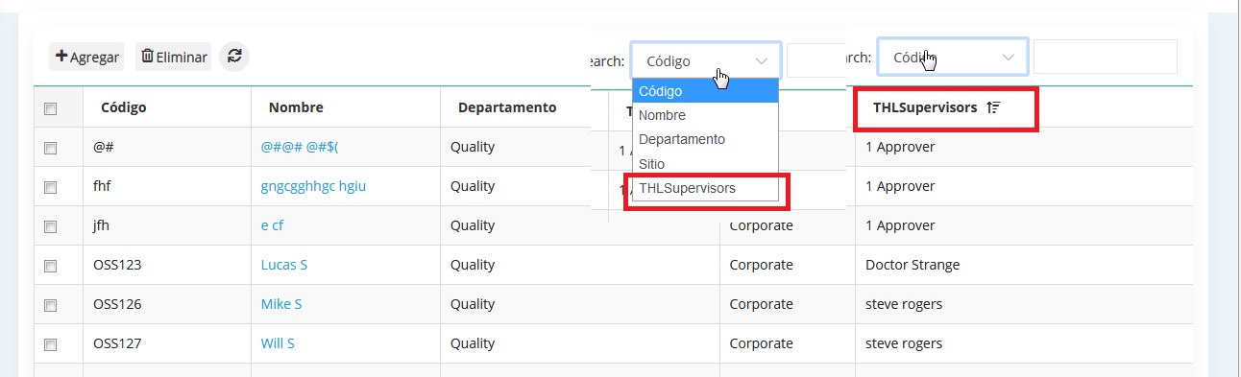

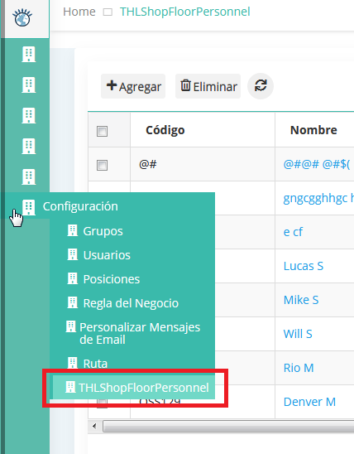

Add supervisor page – title

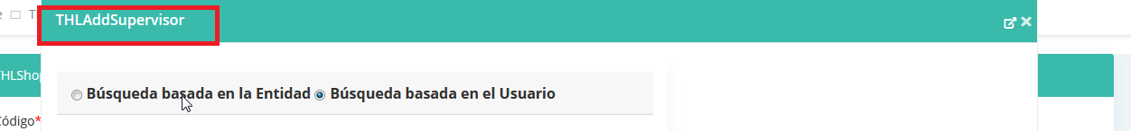

Add supervisor alert and labels

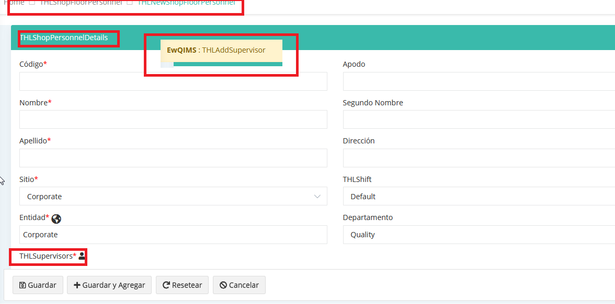

Delete confirm alert

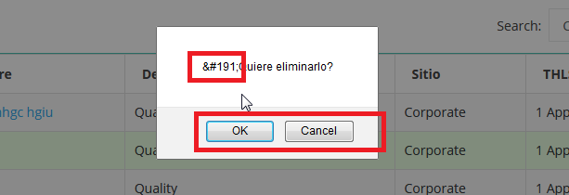

6. Survey

Rating - alerts are not converted. Without enter any data click save, shows THL required

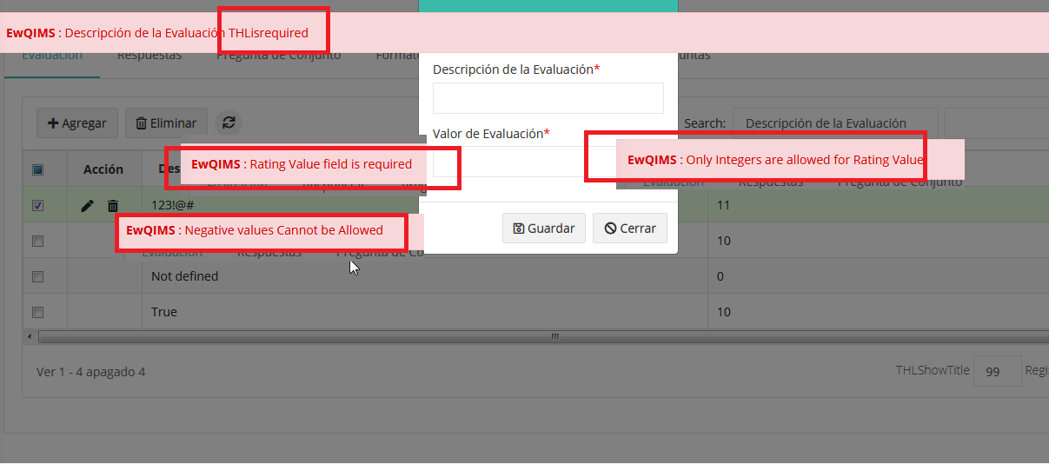

Response page

Add rating page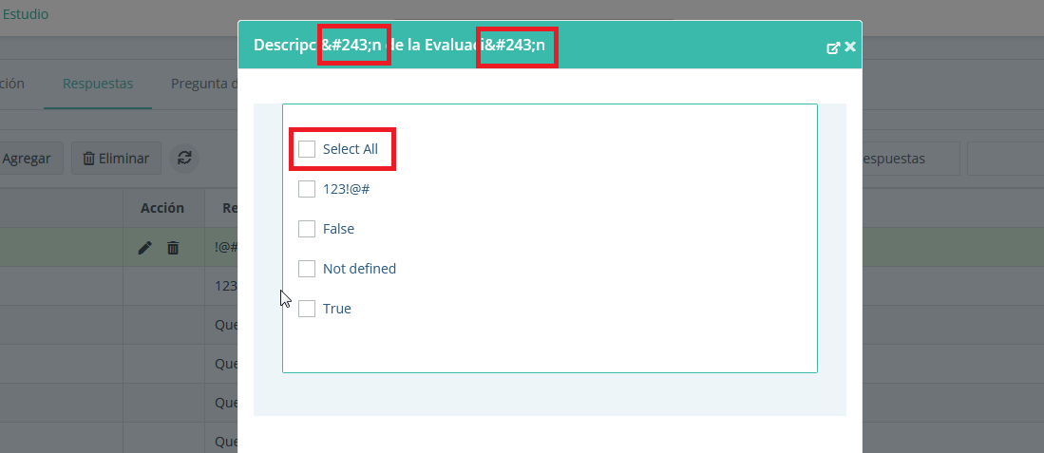

Edit page title

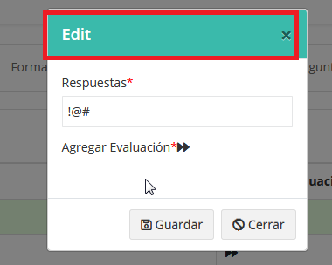

Question pool – question reuqired alert, response is required alert

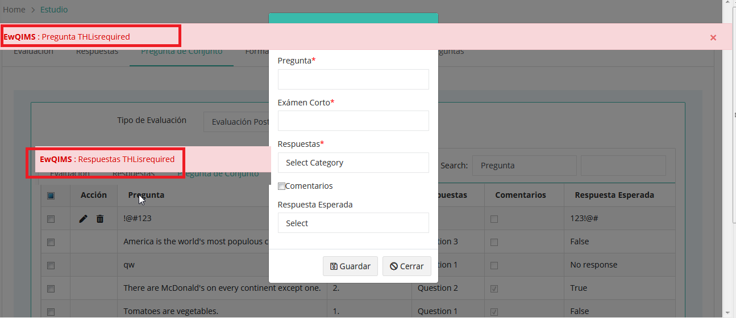

Question format page –delete button

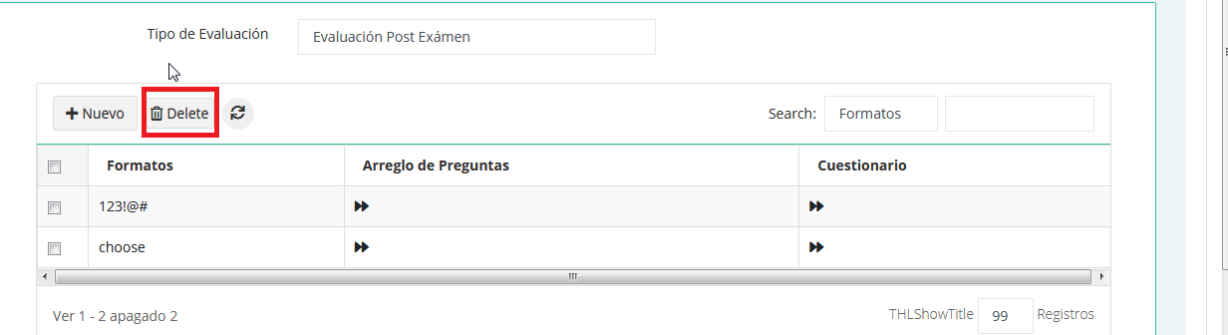

Question format – questionnaire

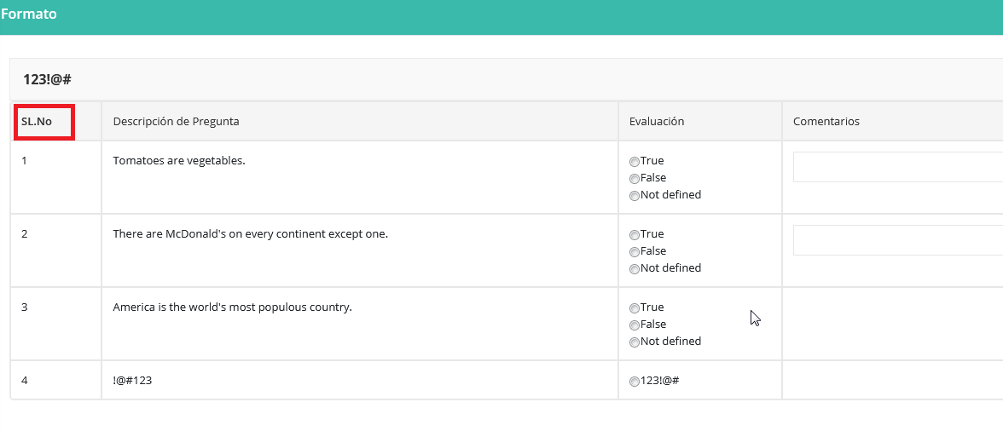

7. Training setup

Training series add page

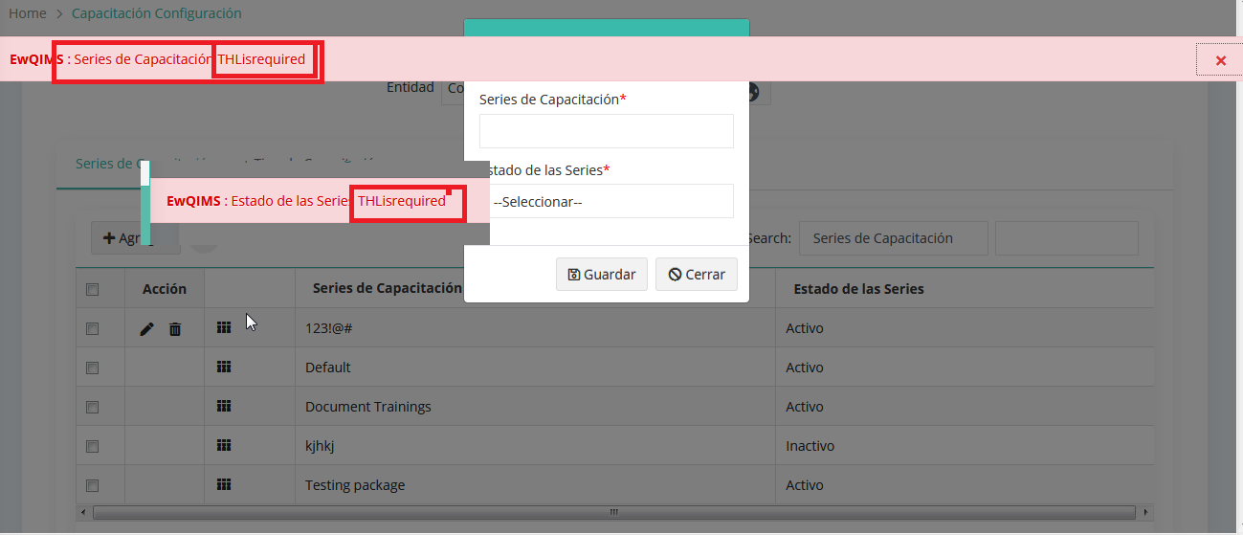

Edit Page

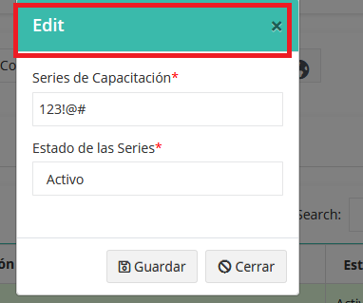

Training course – add page

Alert – course name, start date, course status

Edit title label not converted

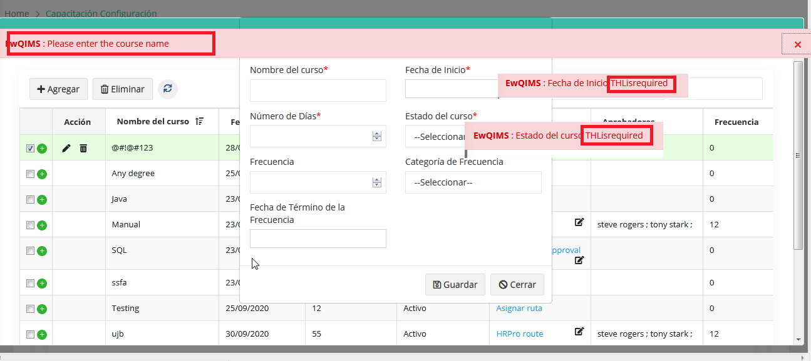

Training type – add

Alert – not handled

Edit title not converted

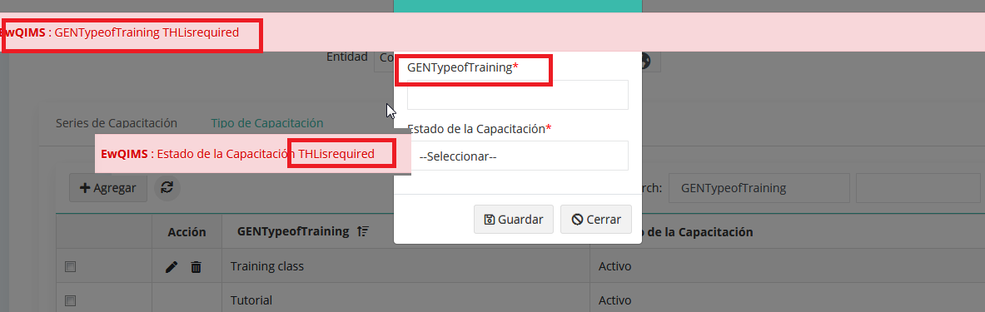

8. Training request

Labels not converted

Note: Image is attached. Not al alignment problem

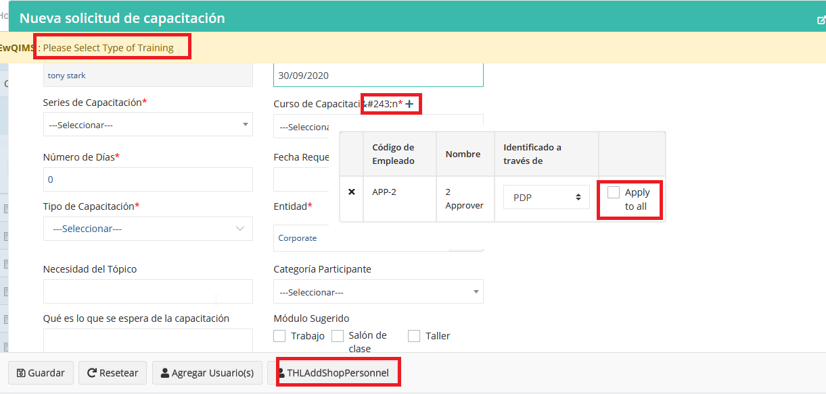

Delete alert- Training request

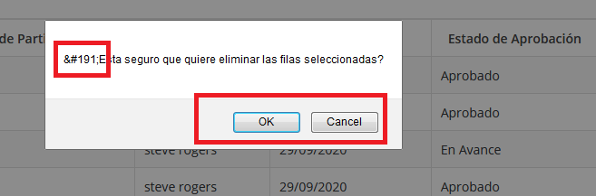

Training Consolidate page – alert not handled

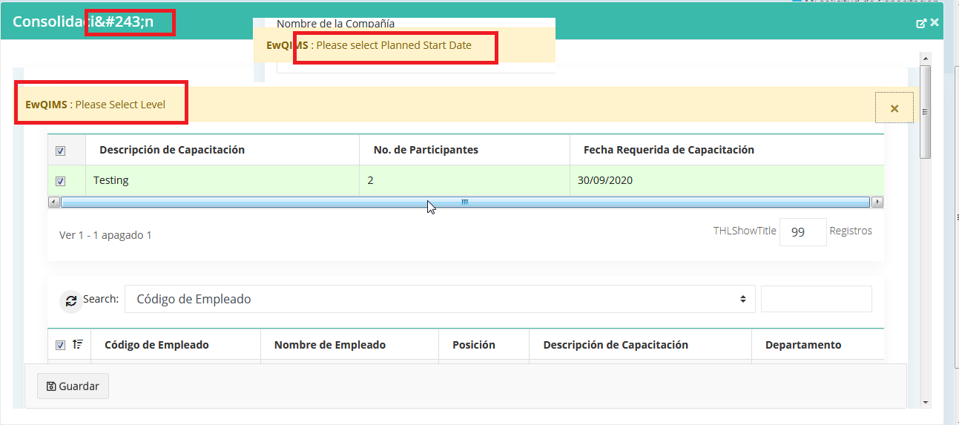

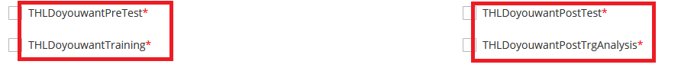

Consolidation page – delete alert

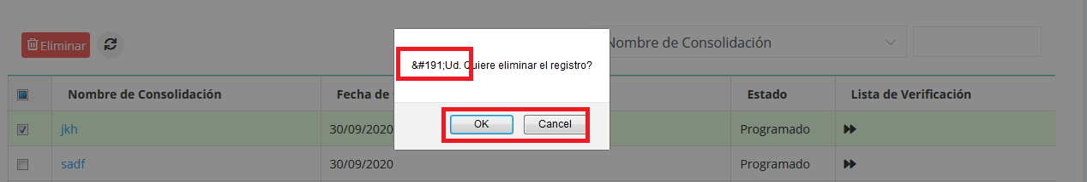

9.Records page

Records – training records

All the alerts show as like this in this page which throws like this

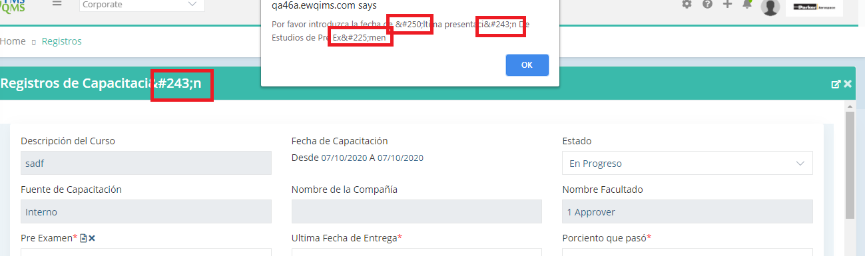

10. Evaluation page

By questions

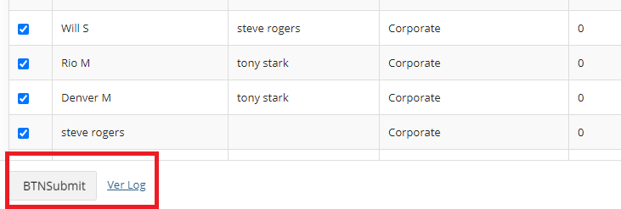

View log page

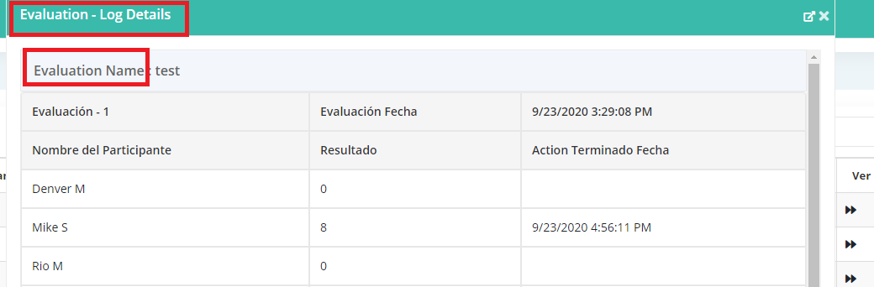

11. Calendar page

Alignment issue in multi language

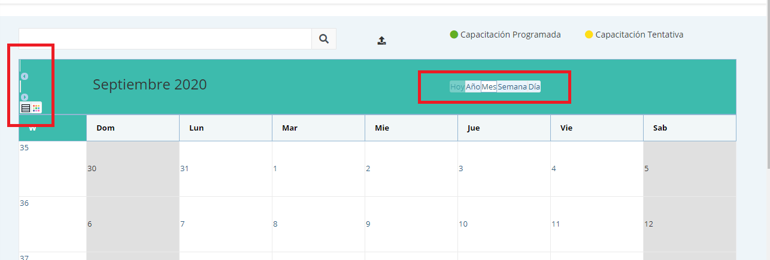

12.Training assigned page

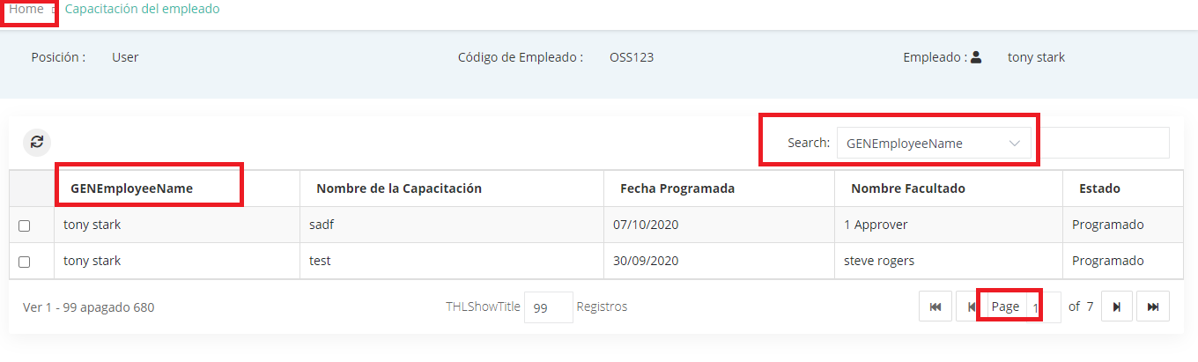

13. Expectation category page

Add page – target value, target date, frequency alert

Frequency dropdown – not converted

Edit popup title – not converted

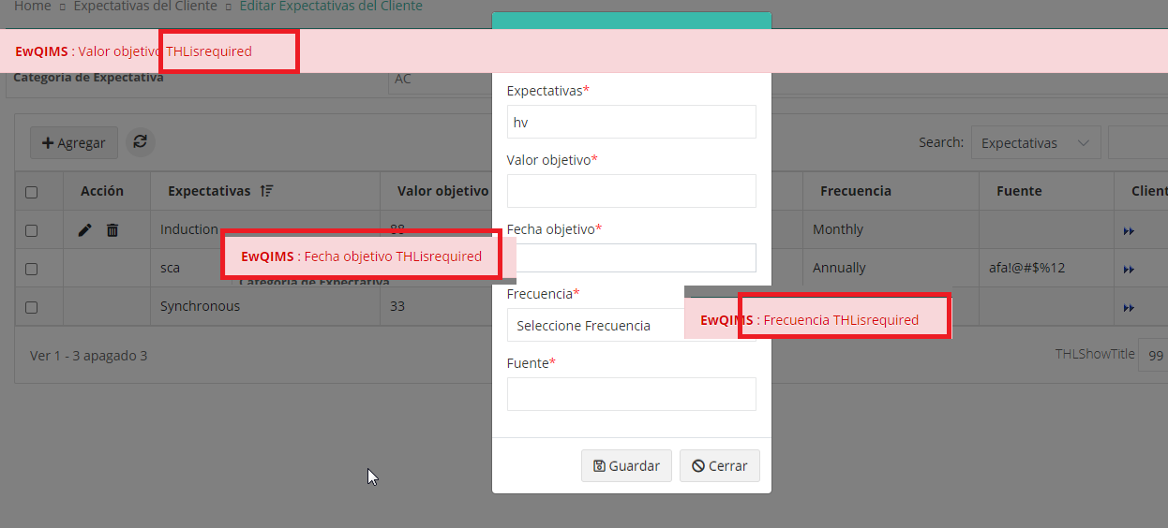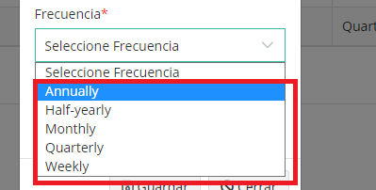

14. Goals and objectives page

Expectation alert, long term, short term goal alert

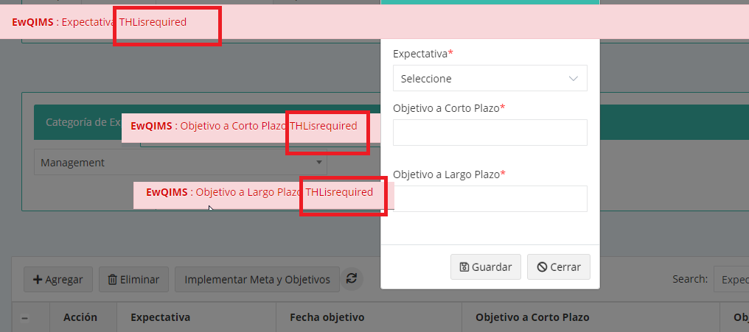

15. Performance review report page

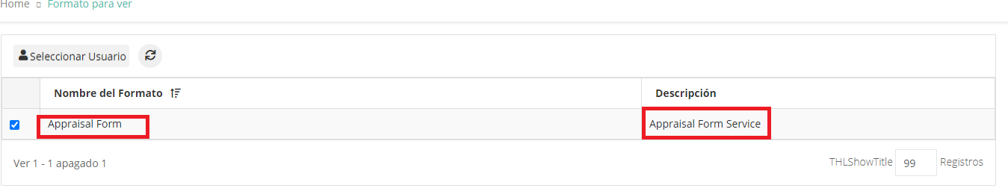

Select user page

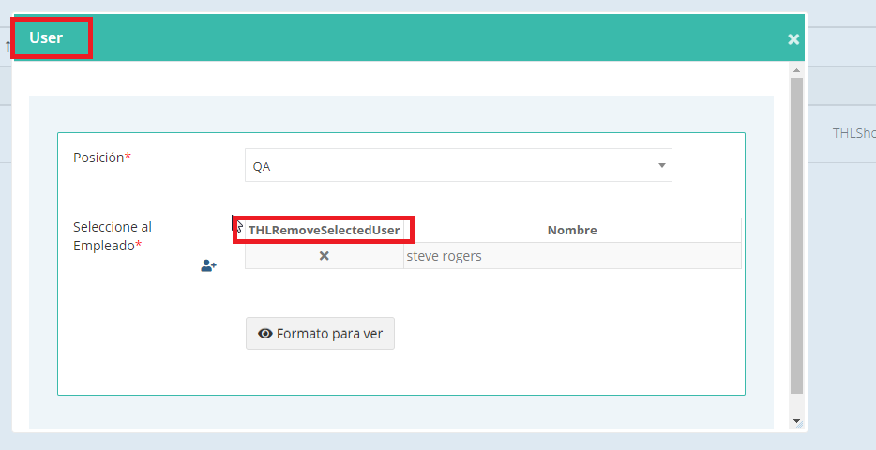

16. Actions page

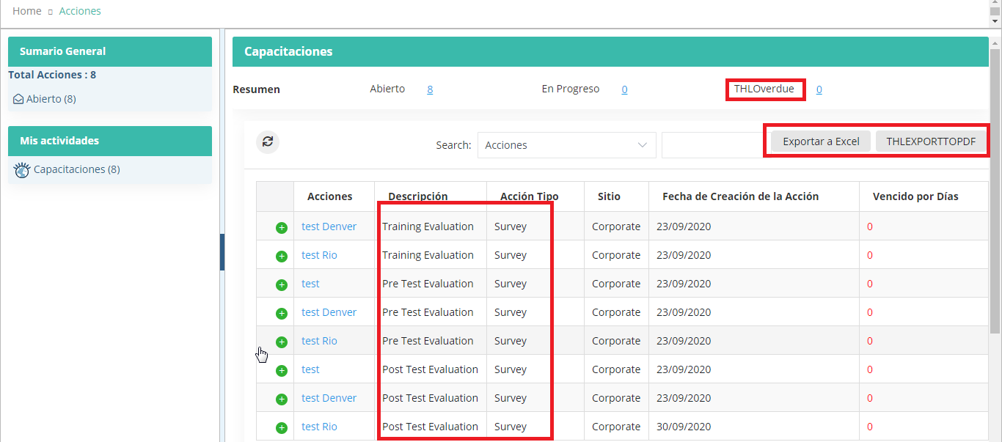

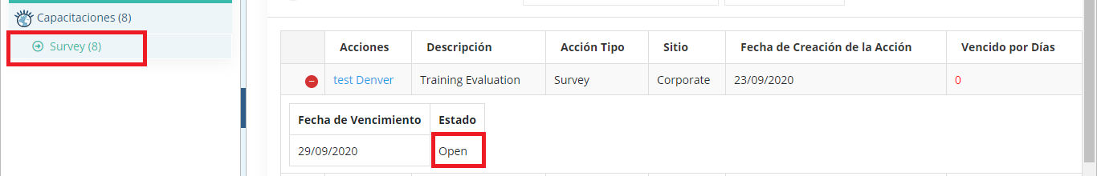

Test taken page

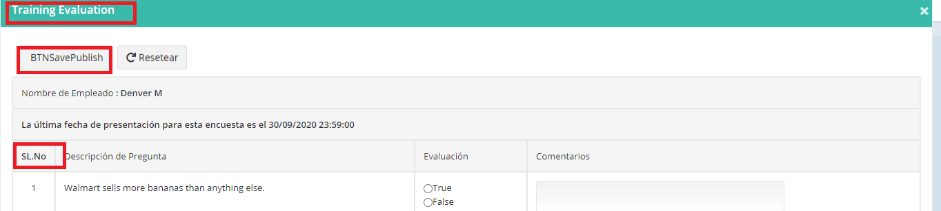

17. Job requirement page- after selecting position

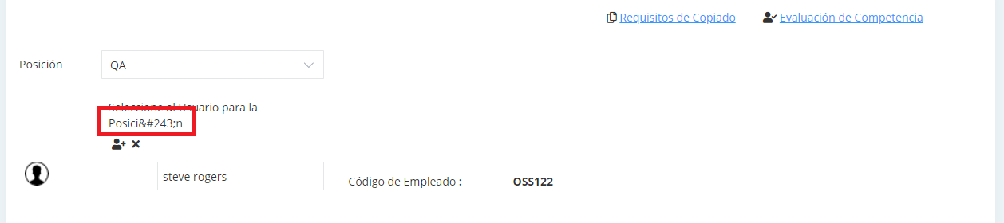

18.Competency evaluation

User selection page

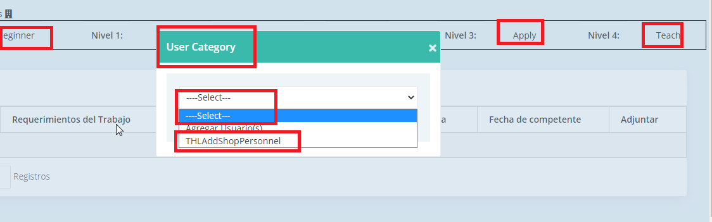

Legend for level page

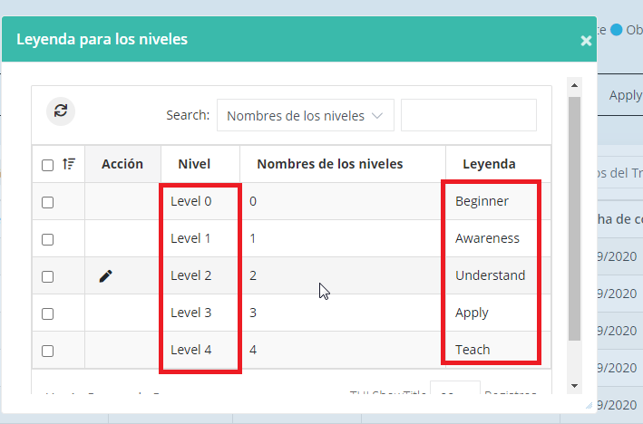

Legend for level page – alert edit title, without enter data and save

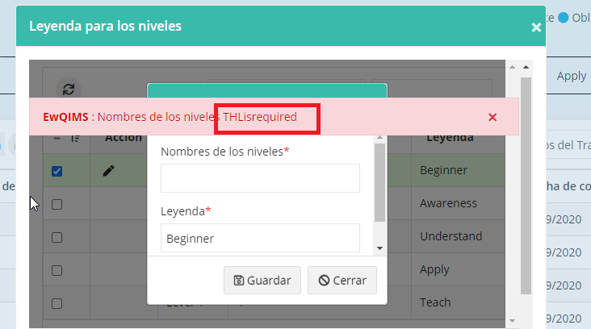

19.Update competency

Proof attachment page

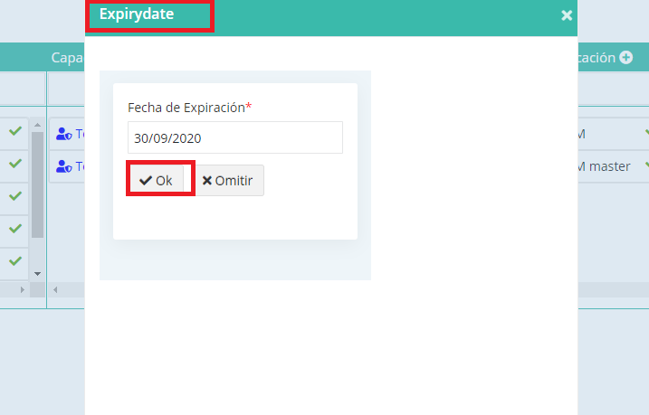

Add page

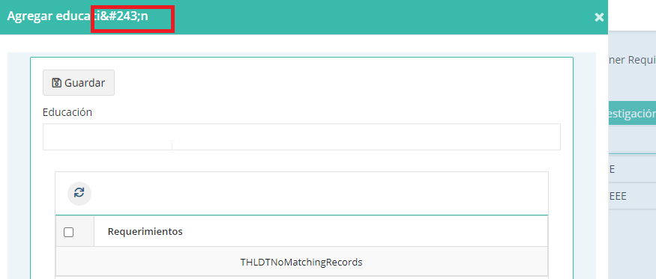

20. Certification details page

