4) Audit mode,Audit type,Audit Criteria->Save/update alert in blue instead it should be green

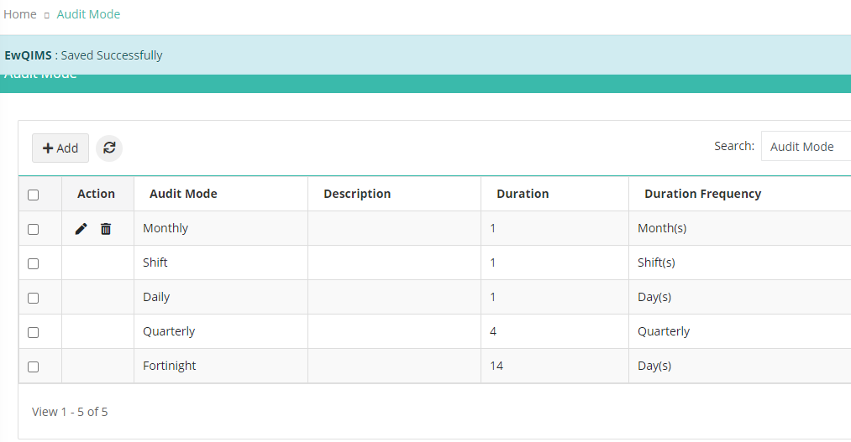

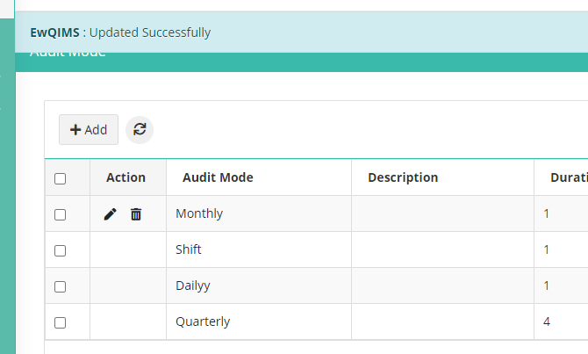

5)Audit criteria button on mouse hovering should be in blue instead it show as green

8.Add button in findings category on mouse hovering should be in blue

9. NC findings category->Saved alert should be in green theme not in orange

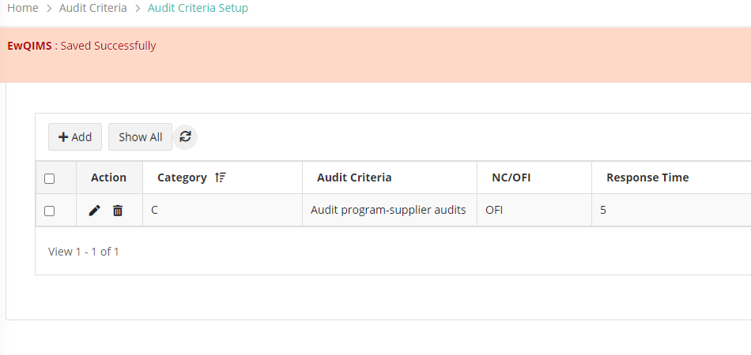

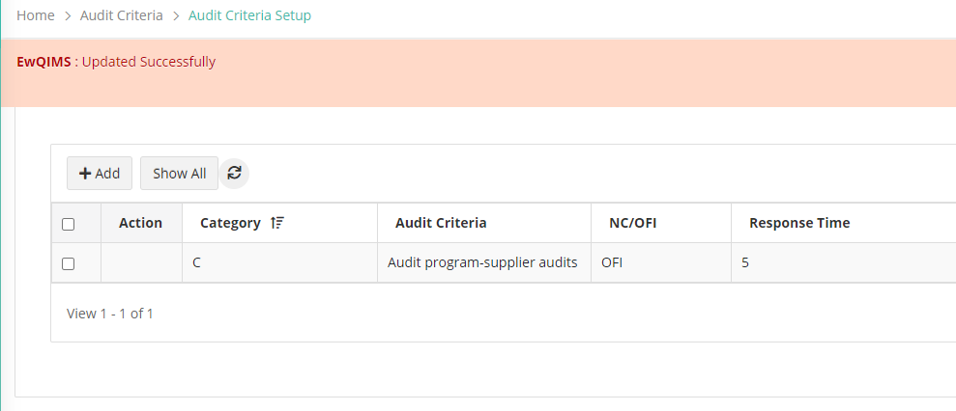

10. All delete alert Do you want to delete? Ok button on mouse hovering should be in green and cancel in red

11.