1. Icon for Context menu in PI Table is not good.

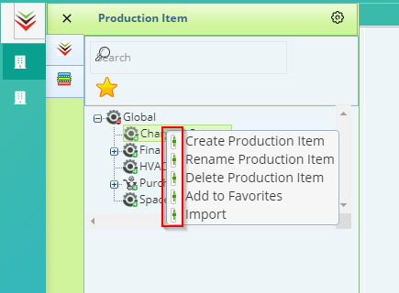

1. Item Element name is not properly displayed in both the labels in slider window

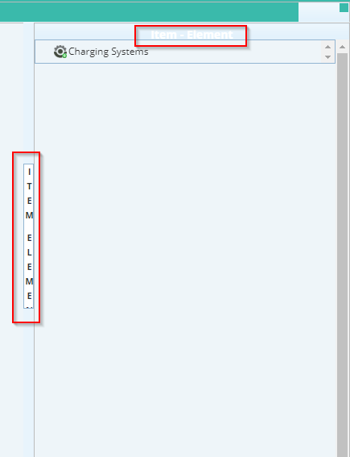

1. Saved Successfully Alert is not good. 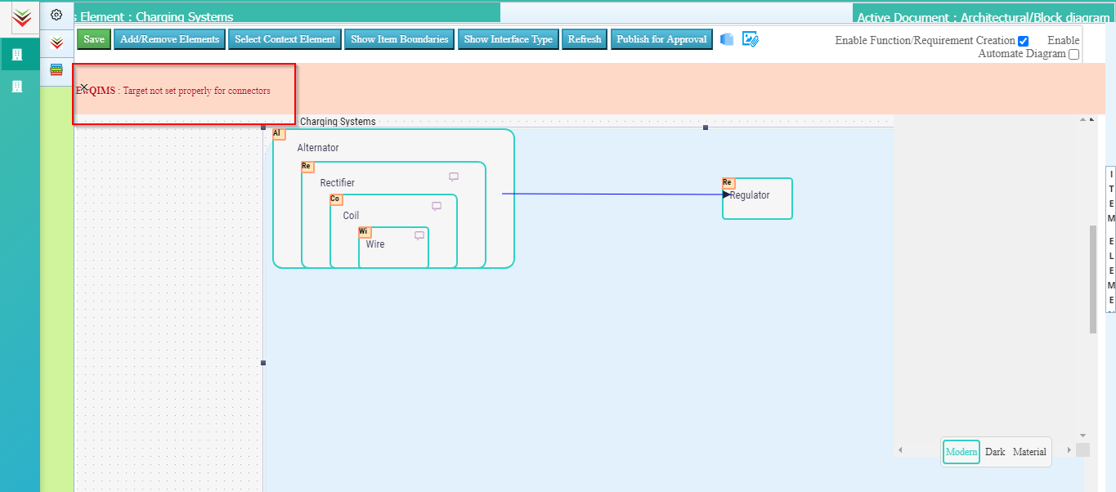
2. Focus element label is partially hidden.

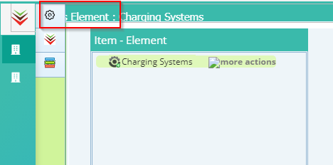

1. Associate Characteristics popup is not properly displayed

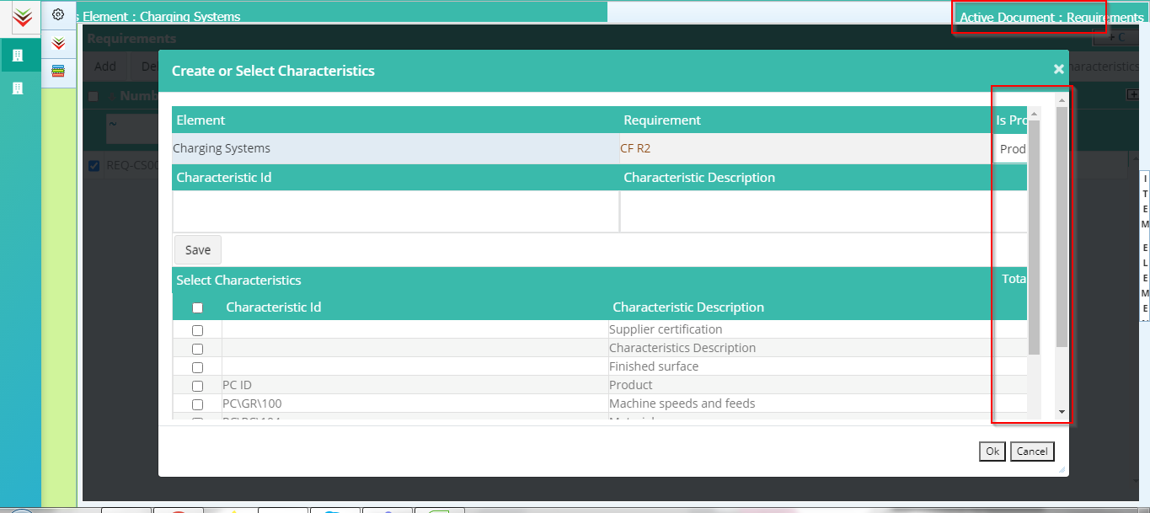

1. Associate Characteristics Saved successfully alert is not properly displayed
2. Saved successfully for New Characteristics is not good.
3. After associating Characteristics, system displays black page.

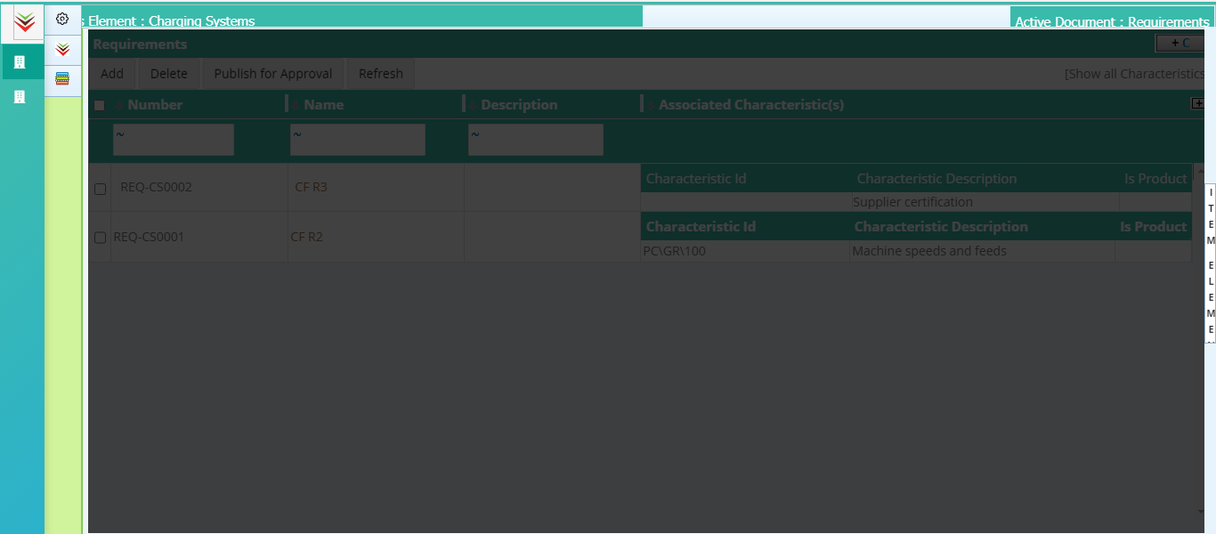

1. Search box is not aligned properly.
2. More actions label is displayed on Mouse hover on the PI’s.

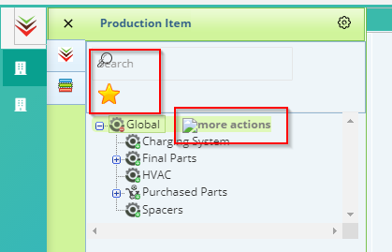

1. Requirement Type button is placed on top of VOC table.

