1. User select windows multiple slide bars on RHS

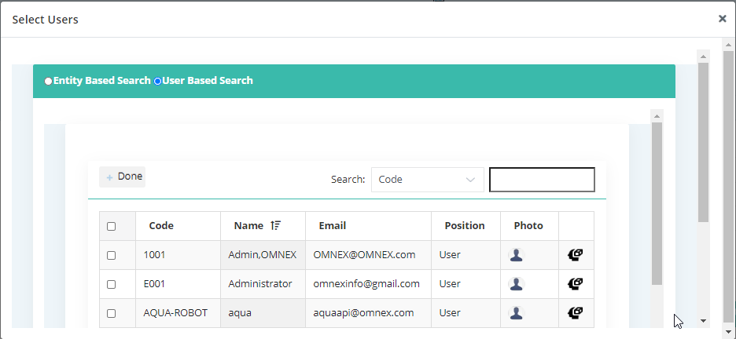

1. System is not allowing to enter Entity contact person
2. Modules administrator-> displays part of code next to the checkbox

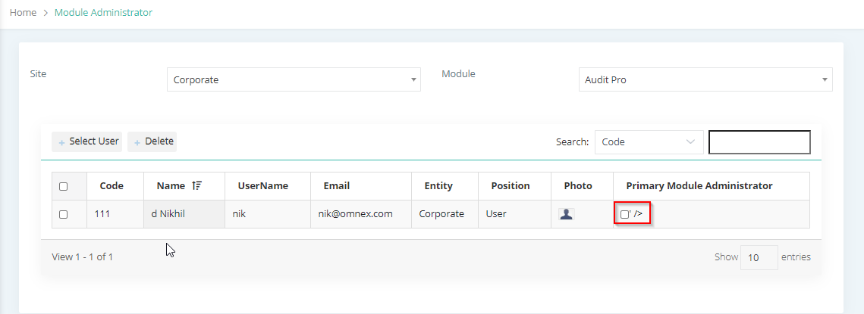

1. Create Department->Department mapped as Production department (opt) is not displaying in the listing screen.

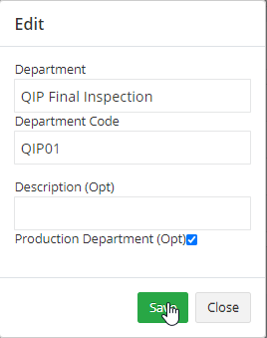

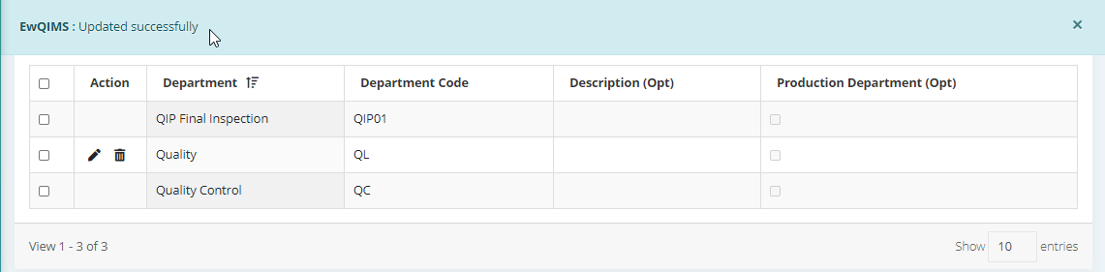

1. Though alert is available system allows to modify the data.

