1. Percentage Allocation – Step 7 is overlapping

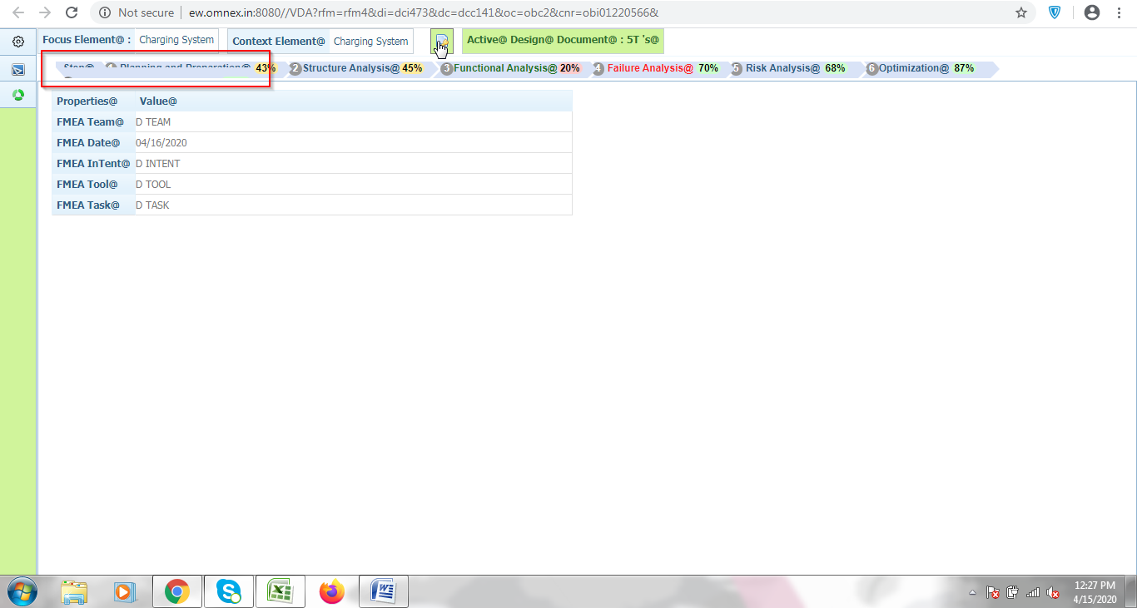

1. Process VDA- Failure context menu

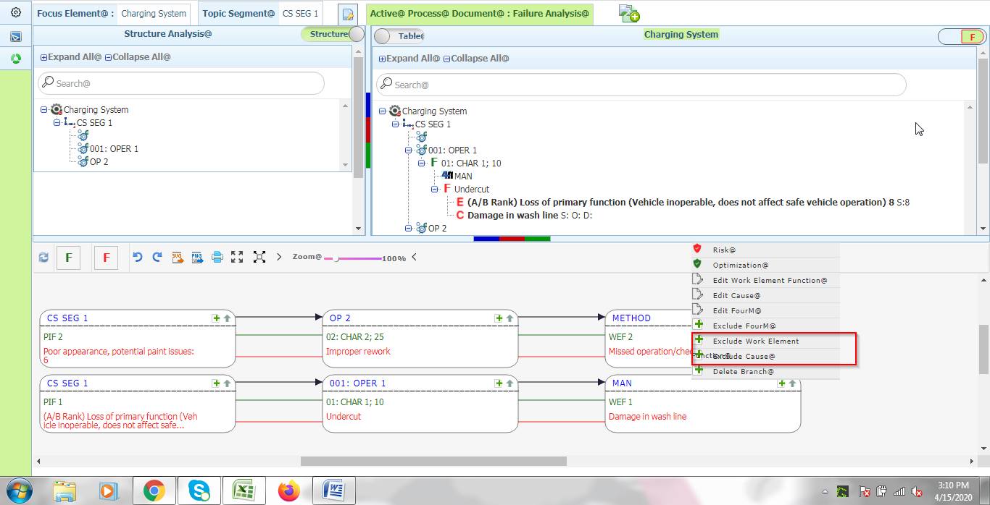

1. Process VDA – Create and Map

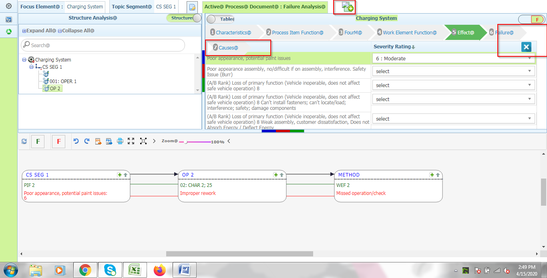

**RFD**:

1. Block Diagram – Publish and Publish history option are listed below

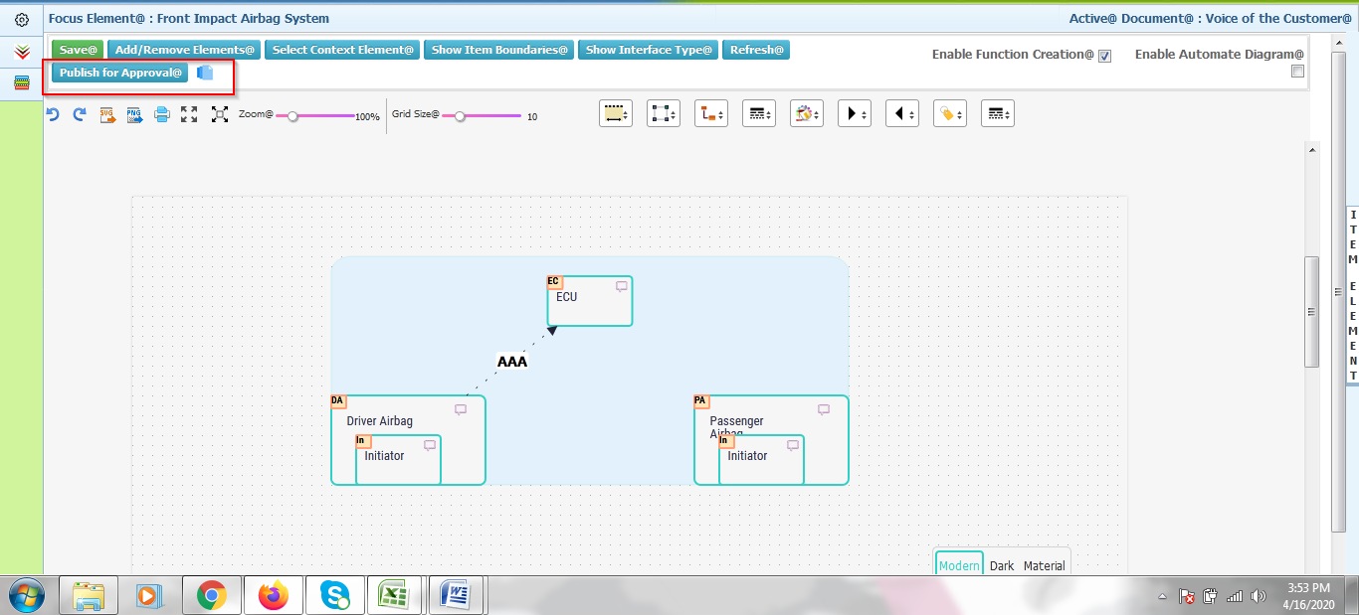

1. Interface Matrix: Cell values alignment is not good

