1.In homepage.

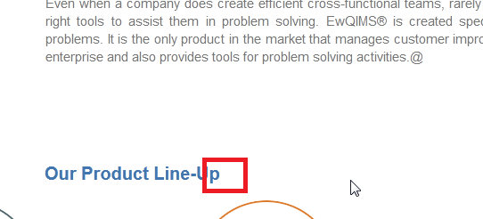

**Steps to reproduce:**

* Login as HRPRo admin
* Modules-Click on this symbol and select hrpro.
* HRPro homepage will open.

2.customize email messages

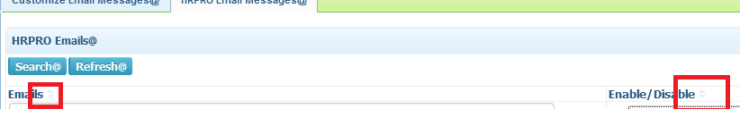

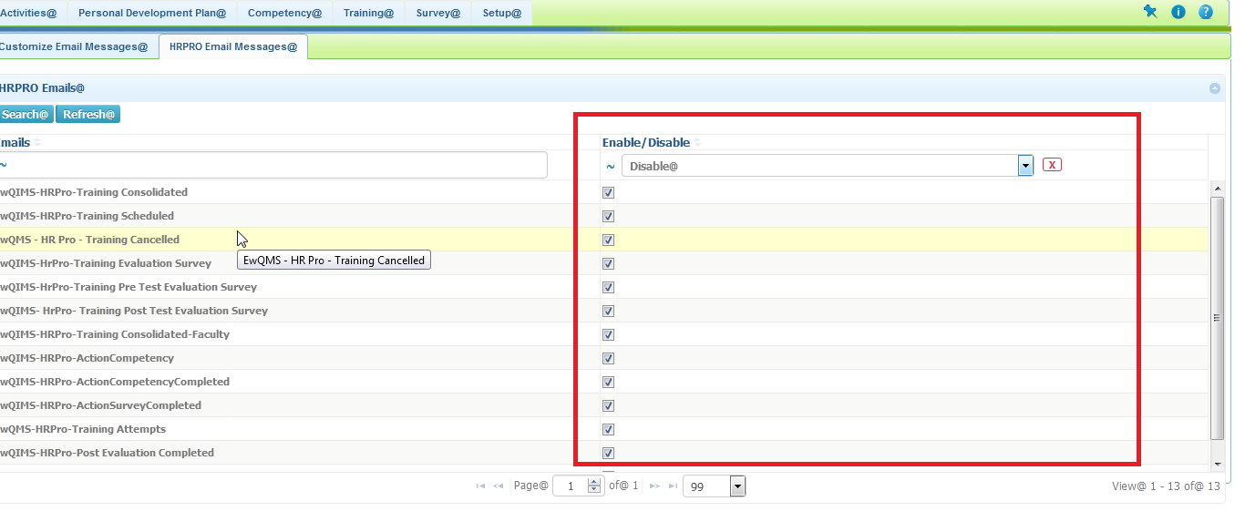

**Steps to Reproduce:**

* Login as HRPRo admin
* Modules-Click on this symbol and select hrpro.
* HRPro homepage will open.
* Click on the setup tab and select the customize email messages. Then in that page, click on the Hrpro email messages.
* Select the enable/disable dropdown, then if you select any one either enable/disable. It shows all the messages.(image-1).
* On the same the symbol @ is not there as shown in the first image.

3.HRPRo -Route-Add users.

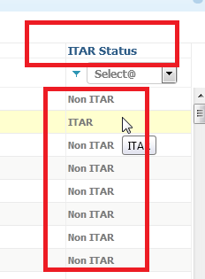

**Steps to reproduce:**

* Login as HRPRo admin
* Modules-Click on this symbol and select hrpro.
* HRPro homepage will open.
* Click on setup tab and select route. It will open the route details page.
* Click on the new route button and on the opening page select the add users' button.
* It will open the add users page.
* On that ITAR status column is not having @ as shown in the above image.

4. Training-Training request-new-add users

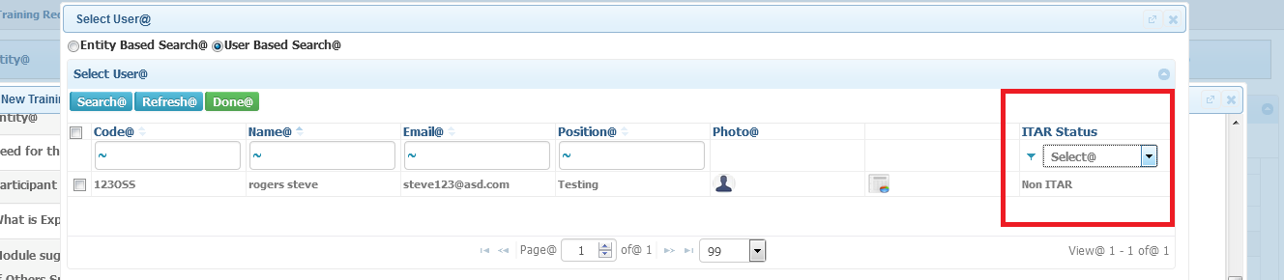

**Steps to reproduce:**

* Login as HRPRo admin
* Modules-Click on this symbol and select hrpro.
* HRPro homepage will open.
* Select training tab click on request, it will open the request page.
* Then click on the new button. It will open the new training request page.
* Scroll down and click the add users' button.
* It will open the select users page. The ITAR status column is not having @ as shown as in the above image

5.Training -Training Request-Approval Status-Wen it is change to inprogress, it shows no data found

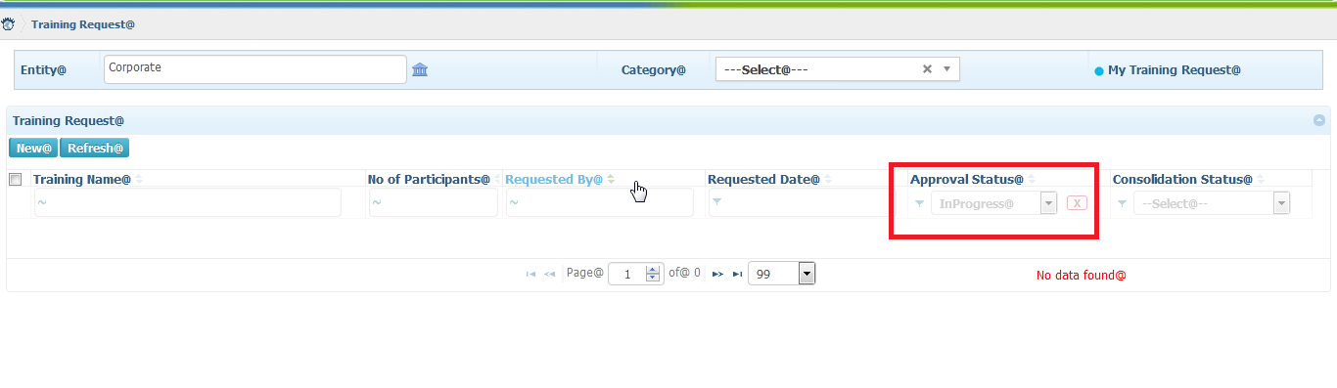

**Steps to Reproduce:**

* Login as HRPRo admin
* Modules-Click on this symbol and select hrpro.
* HRPro homepage will open.
* Select training tab click on request, it will open the request page.
* Select the approval status dropdown and click inprogress
* It will show no data found.

6. Consolidation menu

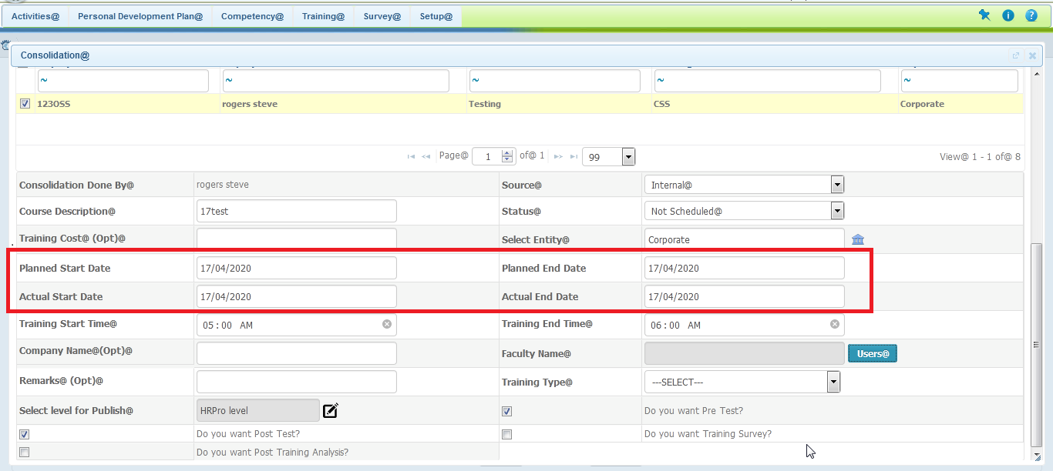

**Steps to reproduce:**

* Login as HRPRo admin
* Modules-Click on this symbol and select hrpro.
* HRPro homepage will open.
* Select training tab click on request, it will open the request page.
* Click on the check box (training name) and select consolidate, by which it is in the status of not consolidated. Also, in consolidation menu).
* It will open the consolidation page.
* The above-mentioned image as red box is shown(issue).

**7.** Consolidation-users button.

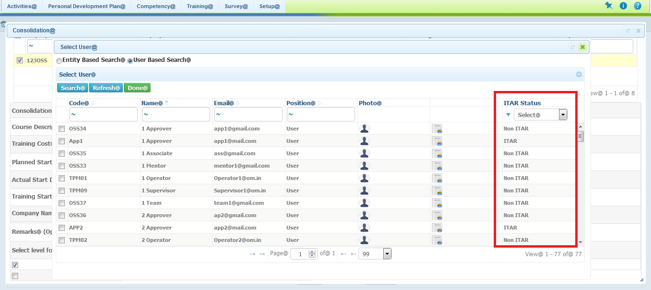

**Steps to reproduce:**

* Login as HRPRo admin
* Modules-Click on this symbol and select hrpro.
* HRPro homepage will open.
* Select training tab click on request, it will open the request page.
* Click on thecheck box (training name) and select consolidate, by which it is in the status of not consolidated.
* It will open the consolidation page.
* Click on the users' button. It will open the select users page.
* On that the ITAR status column has shown in the image

8. setup-training-records

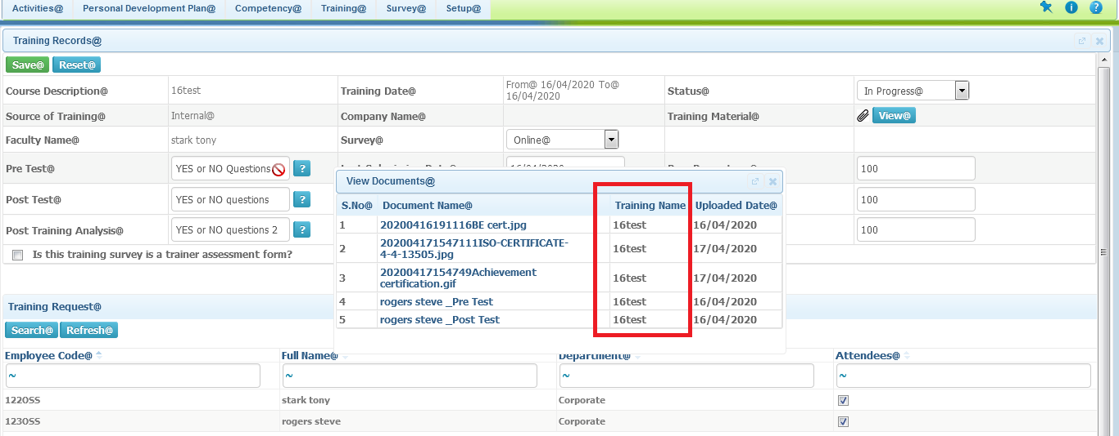

**Steps to reproduce:**

* Login as HRPRo admin
* Click on this symbol and select hrpro.
* HRPro homepage will open.
* Select training tab click on records, it will open the records page.
* Click on any course description and It will open the training records page
* Click this symbol near the training material and it will show the above menu as in the image.

9. Competency-competency evaluation-select employee

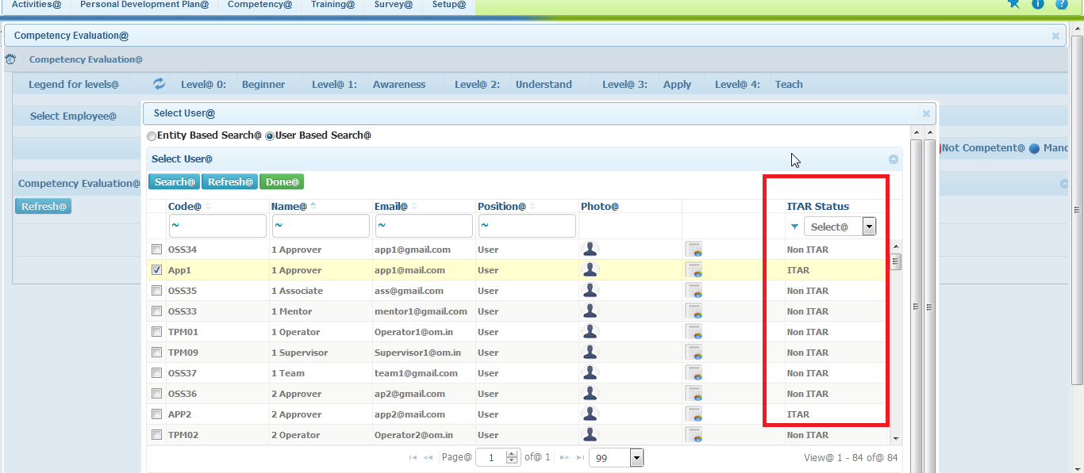

**Steps to reproduce:**

* Login as HRPRo admin
* Click on this symbol and select hrpro.
* HRPro homepage will open.
* Then go to competency menu and select the competency evaluation and then on that select employee on the side symbol
* It will open the user category and select the add user from the drop down.
* Then the select users page will open on that it is same as above image. The @ symbol is not there as shown in above image marked red.

10. Competency-certification details

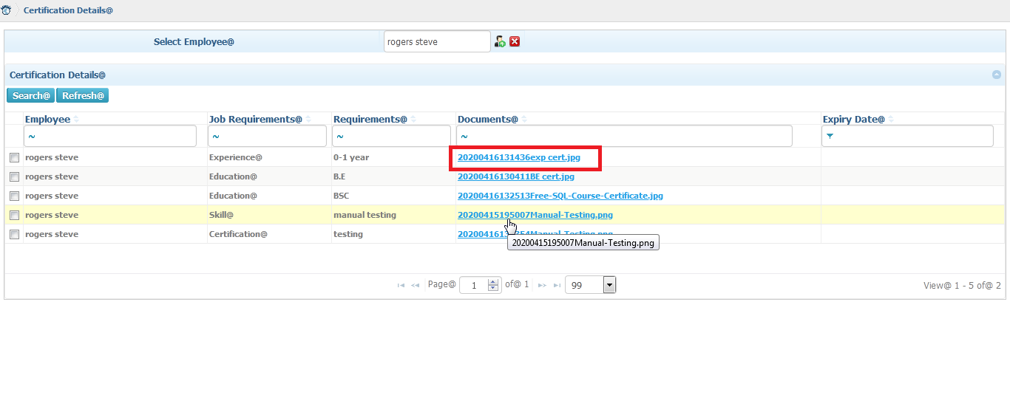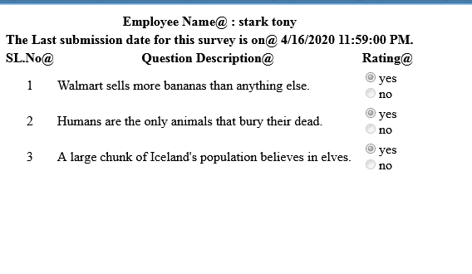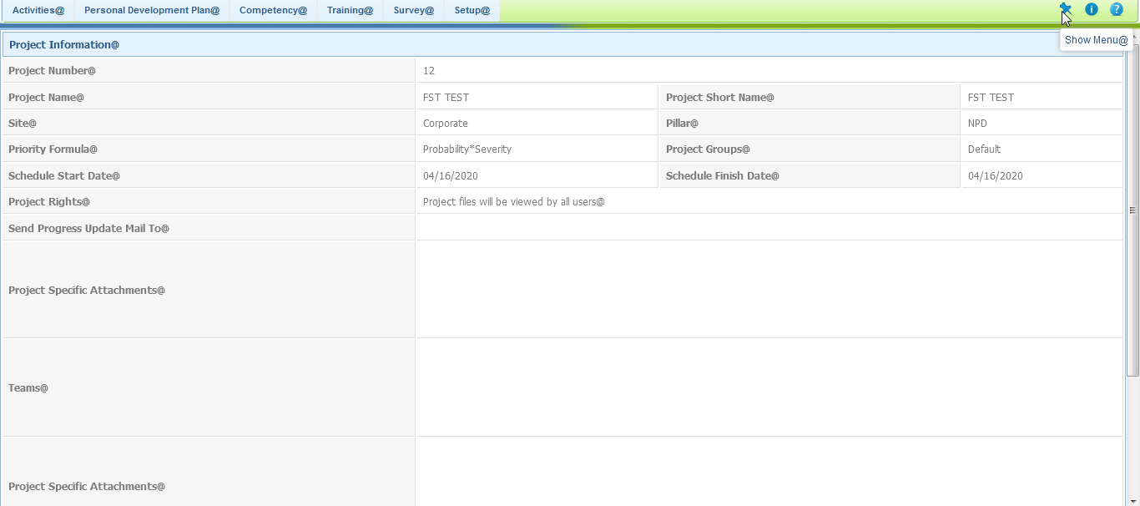

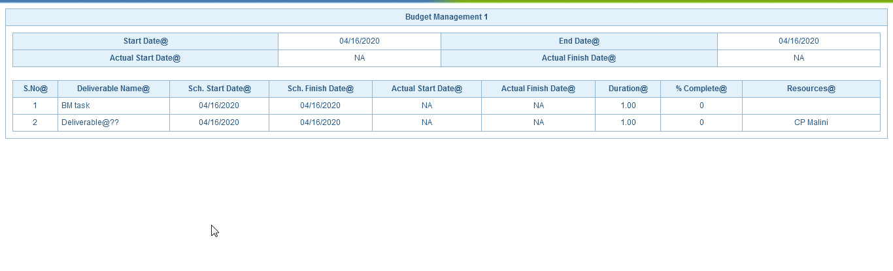

**Steps to reproduce:**

* Login as HRPRo admin
* Click on this symbol and select hrpro.
* HRPro homepage will open
* Click on competency menu and select certification details.It will open that page.
* Then select the first one of the documents.
* By clicking on that, it will open the test result as shown in the 2ND IMAGE.
* Then select the second one of the documents.
* By clicking on that, it will open result as shown in the 3rd IMAGE.
* Then select the last one of the documents.
* By clicking on that, it will open result as shown in the 4th IMAGE.

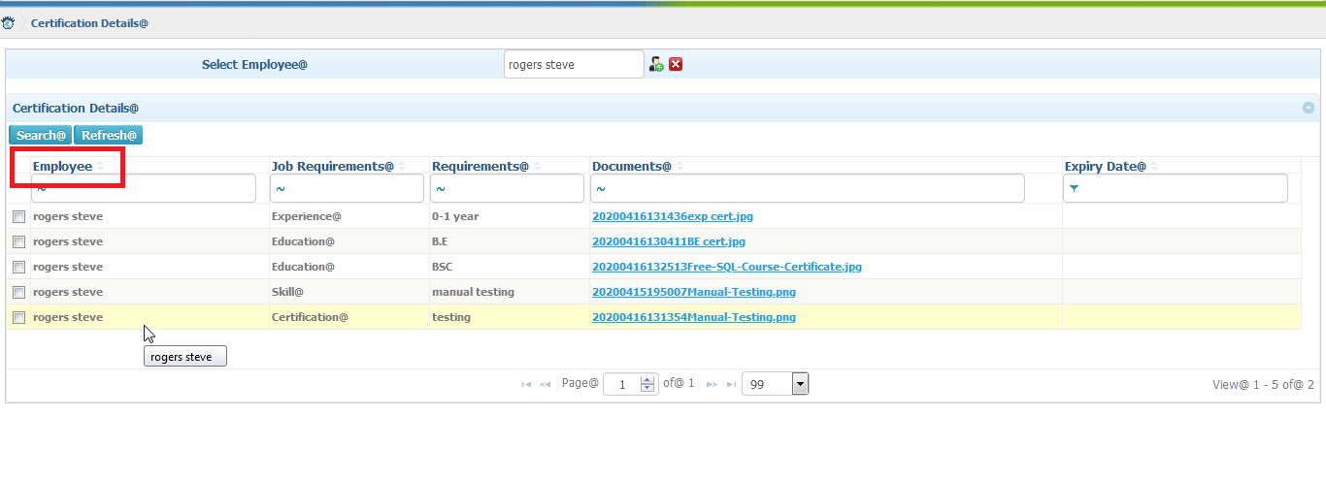

**Steps to reproduce:**

* Login as HRPRo admin
* Click on this symbol and select hrpro.
* HRPro homepage will open
* Click on competency menu and select certification details. It will open that page.
* In employee it doesn’t have the @ symbol as shown in the above image as red.

11.Training-training assigned

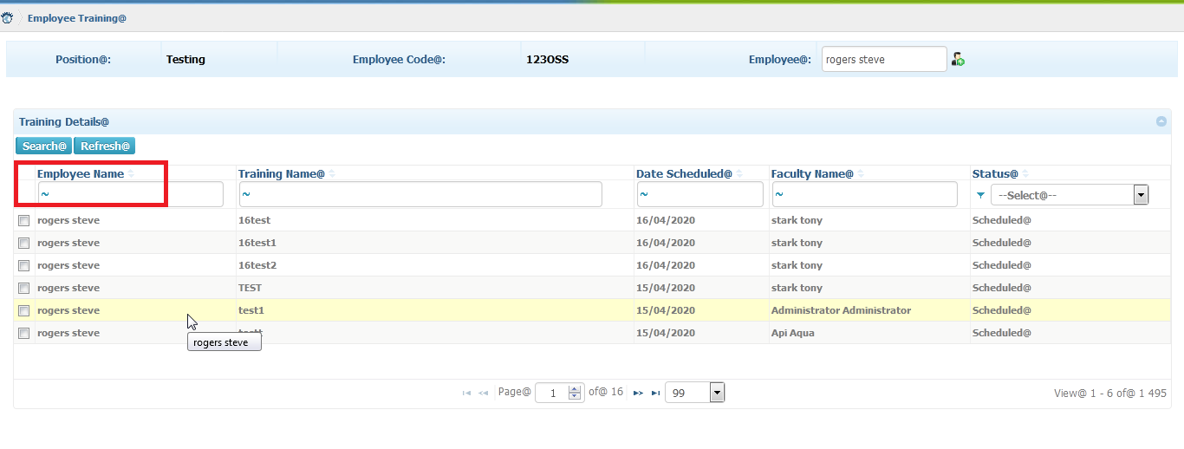

**Steps to reproduce:**

* Login as HRPRo admin
* Click on this symbol and select hrpro.
* HRPro homepage will open.
* Click on the training tab and select training assigned.
* On that page the employe name is not had the @ as shown in the red box.

12. Training-training setup-training type

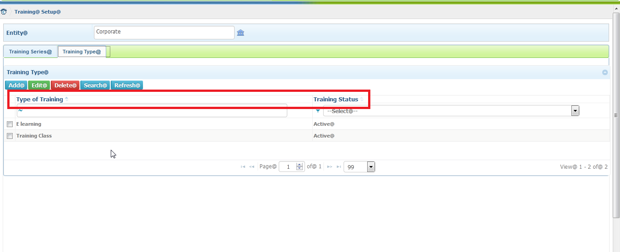

**Steps to reproduce:**

* Login as HRPRo admin
* Click on this symbol and select hrpro.
* HRPro homepage will open.
* Click on the training tab and select training setup
* Onthat page click training type.It will be as above image.
* As markes in redbox.

13.competency-update competency

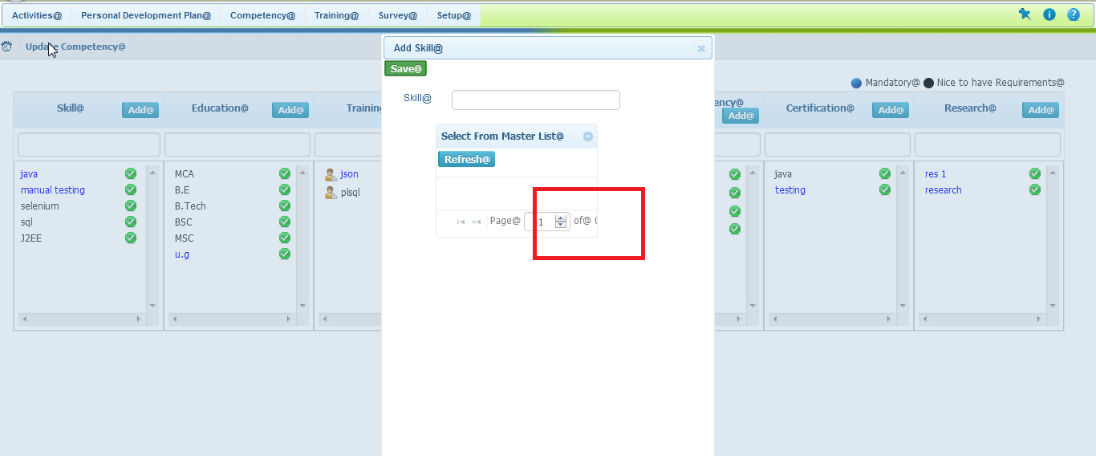

**Steps to reproduce:**

* Login as HRPRo admin
* Click on this symbol and select hrpro.
* HRPro homepage will open.
* Click on the competency tab and select update competency.
* Then click the page will displayed as above.
* The red box shows the details missing as 2nd image.
* It is also same occurs in the job requirements.

14. Activities-actions

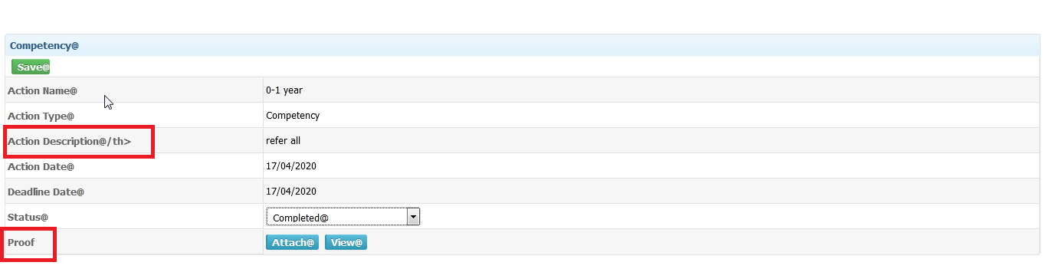

**Steps to reproduce:**

* Login as HRPRo admin
* Click on this symbol and select hrpro.
* HRPro homepage will open.
* Select activities tab and click actions.Then select the actions it will take to new tab and there it is shown(image).