1.Groups-Suppier administrator has not contains ###

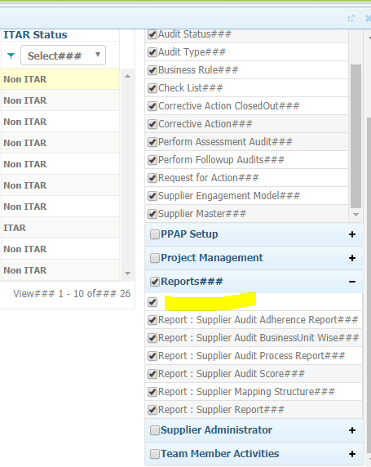

2.Production item adding screen-Tree loaded by label not having ###

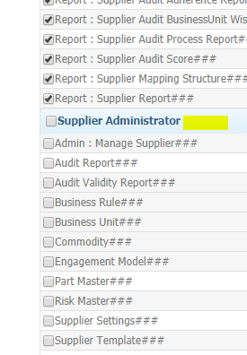

3.Fill checkliats-Checkpoint legends has no ### symbols

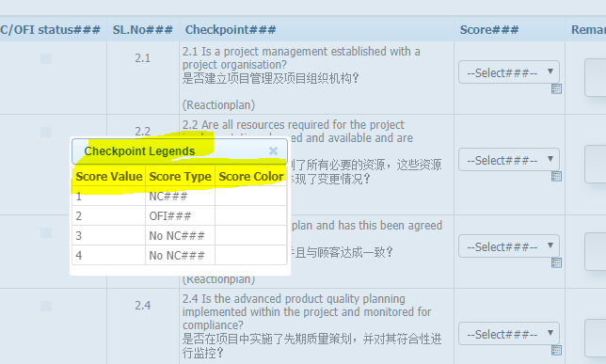

4.Submit to auditte-publish report-Score details section-Result label has no ###

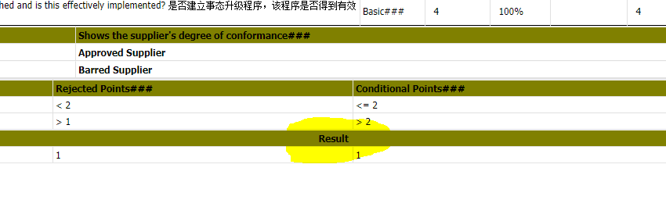

5.Publish report-Export to PDF has no ###

6.Social media-supplier contact login-“Suppliers” has no ### symbol

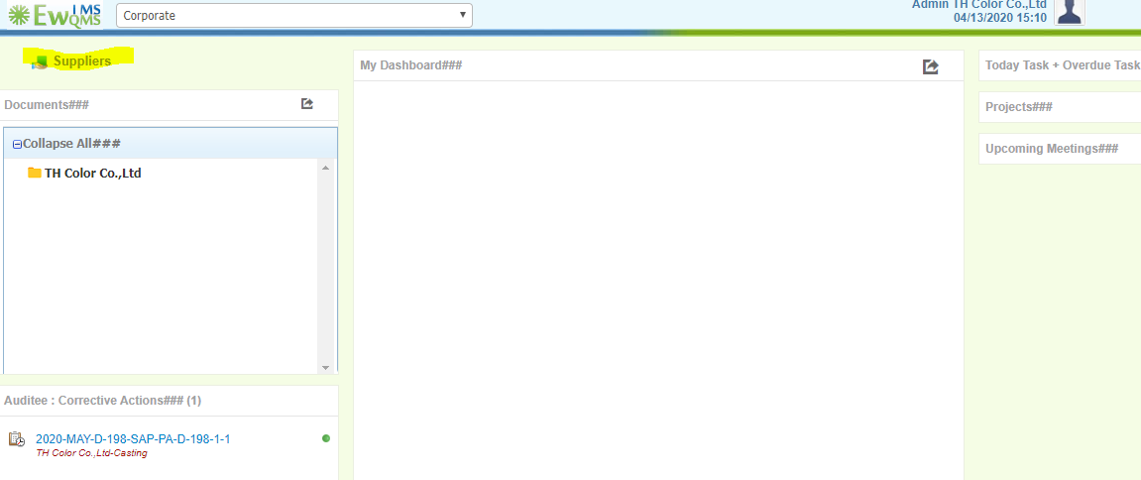

7.Click on legend-Details showing”Assessment details” label has no ###

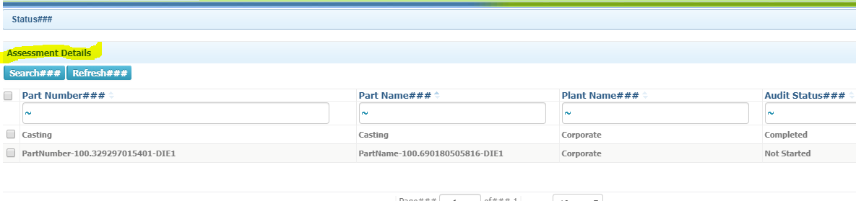

8.VAM audit-publising-“Do you want to repeat audit? Pop up->Start date and end date has no ###

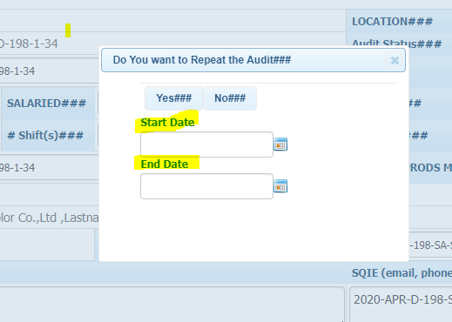

9.Supplier audit expiry report label has no ###

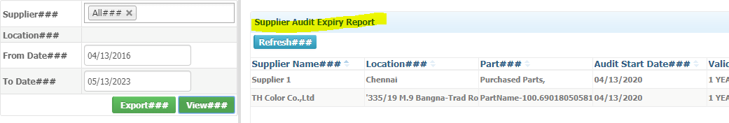

10.