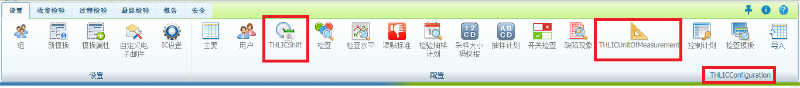

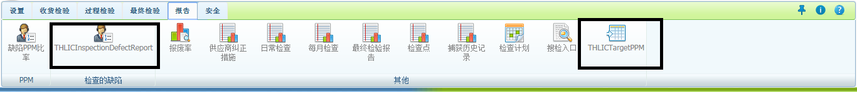

**Group Rights**

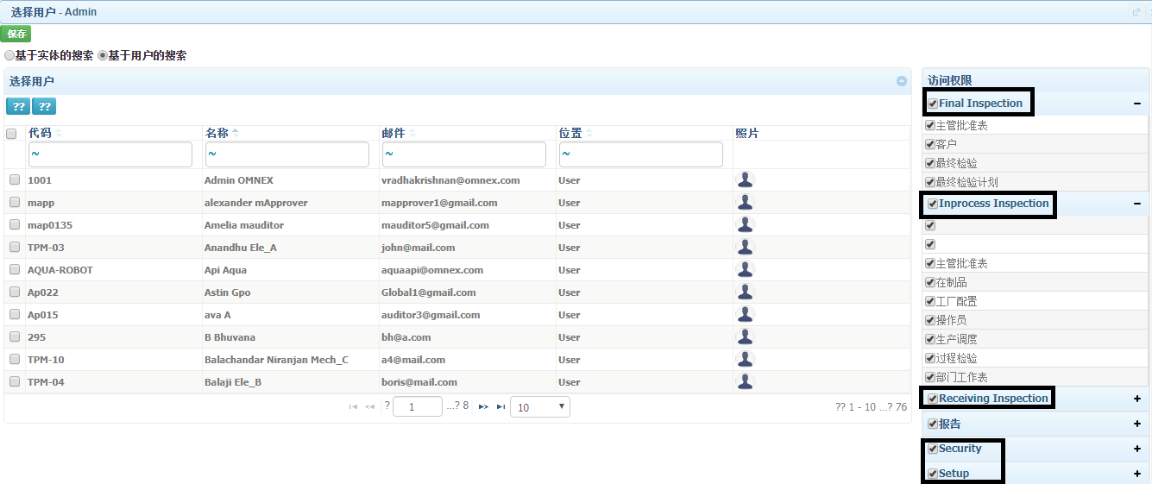

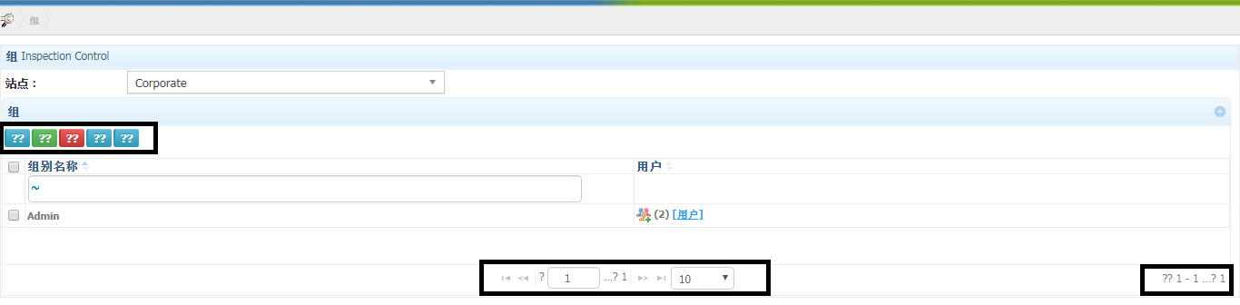

**Customize Email Msg**

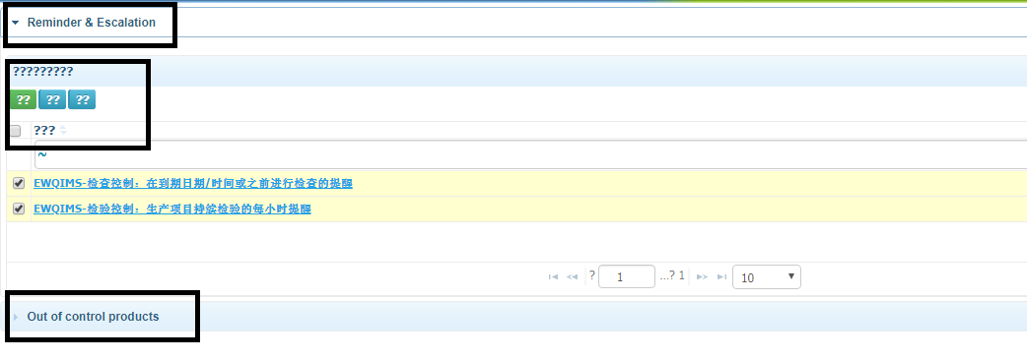

**IC Settings**

**Edit and Save not working in IC Settings page**

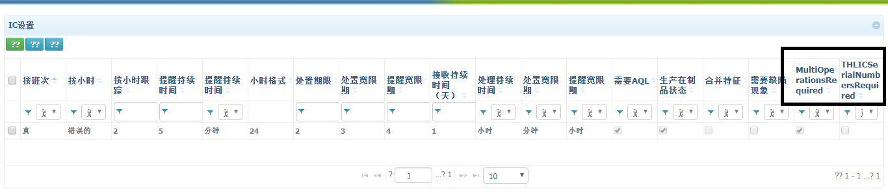

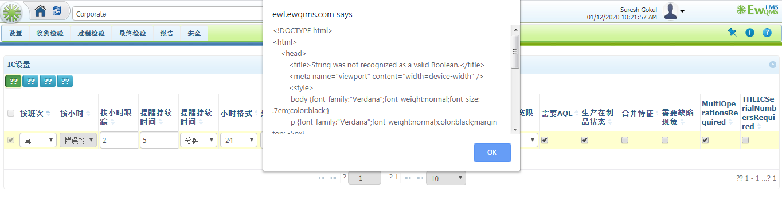

**Inspection Sampling Plan**

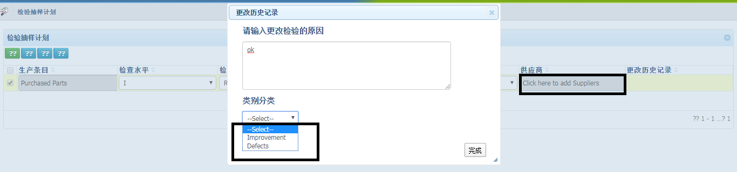

**Unit of measurement**

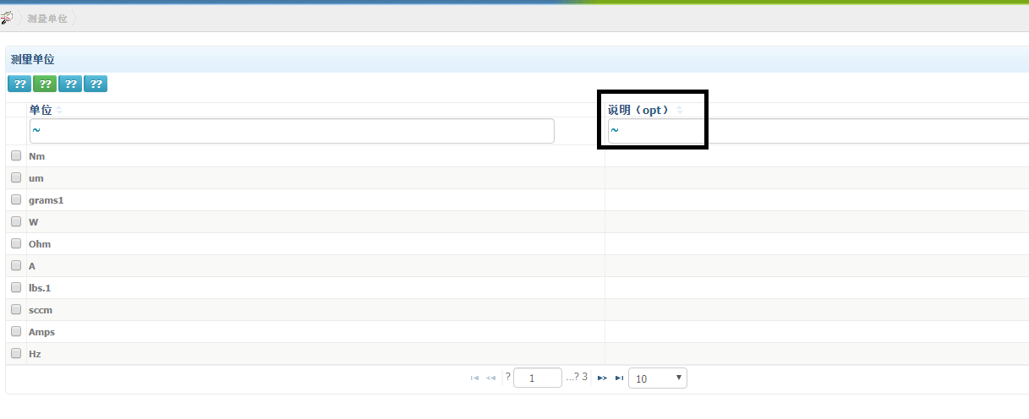

**Defects**

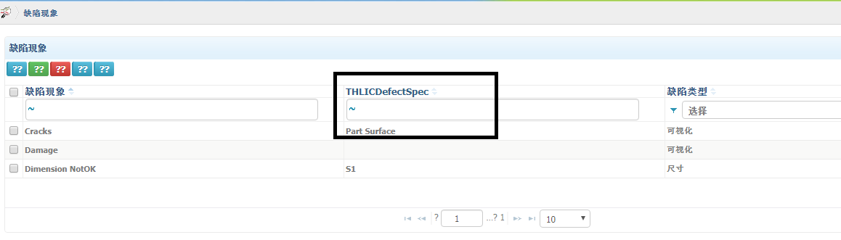

**Receiving Inspection scheduling**

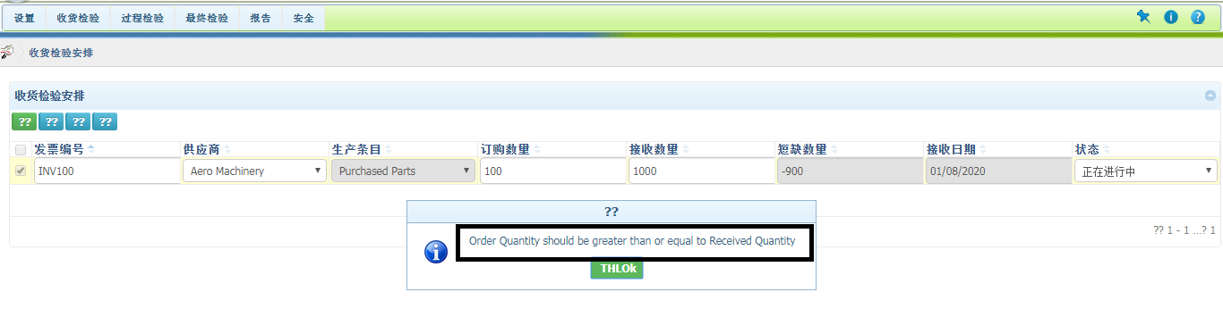

**Supervisor Approval page**

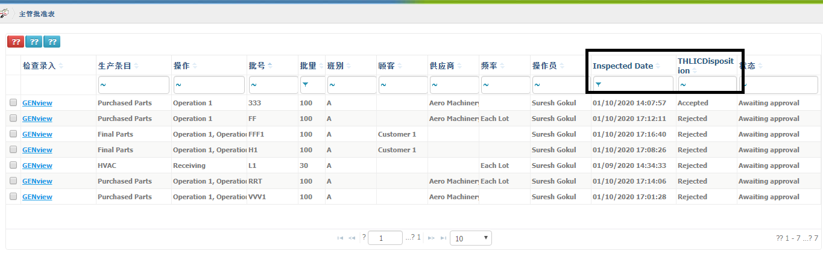

**Inspection Entry Pop-up**

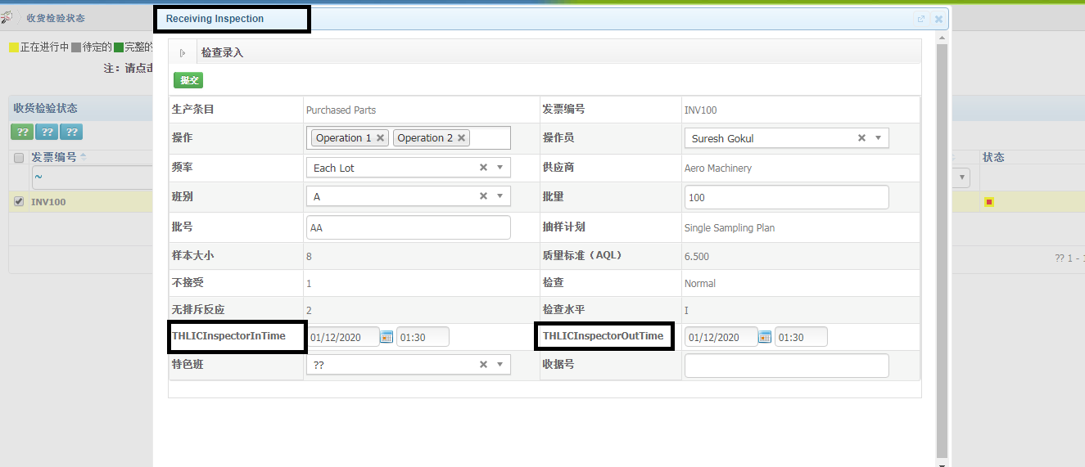

**Alerts in Inspection Sheet**

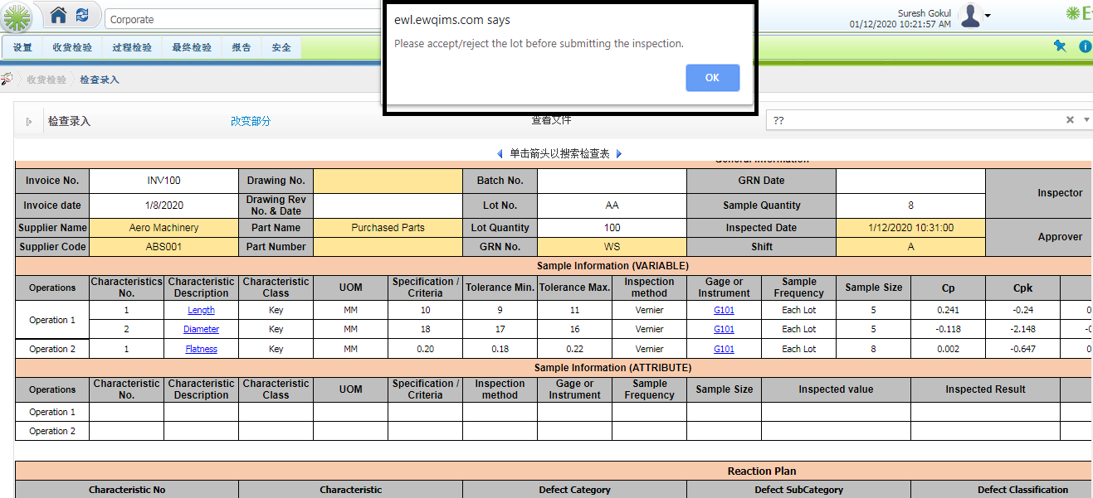

**Report**

