2. Tooltip for Favourites - FIXED

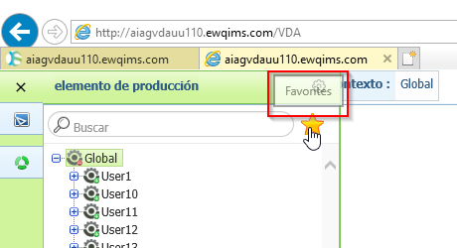

3. Percentage Allocation Tooltip – NOT FIXED (NAME NOT CONVERTED)

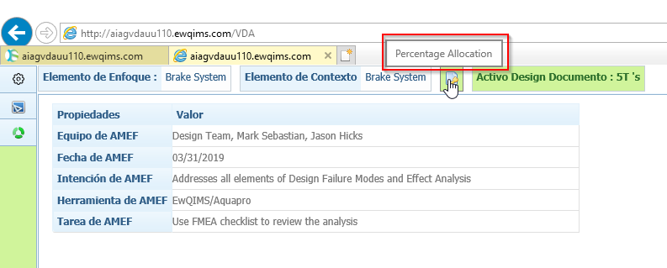

4. Label for Step in Percentage allocation and Step No.5 is overlapped. – NOT FIXED (NAME NOT CONVERTED)

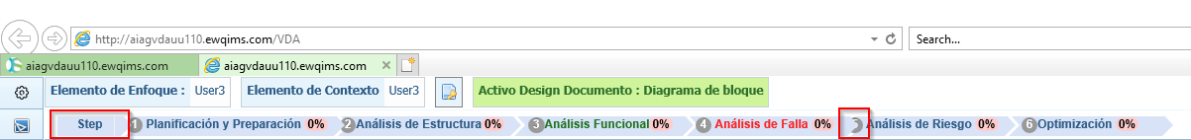

5. Change Grid Size and Redo tooltips and label for Zoom and Grid Size are not converted. – NOT FIXED (NAME NOT CONVERTED)

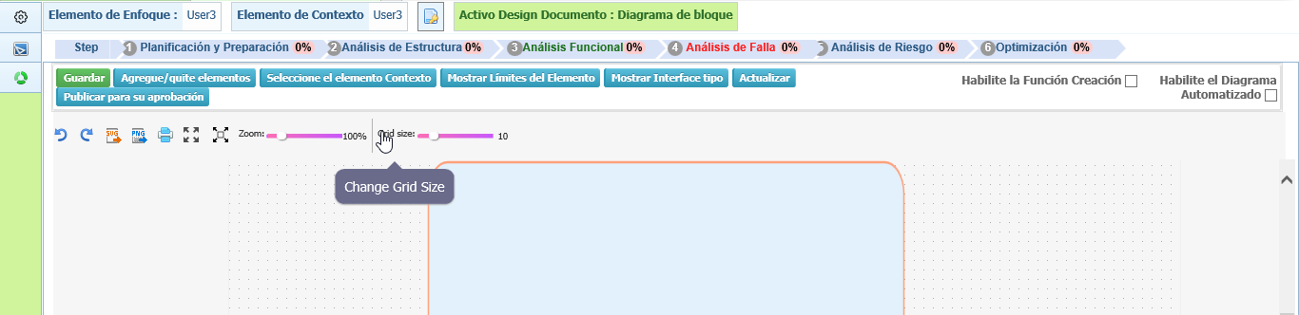

6. Percentage allocation is not opening. – NOT FIXED

7. Ok button for Add/Remove BOM Elements and Context Elements. – NOT FIXED

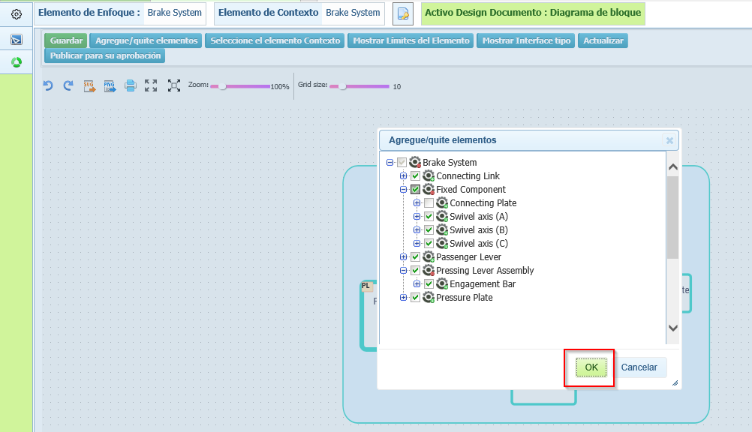

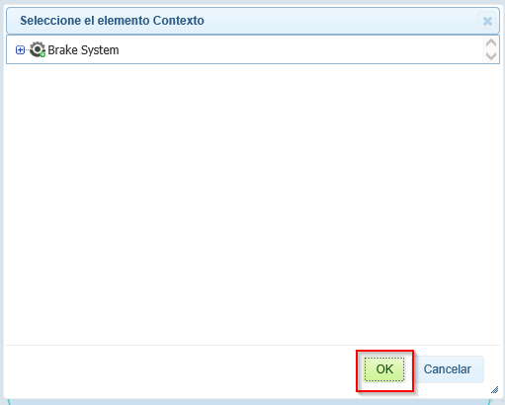

8. Item Boundaries Header – NOT FIXED

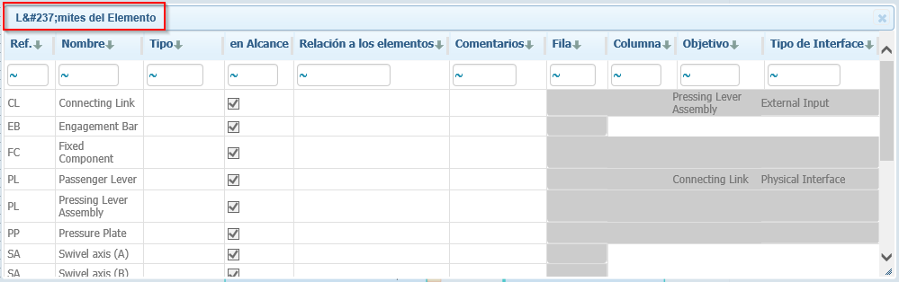

9. Interface Types – Color label - FIXED

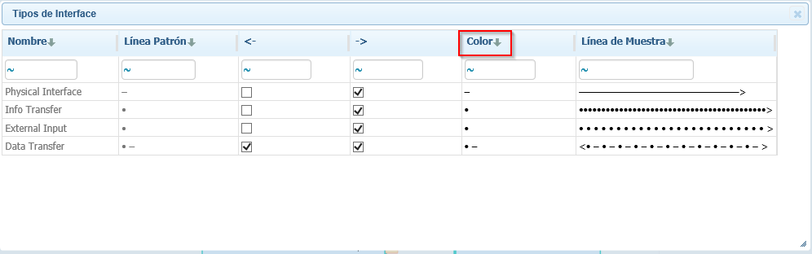

10. Publish for Approval Label - FIXED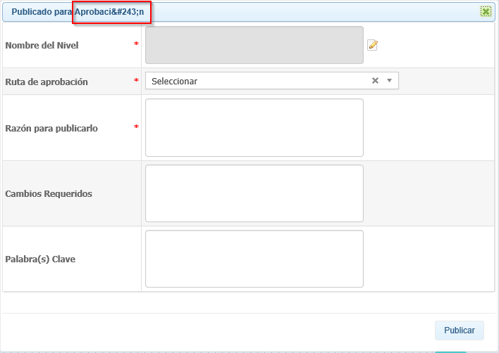

11. Structure Analysis Header – FIXED

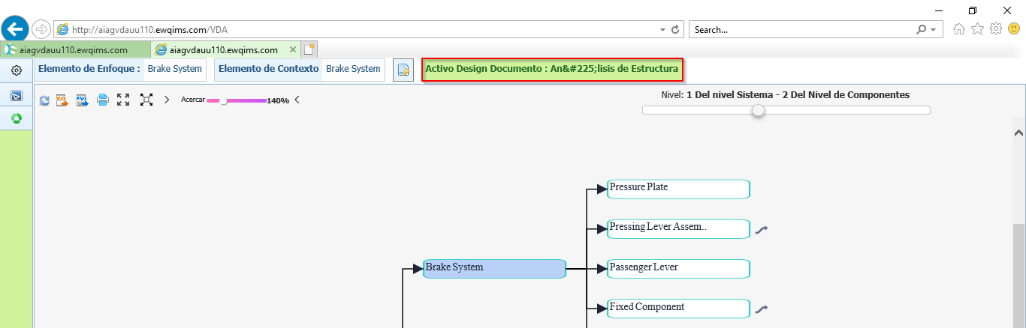

12. Create and Add Production Item header in both PI table and BOM table – NOT FIXED

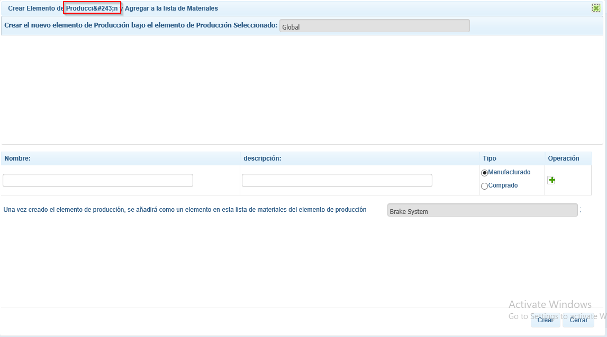

13. Add Characteristics – OK Button – NOT FIXED

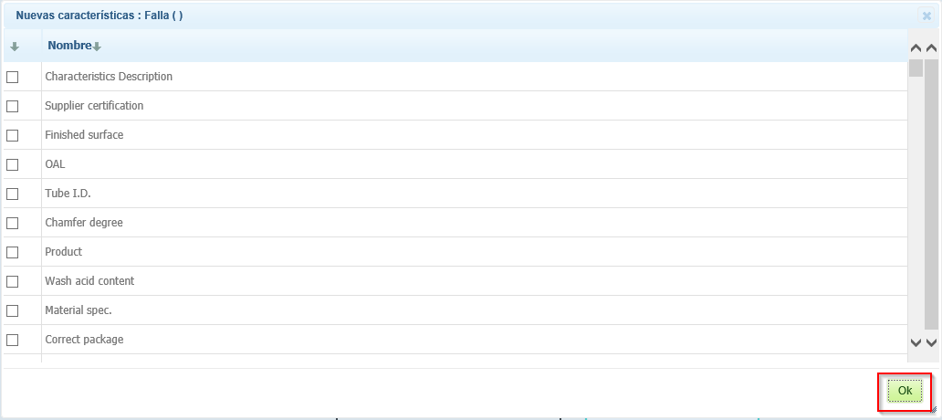

14. Functional/Failure Analysis Active Document - FIXED

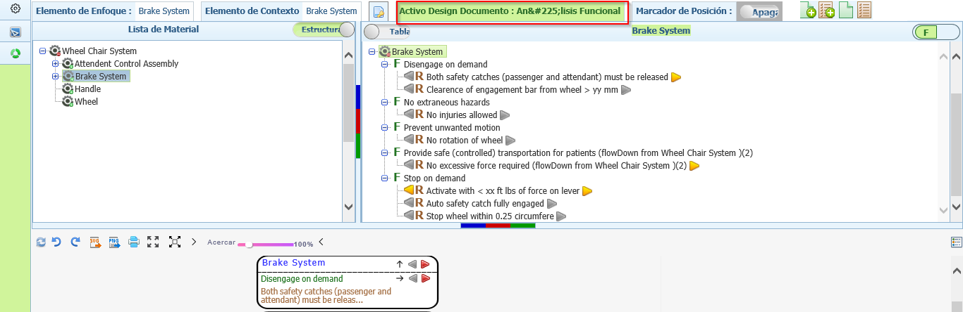

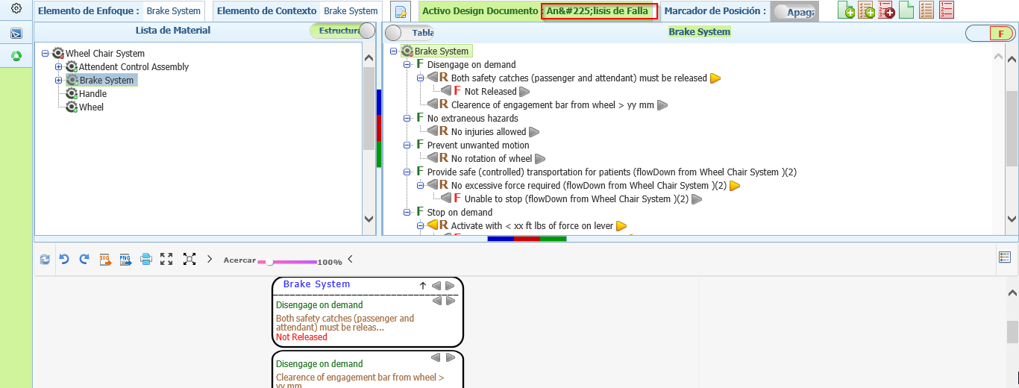

15. OK button for Flow Up, Flow Down, Edit Requirement, Flows Done and Reset Flows Done Popup. – NOT FIXED

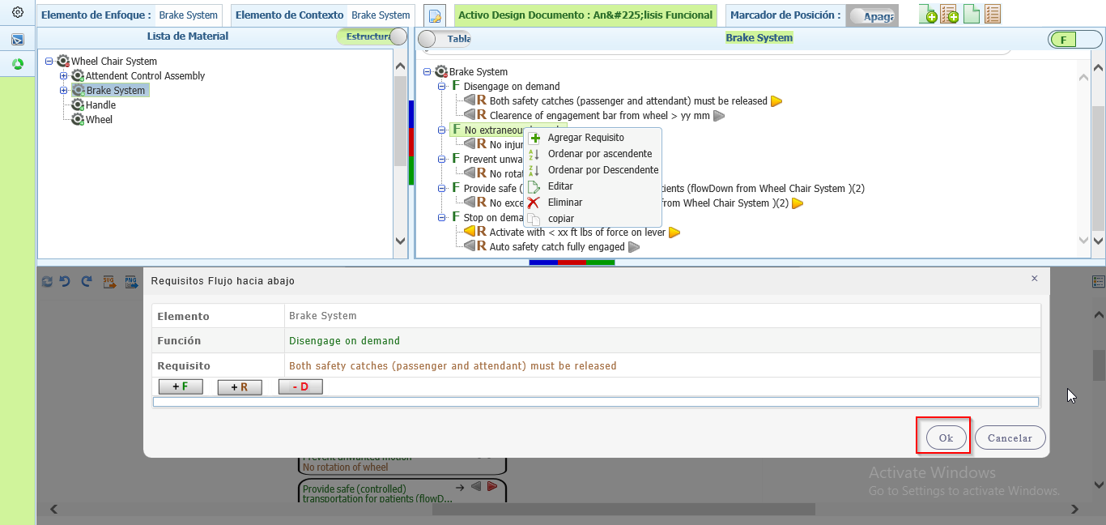

16. Function/ Requirement/ Failure master table and Show/Hide Function/ Requirement/ Failure Tooltips are not converted – FIXED

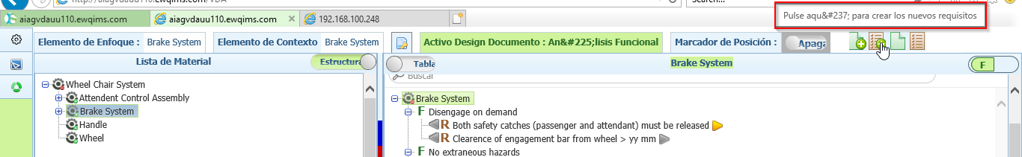

17. IFM - Description for Risk Values and DFMEA is displayed as AMEFD – NOT FIXED

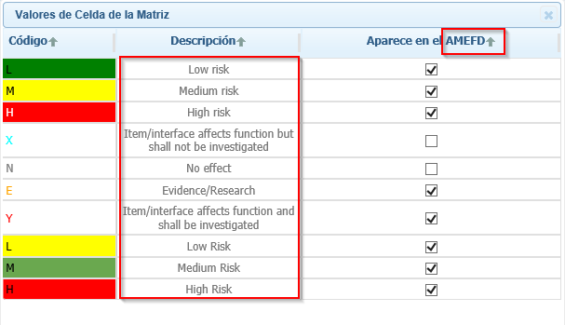

18. IFM - De-allocate label – NOT FIXED

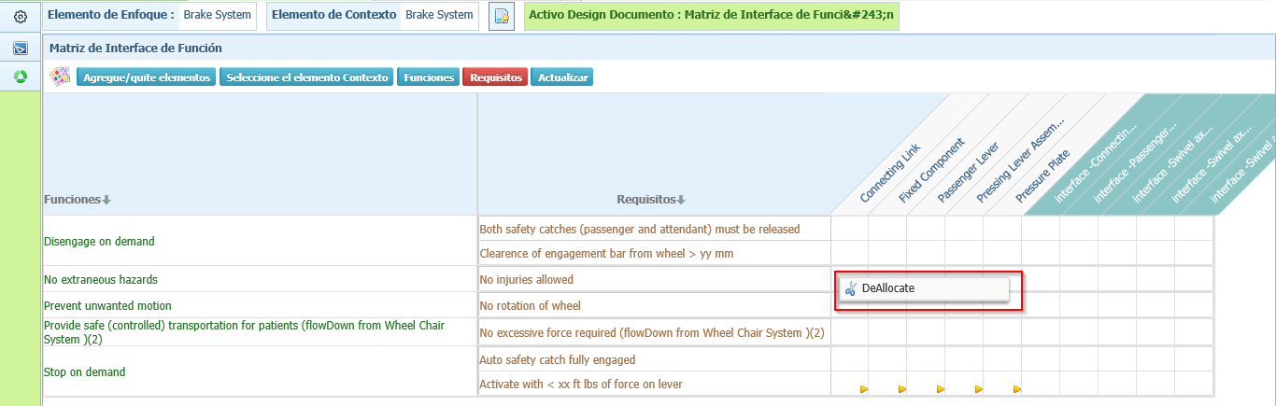

19. Risk Allocation Table in IFM – FIXED

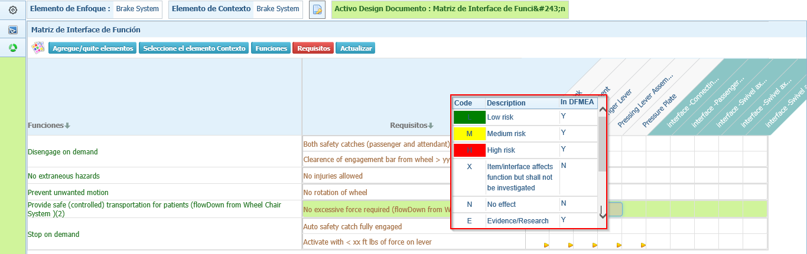

20. Name label and OK button for Function and Requirement Master table – NOT FIXED

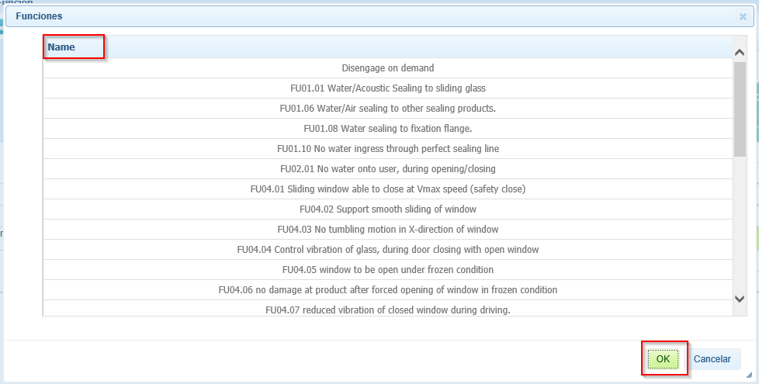

21. Interface Matrix – Legend table and Tooltip – NOT FIXED

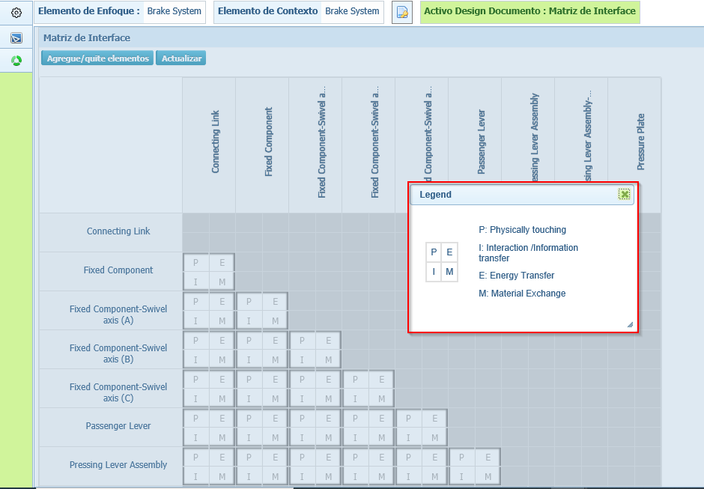

22. OK button for Cause/ Select dropdown for Effect/ Characteristics Master tables. – NOT FIXED

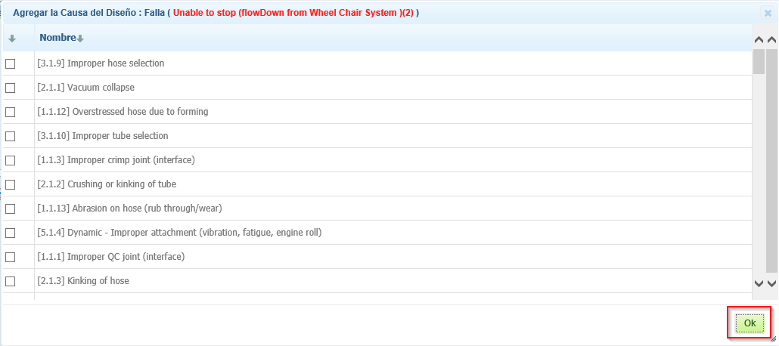

23. Status Dropdown and OK in Risk and Optimization page in both Process/Design VDA – NOT FIXED

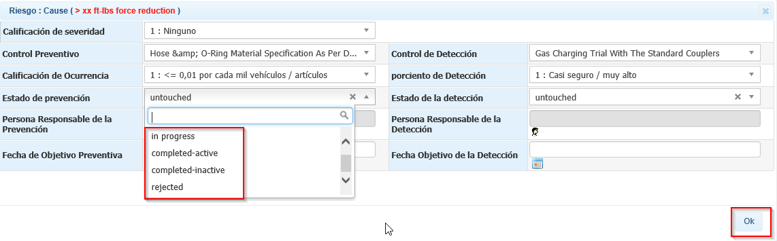

24. Responsible person – Select User popup Header. – NOT FIXED (Name Not Converted)

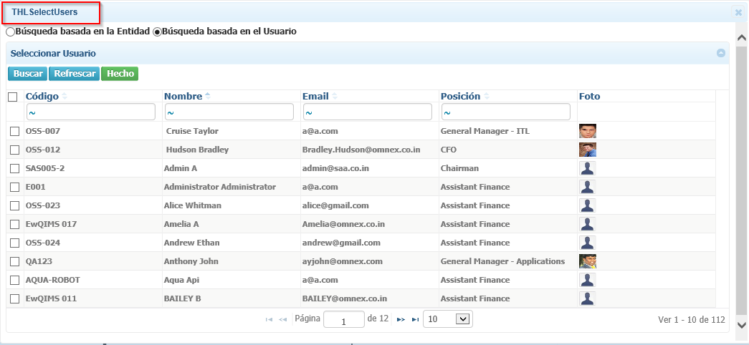

25. Calendar buttons are not converted. – NOT FIXED

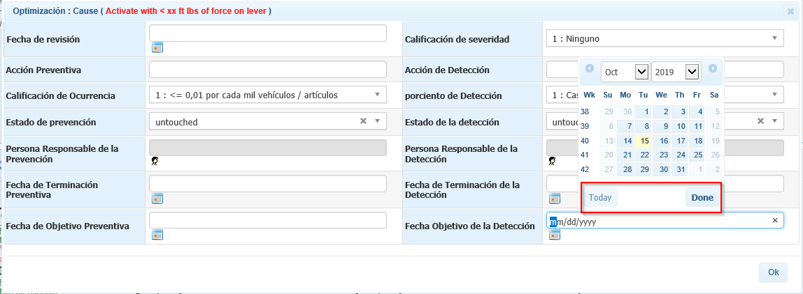

26. Active Document label for DFMEA and the entire Document. - FIXED

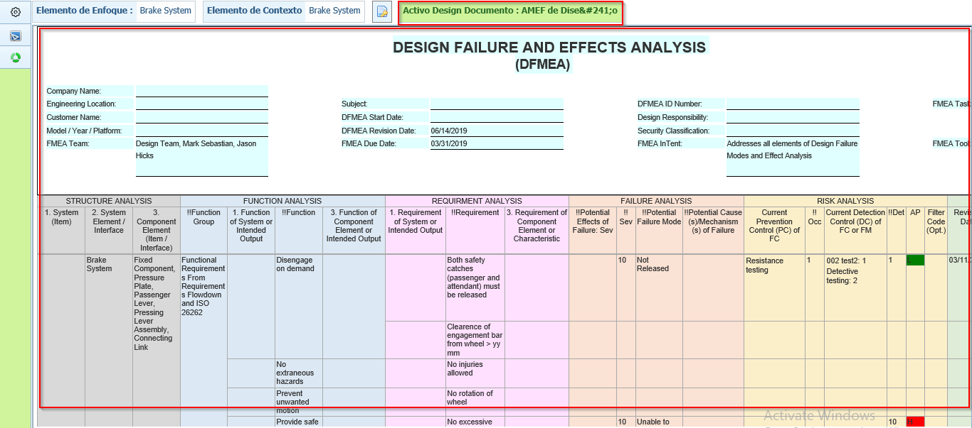

**Process VDA:**

27. FMEA is displayed as AMEF in both Design and Process – NOT FIXED

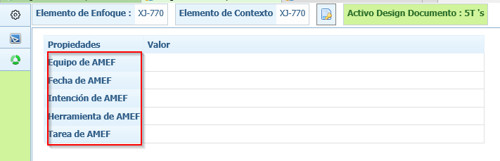

28. Topic Segment Header and Process label – HEADER (NOT FIXED) & PROCESS LABLE (FIXED)

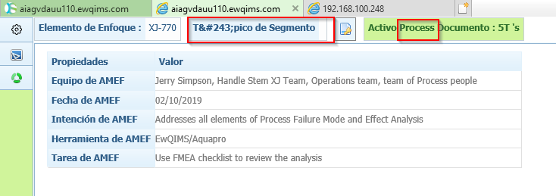

29. Favourite Production Item

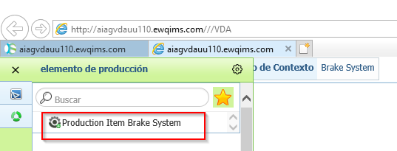

30. Active Document Label for Structure Analysis – FIXED

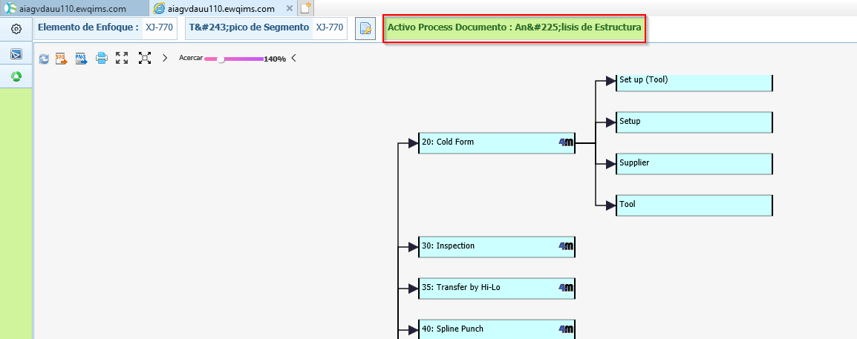

31. 4M Popup window – Select an Option for Failure – NOT FIXED

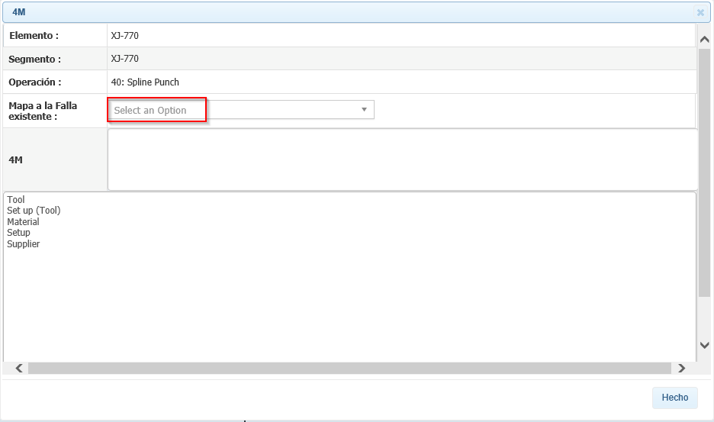

32. Operation Popup – Header and select Dropdown – NOT FIXED (SELECT DROPDOWN OPTION) & FIXED (HEADER)

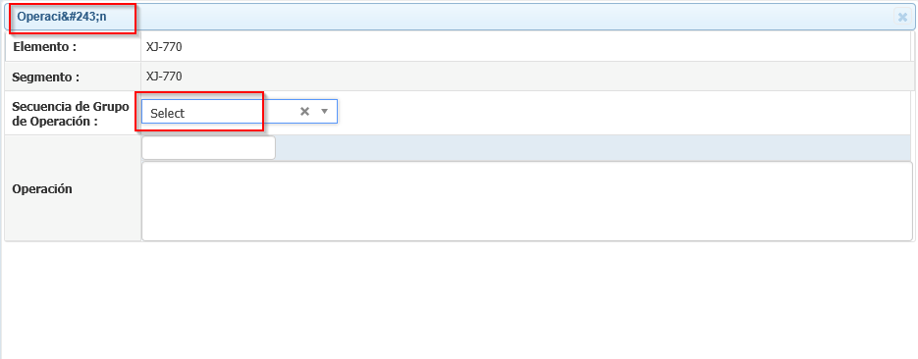

33. Functional Analysis – Active Document Label and Structure View Header – Active Document is FIXED Structure View header is Not Fixed

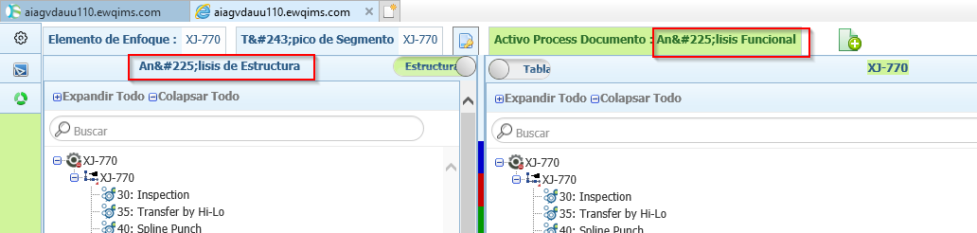

34. (Tree View) Delete confirmation for Segment/ Operation/ Characteristics/ Failure/ Effect/ Cause - FIXED

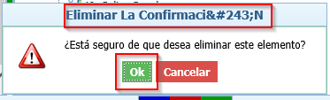

35. (Tree view) Edit Popup window for Operation/ Characteristics/ – OK and Header

Ok button for Effect and Cause – NOT FIXED

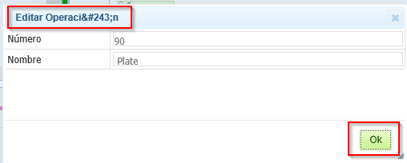

36. (Diagrammatic View) **Edit Effect/ Edit Cause/ Edit Work Element Function/ Edit Process Item Function/ FourM** Pop windows are not converted completely. FIXED

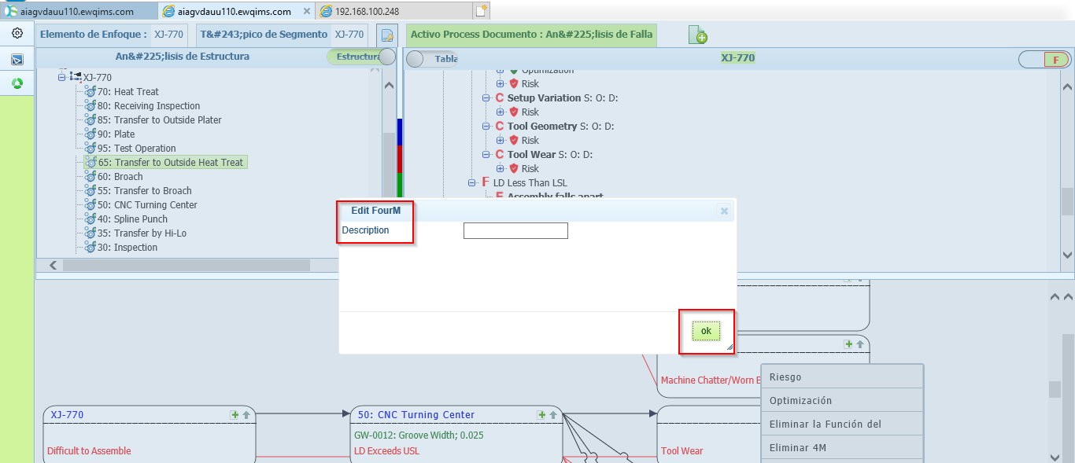

37. (Tree View) Header for Process Item Function/ Work Element Function/ 4M Dialog window - FIXED

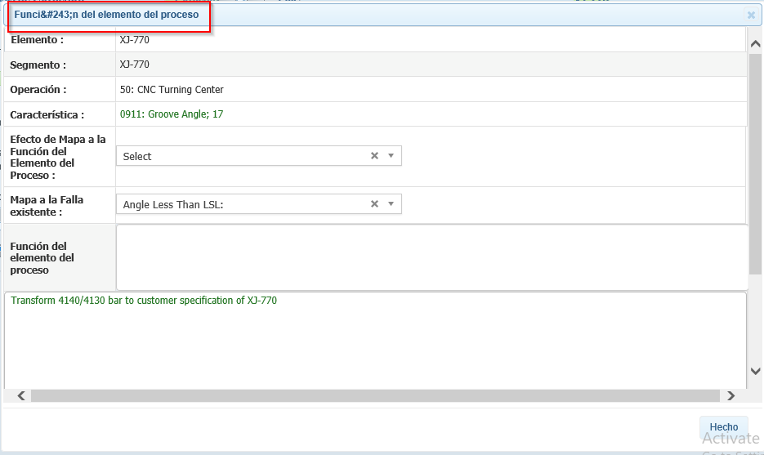

38. Name label for Create and Map option for all master tables - FIXED

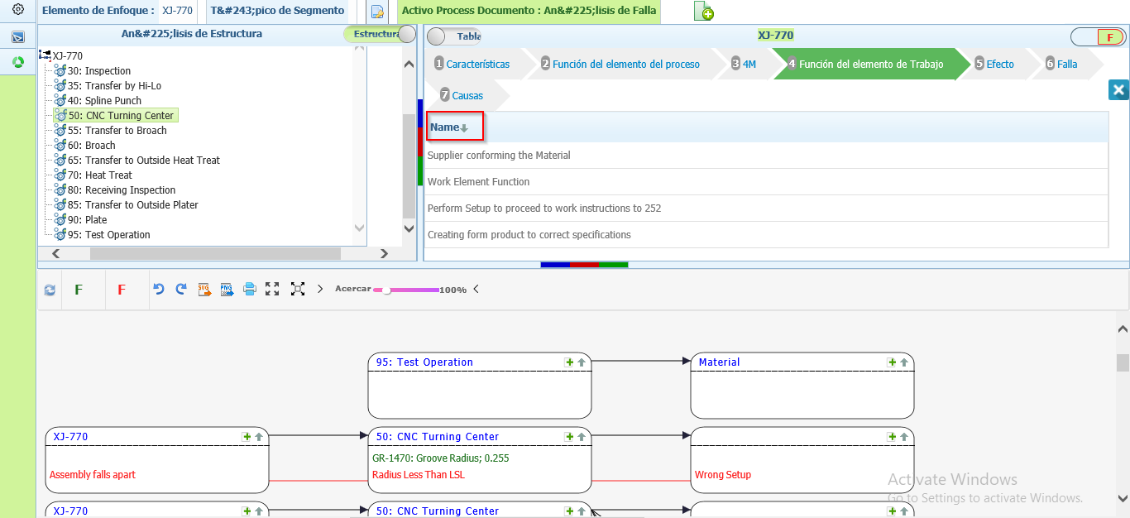

39. (Table View) Right Click context menu list is overlapping on each other. – NOT FIXED

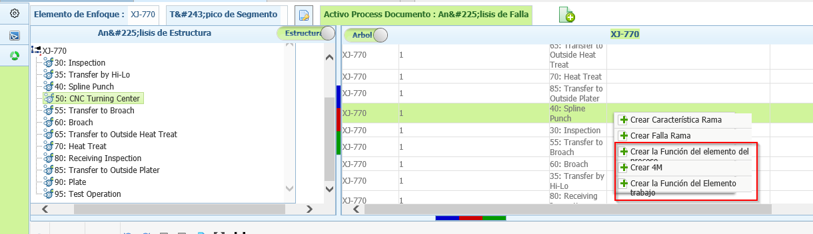

40. Header Name for master Table and Tooltip – NOT FIXED (Tool Tip for TABLE(S) is not fixed)

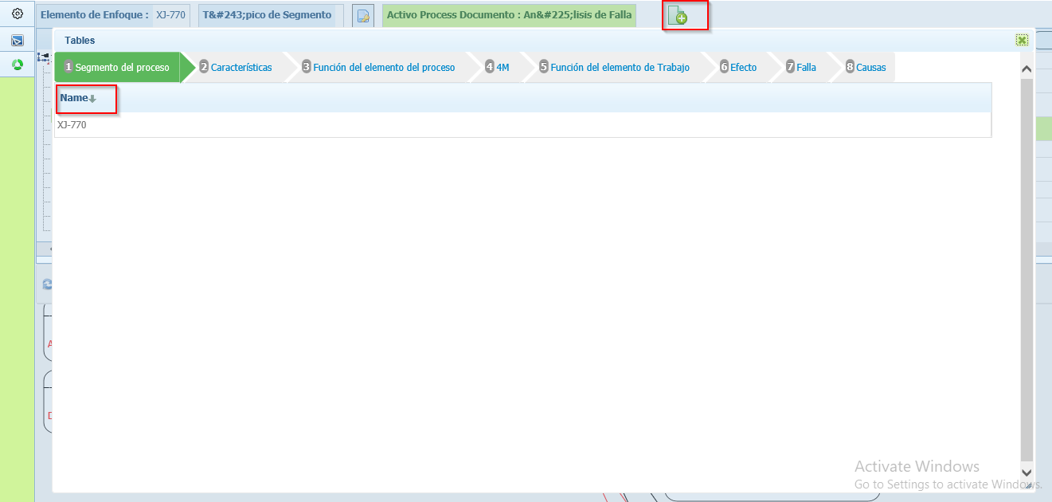

41. Tooltip for Show/Hide Function (Characteristics)/Failure option in Diagrammatic view – NOT FIXED

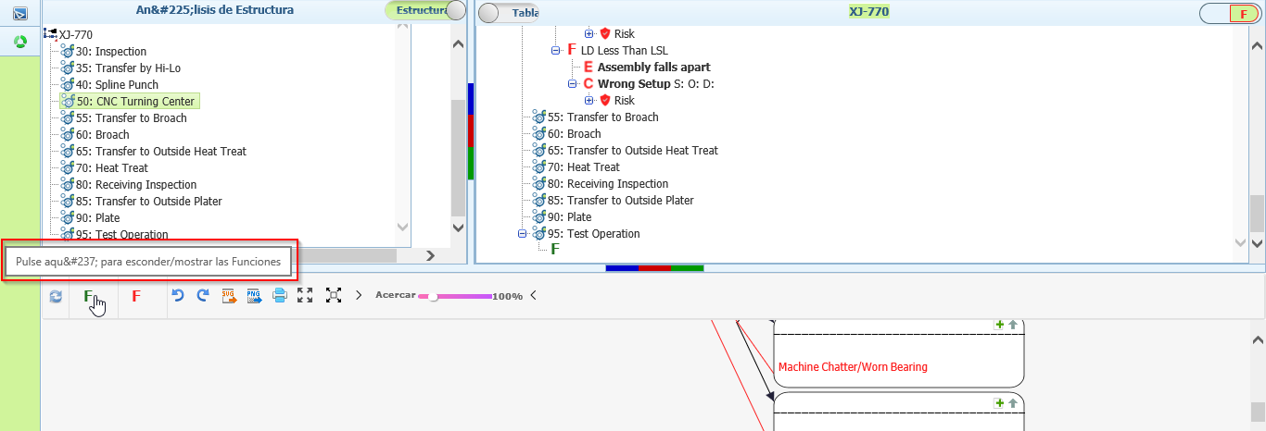

42. Process FMEA Active Document header and Whole Document is not converted. – NOT FIXED

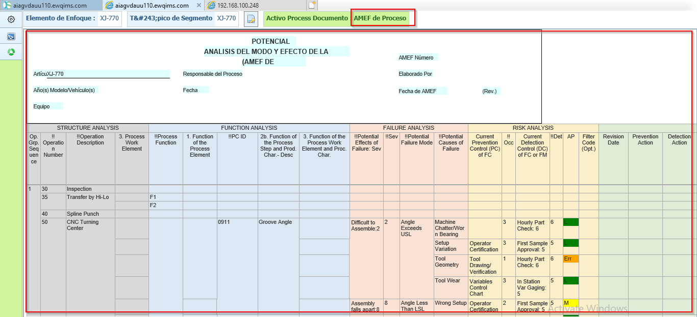

43. Tooltip for Maximize, Reset, and Minimize is not converted – NOT FIXED

