1. Delete PI cancel should be converted

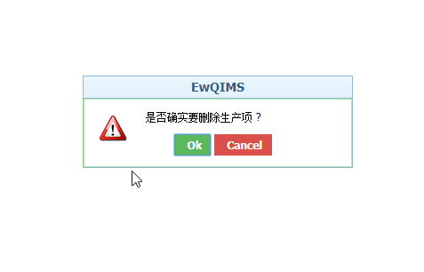

2. Import > browse and upload should be converted

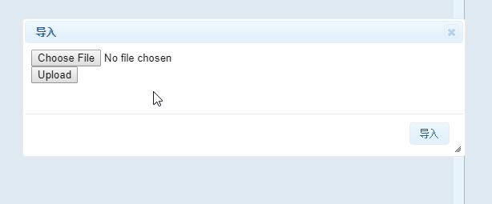

3. VOC>flow down Indicator> Delete function button>cancel should be converted

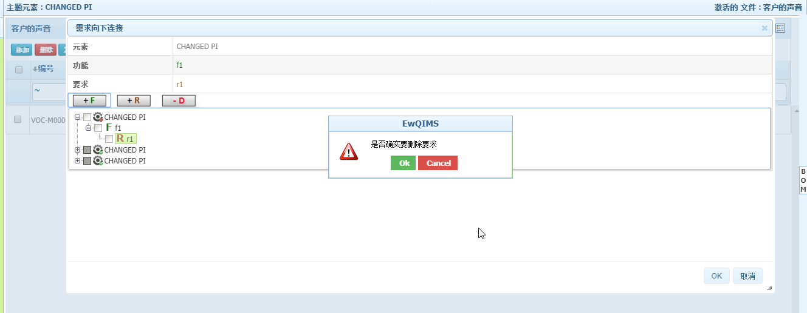

4. Function>Rightclick on header>Edit dropdown/manage item type/ready-only should be converted

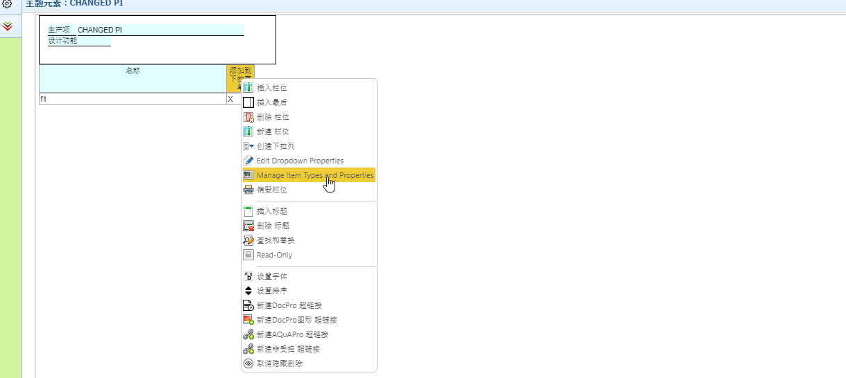

5. Failure> Rightclick on branch>Undo and replace should be converted

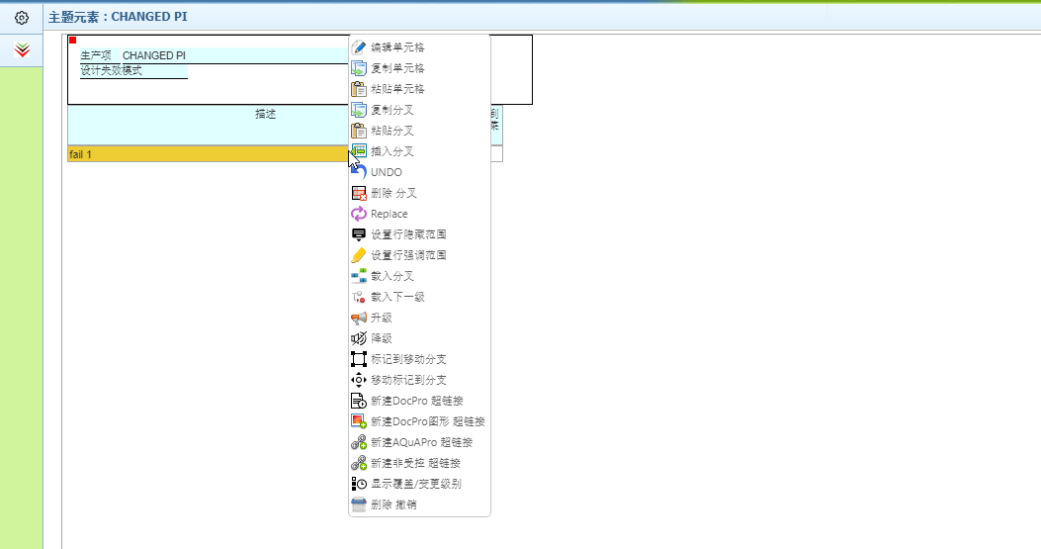

6. Failure Tree>Tooltip option for undo/redo/open as SVG/PNG/print/fullscreen/Zoom tofit/zoom in/zoom out should be converted

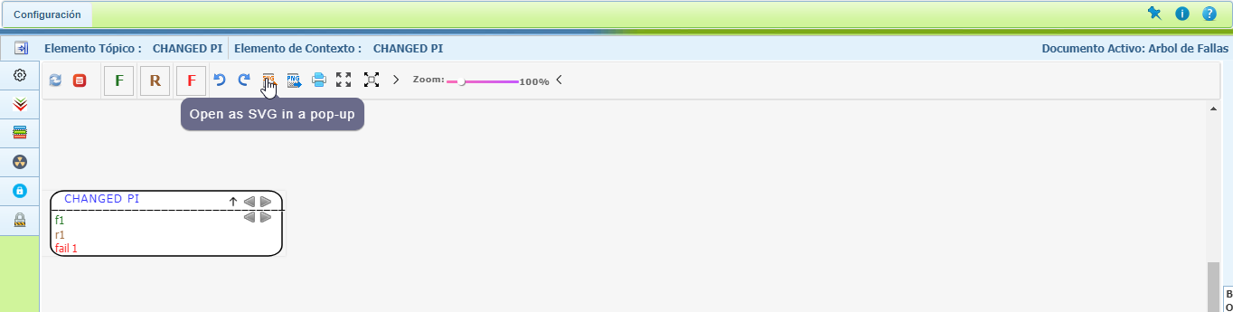

7. EFC Tree> Publish Should be converted 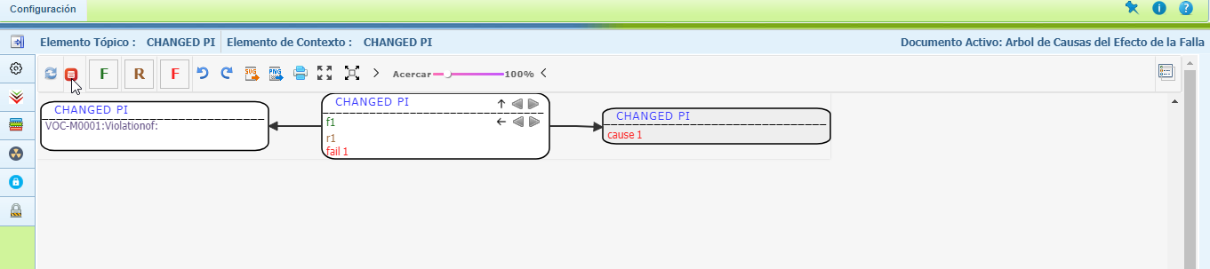

8. DFMEA page should be converted

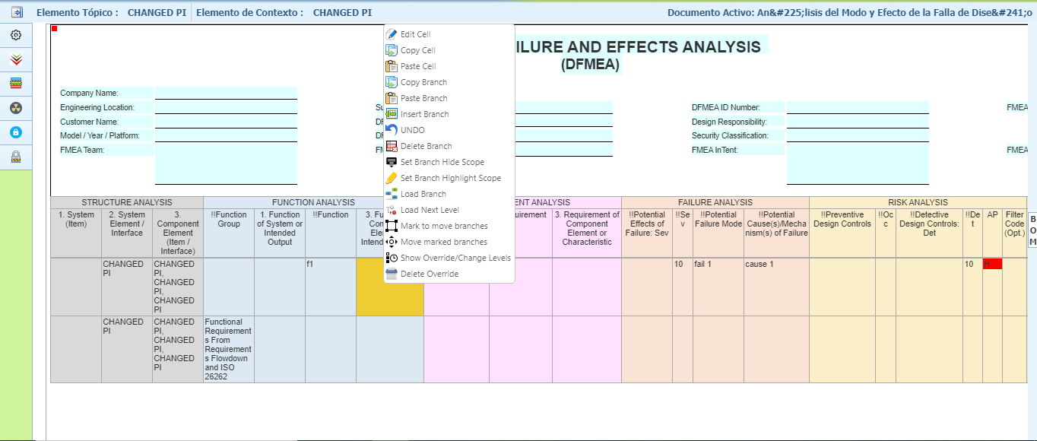

9. DVP&R page should be converted

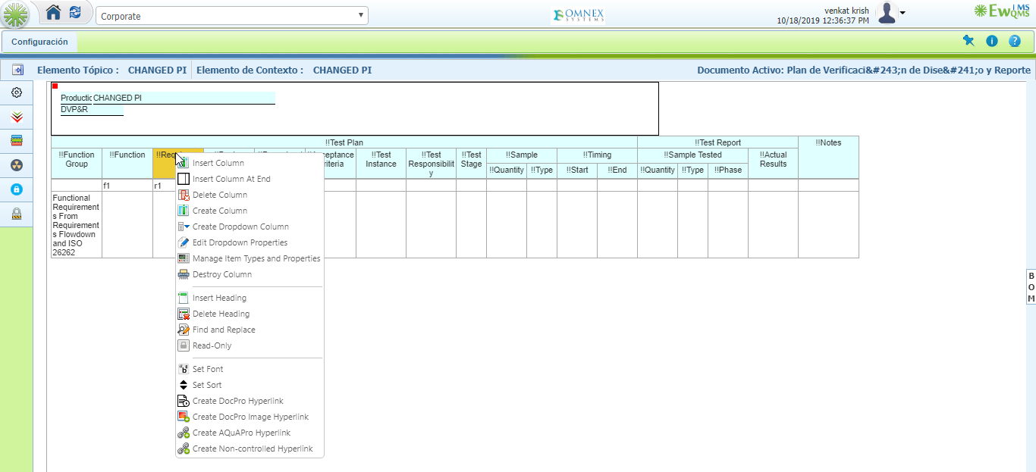

10. Impact Analysis: Tool Tip options and style/normal/size for impact analysis should be converted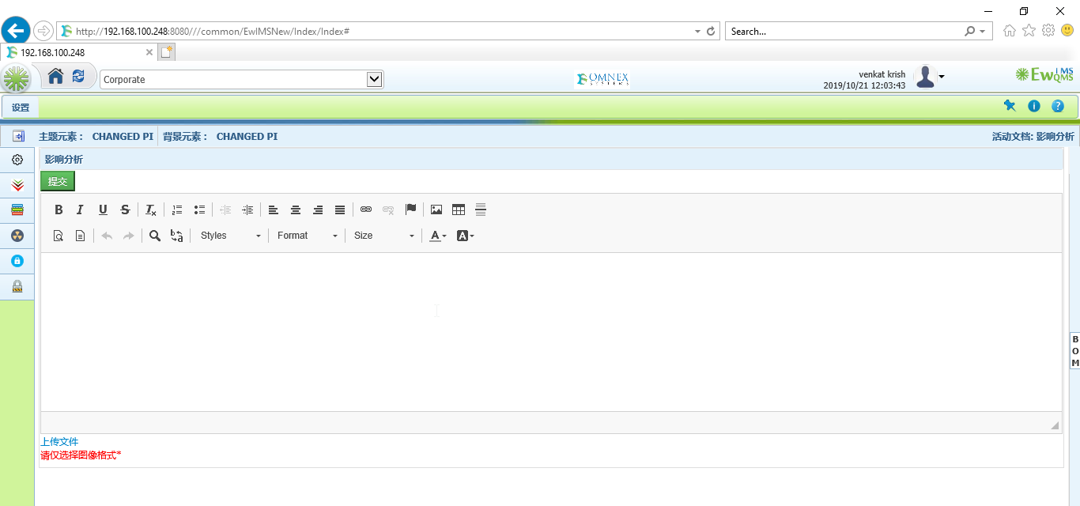

11. SEooC: Tool Tip options and style/normal/size for impact analysis should be converted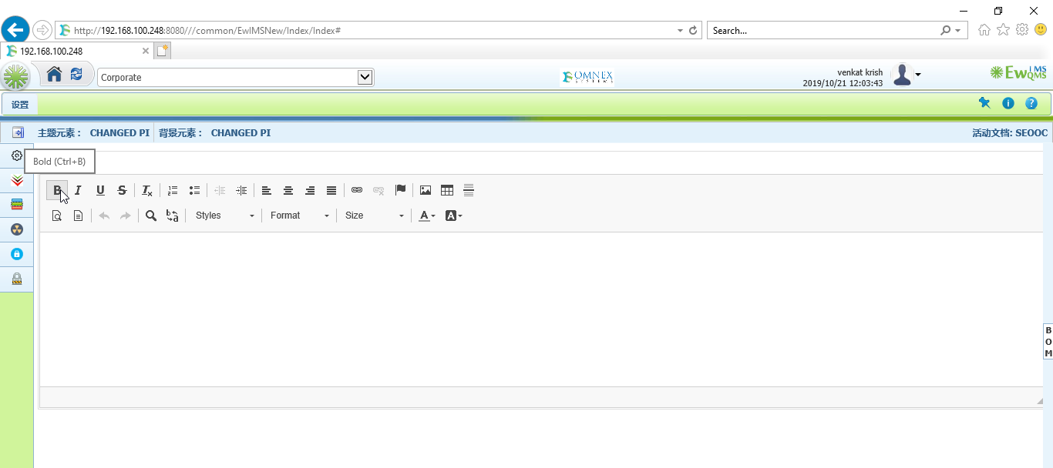

12. Item details: Tool Tip options and style/normal/size for impact analysis should be converted 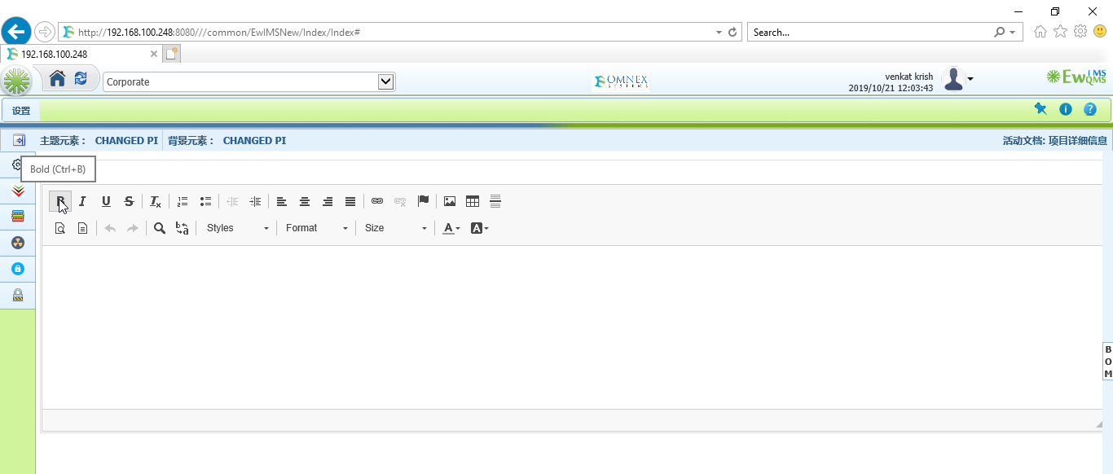

13. Block Diagram: Mordern/Dark/Material should be converted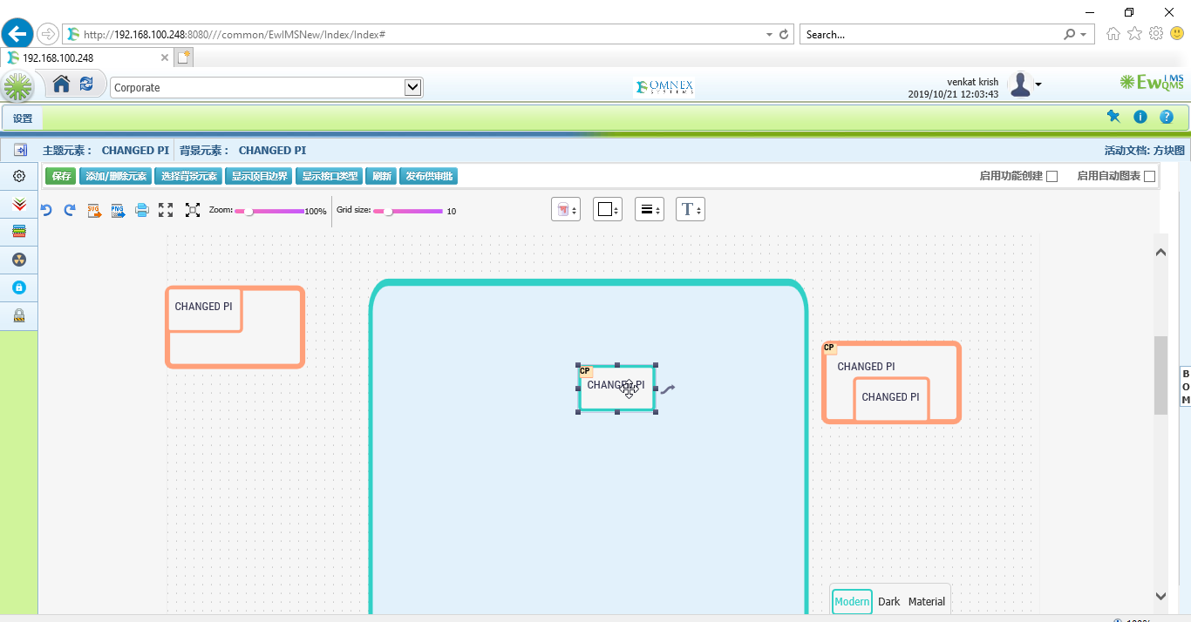

14. Interface function matrix: Select context element>cancel should be converted 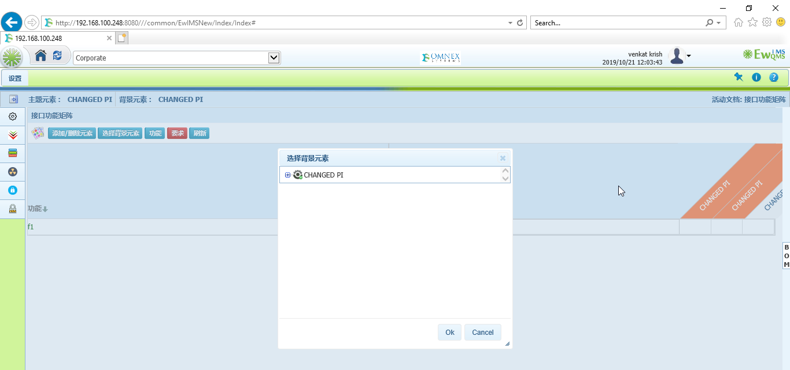

15. IFM: Function button> Name should be converted 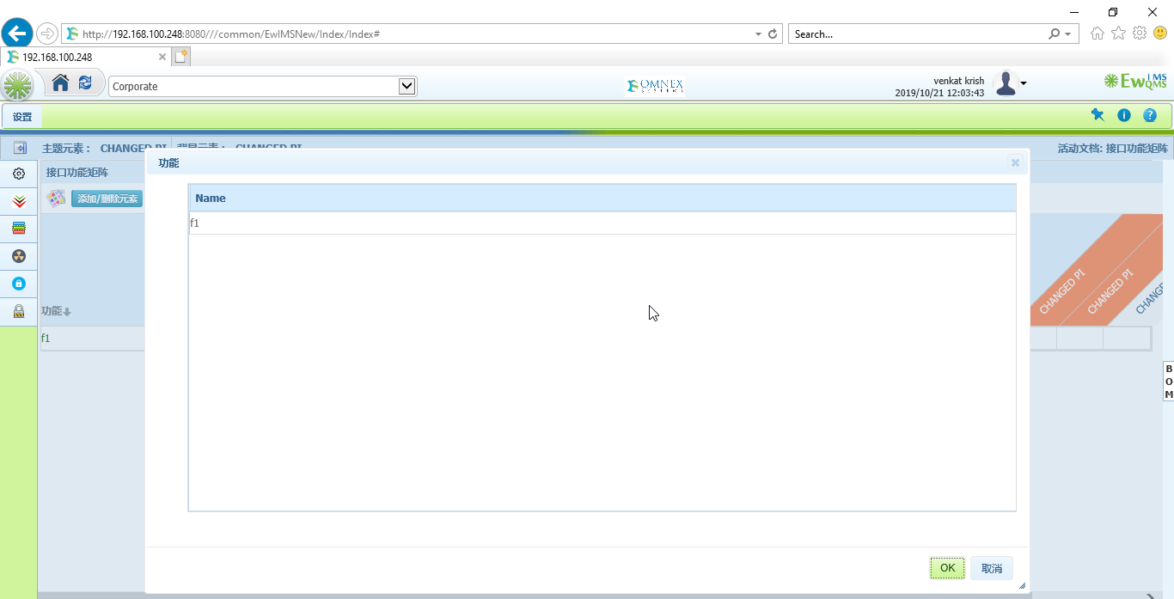

16. IFM: Requirement button> Name should be converted 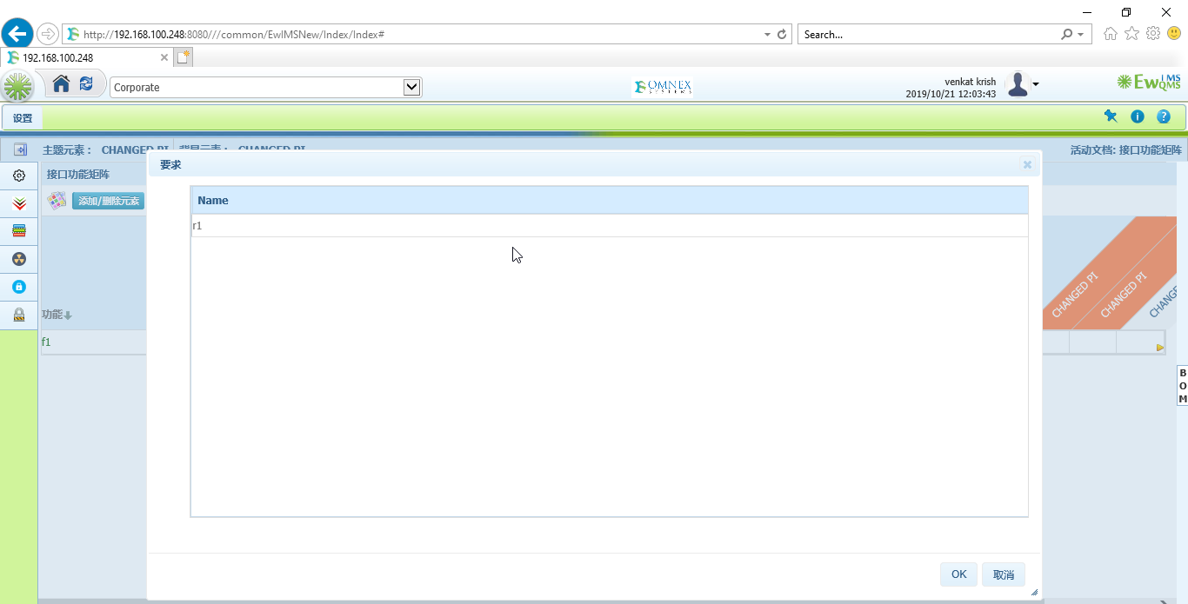

17. Combined interface Matrix: Select context element>cancel should be converted 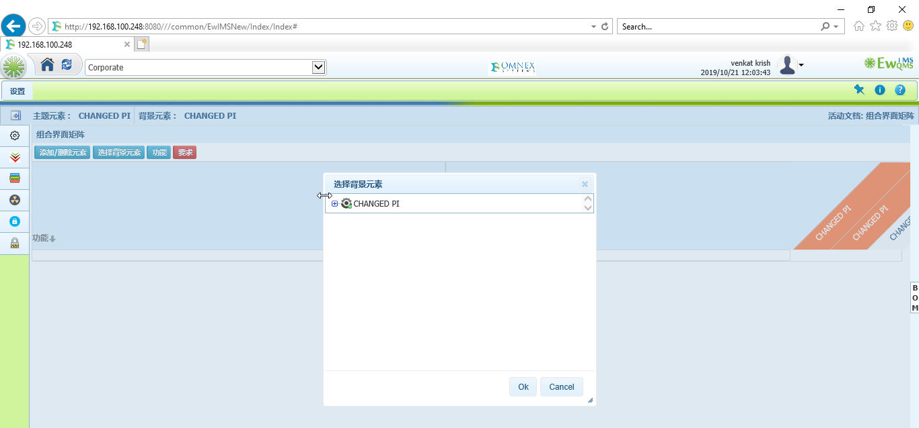

18. CIM: Function button> Name should be converted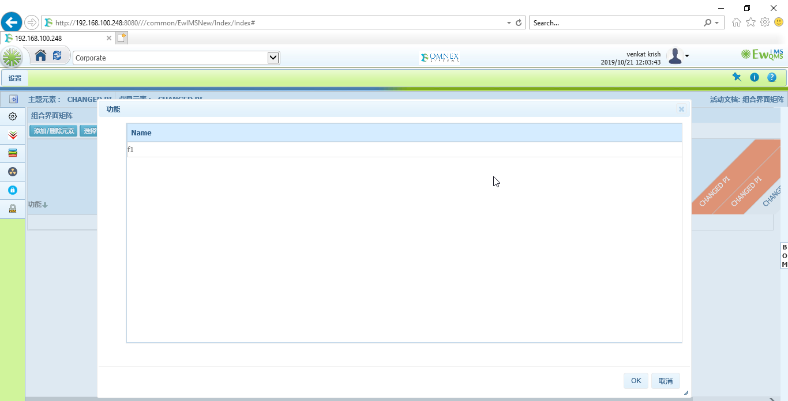

19. CIM: Requirement button> Name should be converted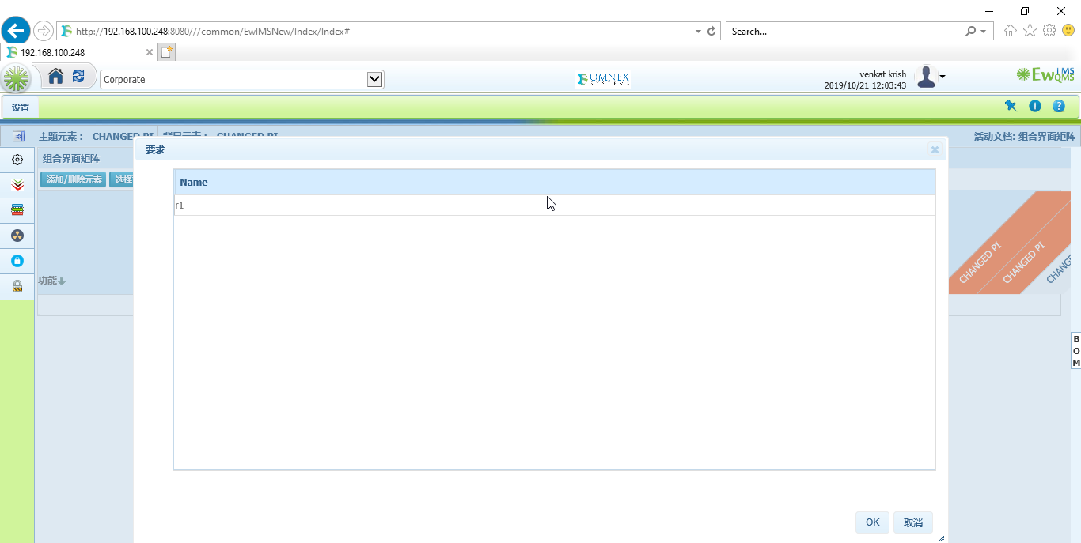

20. Interface Matrix: Legent should be converted 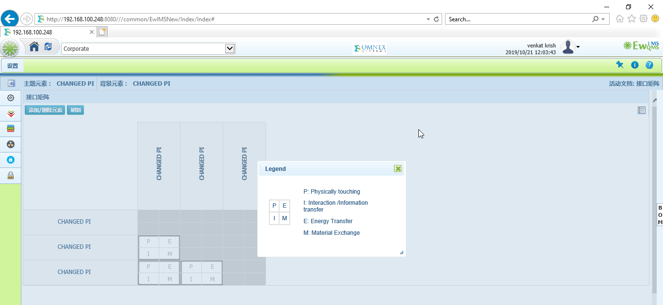

21. Element Type: Name should be converted 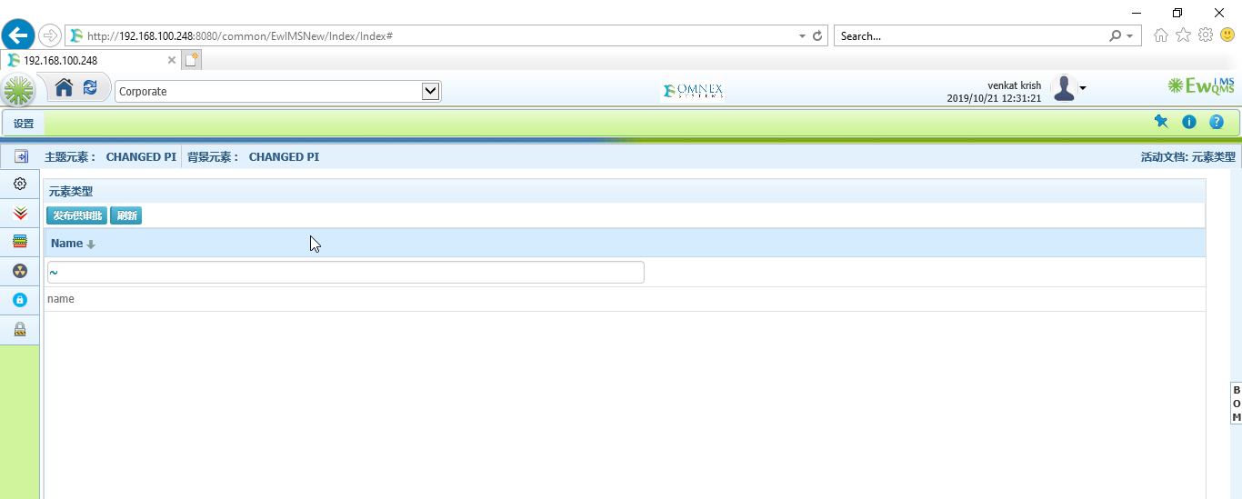

22.Interface Type: Colors should be converted 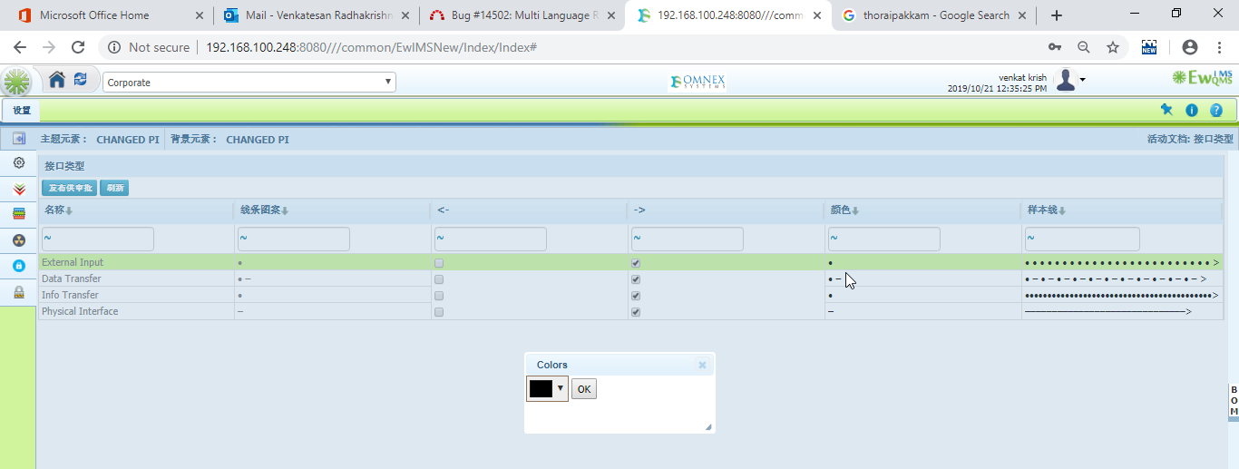

23. Functional Analysis: Failure Mode and Name should be converted 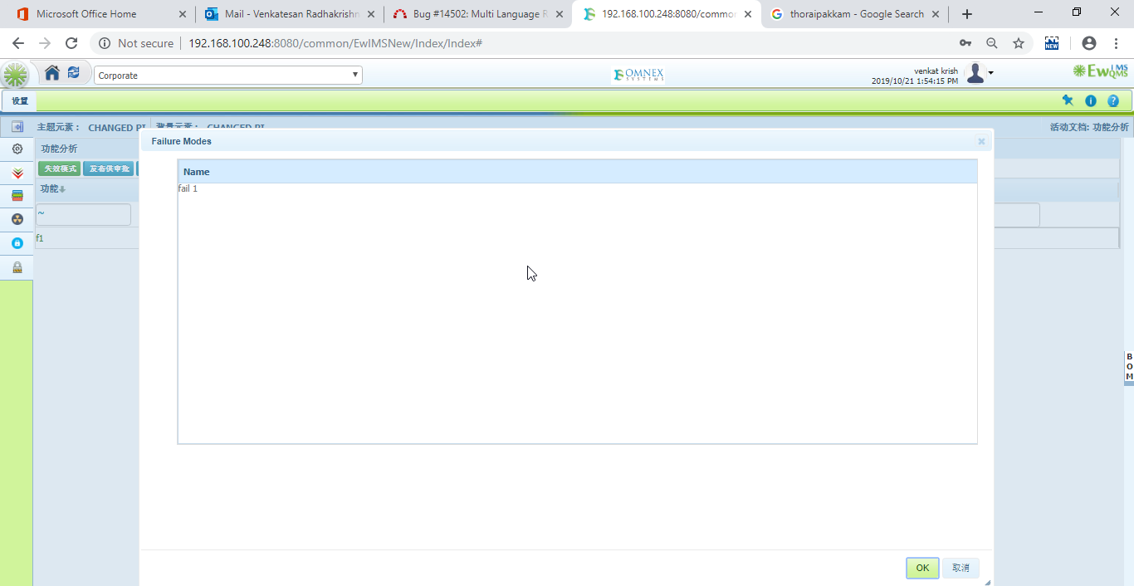

24.Operation situation: Delete button>cancel should be converted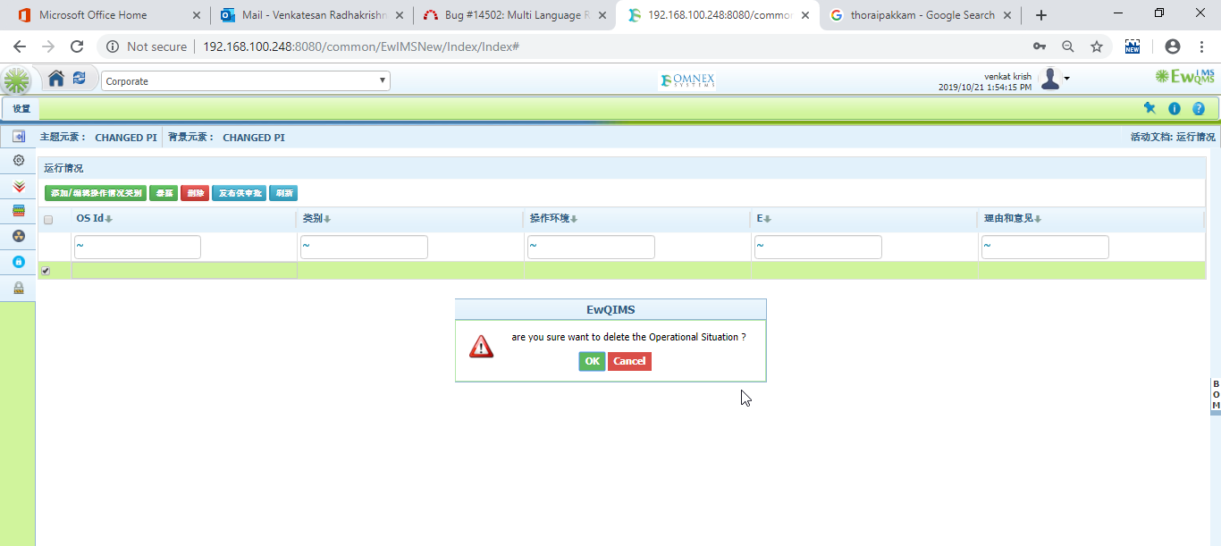

25. Deleted branch Alert from Hara and cancel should be convered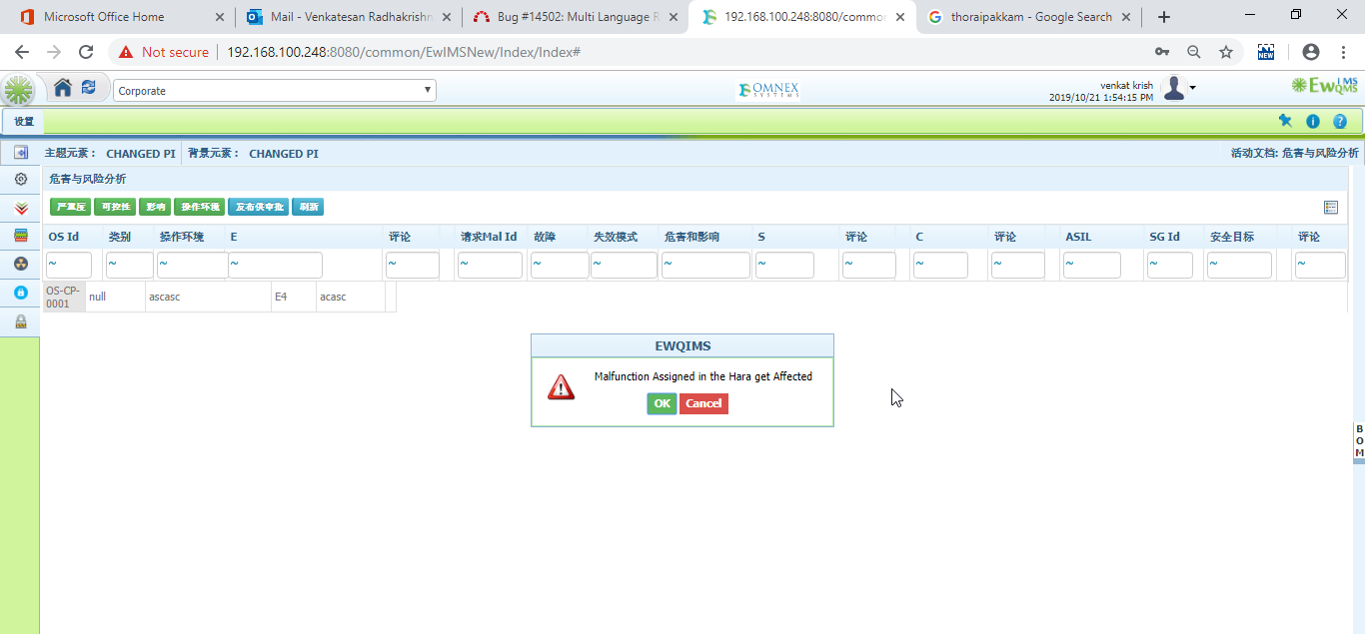

26. Select Malfunction/Failure popup window should be converted from HARA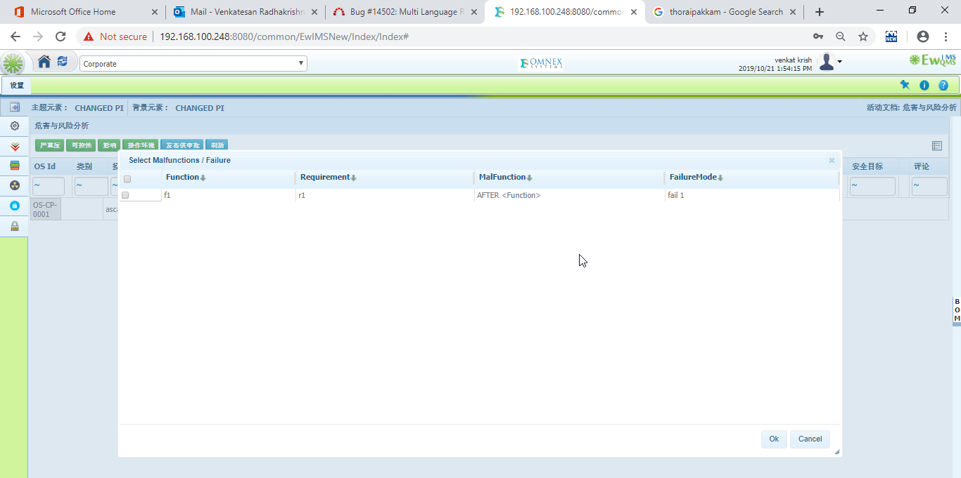

27. Safety goal pop up window should be converted from HARA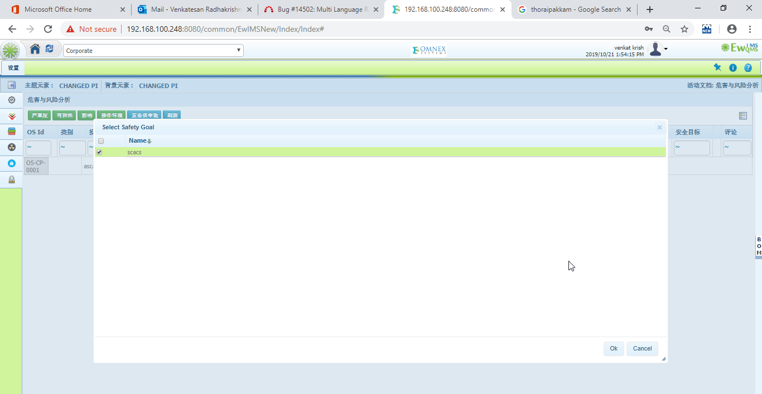

28.Cancel should be converted form FSR

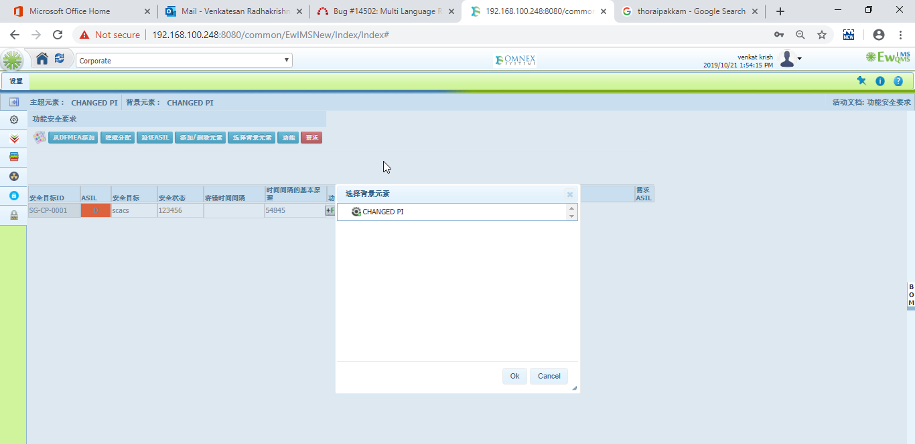

29. FSR: Name in function button should be convereted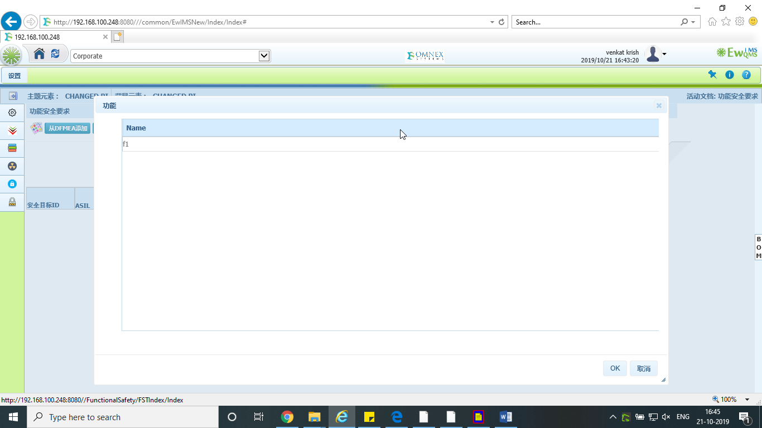

30. FSR: Name in Requirement button should be convereted

