1. Import > browse and upload should be converted

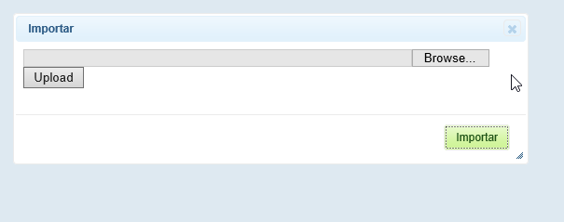

2. VOC>flow down Indicator> Delete function button>cancel should be converted

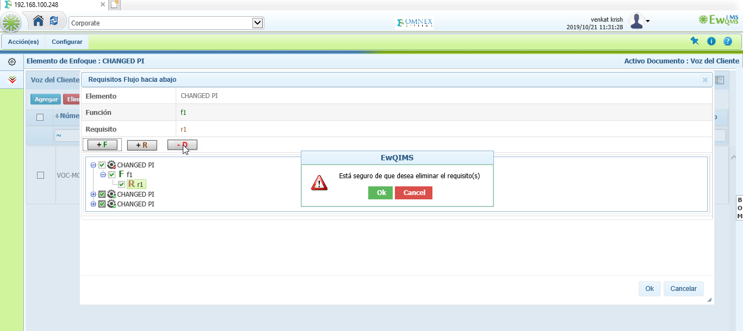

3. Function>Rightclick on header>All right click options should be converted

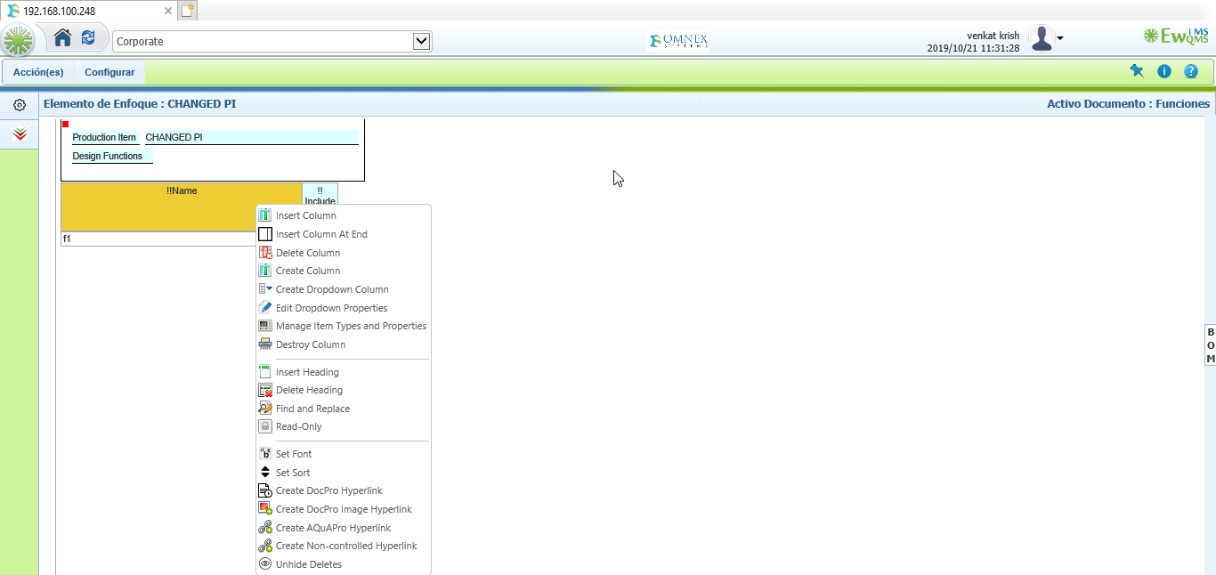

4. Failure> Rightclick on branch>All rightclick options should be converted

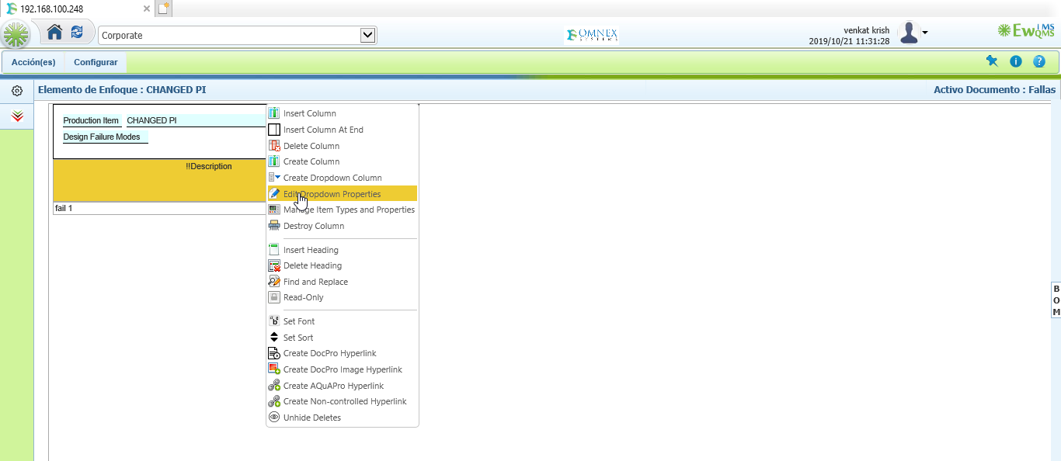

5. EFC Tree> Publish Should be converted 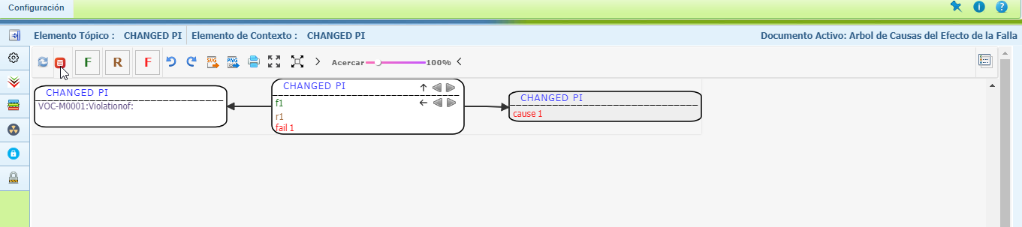

6. DFMEA page should be converted

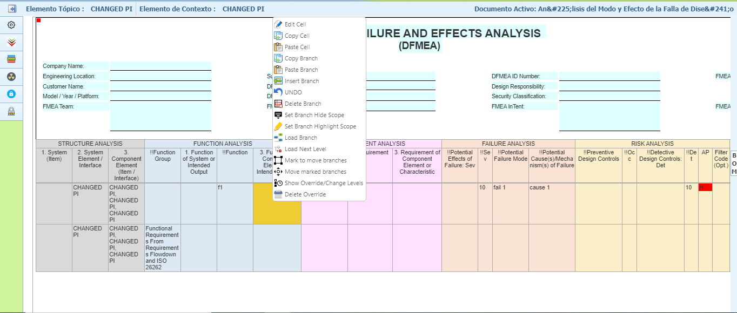

7. DVP&R page should be converted

