Chinese

1.Favourites Tooltips for PI

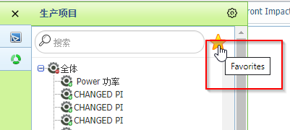

2. Active Document – Design Label and Tooltip for Percentage Allocation

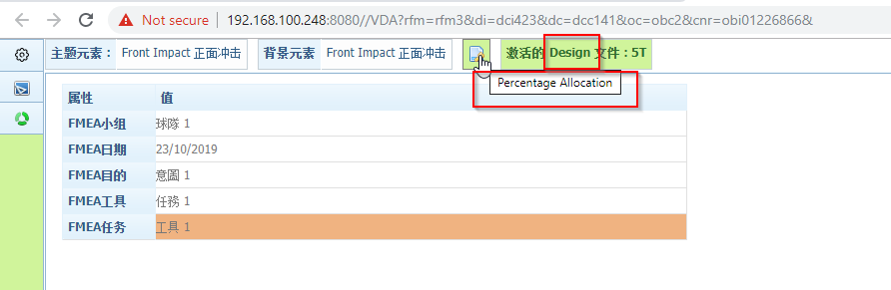

3. Structure Analysis – Exclude Element

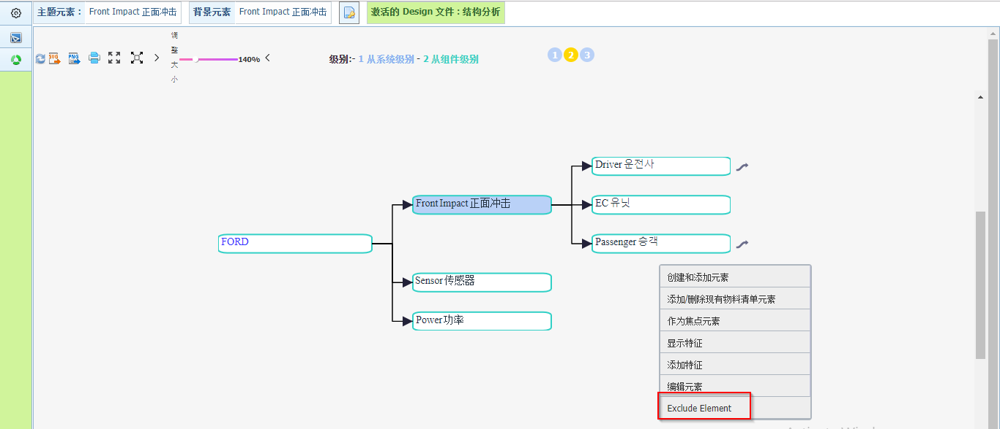

4. Ok button for Add/Remove Element and Context Element popup window

5. Zoom and Grid Size label and Tooltip

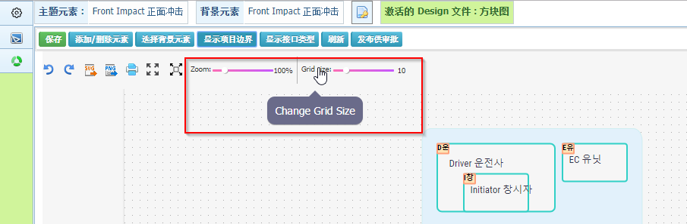

6. Select Dropdown to add Function/Requirement/Failure

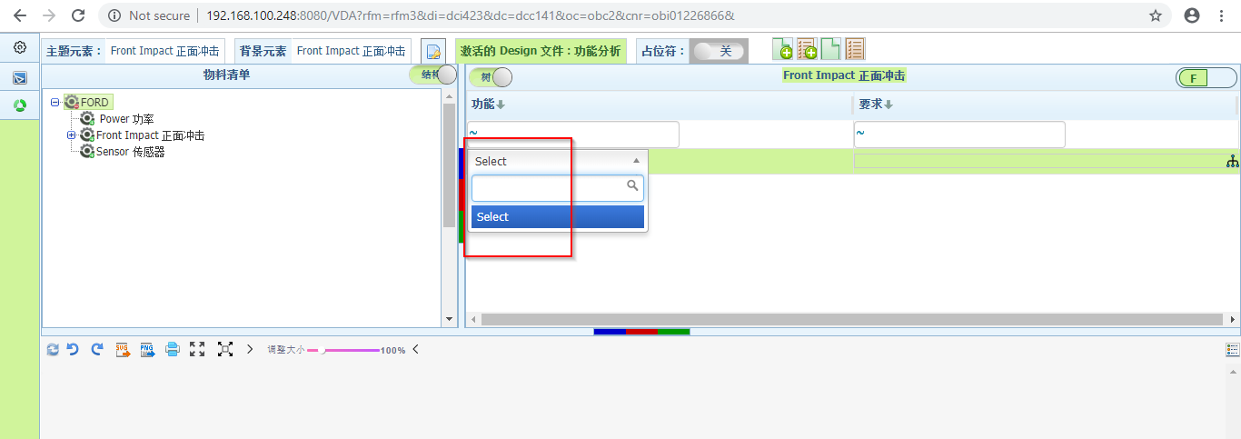

7. Functional/Failure Analysis - Assign Severity Rating is not converted

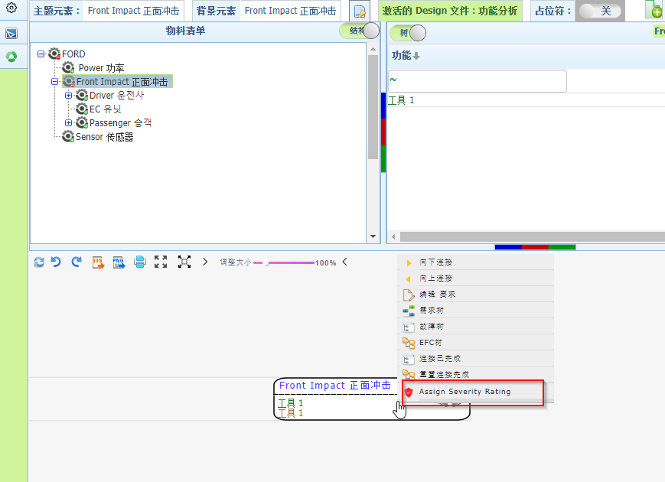

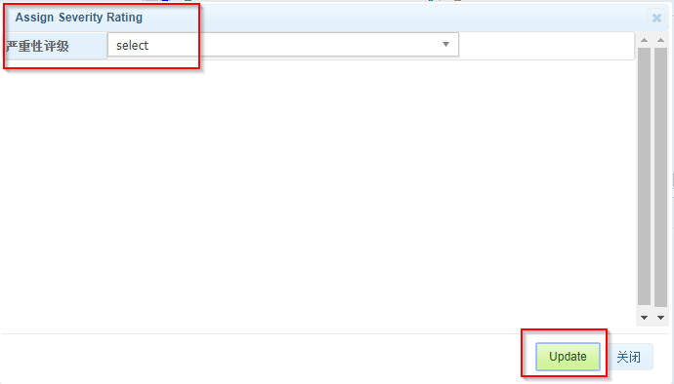

8. OK and Cancel button and Close Tooltip in Add Function/ Requirement/ Failure popup window

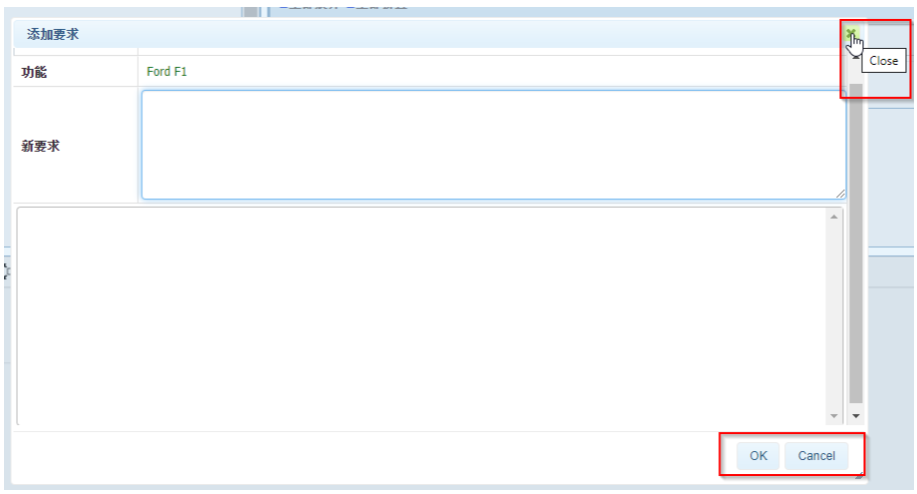

9. Unable to add Risk and Optimization VDA pages.

10. DFMEA page is not converted

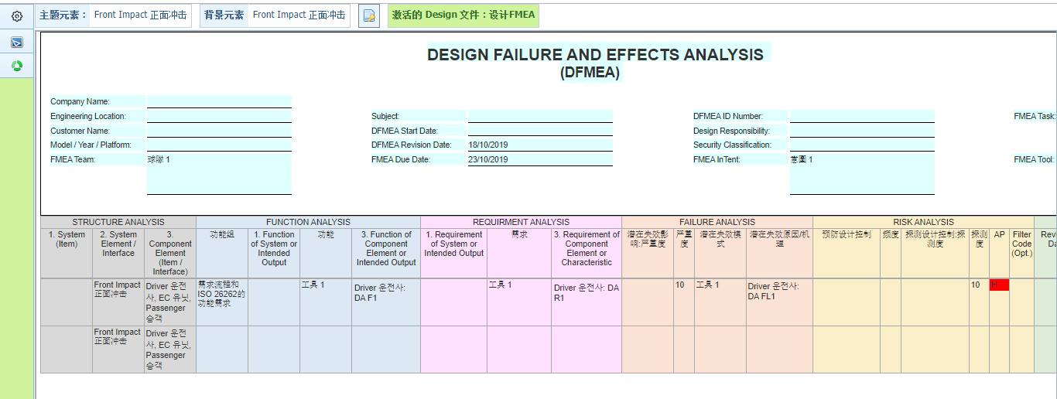

11. Process Flow Displays THL

