2. Tooltip for Favourites

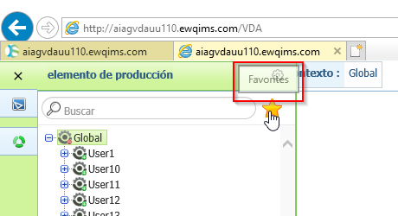

3. Percentage Allocation Tooltip

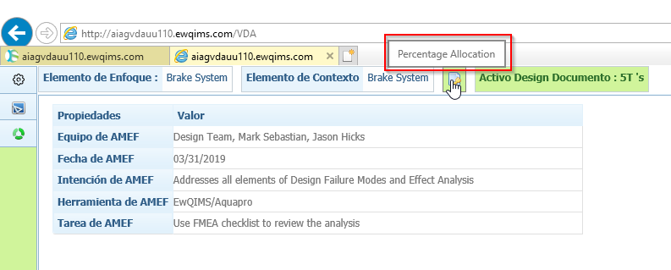

4. Label for Step in Percentage allocation and Step No.5 is overlapped.

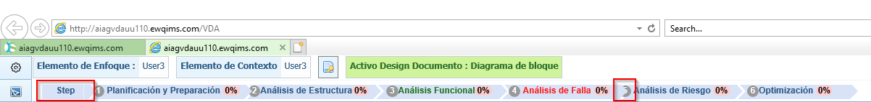

5. Change Grid Size and Redo tooltips and label for Zoom and Grid Size are not converted.

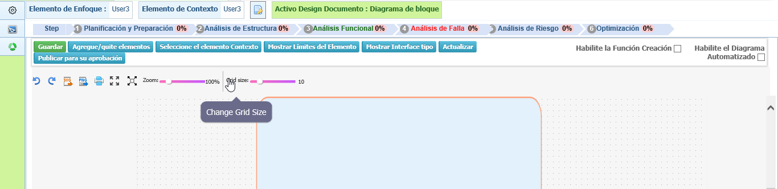

6. Percentage allocation is not opening.

7. Ok button for Add/Remove BOM Elements and Context Elements.

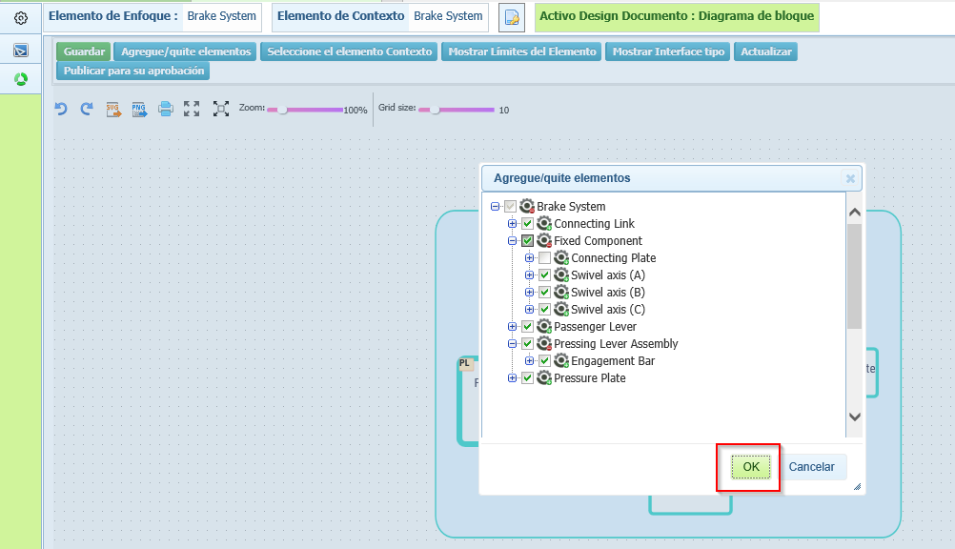

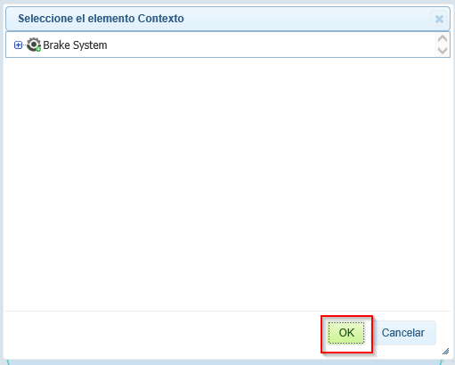

8. Item Boundaries Header

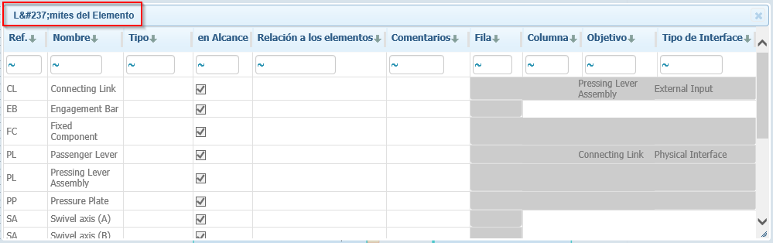

9. Interface Types – Color label

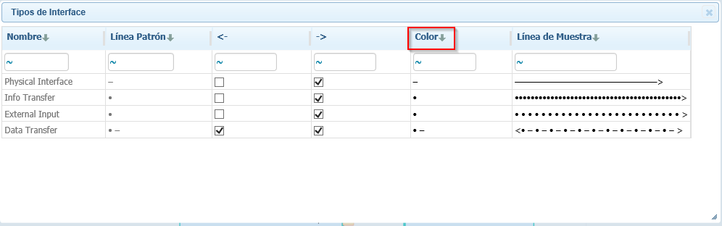

10. Publish for Approval Label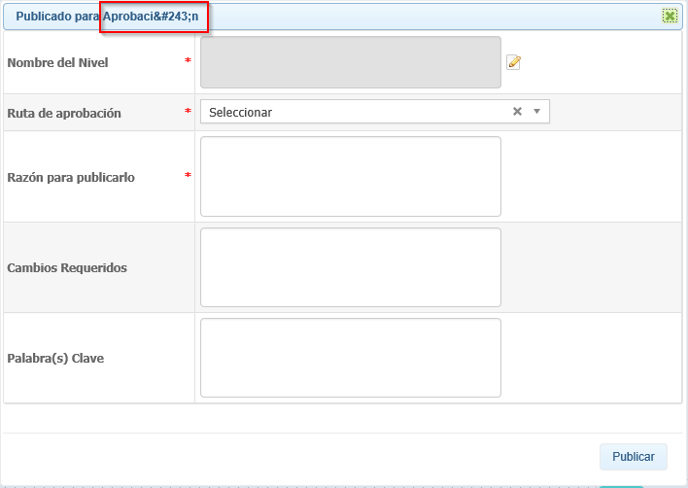

11. Structure Analysis Header

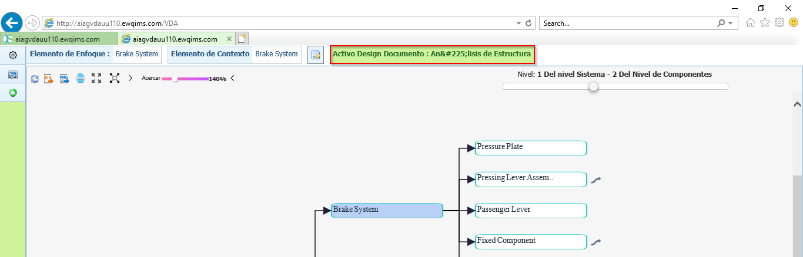

12. Create and Add Production Item header in both PI table and BOM table

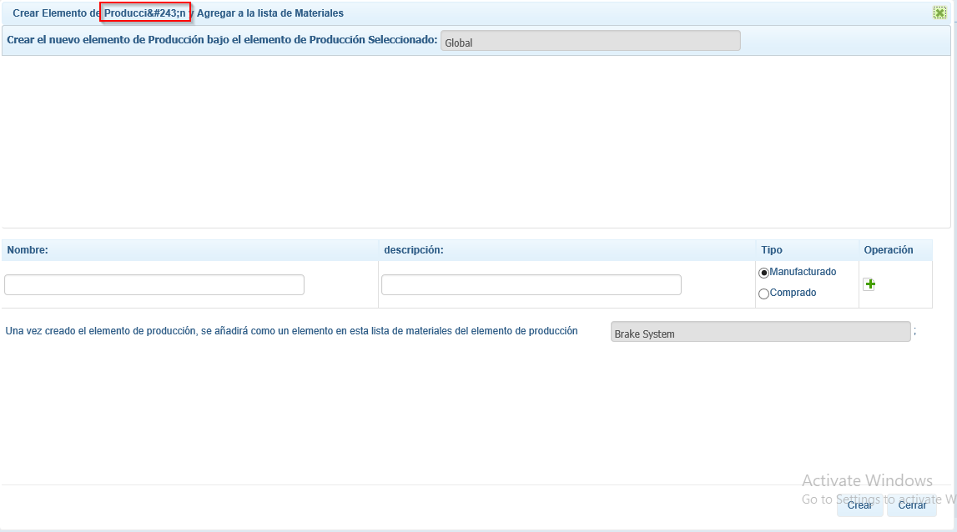

13. Add Characteristics – OK Button

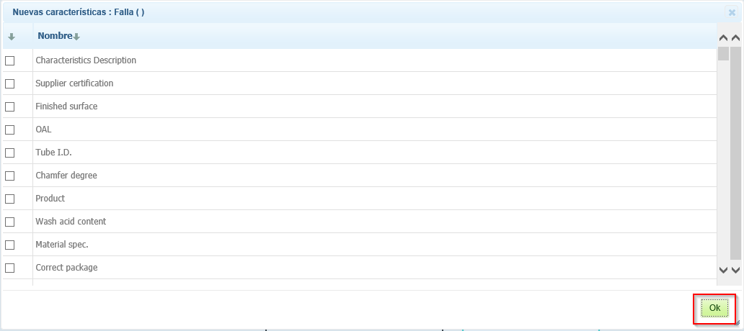

14. Functional/Failure Analysis Active Document

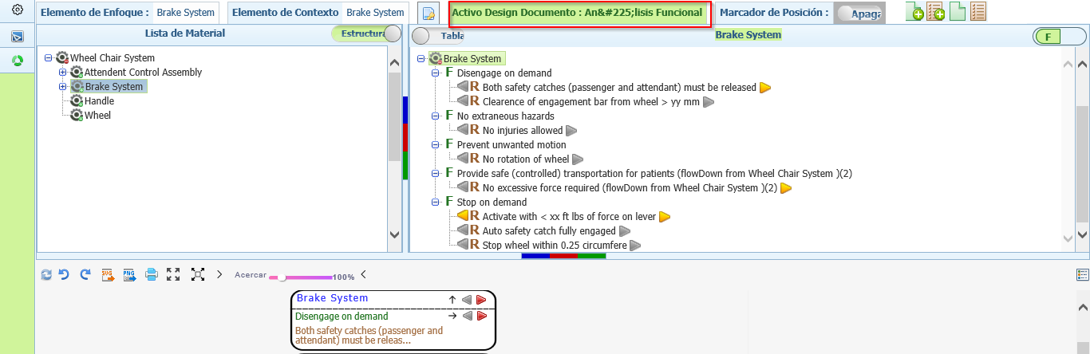

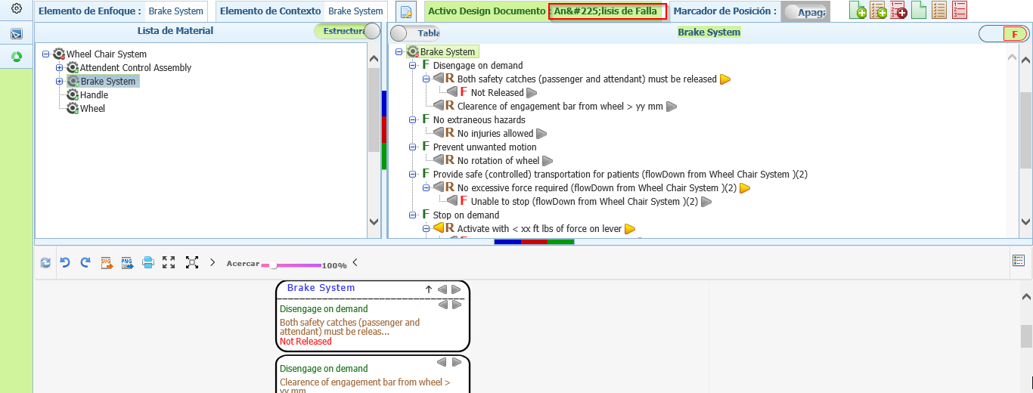

15. OK button for Flow Up, Flow Down, Edit Requirement, Flows Done and Reset Flows Done Popup.

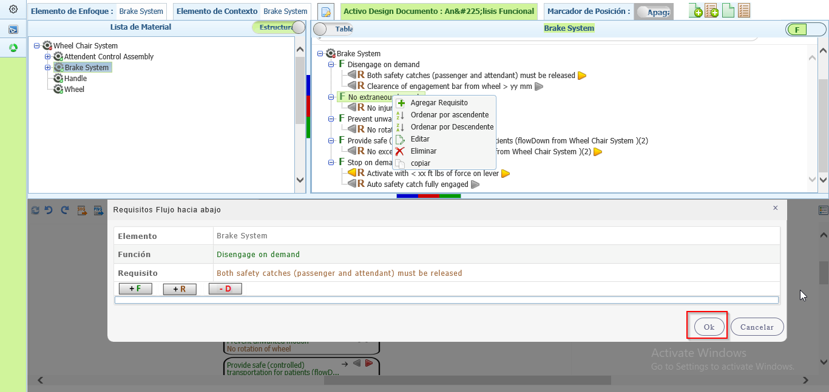

16. Function/ Requirement/ Failure master table and Show/Hide Function/ Requirement/ Failure Tooltips are not converted

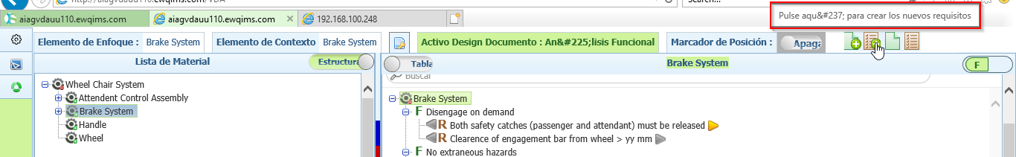

17. IFM - Description for Risk Values and DFMEA is displayed as AMEFD

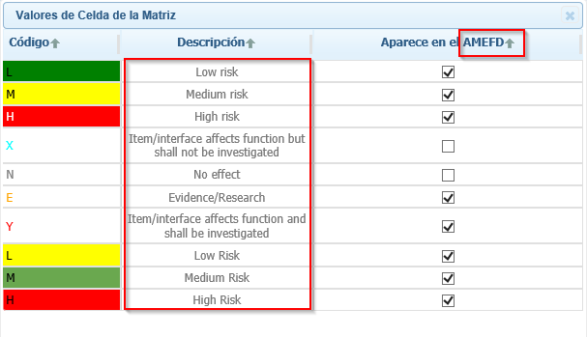

18. IFM - De-allocate label

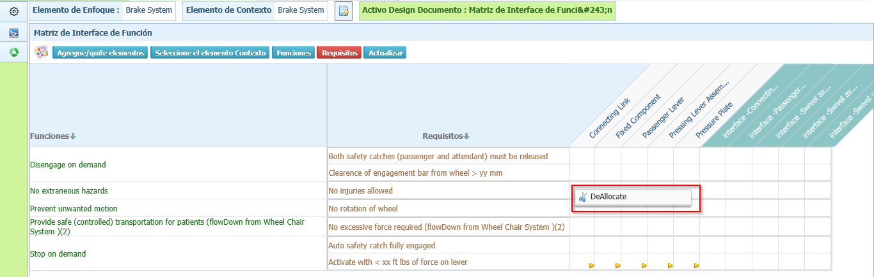

19. Risk Allocation Table in IFM

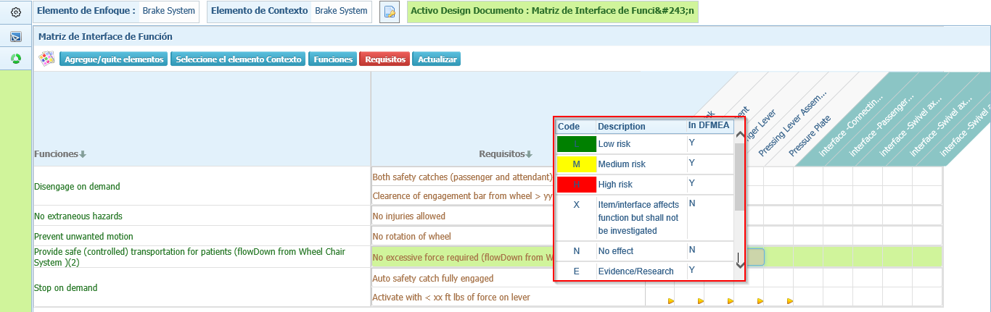

20. Name label and OK button for Function and Requirement Master table

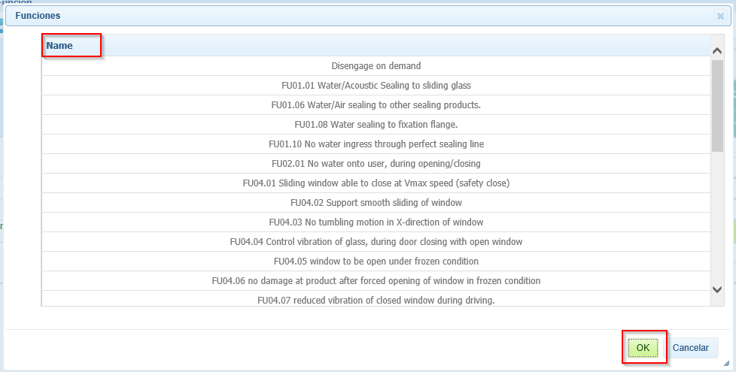

21. Interface Matrix – Legend table and Tooltip

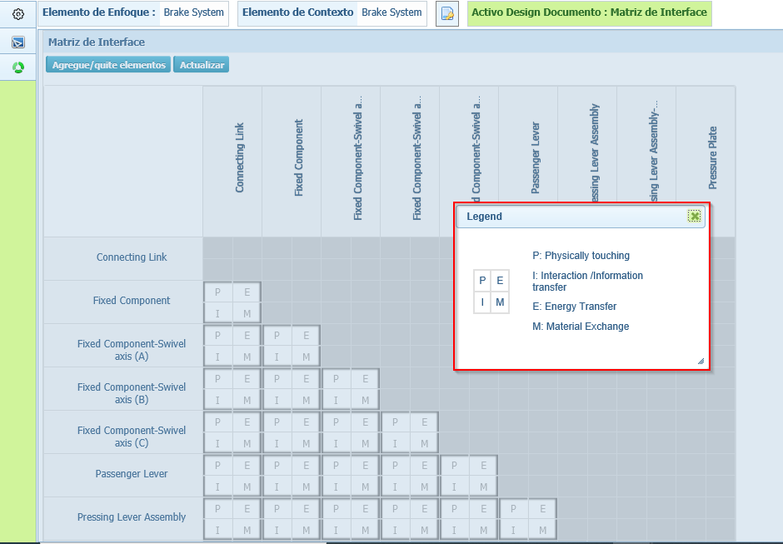

22. OK button for Cause/ Select dropdown for Effect/ Characteristics Master tables.

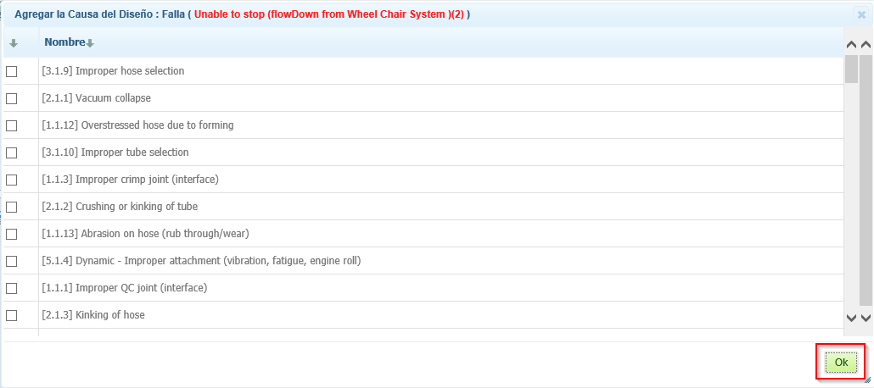

23. Status Dropdown and OK in Risk and Optimization page in both Process/Design VDA

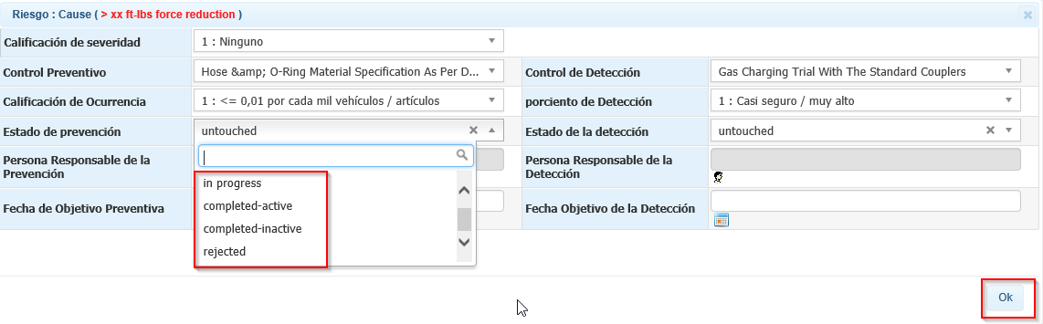

24. Responsible person – Select User popup Header.

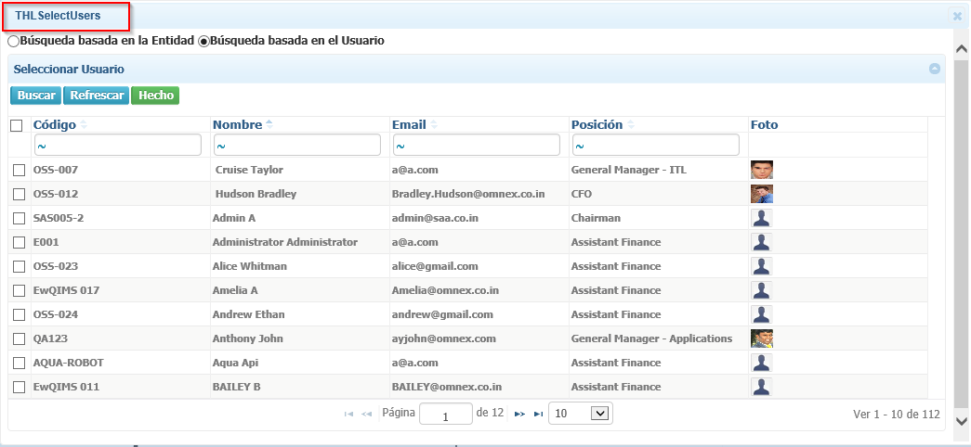

25. Calendar buttons are not converted.

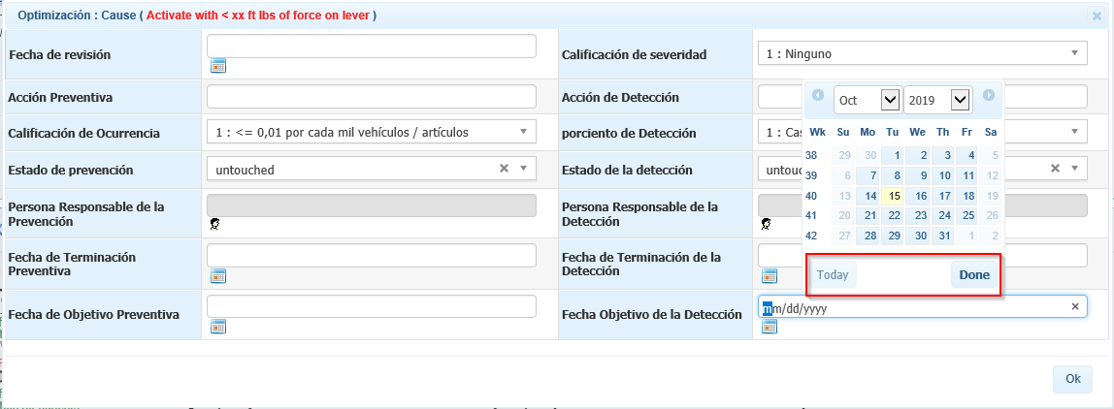

26. Active Document label for DFMEA and the entire Document.

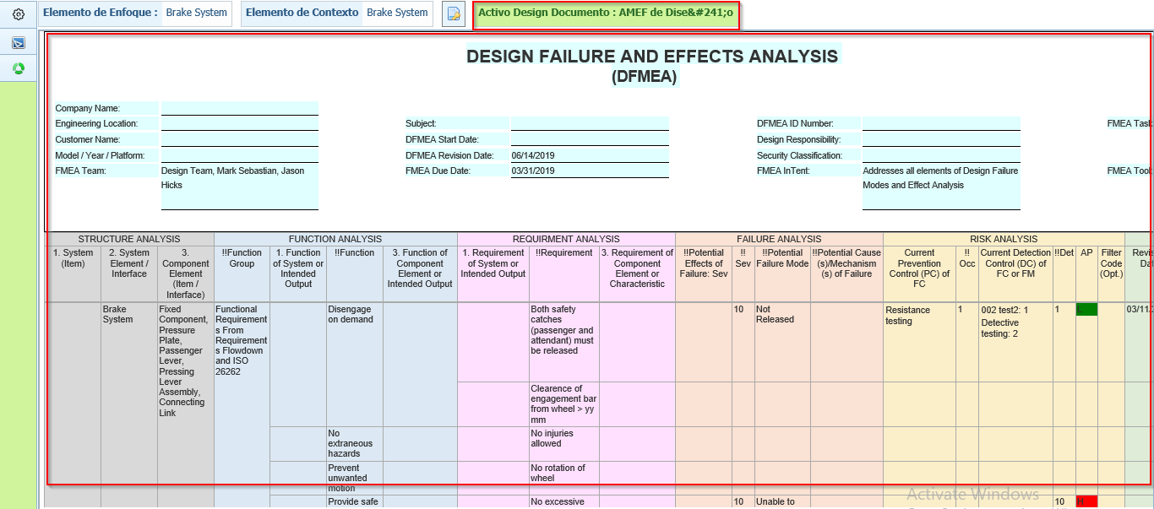

**Process VDA:**

27. FMEA is displayed as AMEF in both Design and Process

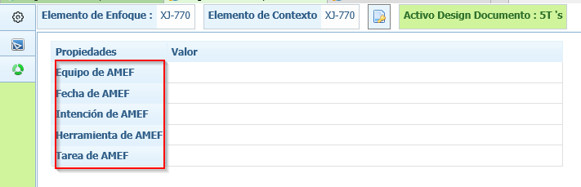

28. Topic Segment Header and Process label

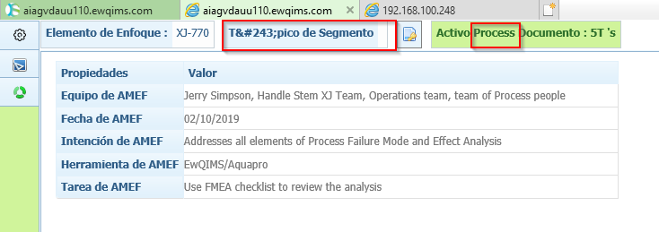

29. Favourite Production Item

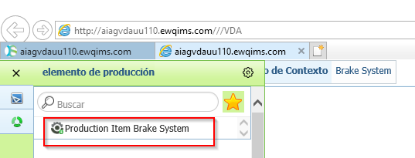

30. Active Document Label for Structure Analysis

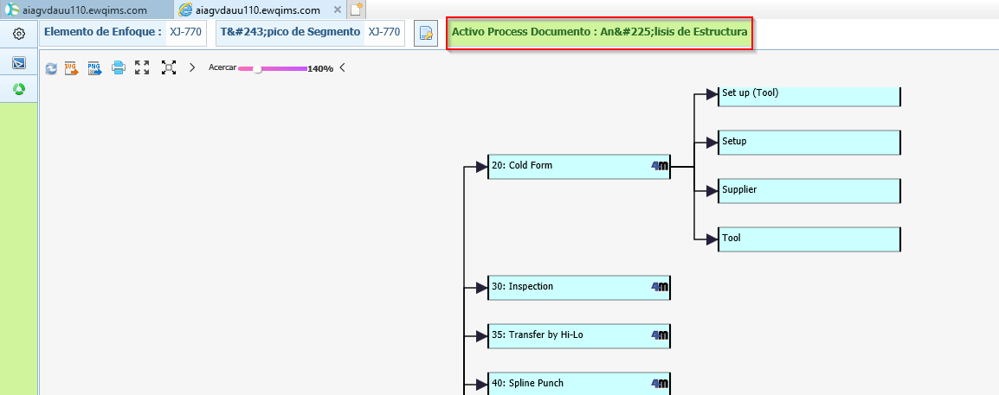

31. 4M Popup window – Select an Option for Failure

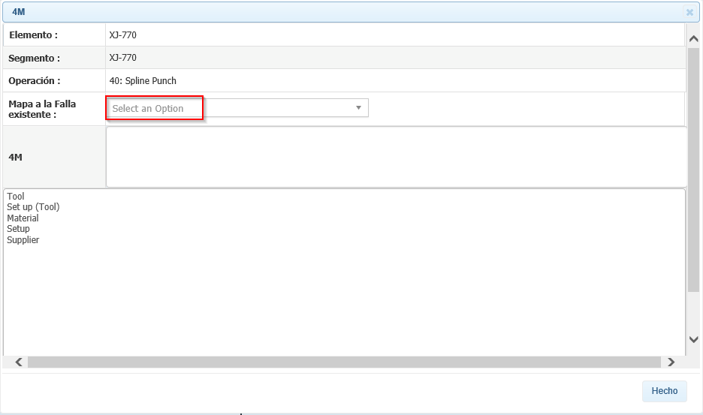

32. Operation Popup – Header and select Dropdown

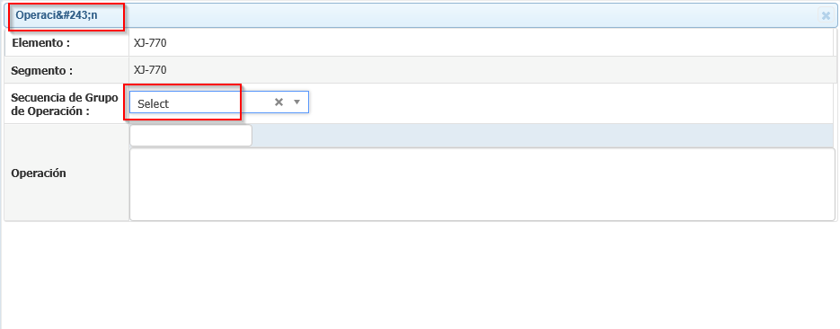

33. Functional Analysis – Active Document Label and Structure View Header

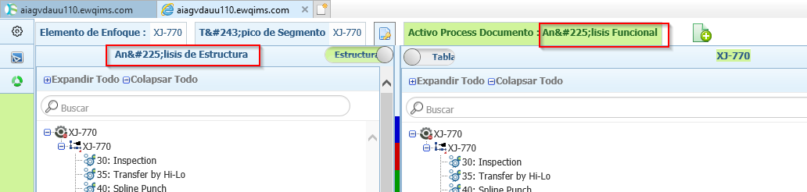

34. (Tree View) Delete confirmation for Segment/ Operation/ Characteristics/ Failure/ Effect/ Cause

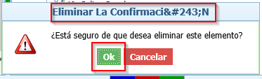

35. (Tree view) Edit Popup window for Operation/ Characteristics/ – OK and Header

Ok button for Effect and Cause

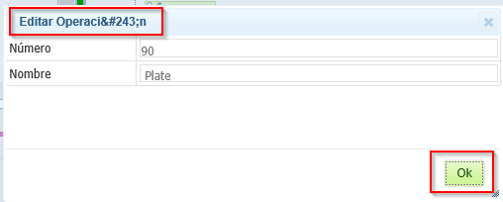

36. (Diagrammatic View) **Edit Effect/ Edit Cause/ Edit Work Element Function/ Edit Process Item Function/ FourM** Pop windows are not converted completely.

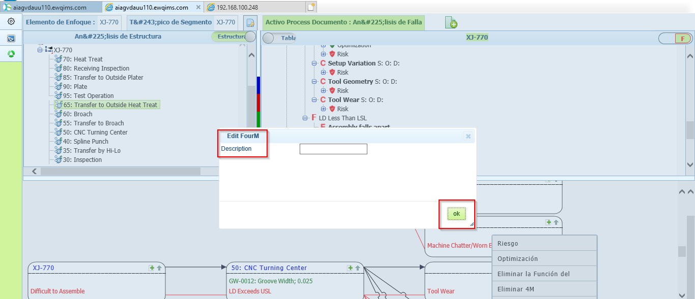

37. (Tree View) Header for Process Item Function/ Work Element Function/ 4M Dialog window

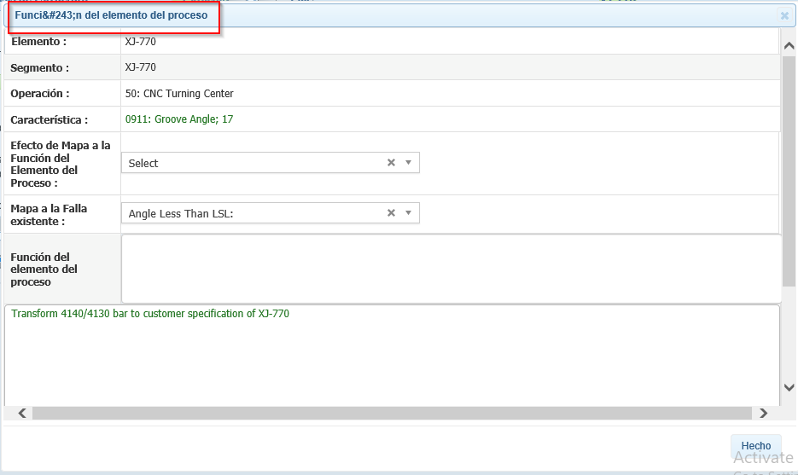

38. Name label for Create and Map option for all master tables

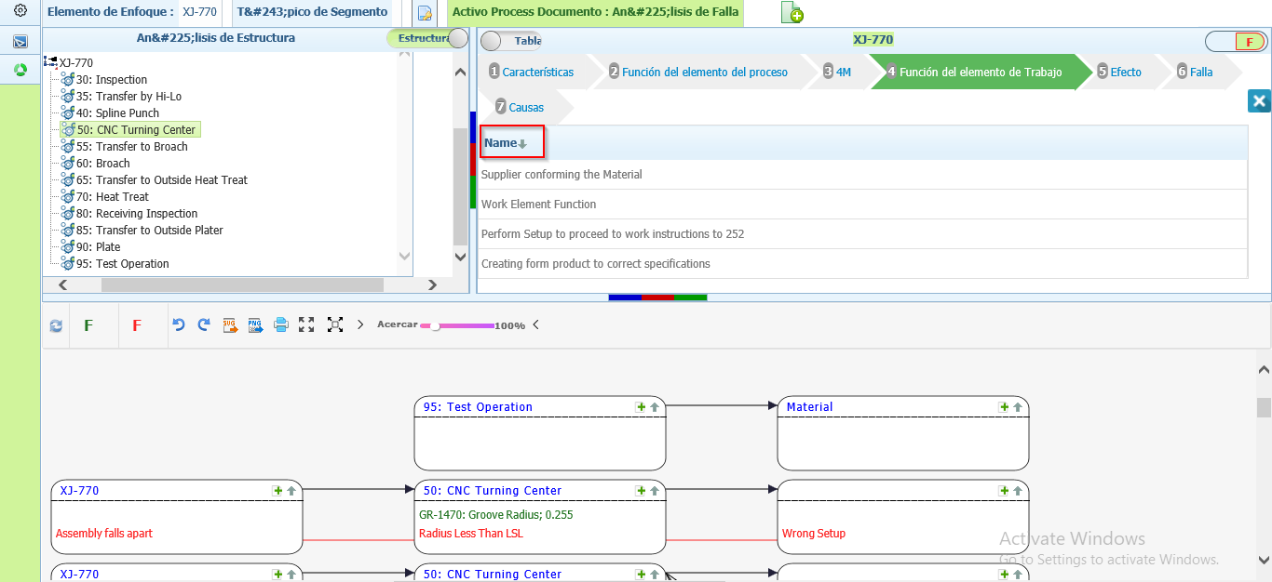

39. (Table View) Right Click context menu list is overlapping on each other.

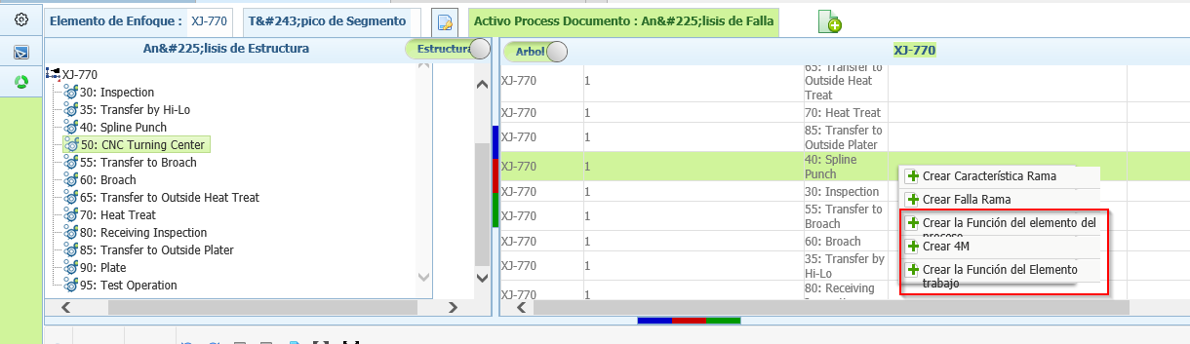

40. Header Name for master Table and Tooltip

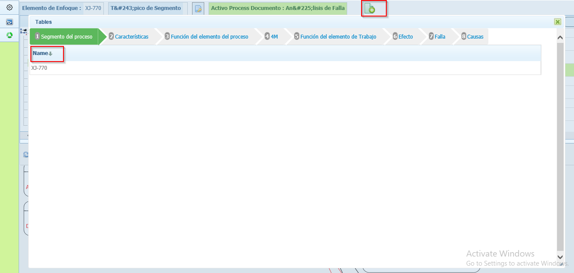

41. Tooltip for Show/Hide Function (Characteristics)/Failure option in Diagrammatic view

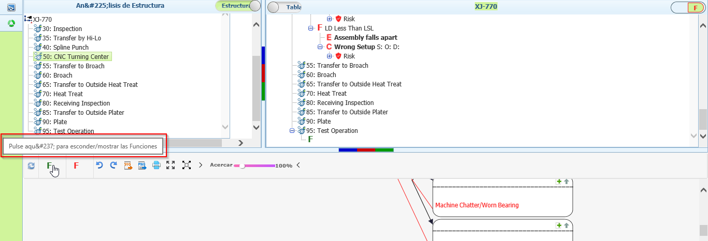

42. Process FMEA Active Document header and Whole Document is not converted.

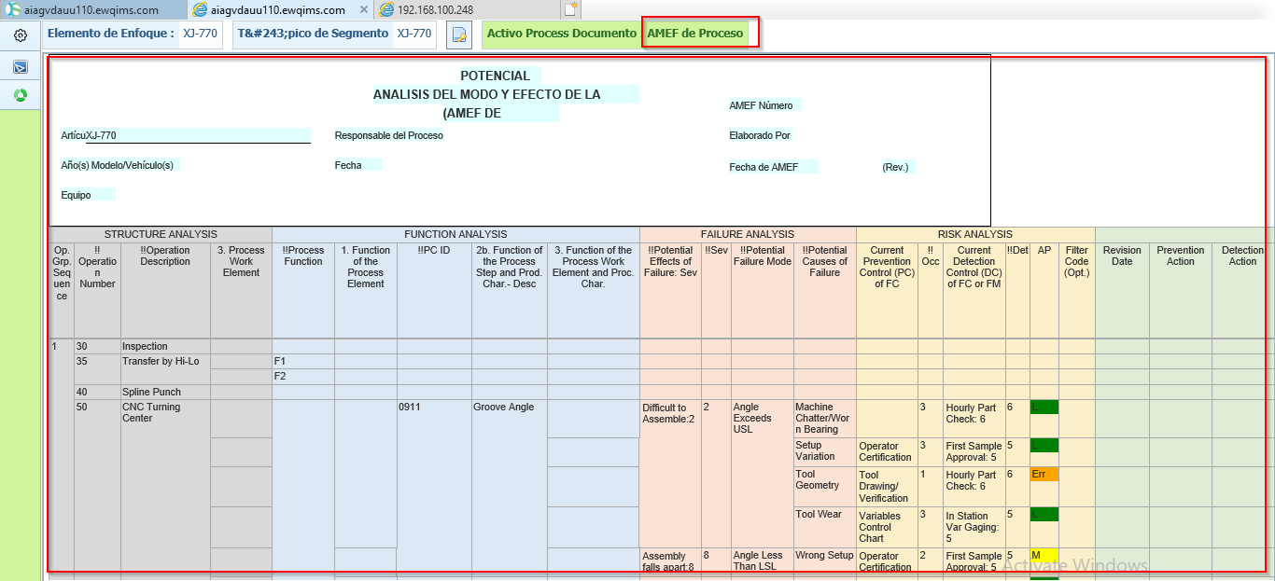

43. Tooltip for Maximize, Reset, and Minimize is not converted

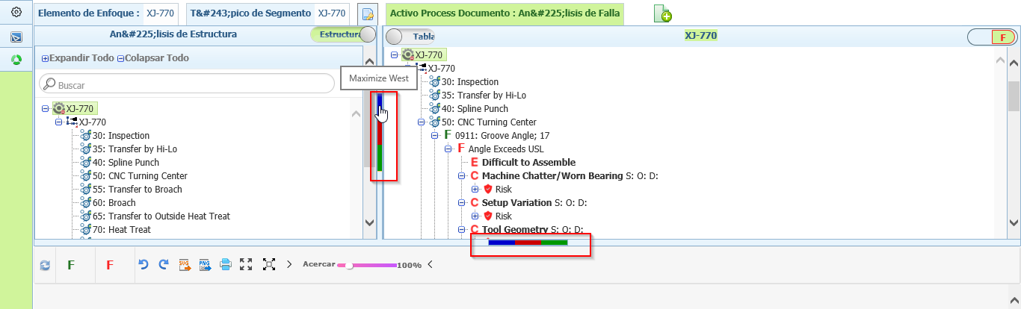

**Note:**

1. **Percentage Allocation is not Working for both Design and Process VDA**
2. **DVP&R and Process Flow is not displayed**