1. Delete PI cancel should be converted

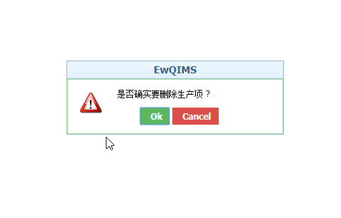

2. Import > browse and upload should be converted

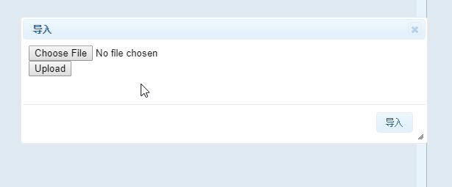

3. VOC>flow down Indicator> Delete function button>cancel should be converted

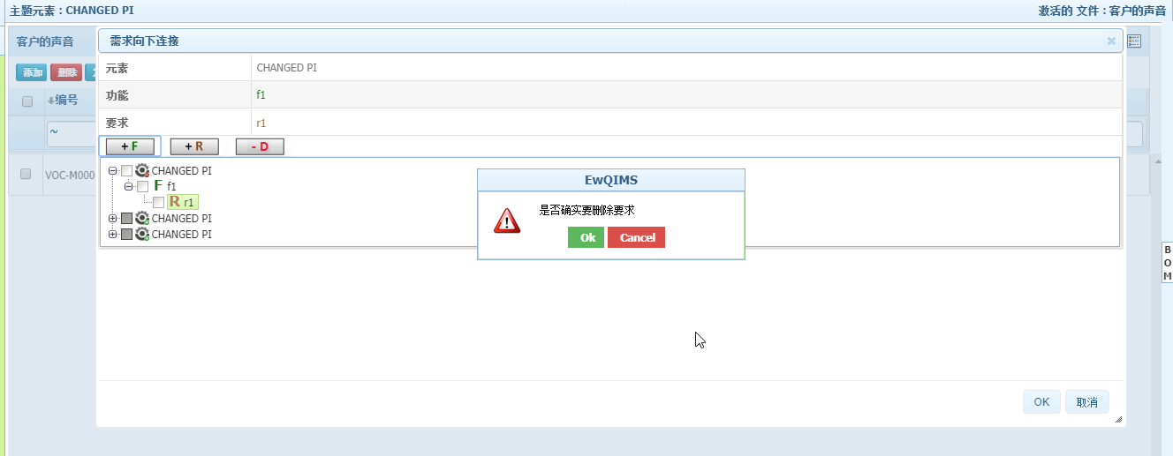

4. Function>Rightclick on header>Edit dropdown/manage item type/ready-only should be converted

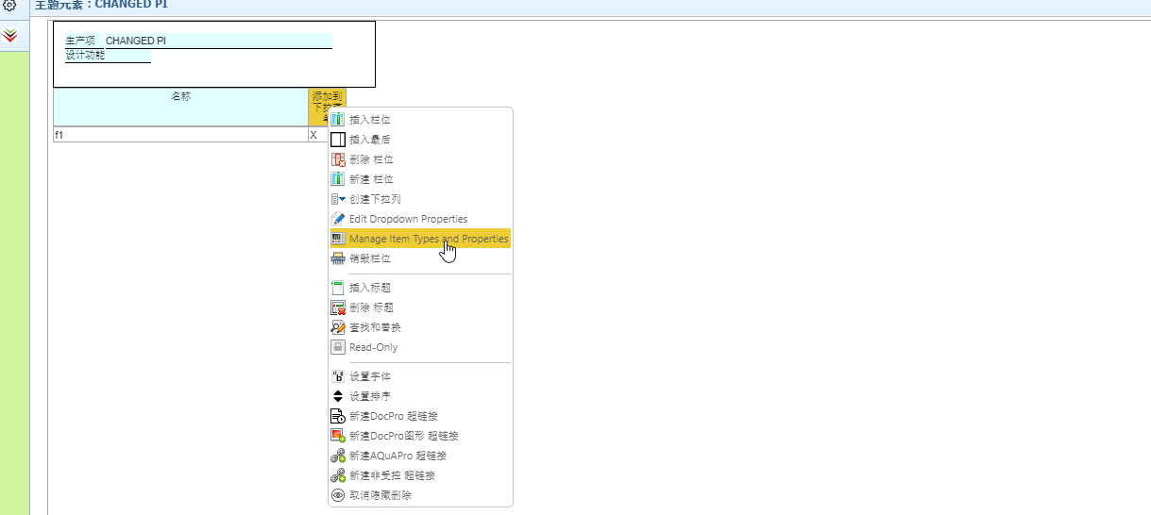

5. Failure> Rightclick on branch>Undo and replace should be converted

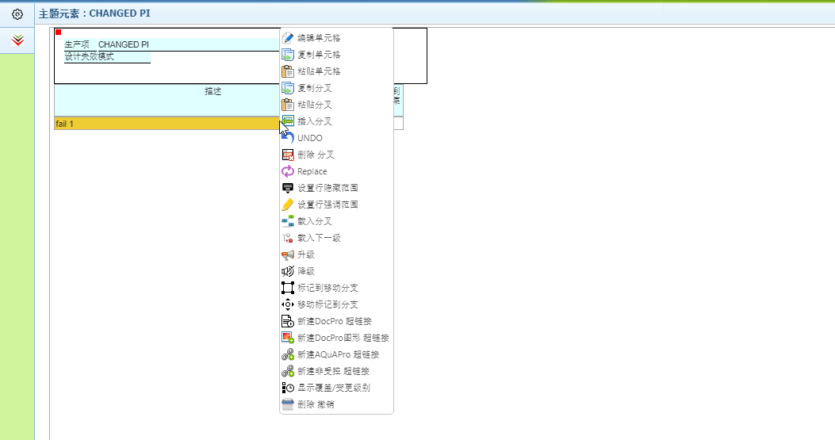

6. Failure Tree>Tooltip option for undo/redo/open as SVG/PNG/print/fullscreen/Zoom tofit/zoom in/zoom out should be converted

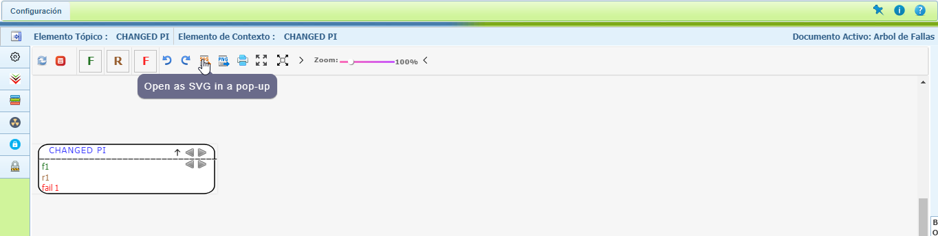

7. EFC Tree> Publish Should be converted 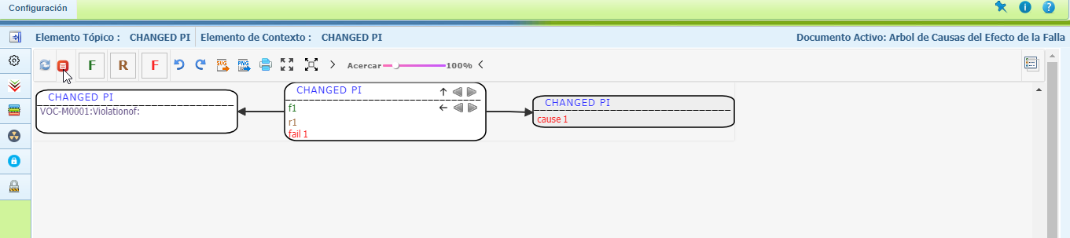

8. DFMEA page should be converted

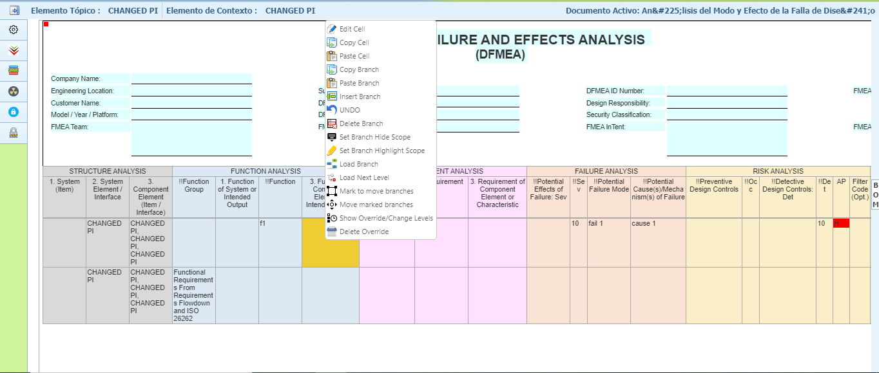

9. DVP&R page should be converted

