1. Delete PI cancel should be converted

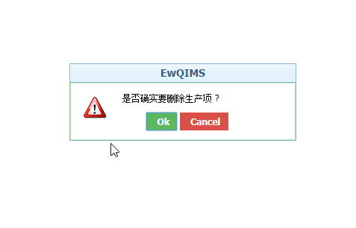

2. Import > browse and upload should be converted

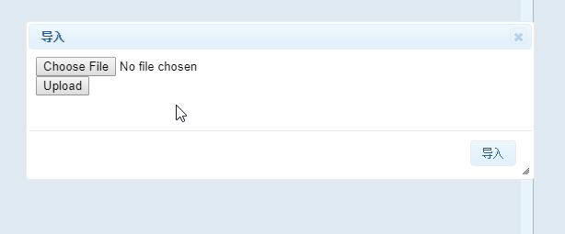

3. VOC>flow down Indicator> Delete function button>cancel should be converted

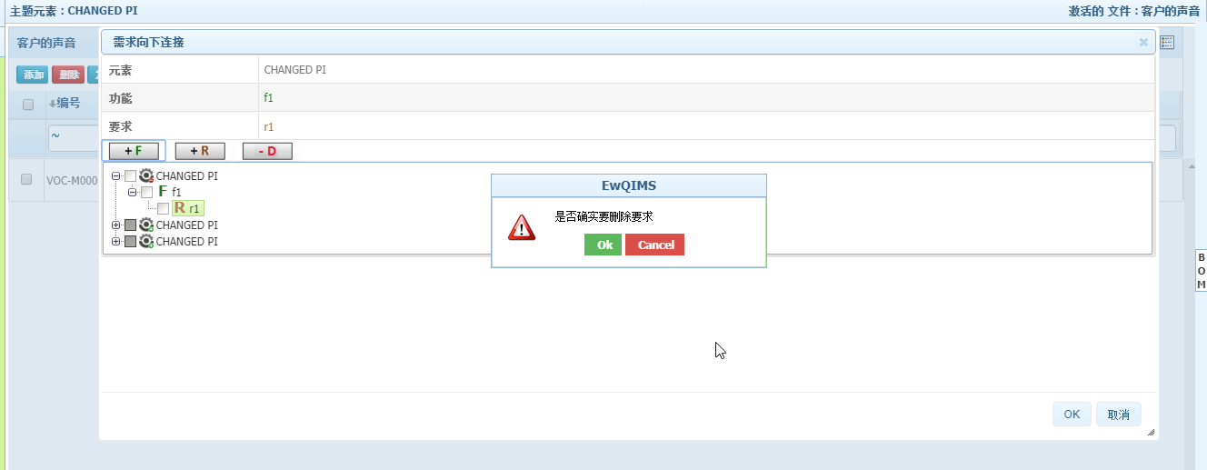

4. Function>Rightclick on header>Edit dropdown/manage item type/ready-only should be converted

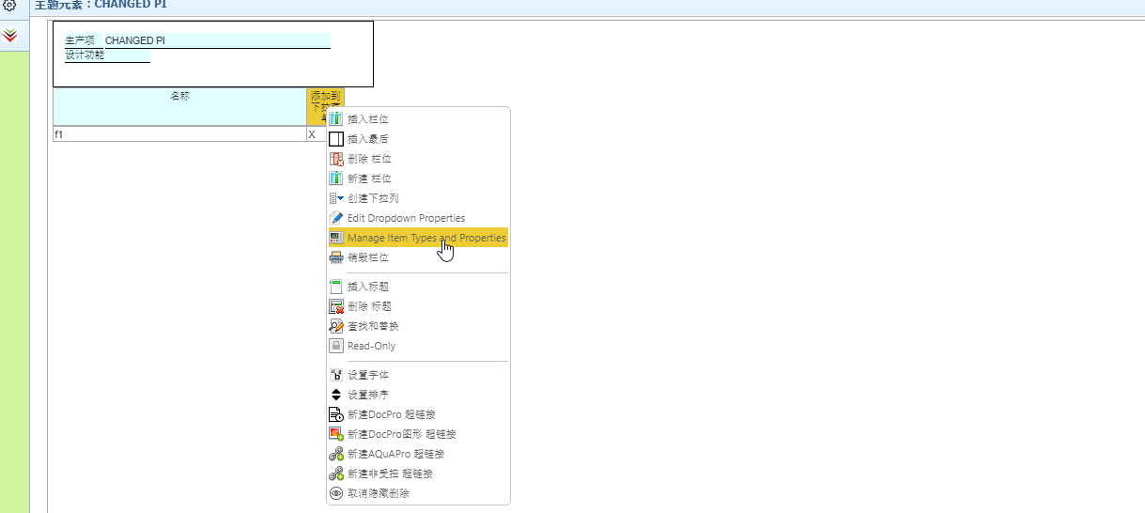

5. Failure> Rightclick on branch>Undo and replace should be converted

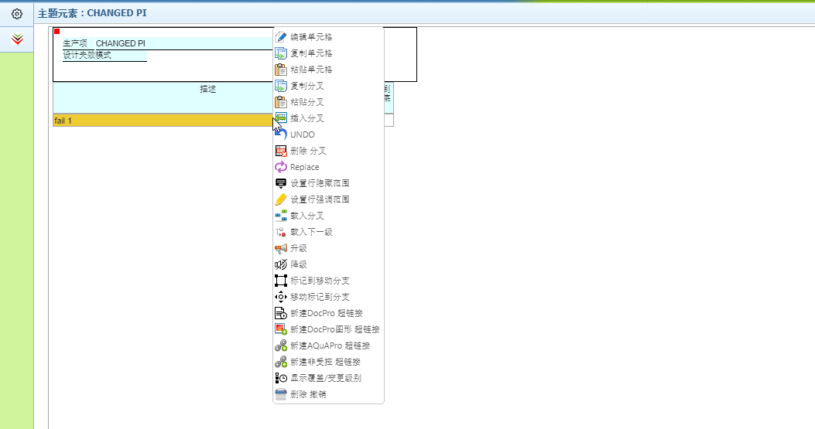

6. Failure Tree>Tooltip option for undo/redo/open as SVG/PNG/print/fullscreen/Zoom tofit/zoom in/zoom out should be converted

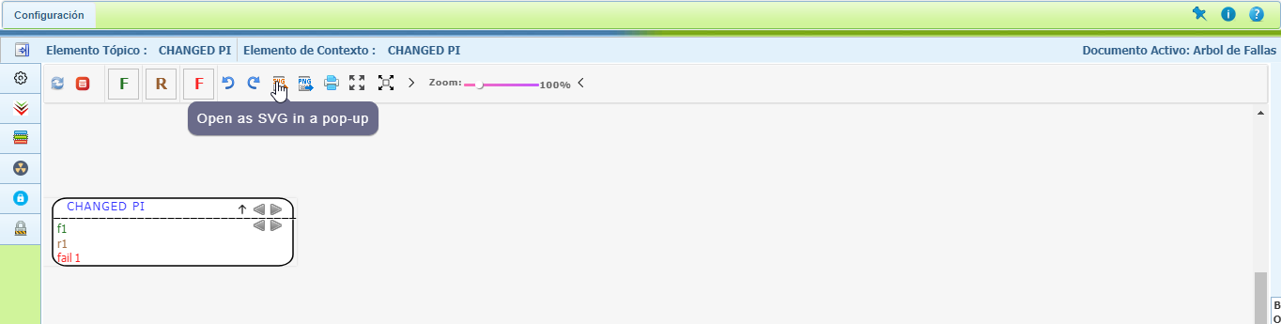

7. EFC Tree> Publish Should be converted 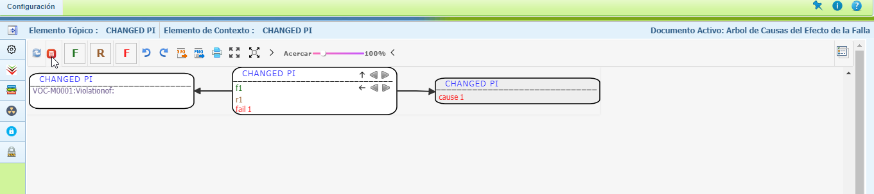

8. DFMEA page should be converted

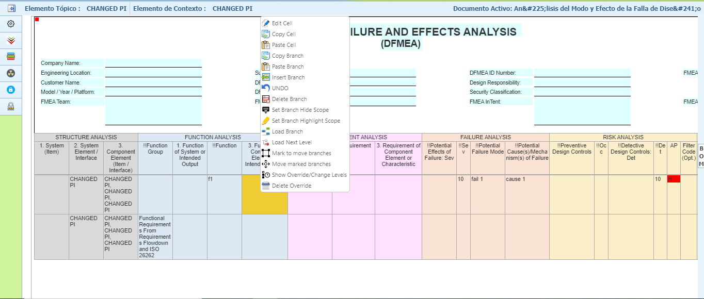

9. DVP&R page should be converted

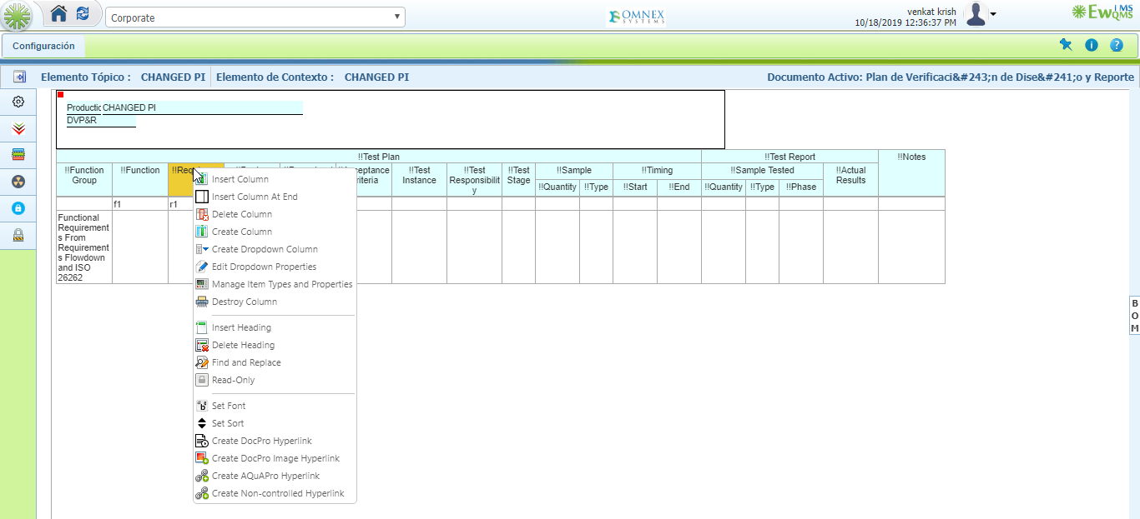

10. Impact Analysis: Tool Tip options and style/normal/size for impact analysis should be converted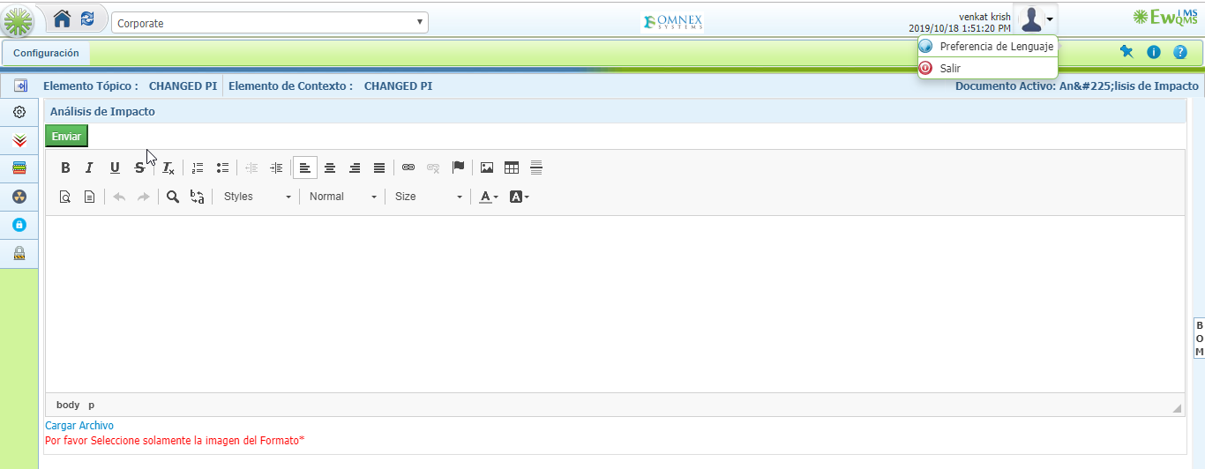

11. SEooC: Tool Tip options and style/normal/size for impact analysis should be converted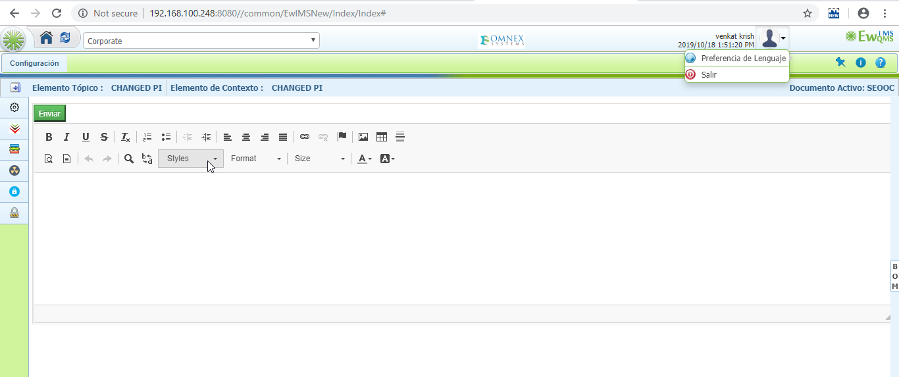

12. Item details: Tool Tip options and style/normal/size for impact analysis should be converted 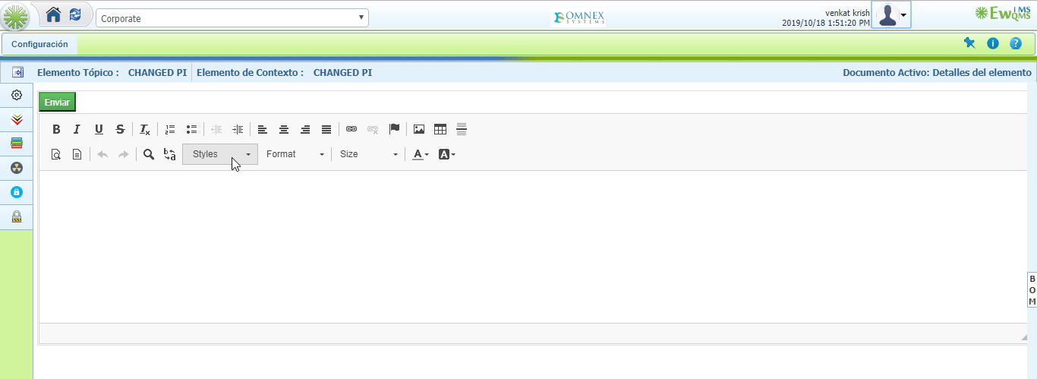

13. Block Diagram: Mordern/Dark/Material should be converted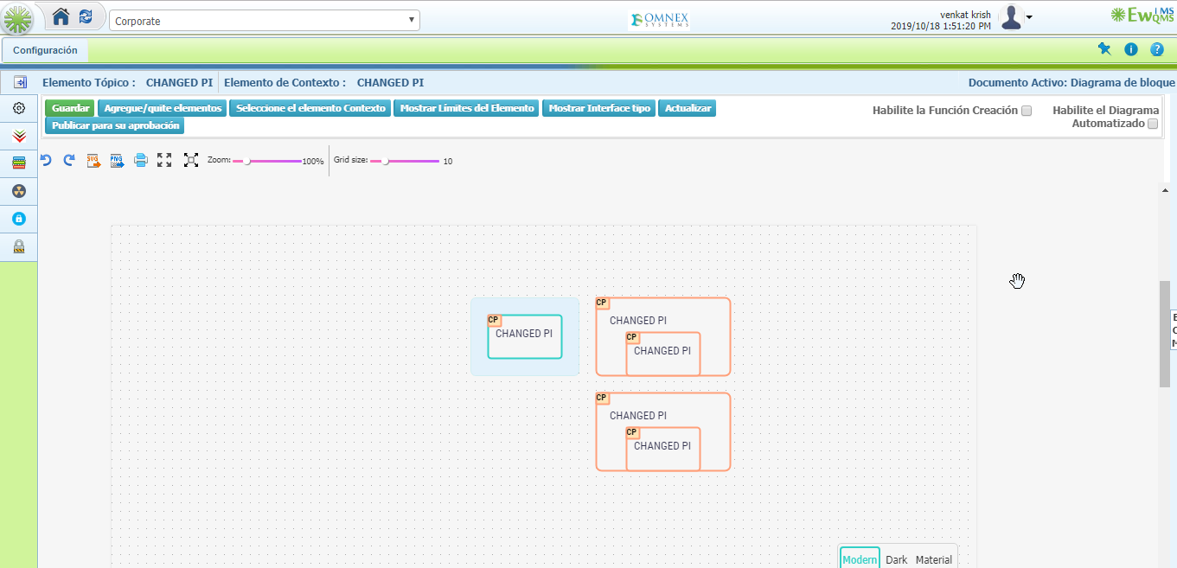

14. Itemboundaries: Publish for Approval and Publish button should be converted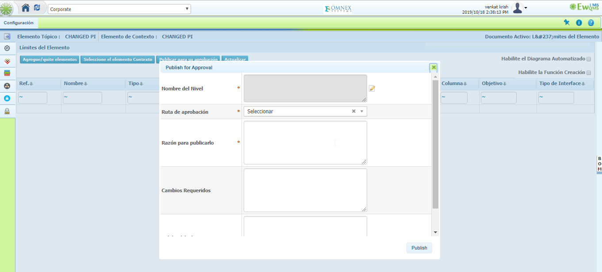

15. Itemboundaries: Active document for itemboundraies should be converted

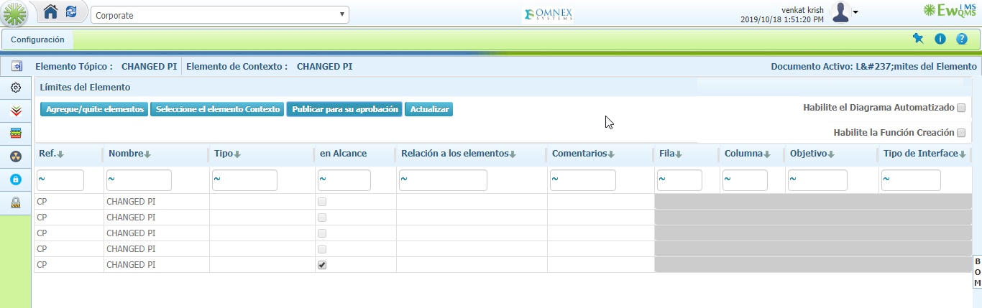

16. Interface function matrix: Select context element>cancel should be converted 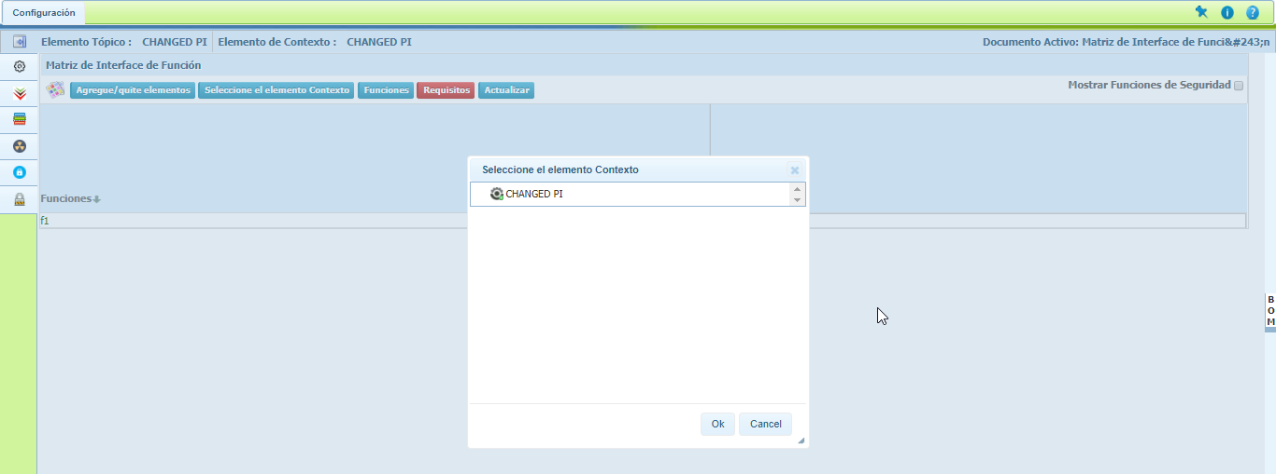

17. IFM: Active document for IFM should be converted 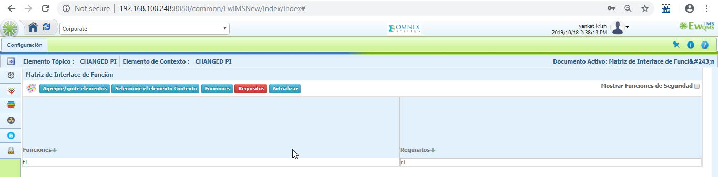

18. Interface Matrix: Legent should be converted 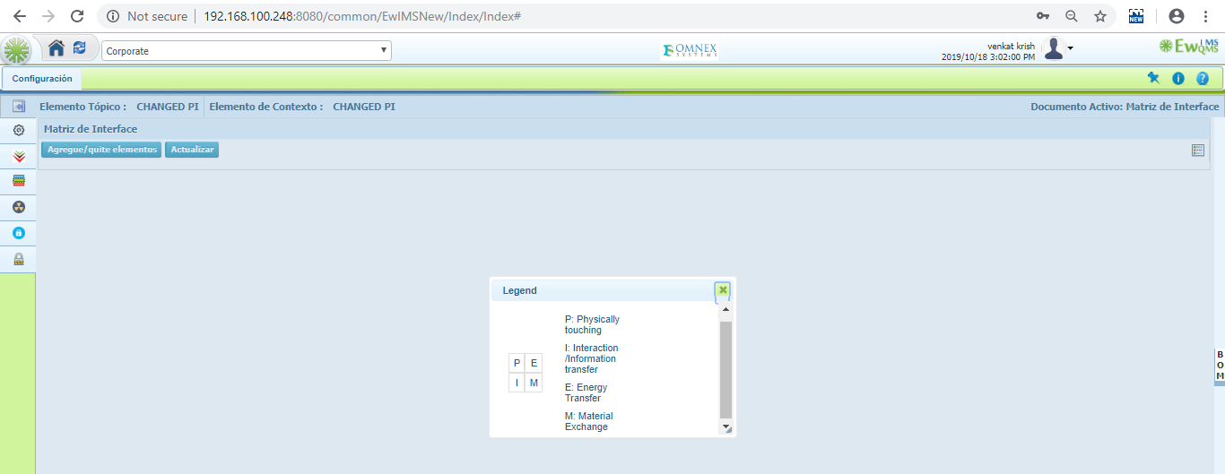

19. Element Type: Publish for Approval and Publish button should be converted 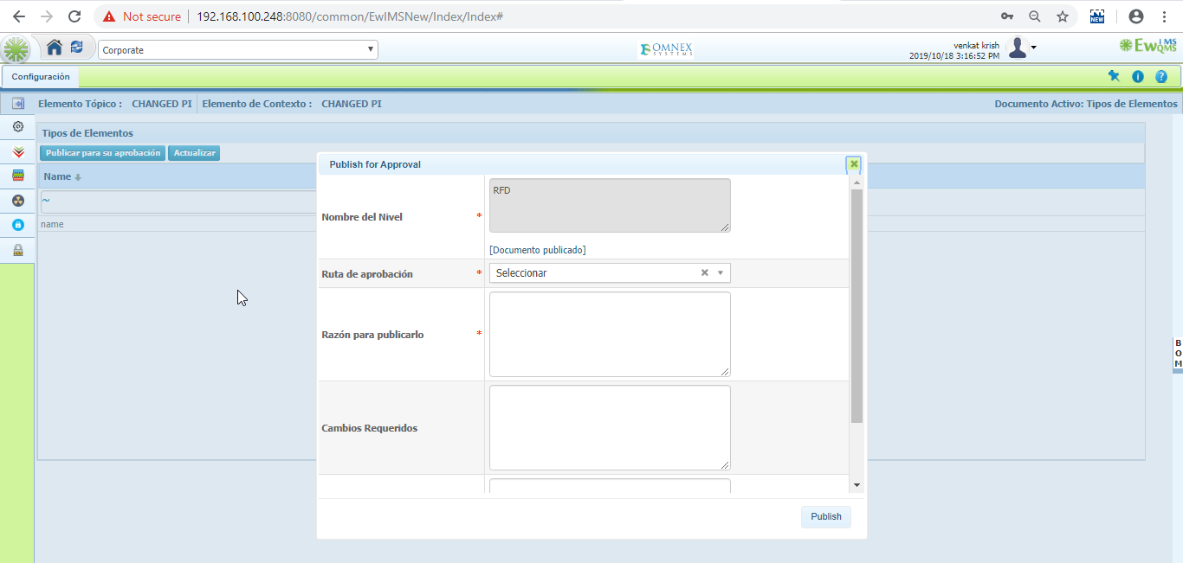

20. Interface Type: Publish for Approval and Publish button should be converted 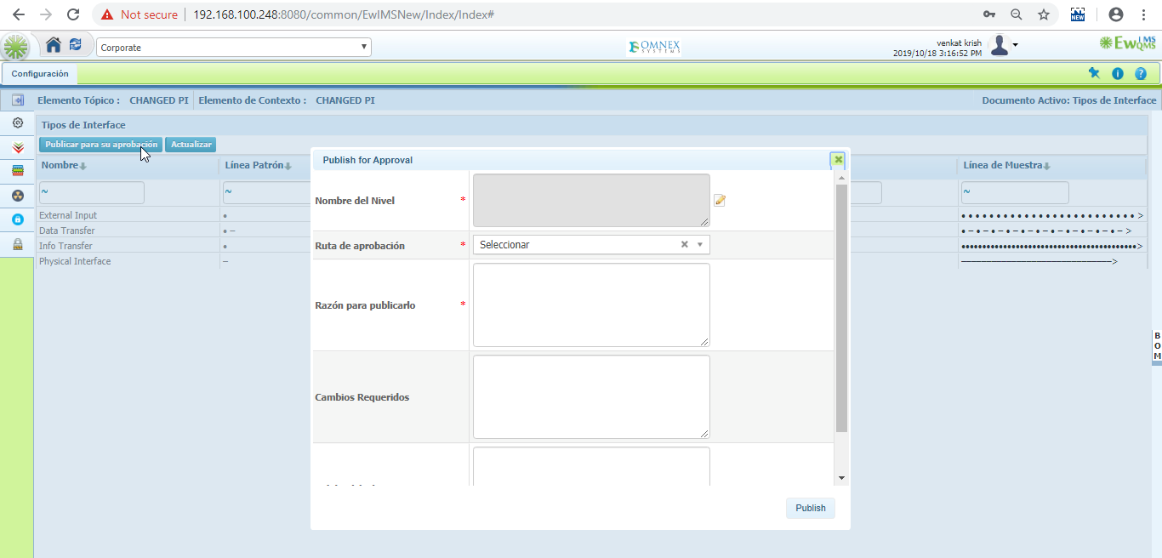

21. Malfunctions: Publish for Approval and Publish button should be converted 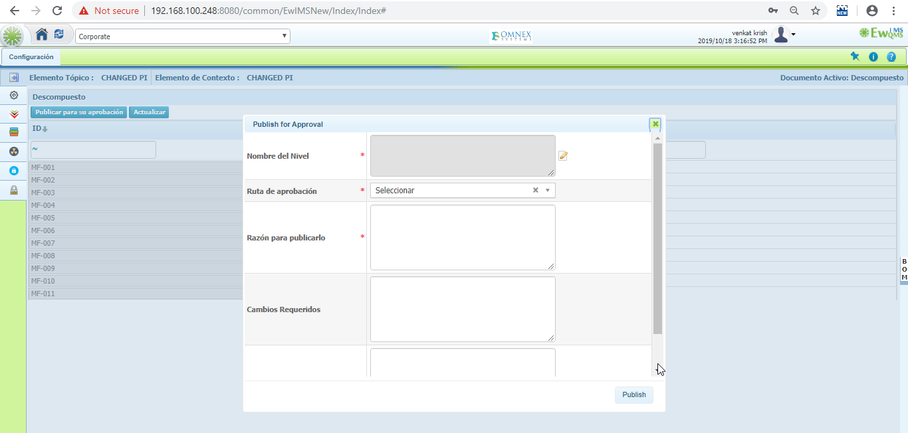

22. Functional Analysis: Publish for Approval and Publish button should be converted 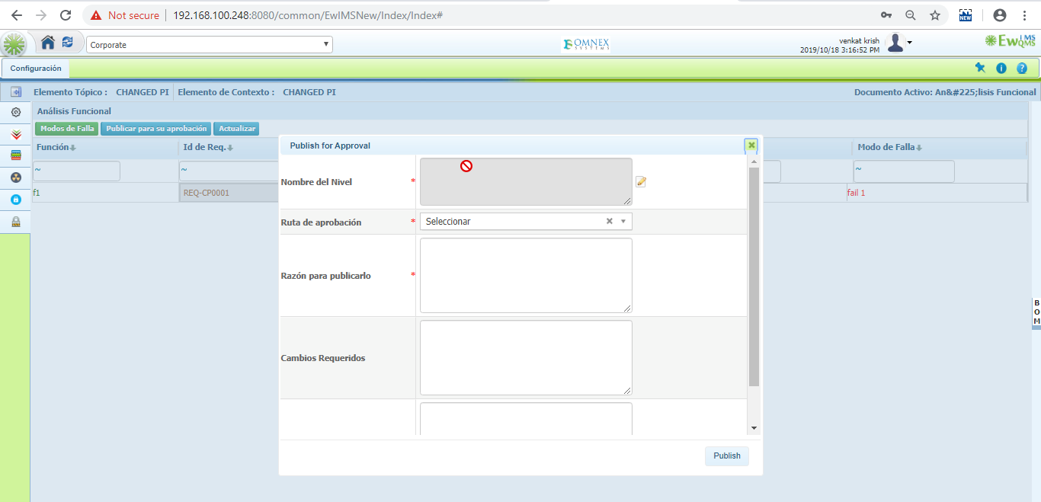

23.Functional Analysis: Active document for itemboundraies should be converted

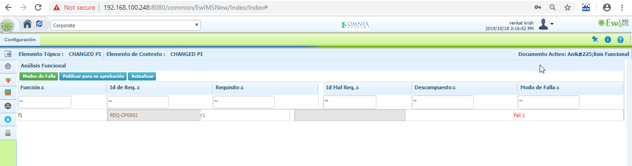

24.Functional Analysis: Name in Failure mode should be converted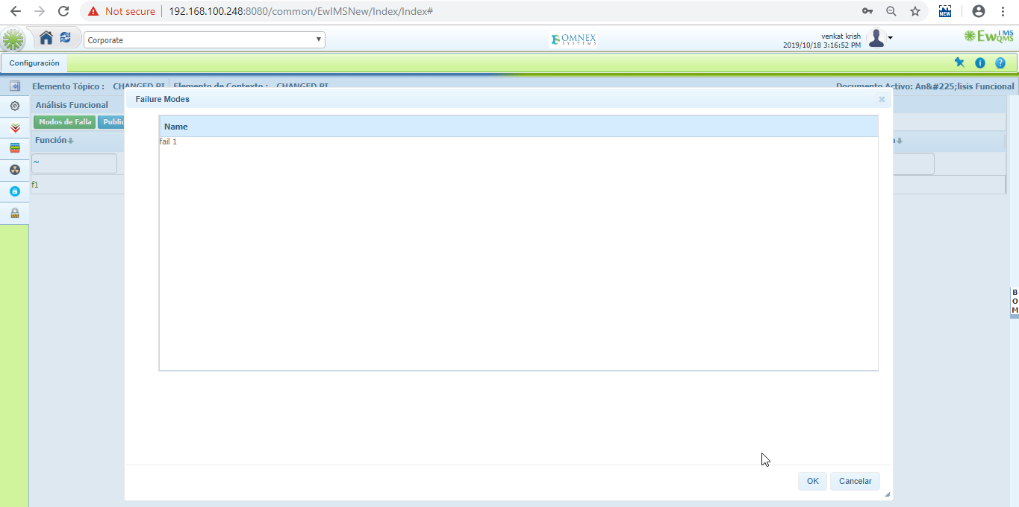

25. Functional Analysis: Publish for Approval and Publish button should be converted 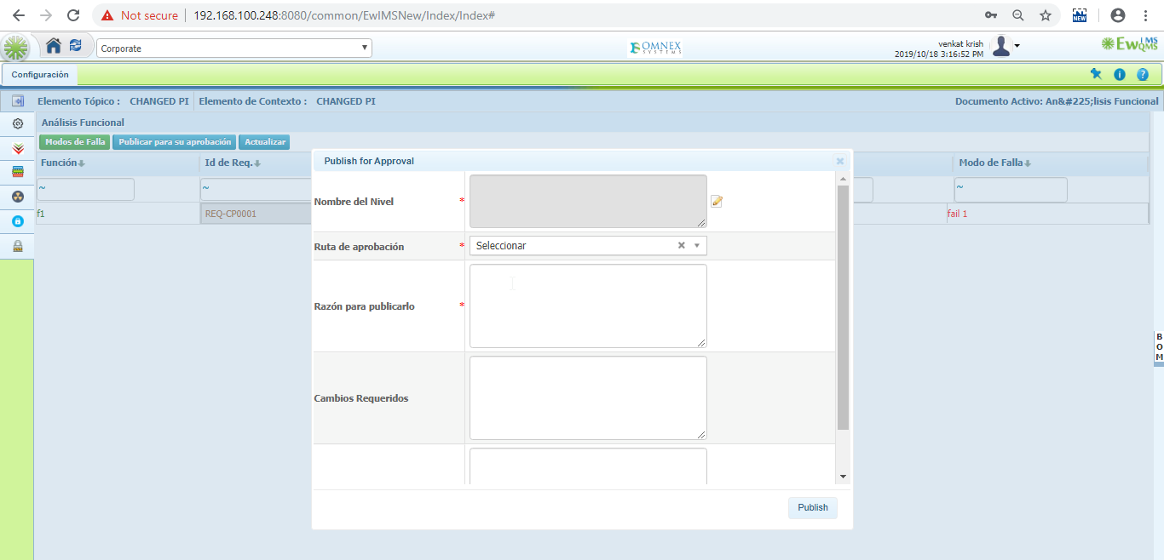

26. Add/Edit Operation Situations: Name in Edit operation situations should be converted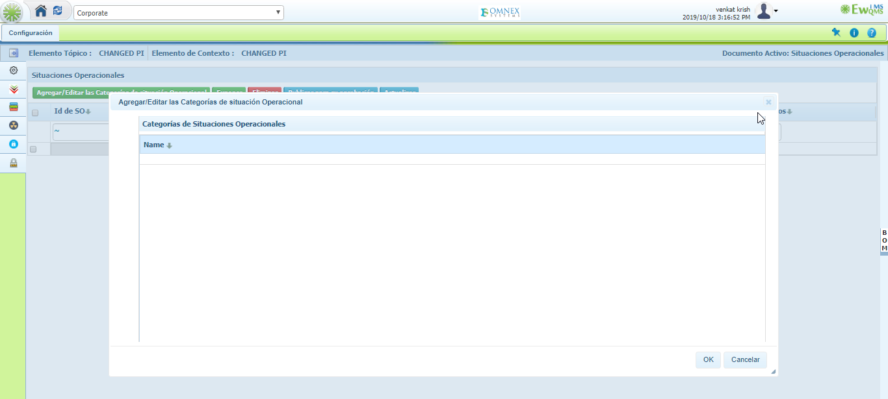

27. **Operational Situations** >Number and description should be converted in Exposure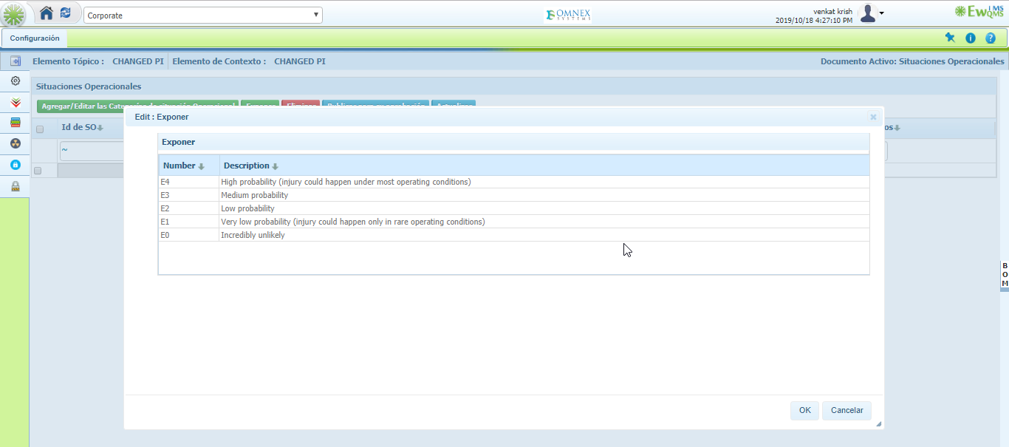

28. **Operational Situations>** Publish for Approval and Publish button should be converted 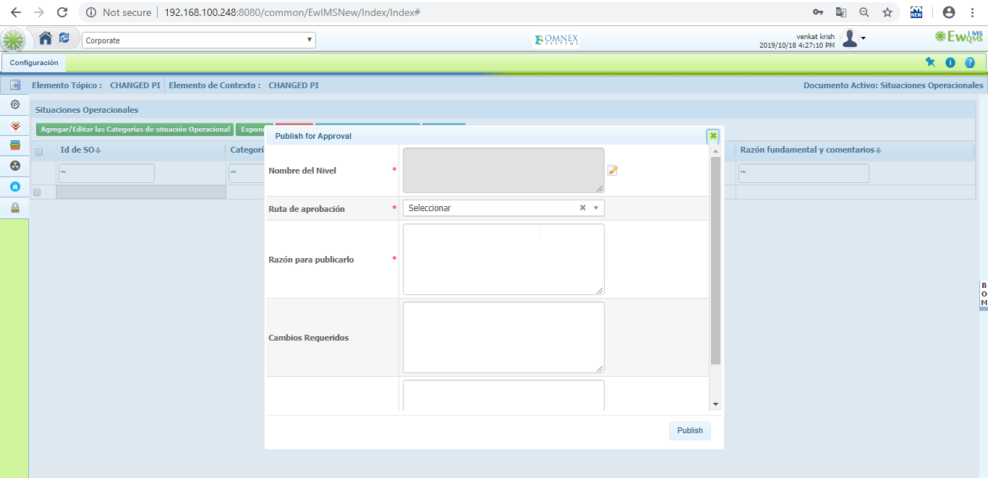

29. **Hazard and Risk Analysis>** Name, Number and description should be converted in Severity/Controllability/Effects.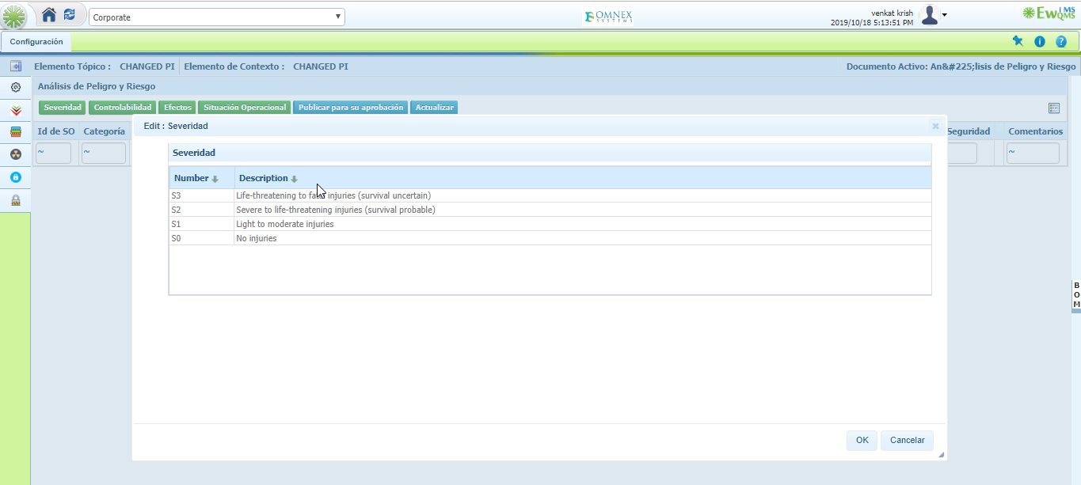

30. Cancel in operation situation should be converted in HARA