Project Review Page issues:

1. Deliverable Summary issues.

-> Need Column Adjustable Resize option. - Suggestion

-> Expand all and Collapse all option needed. - Suggestion

-> Data not displayed with in the column – data alignment issue

->Task not completed but actual finish date is displayed for the task.

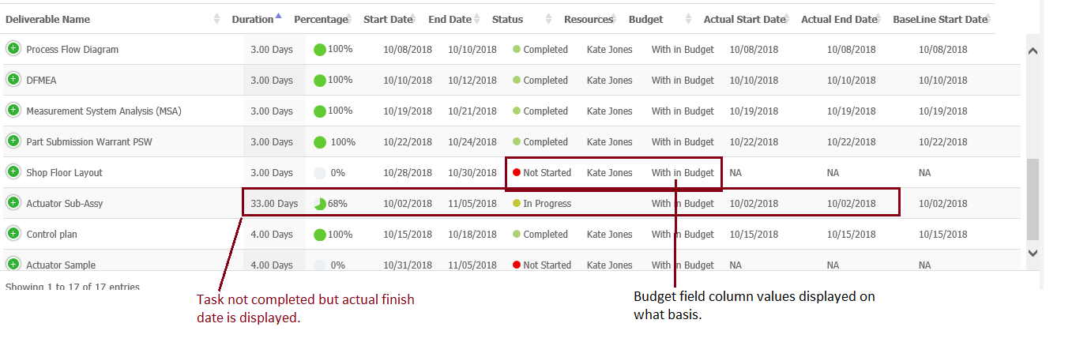

2) Search not working as expected in the deliverable summary.

3) Search not working as expected in the risk section.

4) % completion is displayed incorrectly in the deliverable summary. – To be verified

5) Deliverables are not listed in order in deliverable summary

6) Approval Required is displayed as “Yes”, even when there is no approval set.

7) When navigation from the program / project review to the deliverable list, split window is not displayed.