Project Review Page issues:

1. Icon size to be displayed same as that of project planner screen.



1. Deliverable Summary issues.

-> Need Column Adjustable Resize option.

-> Expand all and Collapse all option needed.

-> Data not displayed with in the column – data alignment issue

->Task not completed but actual finish date is displayed for the task.

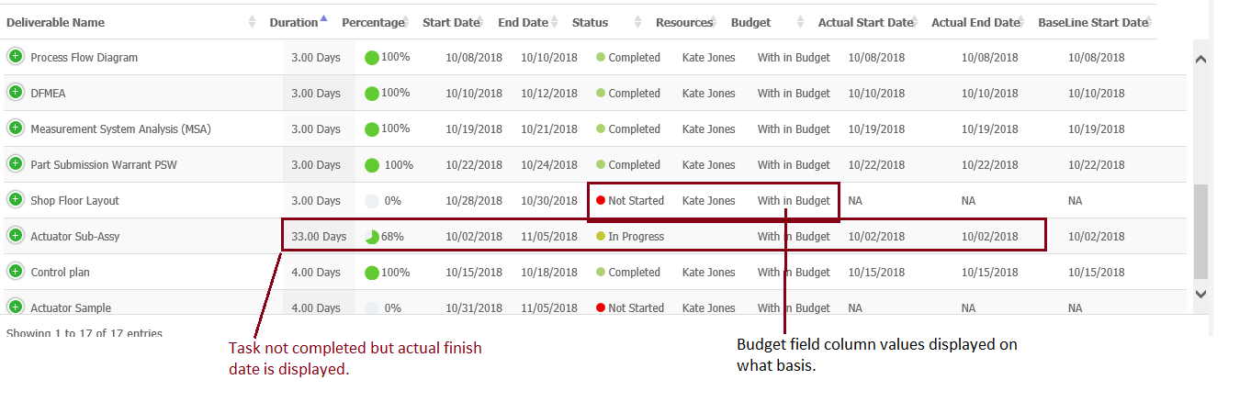

5) Search not working as expected in the deliverable summary.

6) Search not working as expected in the risk section.

11) % completion is displayed incorrectly in the deliverable summary. – To be verified

14) Change the Icon of Deliverable list in the project review page. 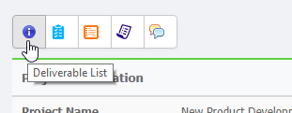

15)When the placing the cursor in the progress bar in the chart it displays the value of all the phases.

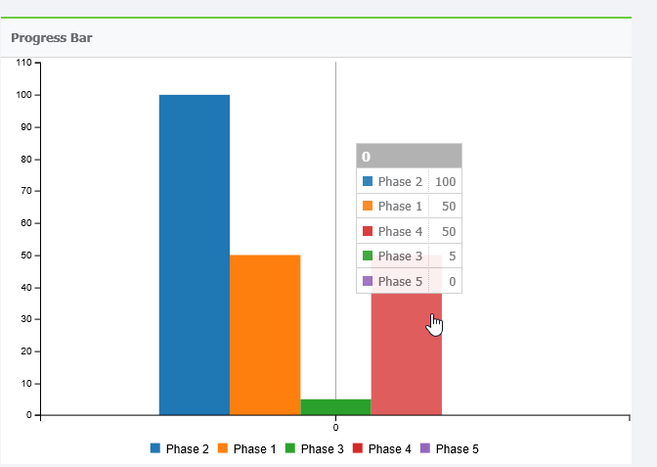

Phases not in order

17)Actions – It is showing incorrect record in the Review Page. - to be verified

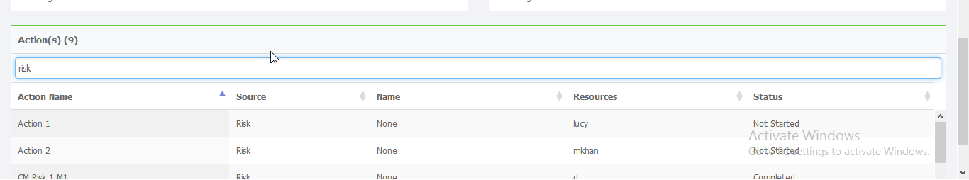

18) Deliverables are not listed in order in deliverable summary

19) Resource login is displayed instead of the resource name in the actions