Project Review Page issues:

1. Forecasted Target: No need of label near the flag.

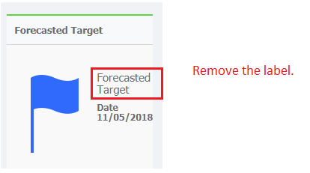

1. Icon size to be displayed same as that of project planner screen.



1. Project Information filed to be changed .

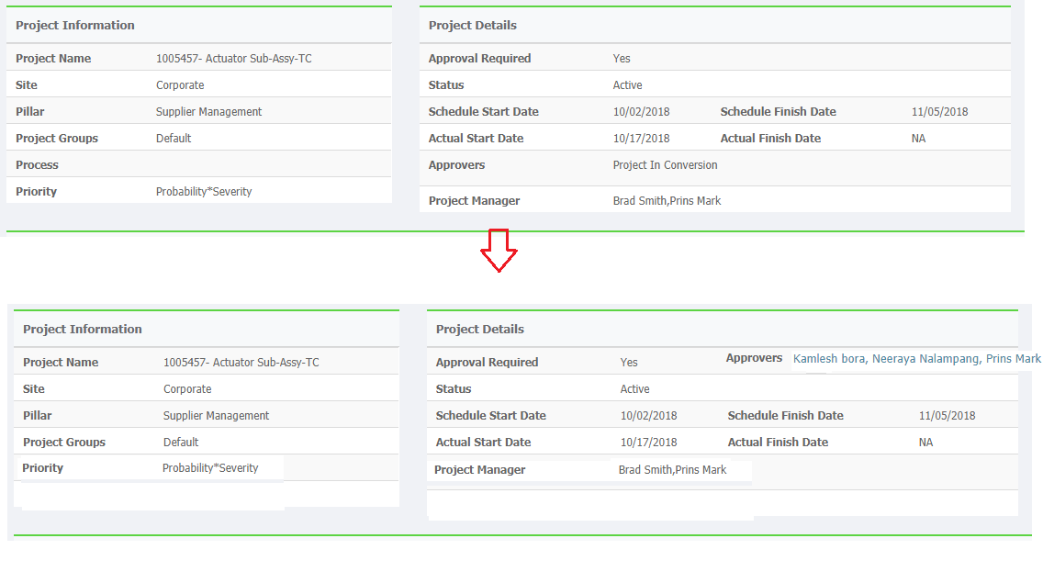

1. Deliverable Summary issues.

-> Need Column Adjustable Resize option.

-> Expand all and Collapse all option needed.

-> Data not displayed with in the column – data alignment issue

->Task not completed but actual finish date is displayed for the task.

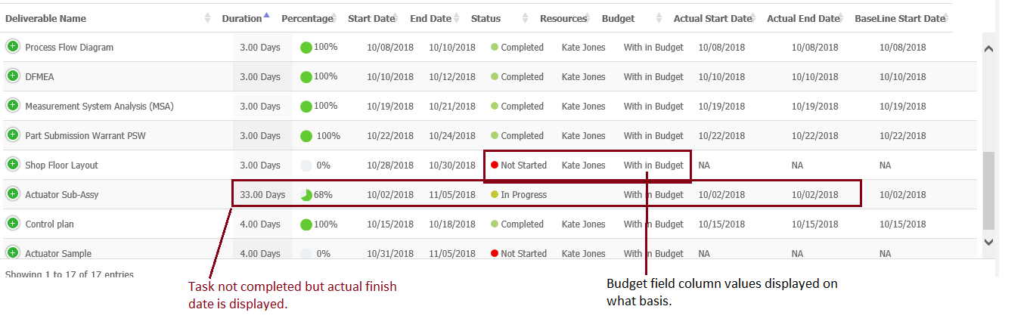

5) Search not working as expected in the deliverable summary.

6) Search not working in the risk section.

7) Risk Actions not displayed.

8) Meeting Name to be renamed as Meeting Subject.

9) Meeting subject is not displayed.

10) Rename “Name” as “Deliverable Name” in the Action section.

11) % completion is displayed incorrectly in the deliverable summary.

12) Meeting action status to be displayed same as that of Meeting actions in the action plan.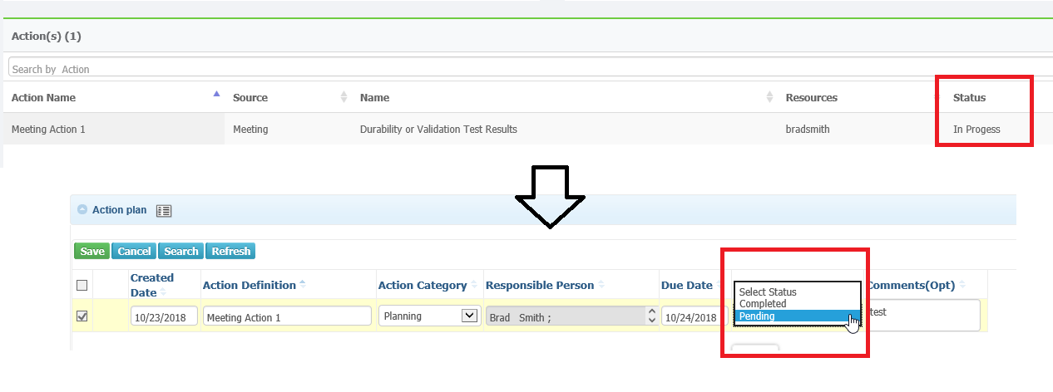

13) 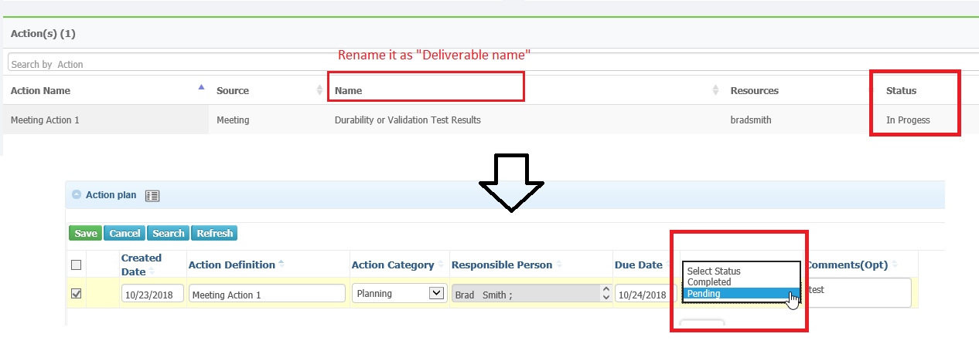

14) Change the Icon of Deliverable list in the project review page. 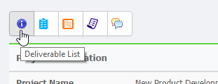

15)When the placing the cursor in the progress bar in the chart it displays the value of all the phases.

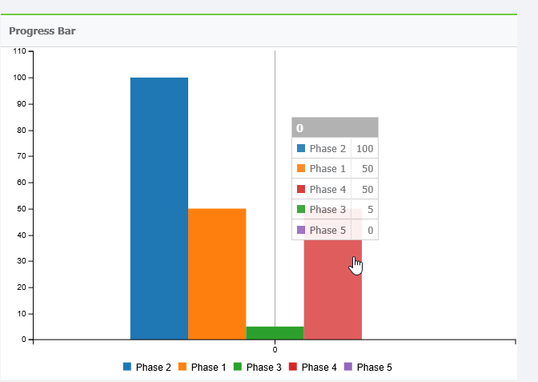

16) Base line is not done but base line date is displayed in the project review page. 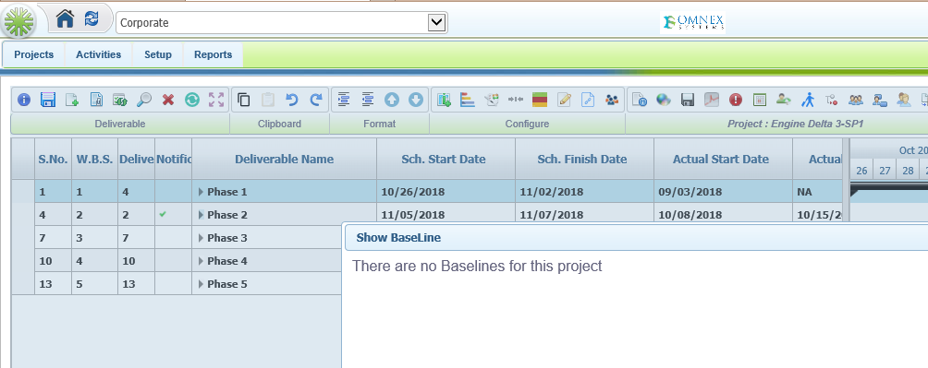

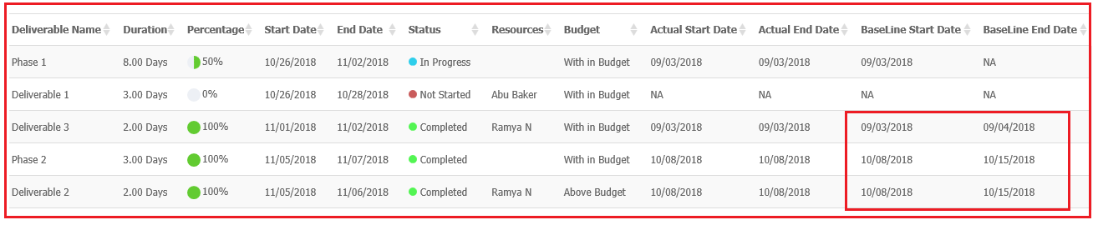

17)Actions – It is showing incorrect record in the Review Page.

