1. Copy deliverable - > Not Fixed

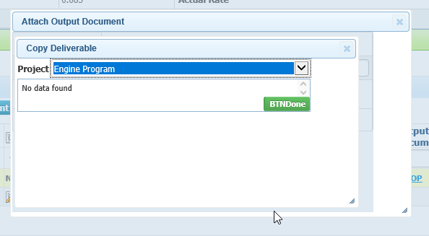

1. Output documents of other deliverable - fixed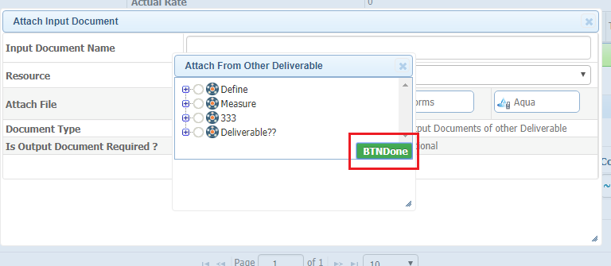
2. Show Baseline – Not Fixed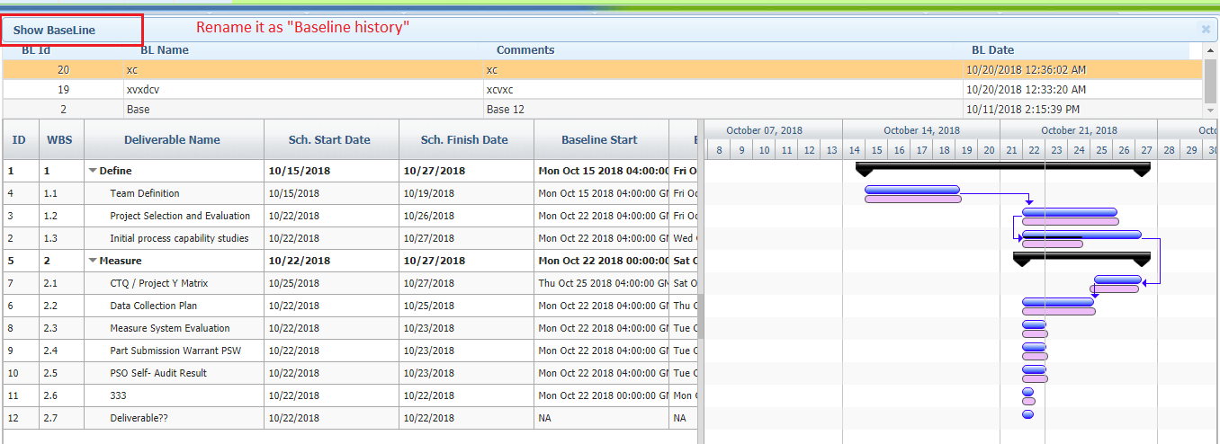
3. Periodic history –Not Fixed

