1. Archive –Message when clicking on archive without selecting a project

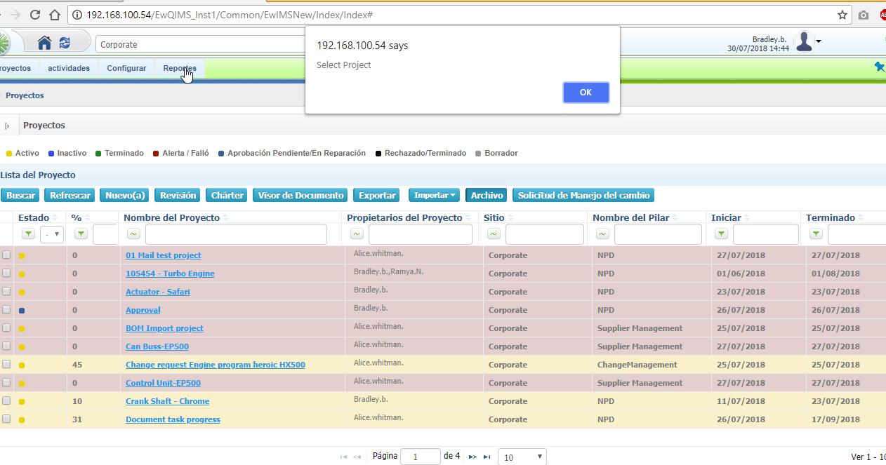

1. Project Plan –Column names are displayed in English

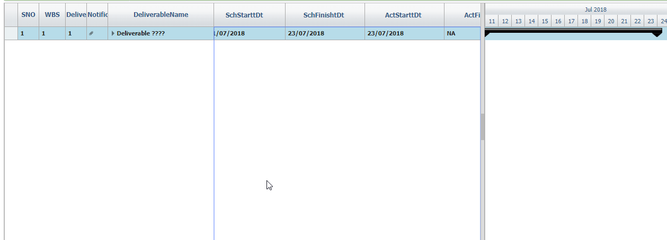

1. Deliverable info –

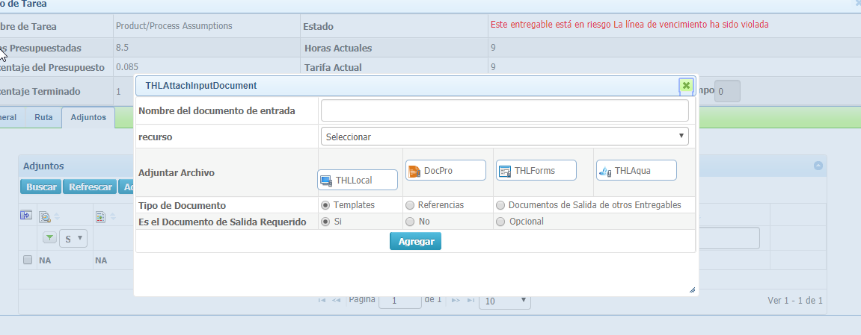

1. Attch from docpro

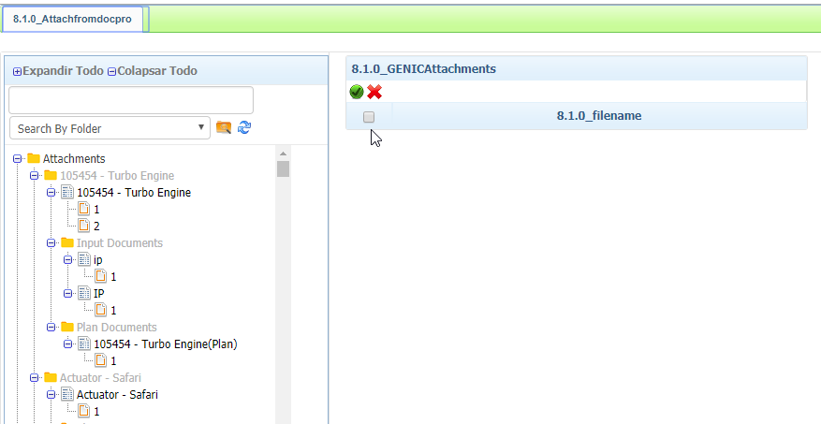

1. Deliverbale info – attach from aqua

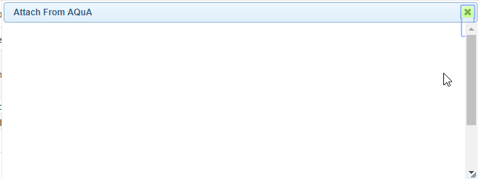

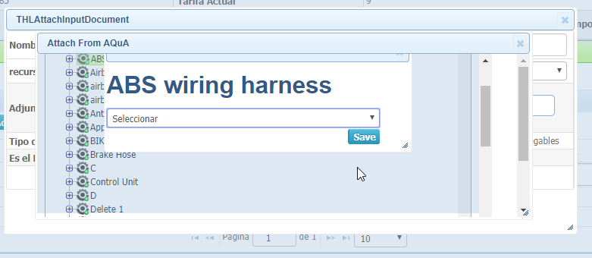

1. Deliverbale info – validation message

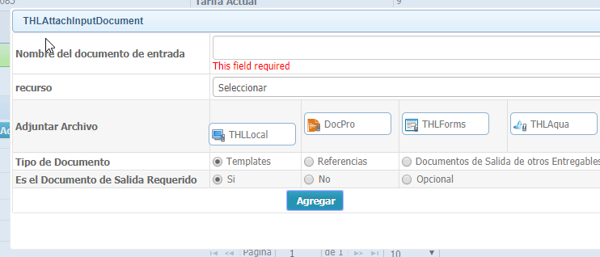

1. Additional document

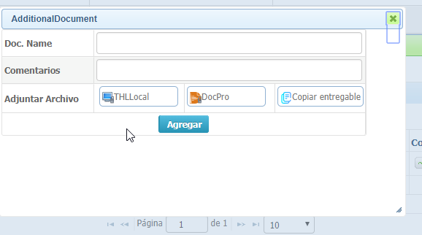

1. Deliverbale info – Route

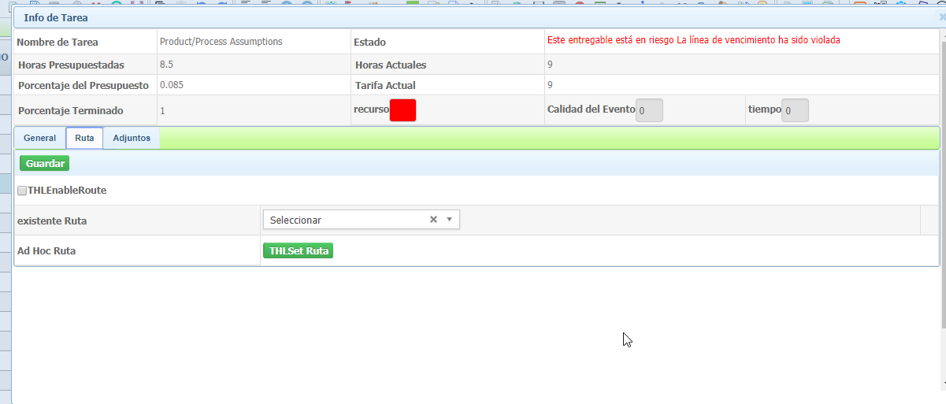

1. Deliverable info- General tab

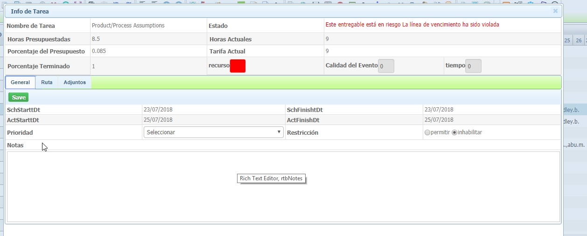

1. Project plan – Right click option

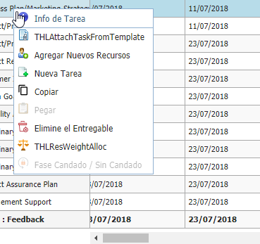

1. Project plan – Right click – attach ta sk from template

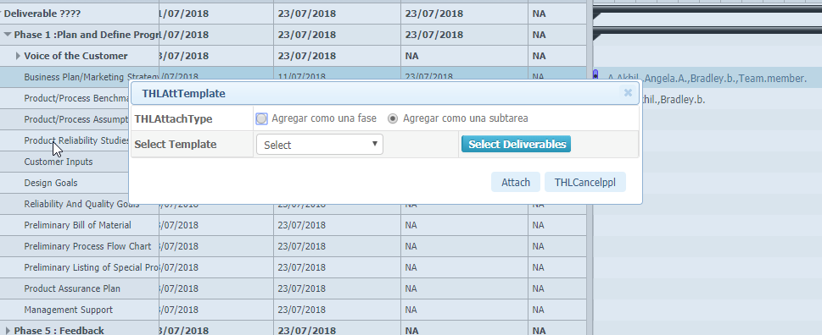

1. Attach task from template – message after attaching the template

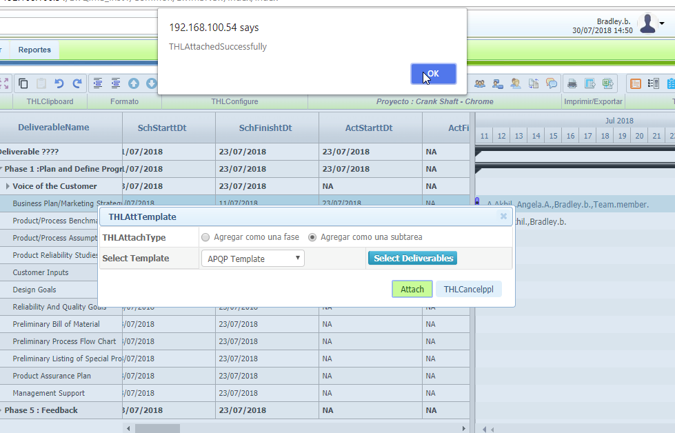

1. Attach task from template – select deliverables

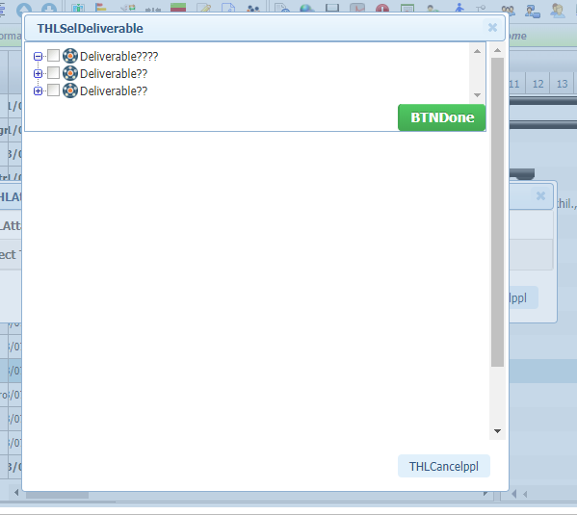

1. Delete deliverbale –When clicking on delete deliverable

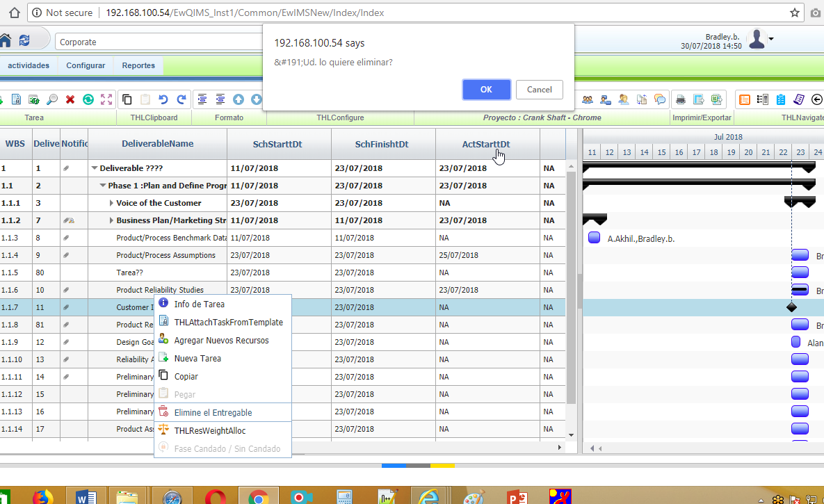

1. Resource allocation and weightage

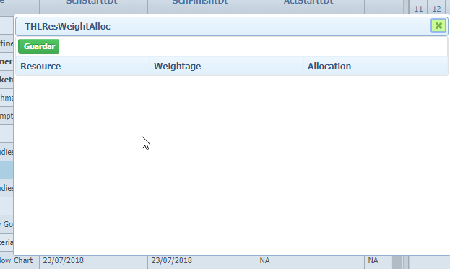

1. Periodic update – Click on periodic update without adding resource

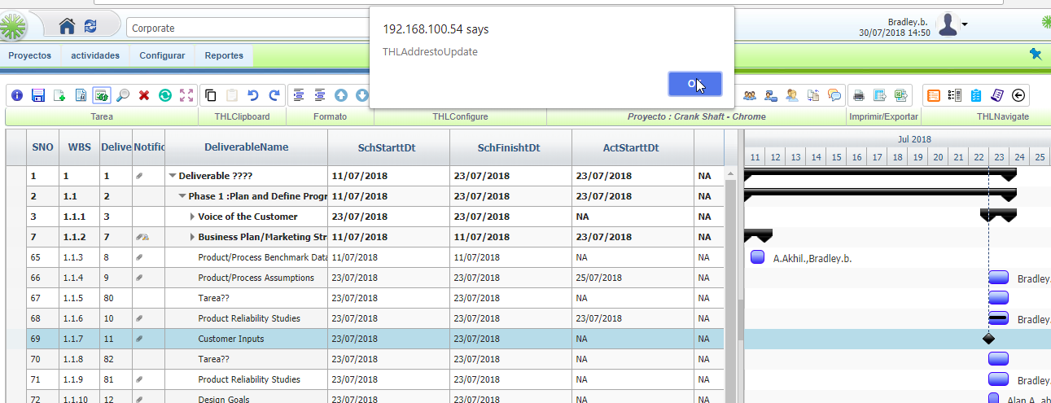

1. Menu



1. No labels for following icons. As well labels are not converted inside the pages of these icons. Same applies for program page too

* Attach task from template
* Expand all task
* Copy
* Undo
* Redo
* Moveup
* Movedown
* Gantt column config
* Link production item
* Meetings
* Charter heard configuration
* Enable task constraints
* Enable task based
* Save baseline
* Show baseline
* Show priority
* Resource holiday setting
* Resource holiday across plan
* Critical path
* Show resource chart
* Level resource
* User replacement
* Convert to template
* Comments
* Print / Export all icon
* Navigate all icons

1. Escalation – Programs and projects

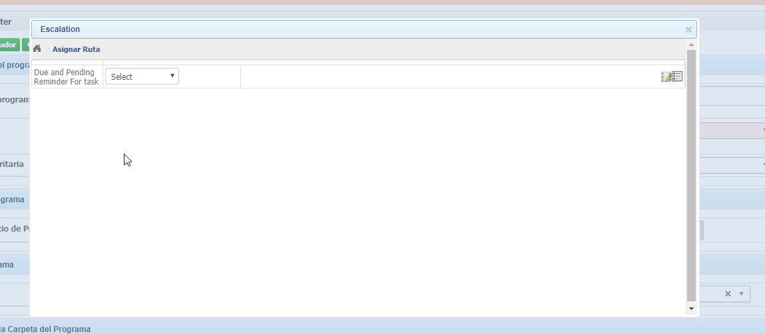

1. Charter - Program and project

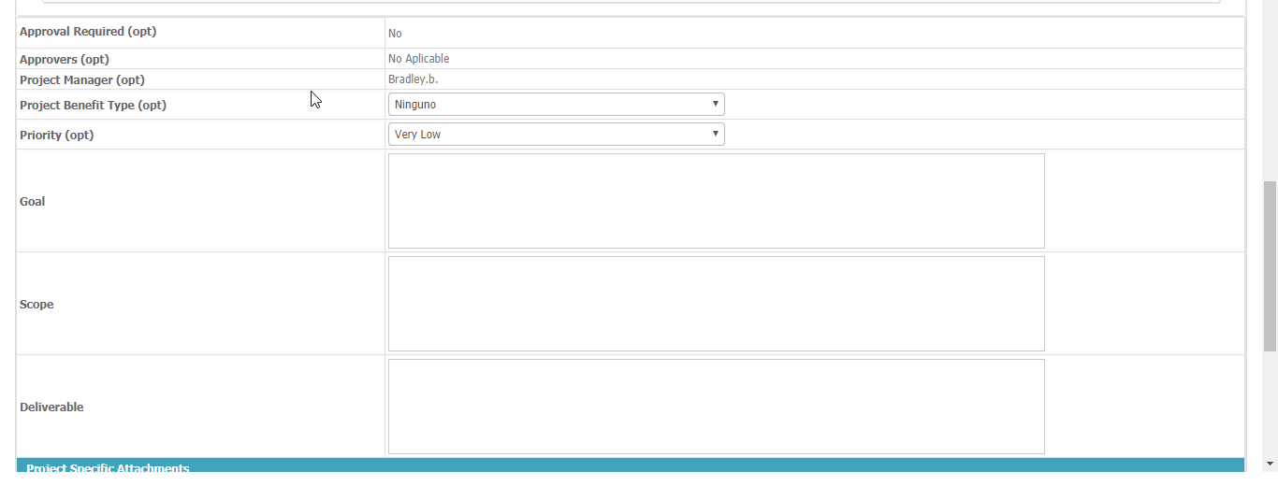



1. Risk setup

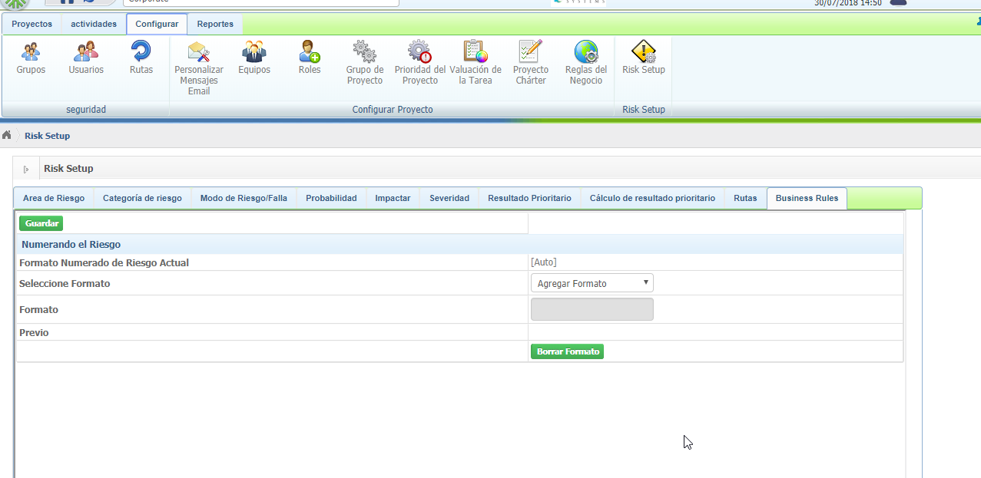

1. Business rules – configure

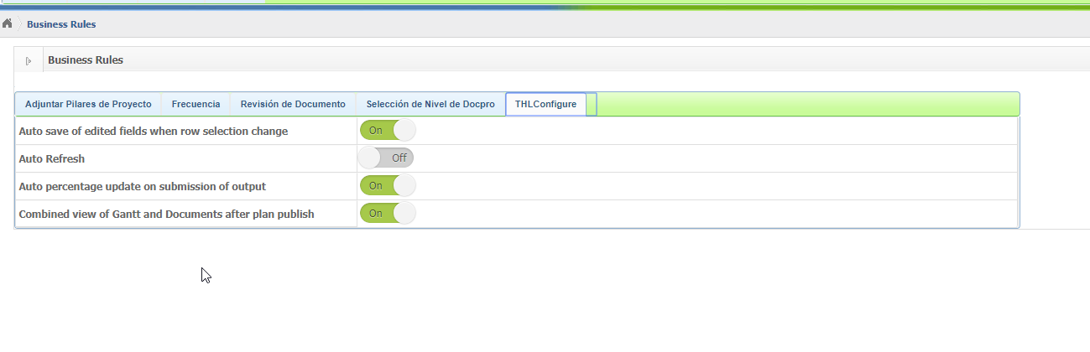

1. Doc viewer in programs

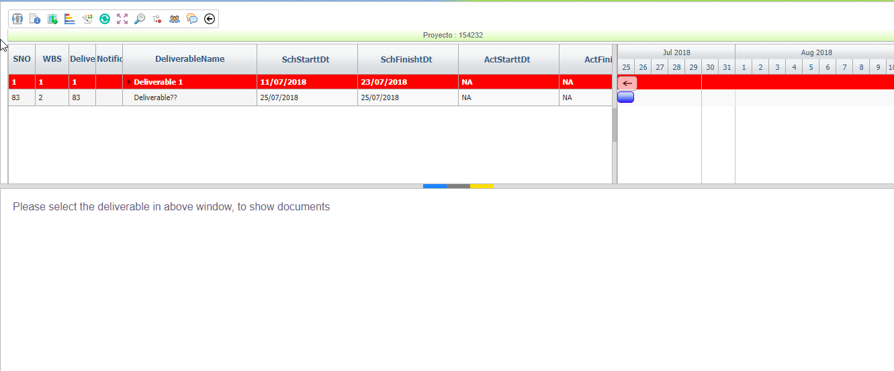

1. Programs – right click

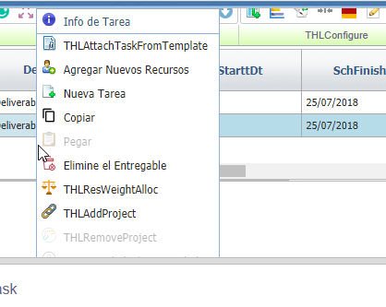

1. Doc viewer

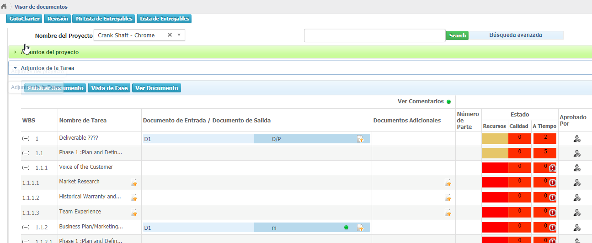

1. When Deliverbale name is in Spanish, the deliverable name is not visible while creating the meeting.

