1. Revision history icon - 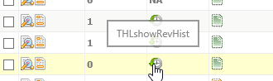
2. Draft history icon - 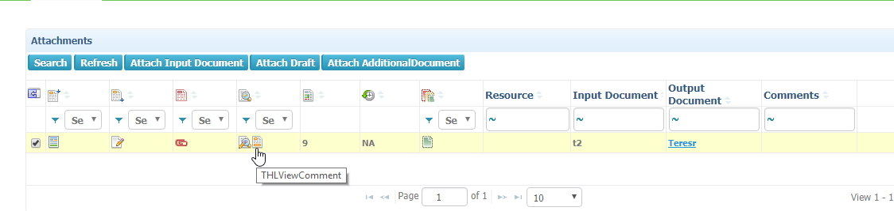
3. Template to project conversion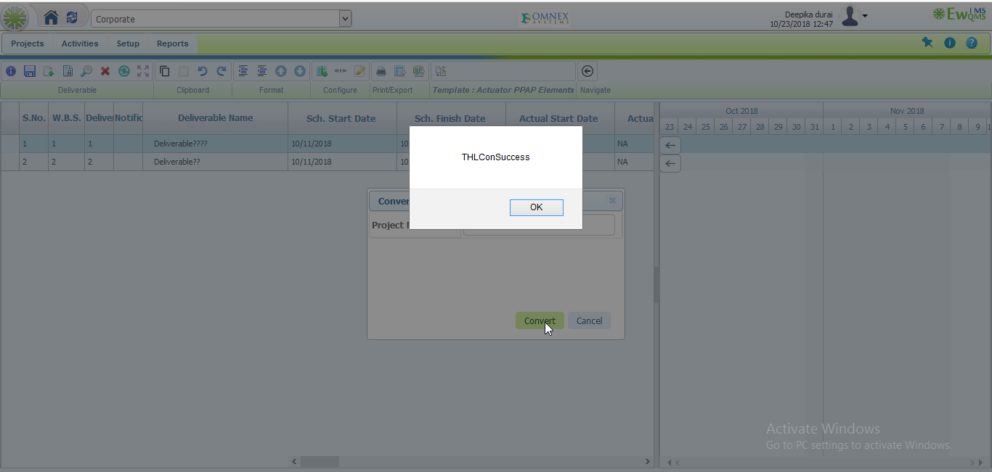
4. Deliverable info -> General tab -> constraints label issue.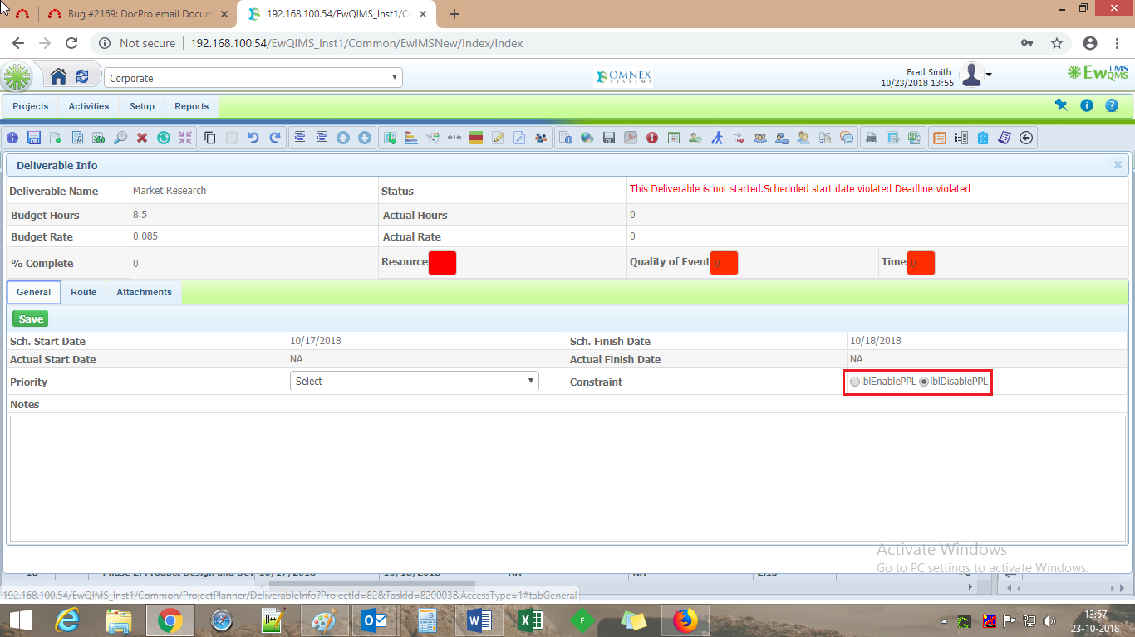
5. Deliverable info -> output mandatory icon – Not Fixed
6. Copy deliverable - > Not Fixed

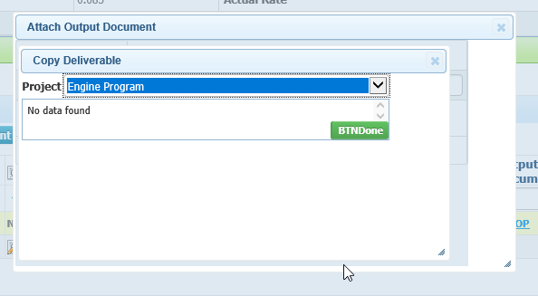

1. Dropdown options not listed in order – Not Fixed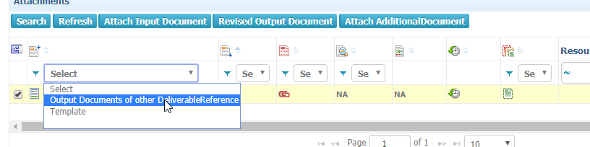
2. Output documents of other deliverable – Not Fixed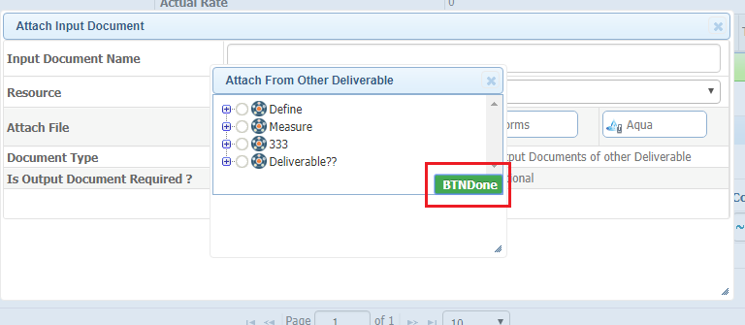
3. Show Baseline – Not Fixed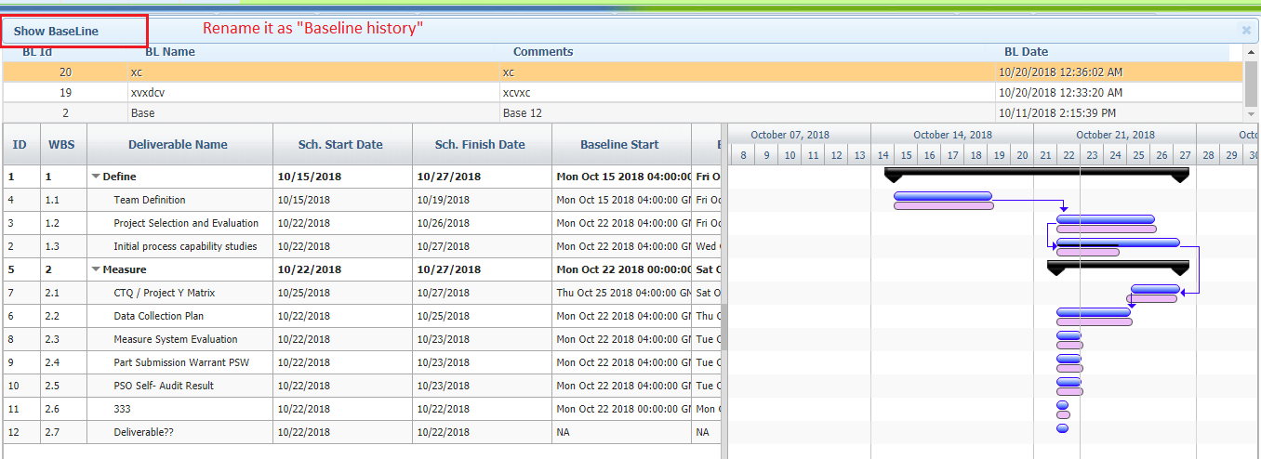
4. Link production Item->Jquery Gantt Page. 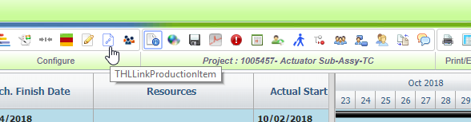
5. Task based and Effort based completion -> Jquery gantt page. 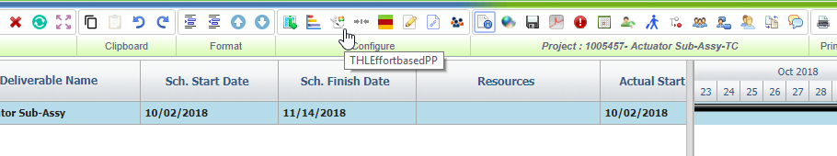

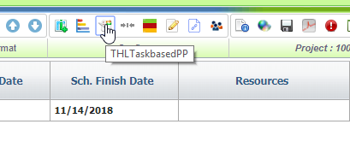

1. Periodic history –Not Fixed

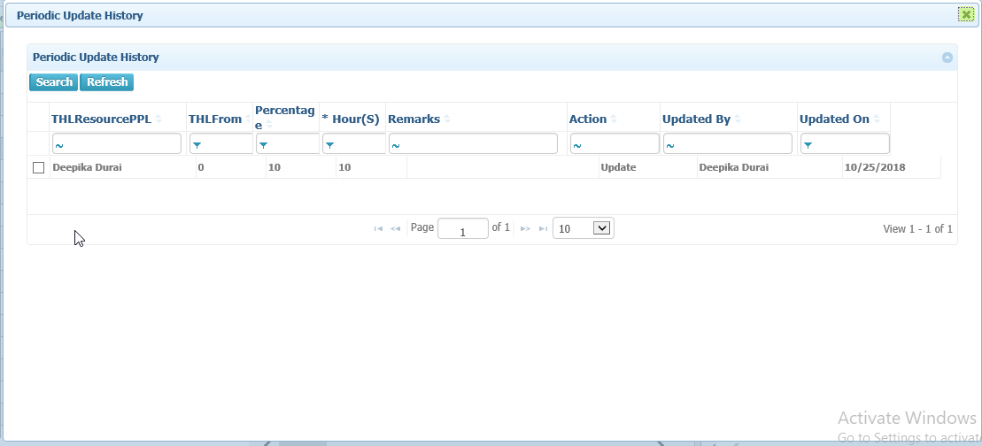

1. Project to Template – Conversion 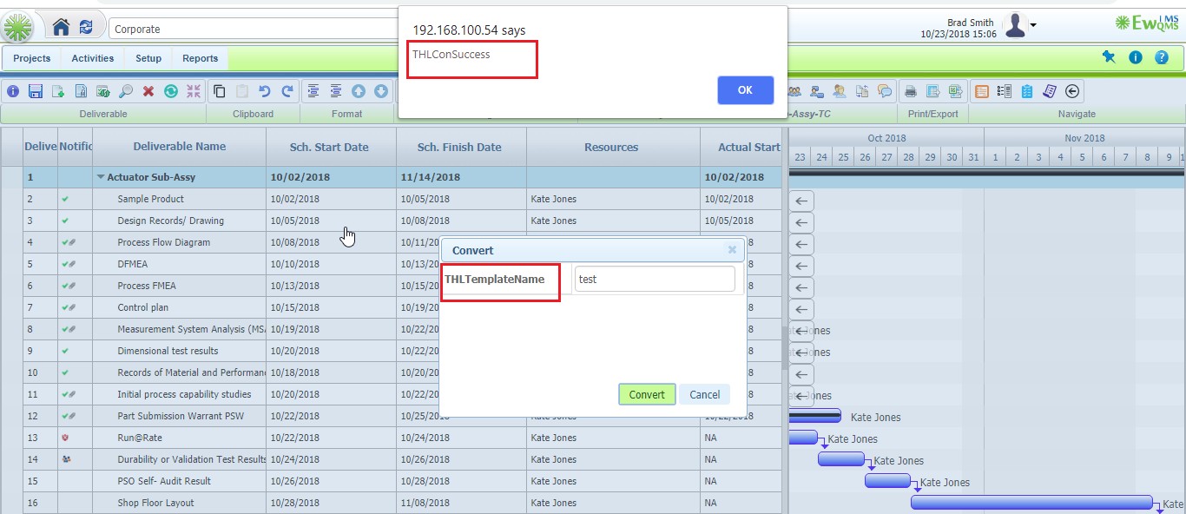
2. Program - > Doc viewer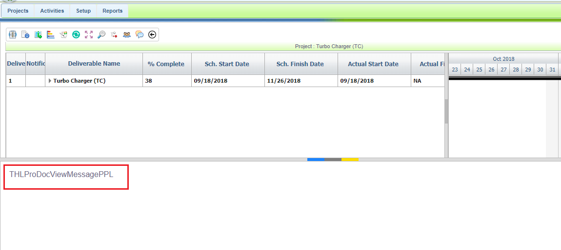
3. Action Page issue in Social Media. 