1. Revision history icon - 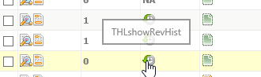
2. Draft history icon - 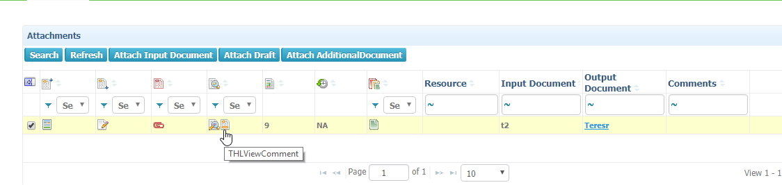
3. Template to project conversion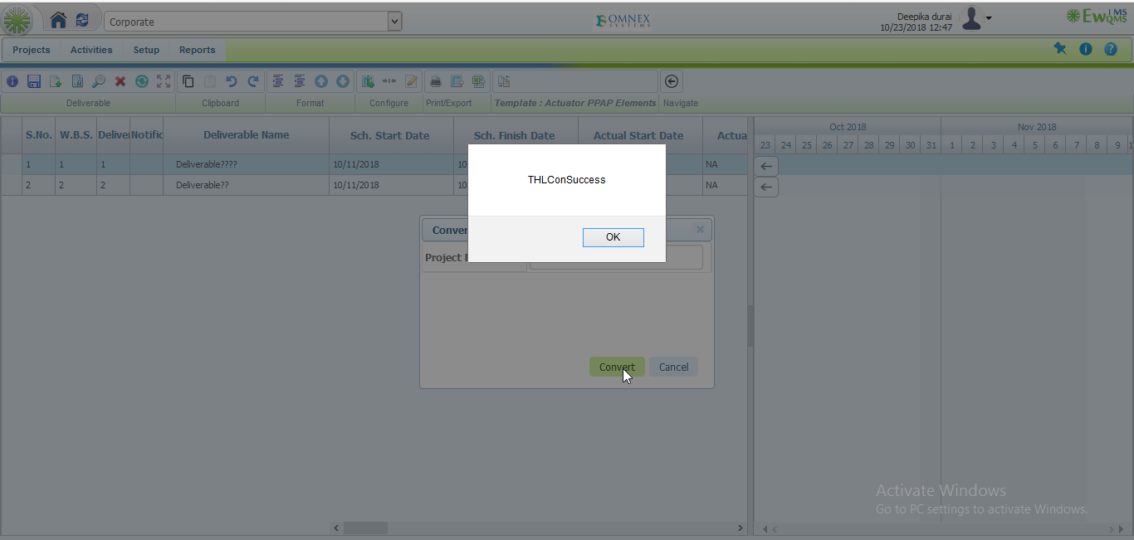
4. Deliverable info -> General tab -> constraints label issue.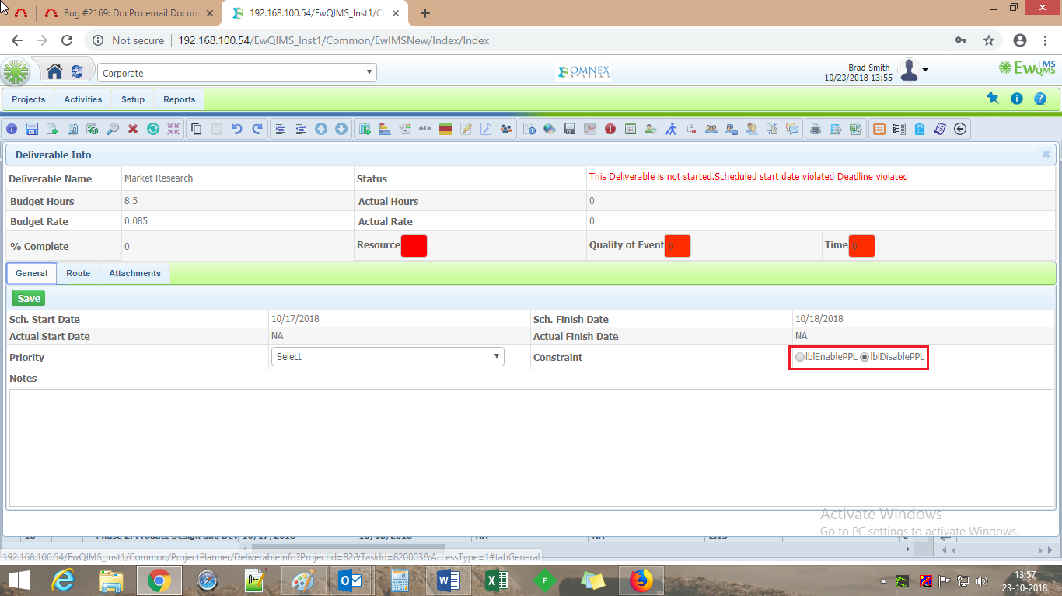
5. Deliverable info -> output mandatory icon
6. Copy deliverable - >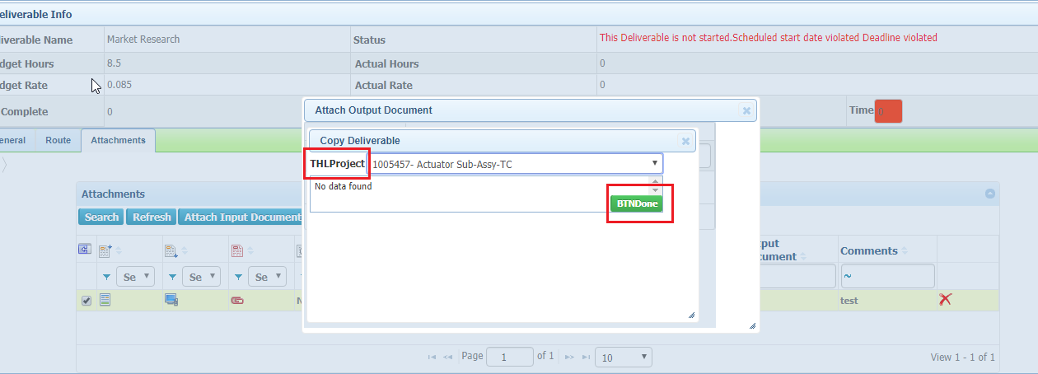
7. Dropdown options not listed in order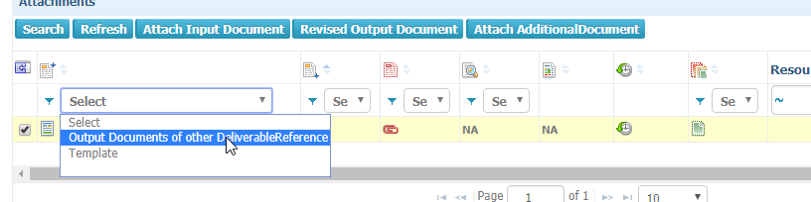

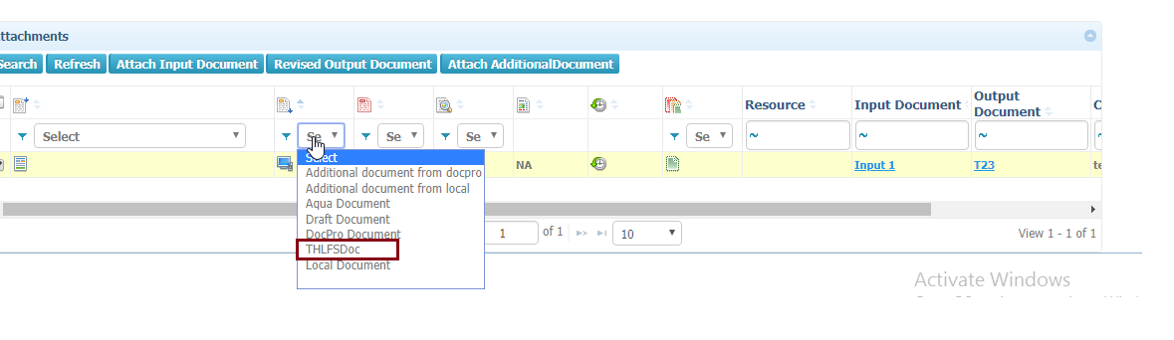

1. Output documents of other deliverable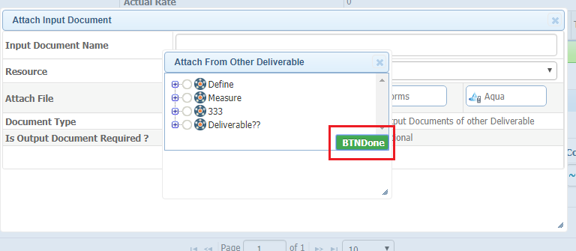
2. Show Baseline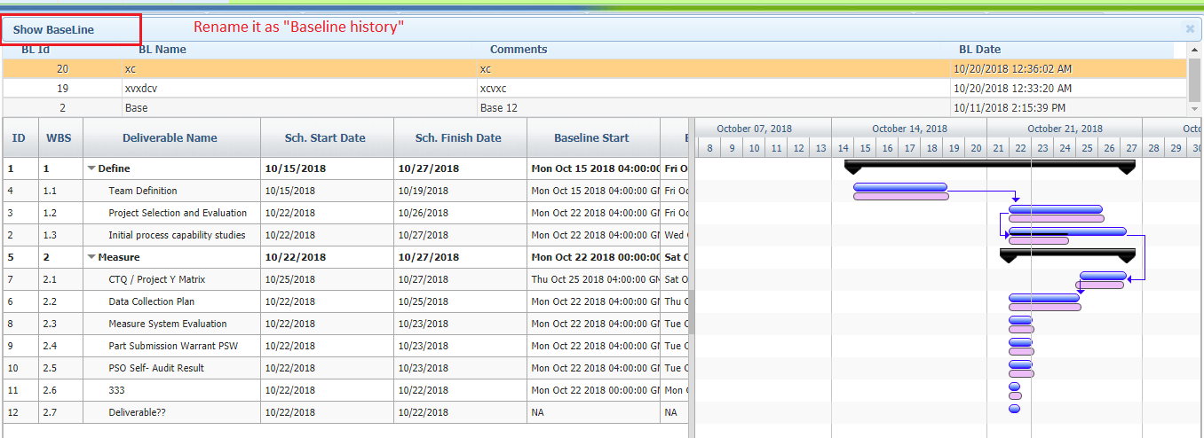
3. Link production Item->Jquery Gantt Page. 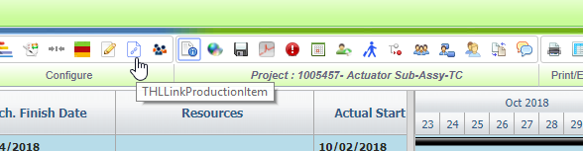
4. Task based and Effort based completion -> Jquery gantt page. 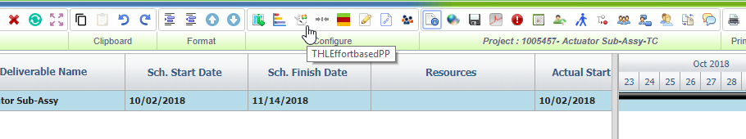

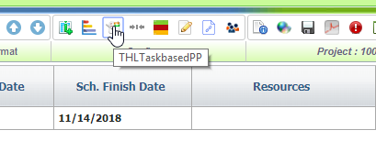

1. Periodic history 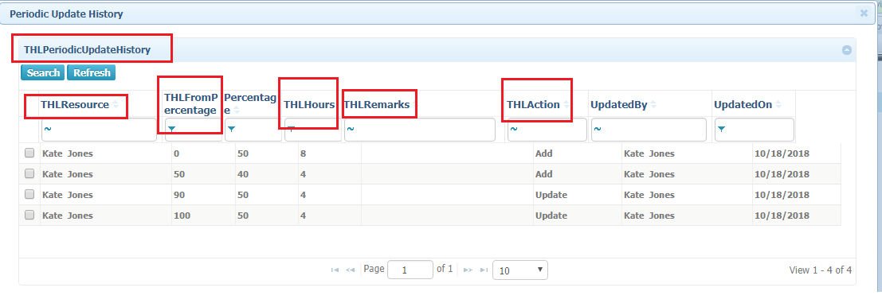
2. Project to Template – Conversion 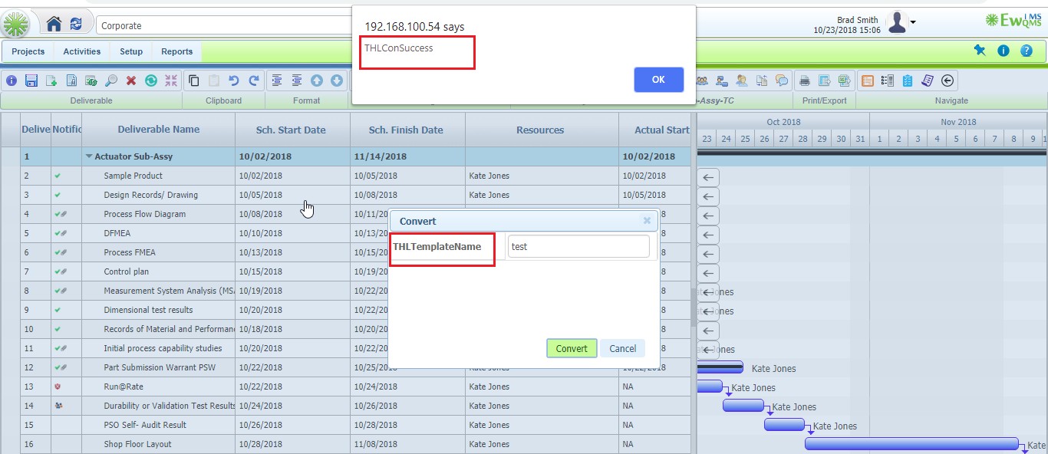
3. Program - > Doc viewer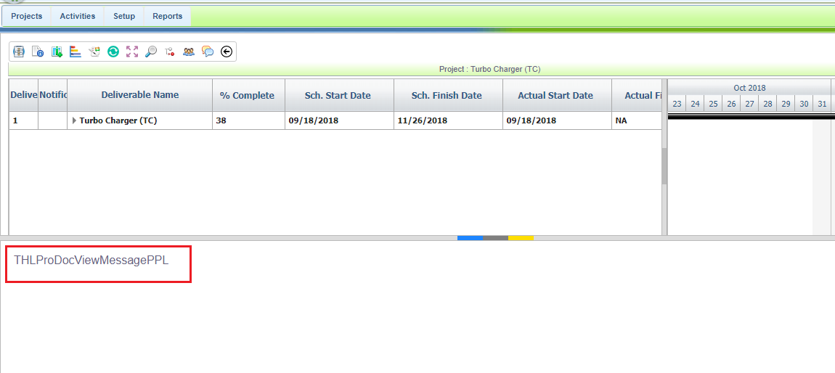
4. Action Page issue in Social Media. 